/content/drive/.shortcut-targets-by-id/1uxGDw2jrgN_sf996q3R-vwZjKIbVlgXL/differentiable-particle-filter/experiments

WARNING:tensorflow:From /tensorflow-1.15.2/python3.7/sonnet/python/modules/util.py:63: The name tf.GraphKeys is deprecated. Please use tf.compat.v1.GraphKeys instead.

WARNING:tensorflow:

The TensorFlow contrib module will not be included in TensorFlow 2.0.

For more information, please see:

* <https://github.com/tensorflow/community/blob/master/rfcs/20180907-contrib-sunset.md>

* <https://github.com/tensorflow/addons>

* <https://github.com/tensorflow/io> (for I/O related ops)

If you depend on functionality not listed there, please file an issue.

noisyfying data ...

WARNING:tensorflow:From /content/drive/MyDrive/differentiable-particle-filter/methods/dpf.py:43: The name tf.placeholder is deprecated. Please use tf.compat.v1.placeholder instead.

WARNING:tensorflow:From /content/drive/MyDrive/differentiable-particle-filter/methods/dpf.py:47: The name tf.placeholder_with_default is deprecated. Please use tf.compat.v1.placeholder_with_default instead.

WARNING:tensorflow:From /content/drive/MyDrive/differentiable-particle-filter/methods/dpf.py:50: to_int32 (from tensorflow.python.ops.math_ops) is deprecated and will be removed in a future version.

Instructions for updating:

Use `tf.cast` instead.

WARNING:tensorflow:From /tensorflow-1.15.2/python3.7/sonnet/python/modules/base.py:177: The name tf.make_template is deprecated. Please use tf.compat.v1.make_template instead.

WARNING:absl:normalize_final is not specified, so using the value of activate_final = True. Change your code to set this kwarg explicitly. In the future, normalize_final will default to True.

WARNING:tensorflow:From /tensorflow-1.15.2/python3.7/sonnet/python/modules/base.py:579: The name tf.variable_scope is deprecated. Please use tf.compat.v1.variable_scope instead.

WARNING:tensorflow:From /tensorflow-1.15.2/python3.7/sonnet/python/modules/base.py:579: The name tf.variable_scope is deprecated. Please use tf.compat.v1.variable_scope instead.

WARNING:tensorflow:From /tensorflow-1.15.2/python3.7/sonnet/python/modules/conv.py:134: The name tf.Dimension is deprecated. Please use tf.compat.v1.Dimension instead.

WARNING:tensorflow:From /tensorflow-1.15.2/python3.7/sonnet/python/modules/conv.py:134: The name tf.Dimension is deprecated. Please use tf.compat.v1.Dimension instead.

SPLIT (1000, 99, 3)

SPLIT --> train: 900

SPLIT --> val: 100

WARNING:tensorflow:From /tensorflow-1.15.2/python3.7/sonnet/python/modules/base.py:278: The name tf.get_default_graph is deprecated. Please use tf.compat.v1.get_default_graph instead.

WARNING:tensorflow:From /tensorflow-1.15.2/python3.7/sonnet/python/modules/base.py:278: The name tf.get_default_graph is deprecated. Please use tf.compat.v1.get_default_graph instead.

WARNING:tensorflow:From /tensorflow-1.15.2/python3.7/sonnet/python/modules/conv.py:299: calling TruncatedNormal.__init__ (from tensorflow.python.ops.init_ops) with dtype is deprecated and will be removed in a future version.

Instructions for updating:

Call initializer instance with the dtype argument instead of passing it to the constructor

WARNING:tensorflow:From /tensorflow-1.15.2/python3.7/sonnet/python/modules/conv.py:299: calling TruncatedNormal.__init__ (from tensorflow.python.ops.init_ops) with dtype is deprecated and will be removed in a future version.

Instructions for updating:

Call initializer instance with the dtype argument instead of passing it to the constructor

WARNING:tensorflow:From /tensorflow-1.15.2/python3.7/sonnet/python/modules/conv.py:665: The name tf.get_variable is deprecated. Please use tf.compat.v1.get_variable instead.

WARNING:tensorflow:From /tensorflow-1.15.2/python3.7/sonnet/python/modules/conv.py:665: The name tf.get_variable is deprecated. Please use tf.compat.v1.get_variable instead.

WARNING:tensorflow:From /tensorflow-1.15.2/python3.7/sonnet/python/modules/conv.py:304: calling Zeros.__init__ (from tensorflow.python.ops.init_ops) with dtype is deprecated and will be removed in a future version.

Instructions for updating:

Call initializer instance with the dtype argument instead of passing it to the constructor

WARNING:tensorflow:From /tensorflow-1.15.2/python3.7/sonnet/python/modules/conv.py:304: calling Zeros.__init__ (from tensorflow.python.ops.init_ops) with dtype is deprecated and will be removed in a future version.

Instructions for updating:

Call initializer instance with the dtype argument instead of passing it to the constructor

WARNING:tensorflow:From /content/drive/MyDrive/differentiable-particle-filter/methods/dpf.py:69: calling dropout (from tensorflow.python.ops.nn_ops) with keep_prob is deprecated and will be removed in a future version.

Instructions for updating:

Please use `rate` instead of `keep_prob`. Rate should be set to `rate = 1 - keep_prob`.

WARNING:tensorflow:From /content/drive/MyDrive/differentiable-particle-filter/methods/dpf.py:69: calling dropout (from tensorflow.python.ops.nn_ops) with keep_prob is deprecated and will be removed in a future version.

Instructions for updating:

Please use `rate` instead of `keep_prob`. Rate should be set to `rate = 1 - keep_prob`.

WARNING:tensorflow:Large dropout rate: 0.85 (>0.5). In TensorFlow 2.x, dropout() uses dropout rate instead of keep_prob. Please ensure that this is intended.

WARNING:tensorflow:Large dropout rate: 0.85 (>0.5). In TensorFlow 2.x, dropout() uses dropout rate instead of keep_prob. Please ensure that this is intended.

WARNING:tensorflow:From /content/drive/MyDrive/differentiable-particle-filter/utils/method_utils.py:29: where (from tensorflow.python.ops.array_ops) is deprecated and will be removed in a future version.

Instructions for updating:

Use tf.where in 2.0, which has the same broadcast rule as np.where

WARNING:tensorflow:From /content/drive/MyDrive/differentiable-particle-filter/utils/method_utils.py:29: where (from tensorflow.python.ops.array_ops) is deprecated and will be removed in a future version.

Instructions for updating:

Use tf.where in 2.0, which has the same broadcast rule as np.where

WARNING:tensorflow:From /content/drive/MyDrive/differentiable-particle-filter/methods/dpf.py:598: The name tf.random_uniform is deprecated. Please use tf.random.uniform instead.

WARNING:tensorflow:From /content/drive/MyDrive/differentiable-particle-filter/methods/dpf.py:598: The name tf.random_uniform is deprecated. Please use tf.random.uniform instead.

WARNING:tensorflow:From /content/drive/MyDrive/differentiable-particle-filter/methods/dpf.py:602: calling argmax (from tensorflow.python.ops.math_ops) with dimension is deprecated and will be removed in a future version.

Instructions for updating:

Use the `axis` argument instead

WARNING:tensorflow:From /content/drive/MyDrive/differentiable-particle-filter/methods/dpf.py:602: calling argmax (from tensorflow.python.ops.math_ops) with dimension is deprecated and will be removed in a future version.

Instructions for updating:

Use the `axis` argument instead

WARNING:tensorflow:From /content/drive/MyDrive/differentiable-particle-filter/methods/dpf.py:169: The name tf.random_normal is deprecated. Please use tf.random.normal instead.

WARNING:tensorflow:From /content/drive/MyDrive/differentiable-particle-filter/methods/dpf.py:169: The name tf.random_normal is deprecated. Please use tf.random.normal instead.

WARNING:tensorflow:Large dropout rate: 0.85 (>0.5). In TensorFlow 2.x, dropout() uses dropout rate instead of keep_prob. Please ensure that this is intended.

WARNING:tensorflow:Large dropout rate: 0.85 (>0.5). In TensorFlow 2.x, dropout() uses dropout rate instead of keep_prob. Please ensure that this is intended.

WARNING:tensorflow:From /content/drive/MyDrive/differentiable-particle-filter/methods/dpf.py:631: calling reduce_sum_v1 (from tensorflow.python.ops.math_ops) with keep_dims is deprecated and will be removed in a future version.

Instructions for updating:

keep_dims is deprecated, use keepdims instead

WARNING:tensorflow:From /content/drive/MyDrive/differentiable-particle-filter/methods/dpf.py:631: calling reduce_sum_v1 (from tensorflow.python.ops.math_ops) with keep_dims is deprecated and will be removed in a future version.

Instructions for updating:

keep_dims is deprecated, use keepdims instead

WARNING:tensorflow:From /content/drive/MyDrive/differentiable-particle-filter/methods/dpf.py:251: The name tf.log is deprecated. Please use tf.math.log instead.

WARNING:tensorflow:From /content/drive/MyDrive/differentiable-particle-filter/methods/dpf.py:251: The name tf.log is deprecated. Please use tf.math.log instead.

WARNING:tensorflow:From /content/drive/MyDrive/differentiable-particle-filter/methods/dpf.py:252: The name tf.train.AdamOptimizer is deprecated. Please use tf.compat.v1.train.AdamOptimizer instead.

WARNING:tensorflow:From /content/drive/MyDrive/differentiable-particle-filter/methods/dpf.py:252: The name tf.train.AdamOptimizer is deprecated. Please use tf.compat.v1.train.AdamOptimizer instead.

WARNING:tensorflow:From /content/drive/MyDrive/differentiable-particle-filter/methods/dpf.py:253: The name tf.get_collection is deprecated. Please use tf.compat.v1.get_collection instead.

WARNING:tensorflow:From /content/drive/MyDrive/differentiable-particle-filter/methods/dpf.py:253: The name tf.get_collection is deprecated. Please use tf.compat.v1.get_collection instead.

WARNING:tensorflow:From /content/drive/MyDrive/differentiable-particle-filter/methods/dpf.py:271: The name tf.diag_part is deprecated. Please use tf.linalg.tensor_diag_part instead.

WARNING:tensorflow:From /content/drive/MyDrive/differentiable-particle-filter/methods/dpf.py:271: The name tf.diag_part is deprecated. Please use tf.linalg.tensor_diag_part instead.

WARNING:tensorflow:From /content/drive/MyDrive/differentiable-particle-filter/methods/dpf.py:272: The name tf.diag is deprecated. Please use tf.linalg.tensor_diag instead.

WARNING:tensorflow:From /content/drive/MyDrive/differentiable-particle-filter/methods/dpf.py:272: The name tf.diag is deprecated. Please use tf.linalg.tensor_diag instead.

WARNING:tensorflow:Large dropout rate: 0.85 (>0.5). In TensorFlow 2.x, dropout() uses dropout rate instead of keep_prob. Please ensure that this is intended.

WARNING:tensorflow:Large dropout rate: 0.85 (>0.5). In TensorFlow 2.x, dropout() uses dropout rate instead of keep_prob. Please ensure that this is intended.

WARNING:tensorflow:From /content/drive/MyDrive/differentiable-particle-filter/methods/dpf.py:417: The name tf.global_variables_initializer is deprecated. Please use tf.compat.v1.global_variables_initializer instead.

WARNING:tensorflow:From /content/drive/MyDrive/differentiable-particle-filter/methods/dpf.py:417: The name tf.global_variables_initializer is deprecated. Please use tf.compat.v1.global_variables_initializer instead.

WARNING:tensorflow:From /content/drive/MyDrive/differentiable-particle-filter/methods/dpf.py:425: The name tf.train.Saver is deprecated. Please use tf.compat.v1.train.Saver instead.

WARNING:tensorflow:From /content/drive/MyDrive/differentiable-particle-filter/methods/dpf.py:425: The name tf.train.Saver is deprecated. Please use tf.compat.v1.train.Saver instead.

epoch 0 >> motion_mle: 25.66+-0.25 --

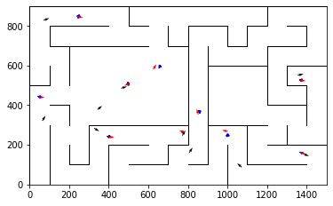

epoch 1 >> motion_mle: 25.77+-0.32/25.48+-0.25 --

epoch 2 >> motion_mle: 25.75+-0.33/25.16+-0.26 --

epoch 3 >> motion_mle: 25.52+-0.29/24.85+-0.26 --

epoch 4 >> motion_mle: 25.07+-0.34/24.55+-0.26 --

epoch 5 >> motion_mle: 24.32+-0.34/24.11+-0.26 --

epoch 6 >> motion_mle: 24.08+-0.37/23.62+-0.26 --

epoch 7 >> motion_mle: 23.64+-0.38/23.08+-0.26 --

epoch 8 >> motion_mle: 22.53+-0.34/22.69+-0.26 --

epoch 9 >> motion_mle: 23.01+-0.37/22.14+-0.26 --

epoch 10 >> motion_mle: 22.14+-0.40/21.62+-0.27 --

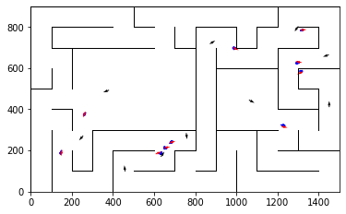

epoch 11 >> motion_mle: 21.57+-0.46/21.21+-0.26 --

epoch 12 >> motion_mle: 20.85+-0.35/20.73+-0.26 --

epoch 13 >> motion_mle: 20.22+-0.39/20.12+-0.26 --

epoch 14 >> motion_mle: 20.17+-0.40/19.64+-0.27 --

epoch 15 >> motion_mle: 19.82+-0.39/19.34+-0.27 --

epoch 16 >> motion_mle: 19.61+-0.41/18.81+-0.27 --

epoch 17 >> motion_mle: 17.63+-0.43/18.54+-0.27 --

epoch 18 >> motion_mle: 18.46+-0.38/18.19+-0.27 --

epoch 19 >> motion_mle: 18.04+-0.34/17.94+-0.26 --

epoch 20 >> motion_mle: 17.67+-0.38/17.61+-0.27 --

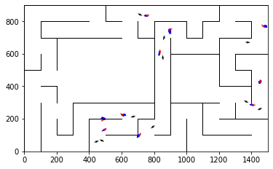

epoch 21 >> motion_mle: 17.44+-0.43/17.48+-0.26 --

epoch 22 >> motion_mle: 16.63+-0.41/17.30+-0.26 --

epoch 23 >> motion_mle: 17.13+-0.38/17.01+-0.26 --

epoch 24 >> motion_mle: 16.08+-0.32/16.77+-0.25 --

epoch 25 == motion_mle: 16.48+-0.42/16.79+-0.25 --

epoch 26 == motion_mle: 16.48+-0.37/16.95+-0.26 --

epoch 27 >> motion_mle: 15.90+-0.35/16.74+-0.26 --

epoch 28 >> motion_mle: 16.86+-0.36/16.21+-0.26 --

epoch 29 >> motion_mle: 16.15+-0.31/16.09+-0.26 --

epoch 30 == motion_mle: 15.93+-0.39/16.33+-0.26 --

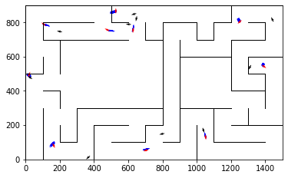

epoch 31 >> motion_mle: 16.16+-0.39/16.01+-0.25 --

epoch 32 >> motion_mle: 16.15+-0.38/15.93+-0.26 --

epoch 33 >> motion_mle: 15.84+-0.27/15.86+-0.26 --

epoch 34 >> motion_mle: 15.75+-0.31/15.67+-0.24 --

epoch 35 == motion_mle: 15.17+-0.31/15.79+-0.25 --

epoch 36 == motion_mle: 16.00+-0.38/15.77+-0.24 --

epoch 37 >> motion_mle: 15.41+-0.30/15.66+-0.24 --

epoch 38 == motion_mle: 15.08+-0.34/15.93+-0.25 --

epoch 39 >> motion_mle: 15.79+-0.39/15.39+-0.26 --

epoch 40 == motion_mle: 15.36+-0.36/15.52+-0.24 --

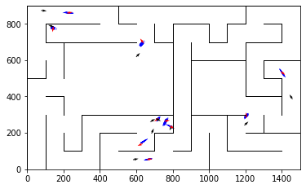

epoch 41 == motion_mle: 15.70+-0.32/15.56+-0.25 --

epoch 42 == motion_mle: 15.07+-0.37/15.42+-0.24 --

epoch 43 >> motion_mle: 15.27+-0.42/15.33+-0.26 --

epoch 44 >> motion_mle: 14.91+-0.32/15.23+-0.25 --

epoch 45 == motion_mle: 14.84+-0.32/15.31+-0.26 --

epoch 46 >> motion_mle: 15.20+-0.28/15.14+-0.26 --

epoch 47 >> motion_mle: 15.31+-0.37/15.13+-0.25 --

epoch 48 >> motion_mle: 14.94+-0.31/14.83+-0.24 --

epoch 49 == motion_mle: 15.35+-0.41/14.98+-0.24 --

epoch 50 >> motion_mle: 15.20+-0.41/14.81+-0.25 --

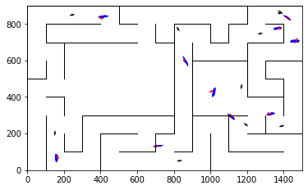

epoch 51 == motion_mle: 14.82+-0.35/15.26+-0.24 --

epoch 52 >> motion_mle: 14.93+-0.39/14.73+-0.25 --

epoch 53 >> motion_mle: 14.41+-0.30/14.56+-0.24 --

epoch 54 == motion_mle: 14.62+-0.38/14.72+-0.24 --

epoch 55 == motion_mle: 14.95+-0.34/14.98+-0.25 --

epoch 56 >> motion_mle: 14.09+-0.33/14.50+-0.25 --

epoch 57 >> motion_mle: 14.70+-0.31/14.47+-0.24 --

epoch 58 == motion_mle: 14.08+-0.36/14.84+-0.25 --

epoch 59 >> motion_mle: 14.16+-0.38/14.37+-0.23 --

epoch 60 == motion_mle: 14.27+-0.34/14.71+-0.24 --

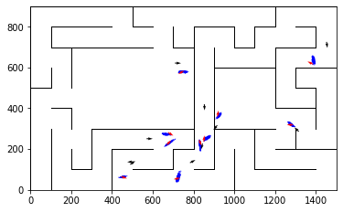

epoch 61 == motion_mle: 14.80+-0.42/14.76+-0.23 --

epoch 62 == motion_mle: 14.51+-0.38/14.45+-0.23 --

epoch 63 >> motion_mle: 14.38+-0.33/14.29+-0.22 --

epoch 64 == motion_mle: 13.64+-0.33/14.43+-0.22 --

epoch 65 == motion_mle: 14.43+-0.35/14.42+-0.23 --

epoch 66 >> motion_mle: 14.46+-0.26/14.22+-0.23 --

epoch 67 == motion_mle: 13.90+-0.30/14.62+-0.22 --

epoch 68 >> motion_mle: 14.25+-0.34/14.12+-0.24 --

epoch 69 >> motion_mle: 14.14+-0.37/14.00+-0.24 --

epoch 70 == motion_mle: 13.85+-0.33/14.22+-0.22 --

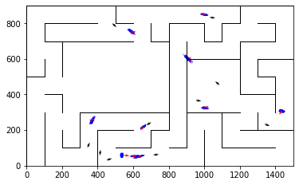

epoch 71 == motion_mle: 13.90+-0.25/14.08+-0.22 --

epoch 72 == motion_mle: 14.18+-0.40/14.35+-0.22 --

epoch 73 == motion_mle: 13.83+-0.30/14.00+-0.23 --

epoch 74 == motion_mle: 13.89+-0.40/14.09+-0.21 --

epoch 75 == motion_mle: 14.16+-0.30/14.36+-0.22 --

epoch 76 == motion_mle: 13.99+-0.31/14.05+-0.22 --

epoch 77 >> motion_mle: 13.78+-0.32/13.97+-0.22 --

epoch 78 >> motion_mle: 13.25+-0.29/13.90+-0.22 --

epoch 79 == motion_mle: 13.92+-0.31/13.97+-0.22 --

epoch 80 >> motion_mle: 13.81+-0.35/13.87+-0.23 --

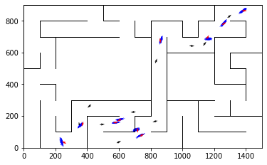

epoch 81 == motion_mle: 14.30+-0.32/13.91+-0.22 --

epoch 82 == motion_mle: 13.99+-0.31/13.90+-0.20 --

epoch 83 >> motion_mle: 13.77+-0.31/13.66+-0.22 --

epoch 84 >> motion_mle: 13.79+-0.31/13.64+-0.22 --

epoch 85 == motion_mle: 13.74+-0.35/13.73+-0.22 --

epoch 86 == motion_mle: 14.38+-0.29/14.21+-0.23 --

epoch 87 == motion_mle: 13.40+-0.31/13.82+-0.21 --

epoch 88 == motion_mle: 13.24+-0.35/13.83+-0.21 --

epoch 89 == motion_mle: 13.78+-0.33/13.99+-0.22 --

epoch 90 == motion_mle: 13.45+-0.31/13.67+-0.22 --

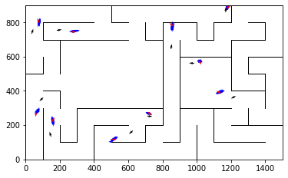

epoch 91 == motion_mle: 14.06+-0.33/13.79+-0.23 --

epoch 92 >> motion_mle: 13.96+-0.28/13.49+-0.21 --

epoch 93 == motion_mle: 13.28+-0.32/13.55+-0.22 --

epoch 94 == motion_mle: 13.84+-0.34/13.70+-0.22 --

epoch 95 == motion_mle: 13.87+-0.35/14.04+-0.24 --

epoch 96 >> motion_mle: 13.46+-0.30/13.47+-0.23 --

epoch 97 == motion_mle: 13.39+-0.30/13.69+-0.22 --

epoch 98 == motion_mle: 13.46+-0.37/13.67+-0.21 --

epoch 99 == motion_mle: 13.94+-0.37/13.77+-0.23 --

epoch 100 == motion_mle: 13.88+-0.40/13.84+-0.20 --

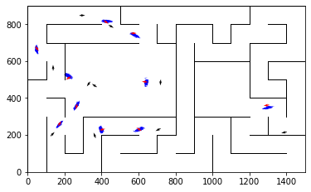

epoch 101 == motion_mle: 13.55+-0.30/13.73+-0.23 --

epoch 102 == motion_mle: 13.50+-0.32/13.68+-0.24 --

epoch 103 >> motion_mle: 13.46+-0.29/13.46+-0.23 --

epoch 104 == motion_mle: 13.55+-0.32/13.57+-0.22 --

epoch 105 == motion_mle: 13.75+-0.35/13.65+-0.22 --

epoch 106 == motion_mle: 13.63+-0.30/13.72+-0.22 --

epoch 107 == motion_mle: 13.65+-0.31/13.50+-0.22 --

epoch 108 == motion_mle: 12.85+-0.32/13.77+-0.20 --

epoch 109 >> motion_mle: 14.04+-0.34/13.44+-0.21 --

epoch 110 == motion_mle: 12.98+-0.25/13.74+-0.21 --

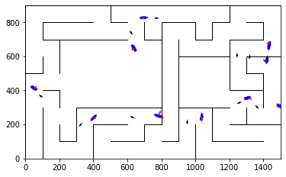

epoch 111 == motion_mle: 14.06+-0.32/13.69+-0.22 --

epoch 112 >> motion_mle: 13.38+-0.32/13.42+-0.23 --

epoch 113 == motion_mle: 12.99+-0.33/13.47+-0.22 --

epoch 114 == motion_mle: 12.90+-0.27/13.58+-0.23 --

epoch 115 == motion_mle: 13.74+-0.26/13.98+-0.23 --

epoch 116 == motion_mle: 13.37+-0.34/13.60+-0.21 --

epoch 117 == motion_mle: 13.61+-0.26/13.46+-0.21 --

epoch 118 == motion_mle: 13.63+-0.27/13.67+-0.24 --

epoch 119 >> motion_mle: 14.54+-0.28/13.41+-0.22 --

epoch 120 == motion_mle: 12.87+-0.38/13.45+-0.21 --

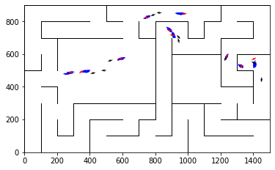

epoch 121 >> motion_mle: 13.21+-0.30/13.33+-0.20 --

epoch 122 == motion_mle: 13.63+-0.34/13.43+-0.23 --

epoch 123 == motion_mle: 13.70+-0.30/13.33+-0.22 --

epoch 124 == motion_mle: 13.68+-0.30/13.40+-0.22 --

epoch 125 == motion_mle: 12.99+-0.24/13.57+-0.21 --

epoch 126 == motion_mle: 13.39+-0.34/13.36+-0.20 --

epoch 127 >> motion_mle: 13.87+-0.34/13.25+-0.22 --

epoch 128 == motion_mle: 13.26+-0.35/13.37+-0.23 --

epoch 129 >> motion_mle: 13.16+-0.32/13.22+-0.21 --

epoch 130 == motion_mle: 12.95+-0.32/13.56+-0.22 --

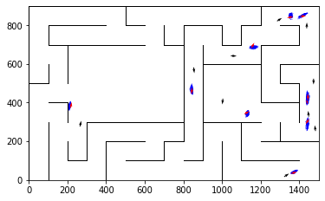

epoch 131 == motion_mle: 12.87+-0.30/13.29+-0.23 --

epoch 132 >> motion_mle: 13.39+-0.32/13.13+-0.22 --

epoch 133 == motion_mle: 12.84+-0.25/13.61+-0.24 --

epoch 134 == motion_mle: 13.17+-0.26/13.61+-0.23 --

epoch 135 == motion_mle: 13.31+-0.22/13.71+-0.22 --

epoch 136 == motion_mle: 13.16+-0.32/13.19+-0.22 --

epoch 137 == motion_mle: 13.53+-0.39/13.36+-0.22 --

epoch 138 == motion_mle: 12.47+-0.27/13.14+-0.23 --

epoch 139 == motion_mle: 12.93+-0.38/13.27+-0.22 --

epoch 140 >> motion_mle: 13.41+-0.31/13.04+-0.22 --

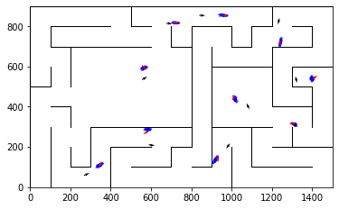

epoch 141 == motion_mle: 13.17+-0.32/13.22+-0.21 --

epoch 142 == motion_mle: 13.35+-0.34/13.42+-0.23 --

epoch 143 == motion_mle: 12.77+-0.34/13.47+-0.24 --

epoch 144 == motion_mle: 12.94+-0.26/13.17+-0.23 --

epoch 145 == motion_mle: 12.82+-0.32/13.33+-0.23 --

epoch 146 == motion_mle: 12.97+-0.27/13.34+-0.21 --

epoch 147 == motion_mle: 12.95+-0.31/13.35+-0.22 --

epoch 148 >> motion_mle: 12.73+-0.27/13.02+-0.23 --

epoch 149 == motion_mle: 13.32+-0.36/13.23+-0.23 --

epoch 150 == motion_mle: 12.20+-0.27/13.11+-0.22 --

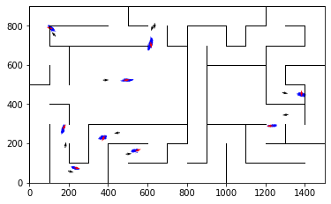

epoch 151 == motion_mle: 12.51+-0.34/13.17+-0.22 --

epoch 152 == motion_mle: 13.22+-0.29/13.33+-0.23 --

epoch 153 == motion_mle: 12.89+-0.26/13.17+-0.24 --

epoch 154 == motion_mle: 12.77+-0.31/13.13+-0.23 --

epoch 155 == motion_mle: 13.18+-0.30/13.08+-0.21 --

epoch 156 >> motion_mle: 12.99+-0.29/12.97+-0.22 --

epoch 157 == motion_mle: 13.53+-0.32/12.98+-0.22 --

epoch 158 >> motion_mle: 13.24+-0.33/12.92+-0.22 --

epoch 159 == motion_mle: 12.99+-0.34/12.97+-0.23 --

epoch 160 == motion_mle: 13.10+-0.34/13.23+-0.24 --

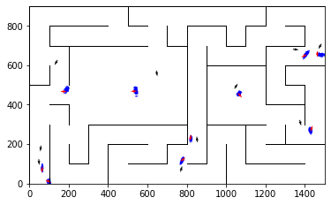

epoch 161 == motion_mle: 12.64+-0.28/12.98+-0.22 --

epoch 162 == motion_mle: 12.87+-0.29/13.21+-0.23 --

epoch 163 == motion_mle: 13.12+-0.31/13.00+-0.21 --

epoch 164 == motion_mle: 12.63+-0.33/13.29+-0.20 --

epoch 165 == motion_mle: 13.21+-0.29/13.07+-0.22 --

epoch 166 == motion_mle: 12.97+-0.34/13.07+-0.23 --

epoch 167 == motion_mle: 13.06+-0.28/13.00+-0.24 --

epoch 168 == motion_mle: 12.72+-0.33/13.05+-0.23 --

epoch 169 >> motion_mle: 12.74+-0.35/12.92+-0.22 --

epoch 170 == motion_mle: 12.42+-0.30/13.04+-0.22 --

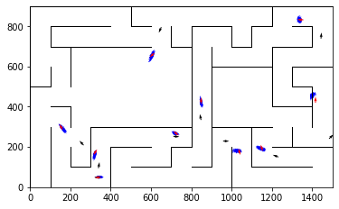

epoch 171 == motion_mle: 12.91+-0.28/13.12+-0.22 --

epoch 172 == motion_mle: 13.10+-0.30/13.12+-0.23 --

epoch 173 == motion_mle: 12.85+-0.38/13.24+-0.24 --

epoch 174 == motion_mle: 13.44+-0.32/13.29+-0.23 --

epoch 175 == motion_mle: 12.83+-0.31/13.07+-0.22 --

epoch 176 == motion_mle: 12.41+-0.31/13.03+-0.20 --

epoch 177 >> motion_mle: 12.86+-0.36/12.76+-0.22 --

epoch 178 == motion_mle: 12.98+-0.30/13.10+-0.24 --

epoch 179 == motion_mle: 13.03+-0.32/13.03+-0.23 --

epoch 180 == motion_mle: 12.73+-0.35/12.97+-0.23 --

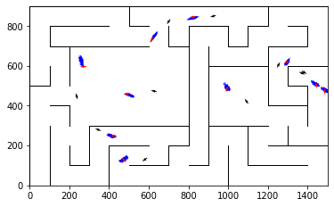

epoch 181 == motion_mle: 13.27+-0.30/12.79+-0.21 --

epoch 182 == motion_mle: 13.03+-0.30/12.94+-0.25 --

epoch 183 == motion_mle: 12.73+-0.31/12.94+-0.22 --

epoch 184 == motion_mle: 12.61+-0.33/12.87+-0.22 --

epoch 185 == motion_mle: 12.47+-0.28/12.99+-0.23 --

epoch 186 == motion_mle: 12.86+-0.34/12.83+-0.22 --

epoch 187 == motion_mle: 12.95+-0.32/13.36+-0.24 --

epoch 188 == motion_mle: 12.48+-0.30/12.85+-0.22 --

epoch 189 == motion_mle: 12.97+-0.28/12.99+-0.22 --

epoch 190 == motion_mle: 12.59+-0.30/12.98+-0.20 --

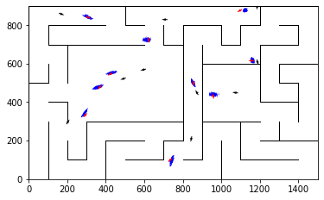

epoch 191 == motion_mle: 12.29+-0.36/12.77+-0.21 --

epoch 192 == motion_mle: 12.65+-0.29/13.03+-0.22 --

epoch 193 == motion_mle: 12.56+-0.36/13.04+-0.25 --

epoch 194 >> motion_mle: 12.74+-0.33/12.61+-0.21 --

epoch 195 == motion_mle: 12.97+-0.31/12.91+-0.24 --

epoch 196 == motion_mle: 12.39+-0.28/12.93+-0.23 --

epoch 197 == motion_mle: 12.67+-0.29/12.92+-0.22 --

epoch 198 == motion_mle: 12.52+-0.29/12.68+-0.21 --

epoch 199 == motion_mle: 13.19+-0.33/12.88+-0.25 --

epoch 200 == motion_mle: 13.05+-0.39/12.81+-0.24 --

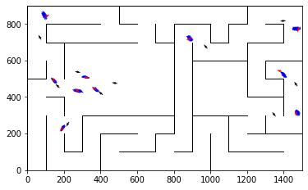

epoch 201 == motion_mle: 13.09+-0.32/12.81+-0.22 --

epoch 202 == motion_mle: 12.47+-0.34/12.91+-0.23 --

epoch 203 == motion_mle: 12.92+-0.31/13.10+-0.21 --

epoch 204 == motion_mle: 12.46+-0.30/12.99+-0.24 --

epoch 205 == motion_mle: 12.65+-0.30/12.97+-0.22 --

epoch 206 == motion_mle: 12.42+-0.27/12.65+-0.23 --

epoch 207 == motion_mle: 12.60+-0.26/12.83+-0.23 --

epoch 208 == motion_mle: 12.61+-0.34/12.86+-0.22 --

epoch 209 == motion_mle: 12.51+-0.28/12.80+-0.21 --

epoch 210 == motion_mle: 12.88+-0.33/12.74+-0.23 --

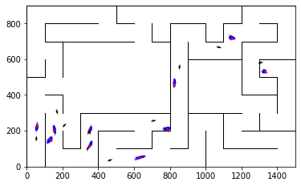

epoch 211 == motion_mle: 12.13+-0.30/12.91+-0.22 --

epoch 212 == motion_mle: 12.66+-0.33/12.84+-0.23 --

epoch 213 == motion_mle: 12.73+-0.32/12.90+-0.21 --

epoch 214 == motion_mle: 13.10+-0.31/12.84+-0.22 --

epoch 215 == motion_mle: 12.47+-0.34/12.82+-0.24 --

epoch 216 == motion_mle: 13.27+-0.32/12.67+-0.22 --

epoch 217 == motion_mle: 12.71+-0.32/12.99+-0.22 --

epoch 218 >> motion_mle: 12.95+-0.30/12.54+-0.22 --

epoch 219 == motion_mle: 13.03+-0.29/13.19+-0.23 --

epoch 220 == motion_mle: 12.48+-0.29/12.69+-0.22 --

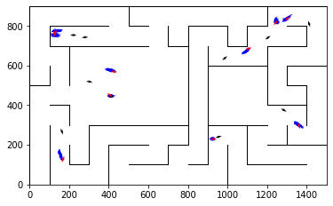

epoch 221 == motion_mle: 12.48+-0.25/12.74+-0.22 --

epoch 222 == motion_mle: 12.29+-0.26/12.70+-0.24 --

epoch 223 == motion_mle: 12.88+-0.32/12.85+-0.23 --

epoch 224 == motion_mle: 12.60+-0.32/12.81+-0.22 --

epoch 225 == motion_mle: 12.72+-0.28/12.57+-0.24 --

epoch 226 == motion_mle: 12.36+-0.28/12.98+-0.22 --

epoch 227 == motion_mle: 12.73+-0.34/12.87+-0.22 --

epoch 228 == motion_mle: 12.49+-0.29/12.81+-0.23 --

epoch 229 == motion_mle: 12.63+-0.26/12.97+-0.23 --

epoch 230 == motion_mle: 12.84+-0.32/12.75+-0.24 --

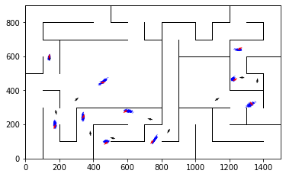

epoch 231 == motion_mle: 12.37+-0.25/12.84+-0.23 --

epoch 232 == motion_mle: 12.37+-0.30/12.73+-0.23 --

epoch 233 == motion_mle: 12.38+-0.29/12.96+-0.23 --

epoch 234 == motion_mle: 12.47+-0.31/12.71+-0.24 --

epoch 235 >> motion_mle: 12.41+-0.26/12.50+-0.23 --

epoch 236 == motion_mle: 12.99+-0.32/12.61+-0.24 --

epoch 237 == motion_mle: 12.69+-0.33/12.56+-0.24 --

epoch 238 == motion_mle: 12.23+-0.25/12.63+-0.22 --

epoch 239 == motion_mle: 12.73+-0.32/12.76+-0.24 --

epoch 240 == motion_mle: 13.18+-0.32/12.61+-0.22 --

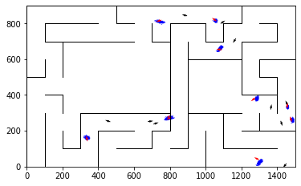

epoch 241 == motion_mle: 12.60+-0.34/12.88+-0.21 --

epoch 242 == motion_mle: 12.64+-0.33/12.80+-0.24 --

epoch 243 == motion_mle: 12.46+-0.24/12.71+-0.22 --

epoch 244 == motion_mle: 13.00+-0.34/12.66+-0.22 --

epoch 245 == motion_mle: 12.51+-0.30/12.69+-0.23 --

epoch 246 >> motion_mle: 12.47+-0.26/12.46+-0.22 --

epoch 247 == motion_mle: 12.42+-0.33/12.55+-0.23 --

epoch 248 == motion_mle: 12.50+-0.36/12.74+-0.22 --

epoch 249 == motion_mle: 12.56+-0.36/12.72+-0.22 --

epoch 250 == motion_mle: 13.05+-0.23/12.64+-0.23 --

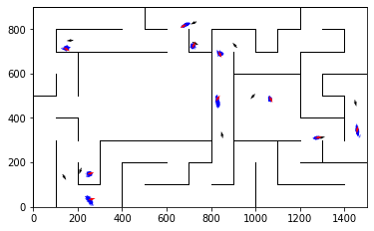

epoch 251 == motion_mle: 12.18+-0.29/12.55+-0.20 --

epoch 252 == motion_mle: 13.03+-0.27/12.76+-0.22 --

epoch 253 == motion_mle: 12.05+-0.34/12.47+-0.22 --

epoch 254 == motion_mle: 12.25+-0.33/12.82+-0.23 --

epoch 255 == motion_mle: 12.57+-0.33/12.70+-0.25 --

epoch 256 == motion_mle: 12.04+-0.34/12.52+-0.21 --

epoch 257 == motion_mle: 11.70+-0.32/12.50+-0.20 --

epoch 258 == motion_mle: 12.71+-0.29/12.54+-0.22 --

epoch 259 == motion_mle: 12.38+-0.32/12.52+-0.24 --

epoch 260 == motion_mle: 12.26+-0.29/12.58+-0.22 --

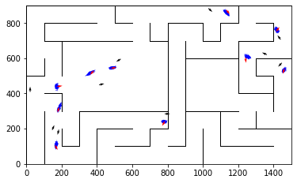

epoch 261 == motion_mle: 12.23+-0.27/12.53+-0.22 --

epoch 262 == motion_mle: 12.15+-0.30/12.64+-0.21 --

epoch 263 >> motion_mle: 12.85+-0.27/12.45+-0.23 --

epoch 264 == motion_mle: 12.33+-0.30/12.69+-0.23 --

epoch 265 == motion_mle: 12.60+-0.27/12.80+-0.23 --

epoch 266 >> motion_mle: 12.29+-0.31/12.38+-0.21 --

epoch 267 == motion_mle: 12.60+-0.30/12.51+-0.23 --

epoch 268 == motion_mle: 12.41+-0.27/12.58+-0.23 --

epoch 269 == motion_mle: 12.60+-0.32/12.66+-0.23 --

epoch 270 >> motion_mle: 12.42+-0.27/12.27+-0.23 --

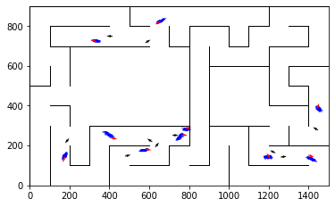

epoch 271 == motion_mle: 12.24+-0.35/12.42+-0.24 --

epoch 272 == motion_mle: 12.92+-0.28/12.64+-0.24 --

epoch 273 == motion_mle: 12.65+-0.32/12.41+-0.21 --

epoch 274 == motion_mle: 12.57+-0.26/12.47+-0.22 --

epoch 275 == motion_mle: 12.38+-0.24/12.45+-0.23 --

epoch 276 == motion_mle: 12.45+-0.28/12.60+-0.24 --

epoch 277 == motion_mle: 12.64+-0.28/12.48+-0.23 --

epoch 278 == motion_mle: 12.67+-0.30/12.46+-0.24 --

epoch 279 == motion_mle: 12.20+-0.26/12.50+-0.25 --

epoch 280 == motion_mle: 12.56+-0.29/12.46+-0.21 --

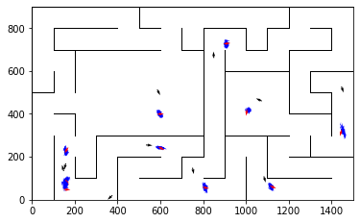

epoch 281 == motion_mle: 12.15+-0.37/12.43+-0.23 --

epoch 282 == motion_mle: 12.22+-0.28/12.67+-0.23 --

epoch 283 == motion_mle: 13.45+-0.29/12.43+-0.23 --

epoch 284 == motion_mle: 12.18+-0.29/12.36+-0.23 --

epoch 285 == motion_mle: 12.06+-0.31/12.37+-0.22 --

epoch 286 == motion_mle: 11.92+-0.23/12.51+-0.22 --

epoch 287 == motion_mle: 12.29+-0.30/12.45+-0.25 --

epoch 288 == motion_mle: 12.16+-0.30/12.52+-0.20 --

epoch 289 == motion_mle: 12.49+-0.27/12.46+-0.21 --

epoch 290 == motion_mle: 11.64+-0.25/12.49+-0.23 --

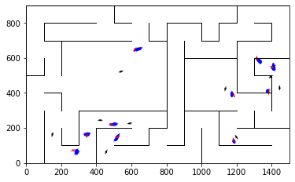

epoch 291 == motion_mle: 11.76+-0.27/12.31+-0.23 --

epoch 292 == motion_mle: 11.82+-0.28/12.38+-0.22 --

epoch 293 == motion_mle: 11.82+-0.30/12.49+-0.23 --

epoch 294 == motion_mle: 12.12+-0.27/12.43+-0.22 --

epoch 295 == motion_mle: 12.27+-0.24/12.38+-0.21 --

epoch 296 == motion_mle: 12.24+-0.34/12.52+-0.22 --

epoch 297 == motion_mle: 11.87+-0.29/12.56+-0.22 --

epoch 298 == motion_mle: 12.17+-0.33/12.39+-0.22 --

epoch 299 == motion_mle: 12.02+-0.36/12.28+-0.23 --

epoch 300 == motion_mle: 12.86+-0.34/12.48+-0.24 --

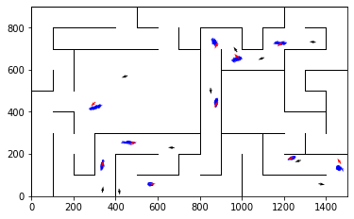

epoch 301 == motion_mle: 12.49+-0.29/12.38+-0.23 --

epoch 302 >> motion_mle: 12.11+-0.32/12.18+-0.21 --

epoch 303 == motion_mle: 12.15+-0.34/12.34+-0.22 --

epoch 304 == motion_mle: 12.37+-0.30/12.38+-0.22 --

epoch 305 == motion_mle: 12.68+-0.31/12.37+-0.22 --

epoch 306 == motion_mle: 12.11+-0.32/12.38+-0.20 --

epoch 307 == motion_mle: 12.38+-0.28/12.29+-0.21 --

epoch 308 == motion_mle: 12.42+-0.34/12.27+-0.23 --

epoch 309 == motion_mle: 11.54+-0.31/12.42+-0.23 --

epoch 310 == motion_mle: 11.86+-0.31/12.35+-0.21 --

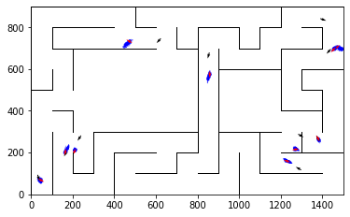

epoch 311 == motion_mle: 12.30+-0.31/12.35+-0.22 --

epoch 312 == motion_mle: 12.36+-0.27/12.34+-0.23 --

epoch 313 == motion_mle: 11.86+-0.30/12.48+-0.22 --

epoch 314 == motion_mle: 12.01+-0.28/12.33+-0.22 --

epoch 315 == motion_mle: 12.08+-0.32/12.51+-0.21 --

epoch 316 == motion_mle: 11.97+-0.34/12.48+-0.23 --

epoch 317 >> motion_mle: 12.43+-0.27/12.17+-0.23 --

epoch 318 == motion_mle: 11.61+-0.24/12.25+-0.25 --

epoch 319 == motion_mle: 11.85+-0.35/12.40+-0.25 --

epoch 320 == motion_mle: 12.27+-0.35/12.18+-0.24 --

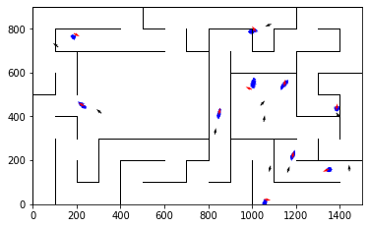

epoch 321 == motion_mle: 11.84+-0.33/12.26+-0.23 --

epoch 322 == motion_mle: 12.15+-0.27/12.25+-0.24 --

epoch 323 >> motion_mle: 11.50+-0.27/12.05+-0.23 --

epoch 324 == motion_mle: 12.19+-0.34/12.27+-0.23 --

epoch 325 == motion_mle: 11.45+-0.26/12.27+-0.23 --

epoch 326 == motion_mle: 11.78+-0.36/12.26+-0.23 --

epoch 327 == motion_mle: 11.99+-0.31/12.19+-0.24 --

epoch 328 == motion_mle: 12.37+-0.29/12.30+-0.23 --

epoch 329 == motion_mle: 12.63+-0.29/12.43+-0.23 --

epoch 330 == motion_mle: 12.32+-0.30/12.20+-0.21 --

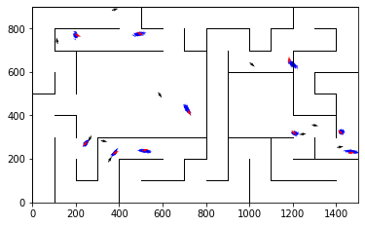

epoch 331 == motion_mle: 11.67+-0.30/12.24+-0.24 --

epoch 332 == motion_mle: 11.93+-0.30/12.17+-0.23 --

epoch 333 == motion_mle: 12.03+-0.31/12.40+-0.21 --

epoch 334 == motion_mle: 12.28+-0.35/12.27+-0.23 --

epoch 335 == motion_mle: 12.24+-0.36/12.54+-0.22 --

epoch 336 == motion_mle: 12.44+-0.29/12.42+-0.24 --

epoch 337 == motion_mle: 11.65+-0.28/12.31+-0.21 --

epoch 338 == motion_mle: 12.32+-0.35/12.27+-0.24 --

epoch 339 == motion_mle: 12.62+-0.34/12.18+-0.22 --

epoch 340 == motion_mle: 12.50+-0.36/12.13+-0.22 --

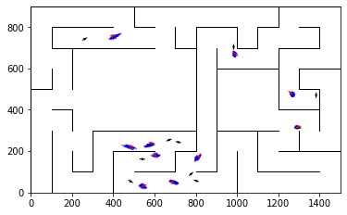

epoch 341 == motion_mle: 12.12+-0.25/12.34+-0.21 --

epoch 342 == motion_mle: 12.17+-0.33/12.37+-0.23 --

epoch 343 == motion_mle: 12.18+-0.37/12.18+-0.23 --

epoch 344 == motion_mle: 12.63+-0.35/12.20+-0.23 --

epoch 345 == motion_mle: 12.22+-0.31/12.19+-0.23 --

epoch 346 == motion_mle: 11.76+-0.25/12.21+-0.21 --

epoch 347 == motion_mle: 12.25+-0.33/12.13+-0.21 --

epoch 348 == motion_mle: 12.28+-0.27/12.30+-0.23 --

epoch 349 >> motion_mle: 11.88+-0.33/12.04+-0.22 --

epoch 350 == motion_mle: 12.20+-0.25/12.25+-0.21 --

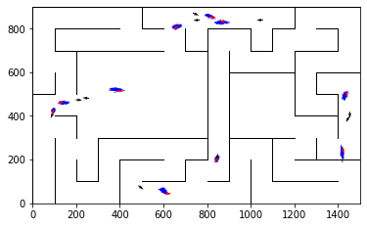

epoch 351 >> motion_mle: 12.45+-0.31/12.04+-0.23 --

epoch 352 == motion_mle: 11.87+-0.32/12.17+-0.21 --

epoch 353 == motion_mle: 12.24+-0.30/12.13+-0.22 --

epoch 354 == motion_mle: 12.14+-0.28/12.19+-0.23 --

epoch 355 >> motion_mle: 11.82+-0.27/11.96+-0.23 --

epoch 356 == motion_mle: 11.64+-0.33/12.32+-0.21 --

epoch 357 == motion_mle: 11.36+-0.28/12.30+-0.23 --

epoch 358 == motion_mle: 12.19+-0.31/12.16+-0.23 --

epoch 359 == motion_mle: 12.10+-0.29/12.18+-0.23 --

epoch 360 == motion_mle: 12.15+-0.31/12.12+-0.22 --

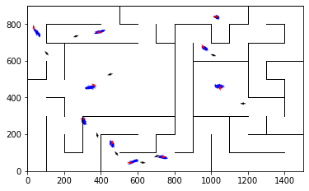

epoch 361 == motion_mle: 11.99+-0.27/12.26+-0.22 --

epoch 362 == motion_mle: 11.53+-0.29/12.25+-0.22 --

epoch 363 == motion_mle: 11.51+-0.32/12.18+-0.24 --

epoch 364 == motion_mle: 12.20+-0.33/12.15+-0.23 --

epoch 365 == motion_mle: 12.40+-0.30/12.15+-0.21 --

epoch 366 == motion_mle: 12.12+-0.31/12.15+-0.24 --

epoch 367 == motion_mle: 11.79+-0.27/12.24+-0.24 --

epoch 368 == motion_mle: 11.53+-0.32/11.98+-0.22 --

epoch 369 == motion_mle: 12.10+-0.33/12.05+-0.22 --

epoch 370 >> motion_mle: 12.11+-0.29/11.91+-0.22 --

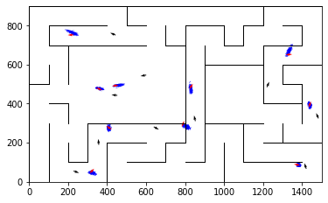

epoch 371 == motion_mle: 11.91+-0.28/11.94+-0.24 --

epoch 372 == motion_mle: 12.03+-0.26/12.13+-0.23 --

epoch 373 == motion_mle: 11.86+-0.31/12.21+-0.23 --

epoch 374 == motion_mle: 11.66+-0.24/11.92+-0.23 --

epoch 375 == motion_mle: 11.95+-0.35/12.19+-0.24 --

epoch 376 == motion_mle: 11.69+-0.30/12.27+-0.21 --

epoch 377 == motion_mle: 12.42+-0.26/12.05+-0.22 --

epoch 378 == motion_mle: 11.34+-0.26/12.24+-0.23 --

epoch 379 == motion_mle: 12.35+-0.33/12.55+-0.25 --

epoch 380 == motion_mle: 11.96+-0.24/12.10+-0.23 --

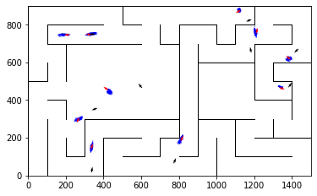

epoch 381 == motion_mle: 12.28+-0.30/12.25+-0.22 --

epoch 382 == motion_mle: 12.16+-0.33/12.22+-0.22 --

epoch 383 == motion_mle: 11.83+-0.29/12.09+-0.25 --

epoch 384 == motion_mle: 12.18+-0.28/12.09+-0.23 --

epoch 385 == motion_mle: 12.18+-0.25/11.96+-0.22 --

epoch 386 == motion_mle: 10.85+-0.30/12.15+-0.22 --

epoch 387 == motion_mle: 11.80+-0.28/12.04+-0.24 --

epoch 388 == motion_mle: 11.59+-0.23/12.22+-0.24 --

epoch 389 == motion_mle: 11.93+-0.28/12.19+-0.23 --

epoch 390 == motion_mle: 11.55+-0.30/11.91+-0.23 --

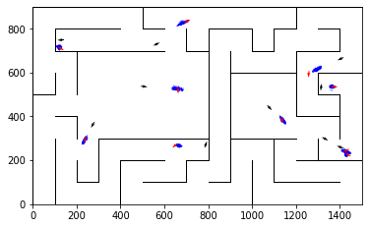

epoch 391 == motion_mle: 11.55+-0.22/11.98+-0.21 --

epoch 392 == motion_mle: 12.17+-0.29/12.17+-0.25 --

epoch 393 == motion_mle: 12.10+-0.28/11.93+-0.24 --

epoch 394 == motion_mle: 12.02+-0.30/11.94+-0.22 --

epoch 395 == motion_mle: 11.96+-0.33/12.08+-0.22 --

epoch 396 == motion_mle: 11.64+-0.30/12.01+-0.23 --

epoch 397 == motion_mle: 11.79+-0.26/11.98+-0.21 --

epoch 398 == motion_mle: 11.76+-0.28/12.17+-0.22 --

epoch 399 == motion_mle: 11.94+-0.31/12.08+-0.23 --

epoch 400 == motion_mle: 11.81+-0.29/12.03+-0.22 --

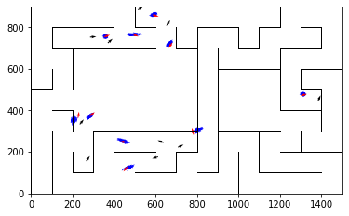

epoch 401 == motion_mle: 12.20+-0.35/12.10+-0.23 --

epoch 402 == motion_mle: 11.78+-0.31/12.07+-0.24 --

epoch 403 == motion_mle: 11.41+-0.35/12.23+-0.22 --

epoch 404 == motion_mle: 11.87+-0.33/11.92+-0.22 --

epoch 405 == motion_mle: 11.72+-0.31/12.25+-0.22 --

epoch 406 == motion_mle: 11.47+-0.30/12.04+-0.23 --

epoch 407 == motion_mle: 11.84+-0.28/12.08+-0.24 --

epoch 408 == motion_mle: 11.61+-0.33/12.08+-0.24 --

epoch 409 == motion_mle: 11.55+-0.27/12.09+-0.24 --

epoch 410 >> motion_mle: 12.18+-0.35/11.72+-0.20 --

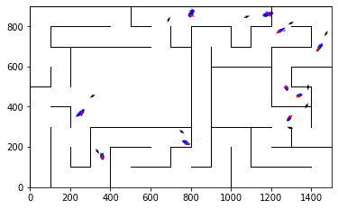

epoch 411 == motion_mle: 11.85+-0.24/11.72+-0.24 --

epoch 412 == motion_mle: 12.34+-0.32/11.94+-0.22 --

epoch 413 == motion_mle: 11.84+-0.30/11.85+-0.23 --

epoch 414 == motion_mle: 11.81+-0.38/11.85+-0.24 --

epoch 415 == motion_mle: 11.61+-0.30/12.05+-0.22 --

epoch 416 == motion_mle: 11.65+-0.28/12.04+-0.22 --

epoch 417 == motion_mle: 11.63+-0.32/12.13+-0.24 --

epoch 418 == motion_mle: 12.07+-0.28/12.07+-0.22 --

epoch 419 == motion_mle: 11.62+-0.26/11.96+-0.23 --

epoch 420 == motion_mle: 11.47+-0.38/12.06+-0.24 --

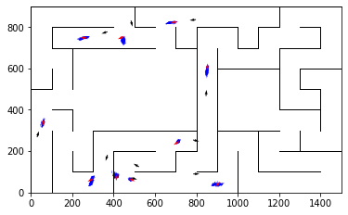

epoch 421 == motion_mle: 11.76+-0.30/12.25+-0.24 --

epoch 422 == motion_mle: 11.78+-0.25/12.26+-0.24 --

epoch 423 == motion_mle: 11.60+-0.33/11.97+-0.23 --

epoch 424 == motion_mle: 12.20+-0.27/12.08+-0.23 --

epoch 425 == motion_mle: 11.91+-0.26/11.91+-0.22 --

epoch 426 == motion_mle: 12.03+-0.32/12.22+-0.22 --

epoch 427 == motion_mle: 11.59+-0.27/11.83+-0.23 --

epoch 428 == motion_mle: 11.77+-0.30/11.95+-0.25 --

epoch 429 == motion_mle: 11.43+-0.32/11.90+-0.22 --

epoch 430 == motion_mle: 11.92+-0.31/11.96+-0.24 --

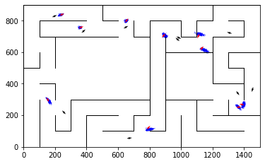

epoch 431 == motion_mle: 12.52+-0.40/12.12+-0.24 --

epoch 432 == motion_mle: 11.74+-0.26/11.98+-0.23 --

epoch 433 == motion_mle: 11.42+-0.28/12.16+-0.21 --

epoch 434 == motion_mle: 11.85+-0.33/11.96+-0.23 --

epoch 435 == motion_mle: 11.80+-0.27/12.01+-0.24 --

epoch 436 == motion_mle: 11.73+-0.28/11.91+-0.22 --

epoch 437 == motion_mle: 11.87+-0.34/12.01+-0.22 --

epoch 438 == motion_mle: 11.70+-0.31/12.08+-0.22 --

epoch 439 == motion_mle: 11.57+-0.30/11.82+-0.25 --

epoch 440 == motion_mle: 11.74+-0.30/11.82+-0.23 --

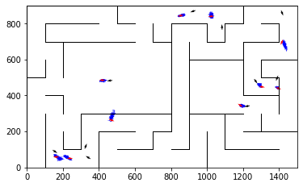

epoch 441 == motion_mle: 11.92+-0.31/12.05+-0.22 --

epoch 442 == motion_mle: 11.26+-0.33/12.23+-0.23 --

epoch 443 == motion_mle: 11.60+-0.23/11.77+-0.23 --

epoch 444 == motion_mle: 11.62+-0.26/12.05+-0.23 --

epoch 445 >> motion_mle: 11.82+-0.30/11.71+-0.23 --

epoch 446 == motion_mle: 11.38+-0.36/11.79+-0.24 --

epoch 447 == motion_mle: 11.91+-0.25/11.76+-0.22 --

epoch 448 == motion_mle: 11.63+-0.23/11.75+-0.21 --

epoch 449 == motion_mle: 12.01+-0.35/11.80+-0.24 --

epoch 450 == motion_mle: 11.65+-0.29/11.83+-0.24 --

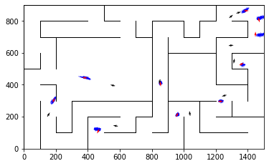

epoch 451 == motion_mle: 11.60+-0.28/11.83+-0.22 --

epoch 452 == motion_mle: 11.44+-0.27/11.82+-0.23 --

epoch 453 == motion_mle: 11.43+-0.31/11.91+-0.23 --

epoch 454 == motion_mle: 11.64+-0.29/11.90+-0.20 --

epoch 455 == motion_mle: 11.84+-0.28/11.92+-0.23 --

epoch 456 == motion_mle: 11.70+-0.34/11.77+-0.23 --

epoch 457 == motion_mle: 11.78+-0.34/11.85+-0.24 --

epoch 458 == motion_mle: 11.63+-0.29/11.84+-0.24 --

epoch 459 == motion_mle: 11.86+-0.30/11.87+-0.22 --

epoch 460 == motion_mle: 11.83+-0.28/11.84+-0.21 --

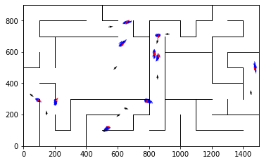

epoch 461 == motion_mle: 11.70+-0.33/11.78+-0.23 --

epoch 462 == motion_mle: 11.93+-0.32/11.78+-0.23 --

epoch 463 == motion_mle: 11.81+-0.31/11.86+-0.22 --

epoch 464 == motion_mle: 12.10+-0.28/12.19+-0.24 --

epoch 465 >> motion_mle: 11.86+-0.27/11.70+-0.22 --

epoch 466 == motion_mle: 11.56+-0.28/11.95+-0.23 --

epoch 467 == motion_mle: 11.90+-0.27/11.76+-0.24 --

epoch 468 == motion_mle: 11.33+-0.32/11.72+-0.22 --

epoch 469 == motion_mle: 11.47+-0.30/11.79+-0.23 --

epoch 470 == motion_mle: 11.28+-0.28/11.73+-0.23 --

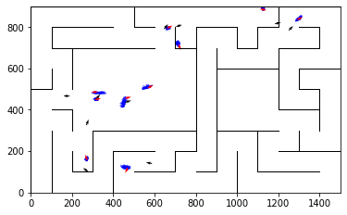

epoch 471 == motion_mle: 11.77+-0.29/11.72+-0.24 --

epoch 472 >> motion_mle: 12.00+-0.34/11.66+-0.22 --

epoch 473 == motion_mle: 11.51+-0.30/11.68+-0.23 --

epoch 474 == motion_mle: 11.49+-0.29/11.98+-0.23 --

epoch 475 >> motion_mle: 11.62+-0.29/11.62+-0.23 --

epoch 476 >> motion_mle: 11.91+-0.30/11.56+-0.23 --

epoch 477 == motion_mle: 10.95+-0.36/11.82+-0.22 --

epoch 478 == motion_mle: 11.63+-0.28/11.89+-0.24 --

epoch 479 == motion_mle: 11.55+-0.26/11.83+-0.24 --

epoch 480 == motion_mle: 11.48+-0.28/11.80+-0.23 --

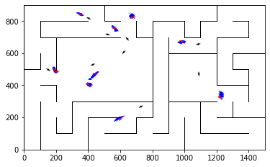

epoch 481 == motion_mle: 12.01+-0.33/11.79+-0.24 --

epoch 482 == motion_mle: 11.81+-0.39/11.63+-0.24 --

epoch 483 == motion_mle: 11.25+-0.28/11.90+-0.25 --

epoch 484 == motion_mle: 11.70+-0.31/11.70+-0.21 --

epoch 485 == motion_mle: 11.40+-0.29/11.96+-0.24 --

epoch 486 == motion_mle: 11.49+-0.34/11.78+-0.22 --

epoch 487 == motion_mle: 11.71+-0.36/11.61+-0.23 --

epoch 488 == motion_mle: 11.02+-0.34/11.87+-0.23 --

epoch 489 == motion_mle: 11.84+-0.34/11.88+-0.24 --

epoch 490 == motion_mle: 11.16+-0.30/11.67+-0.22 --

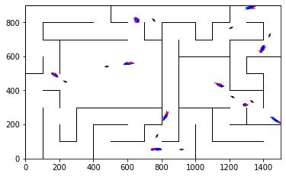

epoch 491 == motion_mle: 11.59+-0.31/11.82+-0.23 --

epoch 492 == motion_mle: 11.95+-0.33/11.87+-0.22 --

epoch 493 == motion_mle: 11.84+-0.29/11.69+-0.23 --

epoch 494 == motion_mle: 11.80+-0.29/11.94+-0.23 --

epoch 495 == motion_mle: 11.58+-0.26/11.63+-0.23 --

epoch 496 == motion_mle: 11.28+-0.32/11.79+-0.22 --

epoch 497 == motion_mle: 11.17+-0.30/11.73+-0.23 --

epoch 498 == motion_mle: 11.33+-0.33/11.78+-0.23 --

epoch 499 == motion_mle: 12.17+-0.27/11.76+-0.22 --

epoch 500 == motion_mle: 11.14+-0.25/11.70+-0.23 --

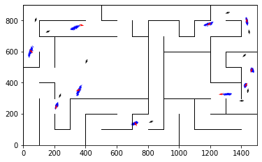

epoch 501 == motion_mle: 11.66+-0.31/11.65+-0.22 --

epoch 502 == motion_mle: 11.46+-0.35/11.70+-0.24 --

epoch 503 >> motion_mle: 11.35+-0.30/11.54+-0.21 --

epoch 504 == motion_mle: 11.54+-0.29/11.63+-0.24 --

epoch 505 == motion_mle: 11.41+-0.29/11.59+-0.23 --

epoch 506 >> motion_mle: 11.19+-0.30/11.54+-0.22 --

epoch 507 == motion_mle: 11.94+-0.28/11.70+-0.22 --

epoch 508 == motion_mle: 11.13+-0.31/11.63+-0.22 --

epoch 509 == motion_mle: 11.54+-0.30/11.71+-0.22 --

epoch 510 == motion_mle: 11.59+-0.31/11.79+-0.23 --

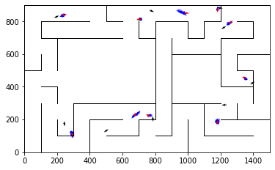

epoch 511 == motion_mle: 11.47+-0.34/11.61+-0.22 --

epoch 512 == motion_mle: 11.28+-0.30/11.86+-0.23 --

epoch 513 == motion_mle: 11.34+-0.28/11.60+-0.24 --

epoch 514 == motion_mle: 11.48+-0.28/11.70+-0.22 --

epoch 515 == motion_mle: 11.74+-0.30/11.70+-0.21 --

epoch 516 == motion_mle: 11.08+-0.32/11.65+-0.23 --

epoch 517 == motion_mle: 11.04+-0.31/11.77+-0.22 --

epoch 518 == motion_mle: 11.15+-0.27/11.55+-0.23 --

epoch 519 >> motion_mle: 11.33+-0.29/11.48+-0.22 --

epoch 520 == motion_mle: 11.37+-0.29/11.66+-0.22 --

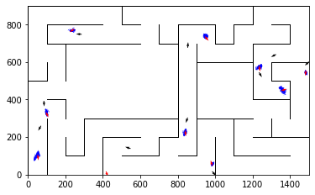

epoch 521 == motion_mle: 11.30+-0.27/11.81+-0.22 --

epoch 522 == motion_mle: 12.14+-0.33/11.58+-0.22 --

epoch 523 == motion_mle: 11.77+-0.27/11.62+-0.23 --

epoch 524 == motion_mle: 11.36+-0.35/11.61+-0.20 --

epoch 525 == motion_mle: 10.97+-0.34/11.49+-0.21 --

epoch 526 == motion_mle: 11.82+-0.28/11.66+-0.20 --

epoch 527 == motion_mle: 11.02+-0.28/11.60+-0.20 --

epoch 528 >> motion_mle: 11.88+-0.31/11.48+-0.23 --

epoch 529 == motion_mle: 11.15+-0.29/11.69+-0.22 --

epoch 530 == motion_mle: 11.71+-0.36/11.65+-0.22 --

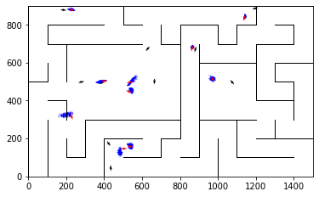

epoch 531 == motion_mle: 11.09+-0.30/11.75+-0.22 --

epoch 532 == motion_mle: 11.25+-0.27/11.60+-0.21 --

epoch 533 == motion_mle: 11.47+-0.28/11.61+-0.23 --

epoch 534 == motion_mle: 11.35+-0.28/11.59+-0.22 --

epoch 535 == motion_mle: 11.54+-0.33/11.58+-0.23 --

epoch 536 == motion_mle: 11.67+-0.29/11.60+-0.23 --

epoch 537 == motion_mle: 11.63+-0.33/11.58+-0.23 --

epoch 538 == motion_mle: 10.83+-0.35/11.73+-0.21 --

epoch 539 == motion_mle: 11.72+-0.35/11.55+-0.22 --

epoch 540 == motion_mle: 11.32+-0.27/11.89+-0.21 --

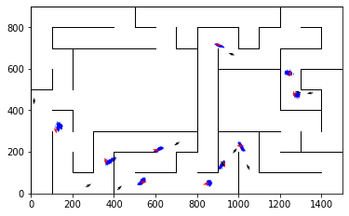

epoch 541 == motion_mle: 11.76+-0.29/11.59+-0.23 --

epoch 542 >> motion_mle: 11.04+-0.25/11.46+-0.22 --

epoch 543 == motion_mle: 11.48+-0.27/11.84+-0.23 --

epoch 544 == motion_mle: 11.17+-0.29/11.69+-0.22 --

epoch 545 == motion_mle: 11.51+-0.29/12.01+-0.23 --

epoch 546 == motion_mle: 11.12+-0.29/11.59+-0.24 --

epoch 547 == motion_mle: 11.26+-0.27/11.65+-0.23 --

epoch 548 == motion_mle: 11.40+-0.27/11.70+-0.23 --

epoch 549 == motion_mle: 10.89+-0.25/11.61+-0.23 --

epoch 550 >> motion_mle: 11.62+-0.36/11.42+-0.23 --

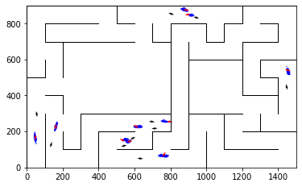

epoch 551 == motion_mle: 10.57+-0.29/11.66+-0.22 --

epoch 552 == motion_mle: 11.63+-0.34/11.56+-0.22 --

epoch 553 == motion_mle: 11.63+-0.29/11.58+-0.23 --

epoch 554 == motion_mle: 12.32+-0.33/11.67+-0.23 --

epoch 555 == motion_mle: 11.35+-0.29/11.68+-0.22 --

epoch 556 == motion_mle: 11.41+-0.24/11.55+-0.22 --

epoch 557 == motion_mle: 11.13+-0.31/11.66+-0.24 --

epoch 558 == motion_mle: 11.83+-0.25/11.65+-0.22 --

epoch 559 == motion_mle: 11.29+-0.28/11.89+-0.23 --

epoch 560 == motion_mle: 11.53+-0.29/11.67+-0.22 --

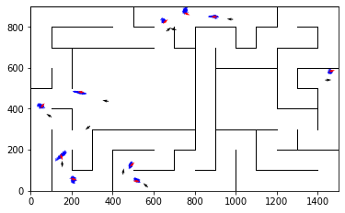

epoch 561 == motion_mle: 11.33+-0.26/11.61+-0.24 --

epoch 562 == motion_mle: 11.08+-0.30/11.68+-0.23 --

epoch 563 == motion_mle: 11.69+-0.26/11.62+-0.22 --

epoch 564 == motion_mle: 11.35+-0.32/11.46+-0.23 --

epoch 565 == motion_mle: 11.33+-0.34/11.69+-0.23 --

epoch 566 == motion_mle: 11.07+-0.31/11.56+-0.22 --

epoch 567 == motion_mle: 11.08+-0.28/11.56+-0.22 --

epoch 568 >> motion_mle: 11.67+-0.35/11.37+-0.21 --

epoch 569 == motion_mle: 11.49+-0.31/11.49+-0.23 --

epoch 570 == motion_mle: 11.14+-0.30/11.57+-0.22 --

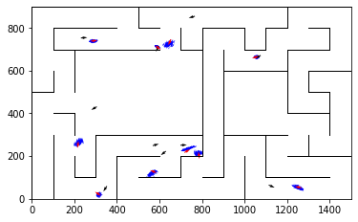

epoch 571 == motion_mle: 10.97+-0.26/11.56+-0.22 --

epoch 572 == motion_mle: 10.58+-0.27/11.44+-0.21 --

epoch 573 == motion_mle: 11.93+-0.35/11.50+-0.21 --

epoch 574 == motion_mle: 11.34+-0.32/11.47+-0.22 --

epoch 575 == motion_mle: 11.69+-0.35/11.50+-0.22 --

epoch 576 == motion_mle: 11.40+-0.32/11.74+-0.22 --

epoch 577 == motion_mle: 11.05+-0.35/11.68+-0.22 --

epoch 578 == motion_mle: 11.22+-0.32/11.66+-0.22 --

epoch 579 == motion_mle: 11.85+-0.30/11.62+-0.24 --

epoch 580 == motion_mle: 10.78+-0.27/11.79+-0.23 --

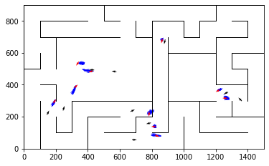

epoch 581 == motion_mle: 11.23+-0.33/11.71+-0.22 --

epoch 582 == motion_mle: 11.15+-0.29/11.44+-0.22 --

epoch 583 == motion_mle: 11.21+-0.30/11.46+-0.20 --

epoch 584 == motion_mle: 11.37+-0.30/11.46+-0.21 --

epoch 585 == motion_mle: 11.11+-0.30/11.52+-0.22 --

epoch 586 == motion_mle: 10.76+-0.33/11.38+-0.22 --

epoch 587 == motion_mle: 10.93+-0.33/11.70+-0.21 --

epoch 588 >> motion_mle: 11.19+-0.29/11.36+-0.23 --

epoch 589 == motion_mle: 11.36+-0.34/11.45+-0.23 --

epoch 590 >> motion_mle: 11.37+-0.24/11.36+-0.23 --

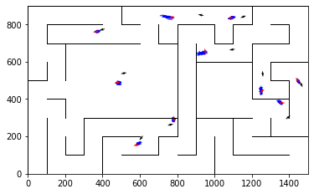

epoch 591 == motion_mle: 11.37+-0.31/11.36+-0.22 --

epoch 592 == motion_mle: 10.76+-0.32/11.37+-0.23 --

epoch 593 == motion_mle: 11.78+-0.32/11.50+-0.21 --

epoch 594 == motion_mle: 10.89+-0.27/11.54+-0.21 --

epoch 595 == motion_mle: 11.13+-0.31/11.62+-0.22 --

epoch 596 == motion_mle: 10.71+-0.31/11.42+-0.22 --

epoch 597 == motion_mle: 11.37+-0.30/11.60+-0.22 --

epoch 598 == motion_mle: 11.08+-0.32/11.47+-0.24 --

epoch 599 >> motion_mle: 10.80+-0.28/11.28+-0.20 --

epoch 600 == motion_mle: 11.09+-0.34/11.34+-0.20 --

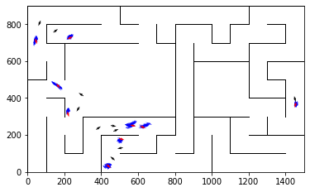

epoch 601 == motion_mle: 10.79+-0.33/11.50+-0.22 --

epoch 602 == motion_mle: 11.12+-0.31/11.37+-0.23 --

epoch 603 == motion_mle: 11.40+-0.30/11.35+-0.23 --

epoch 604 == motion_mle: 10.76+-0.32/11.52+-0.24 --

epoch 605 == motion_mle: 11.60+-0.31/11.58+-0.22 --

epoch 606 == motion_mle: 11.36+-0.30/11.51+-0.23 --

epoch 607 == motion_mle: 11.32+-0.31/11.38+-0.23 --

epoch 608 >> motion_mle: 10.82+-0.28/11.14+-0.24 --

epoch 609 == motion_mle: 11.33+-0.31/11.43+-0.23 --

epoch 610 == motion_mle: 11.39+-0.30/11.63+-0.23 --

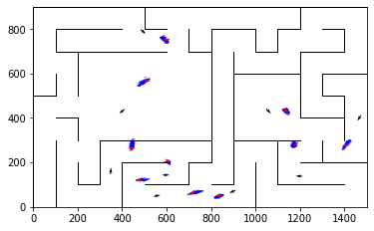

epoch 611 == motion_mle: 10.78+-0.26/11.35+-0.23 --

epoch 612 == motion_mle: 11.17+-0.30/11.43+-0.22 --

epoch 613 == motion_mle: 10.94+-0.26/11.46+-0.21 --

epoch 614 == motion_mle: 11.54+-0.35/11.56+-0.23 --

epoch 615 == motion_mle: 11.11+-0.30/11.22+-0.21 --

epoch 616 == motion_mle: 10.83+-0.28/11.46+-0.23 --

epoch 617 == motion_mle: 11.34+-0.31/11.32+-0.23 --

epoch 618 == motion_mle: 11.27+-0.33/11.43+-0.22 --

epoch 619 == motion_mle: 10.48+-0.24/11.47+-0.21 --

epoch 620 == motion_mle: 11.53+-0.32/11.25+-0.20 --

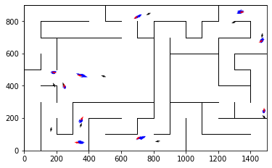

epoch 621 >> motion_mle: 11.57+-0.33/11.07+-0.22 --

epoch 622 == motion_mle: 11.41+-0.30/11.23+-0.23 --

epoch 623 == motion_mle: 11.45+-0.29/11.41+-0.22 --

epoch 624 == motion_mle: 11.05+-0.32/11.30+-0.21 --

epoch 625 == motion_mle: 10.85+-0.28/11.74+-0.23 --

epoch 626 == motion_mle: 11.67+-0.33/11.26+-0.22 --

epoch 627 == motion_mle: 10.84+-0.27/11.49+-0.23 --

epoch 628 == motion_mle: 11.14+-0.26/11.19+-0.22 --

epoch 629 == motion_mle: 11.21+-0.31/11.34+-0.22 --

epoch 630 == motion_mle: 10.48+-0.28/11.35+-0.22 --

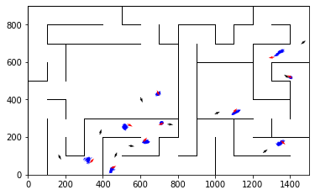

epoch 631 == motion_mle: 10.95+-0.29/11.27+-0.22 --

epoch 632 == motion_mle: 11.28+-0.23/11.37+-0.22 --

epoch 633 == motion_mle: 10.95+-0.26/11.34+-0.22 --

epoch 634 == motion_mle: 10.84+-0.31/11.25+-0.23 --

epoch 635 == motion_mle: 10.81+-0.27/11.60+-0.22 --

epoch 636 == motion_mle: 11.25+-0.29/11.58+-0.23 --

epoch 637 == motion_mle: 11.33+-0.32/11.34+-0.23 --

epoch 638 == motion_mle: 11.38+-0.29/11.45+-0.23 --

epoch 639 == motion_mle: 10.65+-0.31/11.42+-0.22 --

epoch 640 == motion_mle: 11.40+-0.29/11.17+-0.23 --

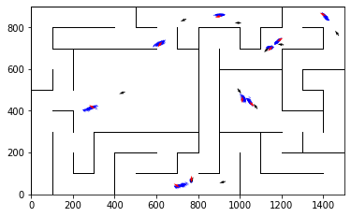

epoch 641 == motion_mle: 10.71+-0.31/11.44+-0.22 --

epoch 642 == motion_mle: 10.68+-0.29/11.30+-0.22 --

epoch 643 == motion_mle: 11.37+-0.33/11.23+-0.21 --

epoch 644 == motion_mle: 11.73+-0.34/11.28+-0.21 --

epoch 645 == motion_mle: 11.18+-0.32/11.31+-0.24 --

epoch 646 == motion_mle: 11.55+-0.34/11.28+-0.22 --

epoch 647 == motion_mle: 11.10+-0.30/11.28+-0.23 --

epoch 648 == motion_mle: 11.24+-0.33/11.09+-0.22 --

epoch 649 == motion_mle: 10.83+-0.29/11.30+-0.22 --

epoch 650 == motion_mle: 11.03+-0.26/11.29+-0.23 --

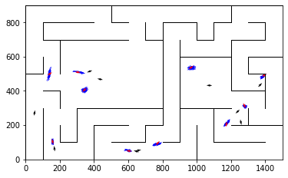

epoch 651 == motion_mle: 10.98+-0.29/11.48+-0.22 --

epoch 652 == motion_mle: 10.99+-0.30/11.34+-0.22 --

epoch 653 >> motion_mle: 11.73+-0.29/11.04+-0.20 --

epoch 654 == motion_mle: 10.63+-0.27/11.45+-0.24 --

epoch 655 == motion_mle: 10.36+-0.32/11.42+-0.21 --

epoch 656 == motion_mle: 11.82+-0.31/11.42+-0.21 --

epoch 657 == motion_mle: 11.00+-0.29/11.22+-0.25 --

epoch 658 == motion_mle: 10.60+-0.27/11.19+-0.20 --

epoch 659 == motion_mle: 11.11+-0.32/11.34+-0.22 --

epoch 660 == motion_mle: 10.52+-0.27/11.33+-0.21 --

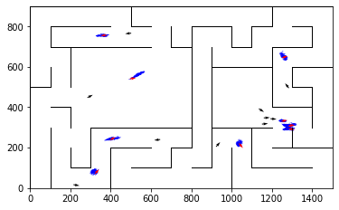

epoch 661 == motion_mle: 10.66+-0.31/11.34+-0.22 --

epoch 662 == motion_mle: 10.57+-0.32/11.28+-0.24 --

epoch 663 == motion_mle: 10.95+-0.28/11.30+-0.22 --

epoch 664 == motion_mle: 10.61+-0.30/11.19+-0.21 --

epoch 665 == motion_mle: 11.18+-0.36/11.47+-0.22 --

epoch 666 == motion_mle: 10.86+-0.25/11.24+-0.20 --

epoch 667 == motion_mle: 10.77+-0.27/11.18+-0.24 --

epoch 668 == motion_mle: 11.14+-0.35/11.20+-0.22 --

epoch 669 == motion_mle: 10.95+-0.26/11.27+-0.22 --

epoch 670 == motion_mle: 10.03+-0.30/11.09+-0.22 --

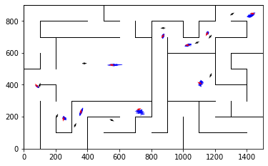

epoch 671 == motion_mle: 11.24+-0.30/11.27+-0.23 --

epoch 672 == motion_mle: 10.43+-0.27/11.12+-0.22 --

epoch 673 >> motion_mle: 11.57+-0.26/11.02+-0.23 --

epoch 674 == motion_mle: 10.31+-0.31/11.16+-0.22 --

epoch 675 >> motion_mle: 10.59+-0.32/10.93+-0.22 --

epoch 676 == motion_mle: 11.20+-0.31/11.00+-0.23 --

epoch 677 == motion_mle: 10.97+-0.33/11.17+-0.21 --

epoch 678 == motion_mle: 11.29+-0.30/11.38+-0.24 --

epoch 679 == motion_mle: 10.80+-0.28/11.20+-0.22 --

epoch 680 == motion_mle: 10.75+-0.32/11.10+-0.23 --

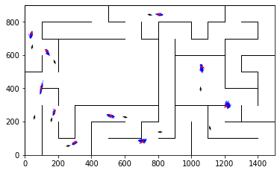

epoch 681 == motion_mle: 11.40+-0.29/11.14+-0.21 --

epoch 682 == motion_mle: 11.02+-0.27/11.19+-0.22 --

epoch 683 == motion_mle: 11.08+-0.26/11.36+-0.22 --

epoch 684 == motion_mle: 10.71+-0.28/11.13+-0.23 --

epoch 685 == motion_mle: 10.44+-0.31/11.25+-0.22 --

epoch 686 == motion_mle: 10.88+-0.29/11.04+-0.22 --

epoch 687 == motion_mle: 10.10+-0.30/11.37+-0.22 --

epoch 688 == motion_mle: 11.07+-0.29/11.14+-0.22 --

epoch 689 == motion_mle: 11.04+-0.24/11.31+-0.23 --

epoch 690 == motion_mle: 10.57+-0.26/11.19+-0.22 --

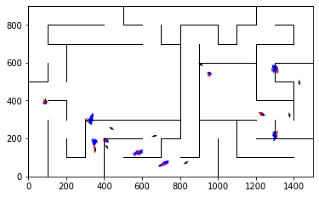

epoch 691 == motion_mle: 10.80+-0.30/11.11+-0.24 --

epoch 692 == motion_mle: 11.15+-0.30/11.14+-0.22 --

epoch 693 == motion_mle: 10.49+-0.27/11.06+-0.22 --

epoch 694 == motion_mle: 10.61+-0.32/11.11+-0.21 --

epoch 695 == motion_mle: 11.25+-0.30/11.23+-0.23 --

epoch 696 == motion_mle: 10.81+-0.31/11.07+-0.23 --

epoch 697 == motion_mle: 11.28+-0.30/11.16+-0.22 --

epoch 698 == motion_mle: 10.75+-0.27/11.20+-0.23 --

epoch 699 == motion_mle: 10.90+-0.26/11.11+-0.24 --

epoch 700 == motion_mle: 10.91+-0.31/10.94+-0.23 --

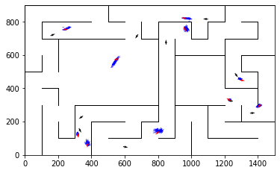

epoch 701 == motion_mle: 10.97+-0.28/11.08+-0.23 --

epoch 702 == motion_mle: 11.24+-0.25/11.04+-0.21 --

epoch 703 == motion_mle: 10.97+-0.30/11.20+-0.22 --

epoch 704 == motion_mle: 10.58+-0.29/11.11+-0.21 --

epoch 705 == motion_mle: 11.14+-0.31/11.16+-0.23 --

epoch 706 == motion_mle: 11.44+-0.27/11.27+-0.22 --

epoch 707 == motion_mle: 11.54+-0.27/11.18+-0.21 --

epoch 708 == motion_mle: 11.08+-0.29/11.01+-0.23 --

epoch 709 == motion_mle: 11.30+-0.35/11.04+-0.21 --

epoch 710 == motion_mle: 10.66+-0.22/11.06+-0.24 --

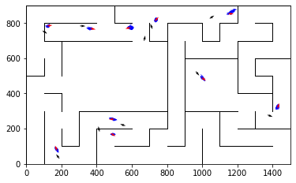

epoch 711 == motion_mle: 10.48+-0.30/11.17+-0.23 --

epoch 712 == motion_mle: 11.40+-0.32/11.08+-0.23 --

epoch 713 == motion_mle: 10.64+-0.35/11.06+-0.23 --

epoch 714 == motion_mle: 10.46+-0.33/10.98+-0.21 --

epoch 715 == motion_mle: 10.83+-0.26/11.04+-0.20 --

epoch 716 >> motion_mle: 10.75+-0.31/10.90+-0.23 --

epoch 717 == motion_mle: 10.51+-0.29/10.96+-0.23 --

epoch 718 == motion_mle: 10.96+-0.29/11.17+-0.21 --

epoch 719 == motion_mle: 10.66+-0.31/11.08+-0.22 --

epoch 720 == motion_mle: 10.37+-0.23/11.00+-0.22 --

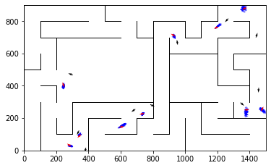

epoch 721 == motion_mle: 10.77+-0.26/10.90+-0.23 --

epoch 722 == motion_mle: 11.19+-0.31/11.07+-0.20 --

epoch 723 == motion_mle: 10.54+-0.30/11.14+-0.22 --

epoch 724 == motion_mle: 10.88+-0.28/11.05+-0.21 --

epoch 725 == motion_mle: 10.43+-0.23/11.02+-0.22 --

epoch 726 == motion_mle: 10.82+-0.31/10.95+-0.23 --

epoch 727 == motion_mle: 10.75+-0.28/11.15+-0.22 --

epoch 728 == motion_mle: 10.61+-0.32/11.05+-0.22 --

epoch 729 == motion_mle: 10.58+-0.30/11.14+-0.23 --

epoch 730 == motion_mle: 11.09+-0.31/11.02+-0.24 --

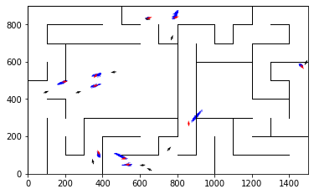

epoch 731 == motion_mle: 10.19+-0.30/10.95+-0.21 --

epoch 732 == motion_mle: 10.98+-0.34/10.91+-0.20 --

epoch 733 >> motion_mle: 10.96+-0.35/10.87+-0.22 --

epoch 734 == motion_mle: 10.46+-0.28/11.05+-0.21 --

epoch 735 == motion_mle: 10.54+-0.28/10.97+-0.21 --

epoch 736 == motion_mle: 11.23+-0.28/11.29+-0.23 --

epoch 737 == motion_mle: 10.85+-0.26/11.04+-0.20 --

epoch 738 == motion_mle: 10.56+-0.35/11.11+-0.22 --

epoch 739 == motion_mle: 10.34+-0.27/10.96+-0.21 --

epoch 740 == motion_mle: 10.77+-0.27/11.08+-0.22 --

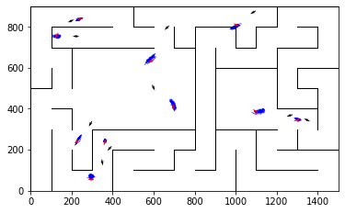

epoch 741 == motion_mle: 11.00+-0.35/10.87+-0.23 --

epoch 742 == motion_mle: 10.56+-0.28/10.90+-0.21 --

epoch 743 == motion_mle: 11.34+-0.25/11.04+-0.22 --

epoch 744 == motion_mle: 10.38+-0.30/10.89+-0.22 --

epoch 745 == motion_mle: 10.61+-0.35/10.99+-0.21 --

epoch 746 == motion_mle: 10.60+-0.29/11.15+-0.21 --

epoch 747 == motion_mle: 10.76+-0.32/11.00+-0.22 --

epoch 748 == motion_mle: 11.26+-0.33/10.97+-0.21 --

epoch 749 >> motion_mle: 10.59+-0.30/10.83+-0.23 --

epoch 750 == motion_mle: 11.11+-0.24/10.97+-0.21 --

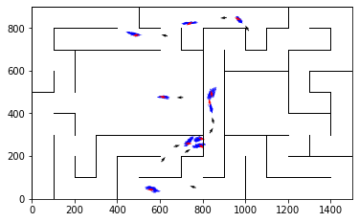

epoch 751 >> motion_mle: 10.76+-0.27/10.78+-0.21 --

epoch 752 == motion_mle: 10.89+-0.25/10.82+-0.21 --

epoch 753 == motion_mle: 10.21+-0.33/10.93+-0.22 --

epoch 754 == motion_mle: 10.39+-0.28/10.92+-0.22 --

epoch 755 == motion_mle: 11.07+-0.30/10.95+-0.21 --

epoch 756 == motion_mle: 10.07+-0.31/11.01+-0.22 --

epoch 757 == motion_mle: 11.09+-0.29/11.00+-0.22 --

epoch 758 == motion_mle: 10.44+-0.28/10.95+-0.22 --

epoch 759 == motion_mle: 10.51+-0.29/10.80+-0.22 --

epoch 760 == motion_mle: 10.39+-0.29/10.93+-0.24 --

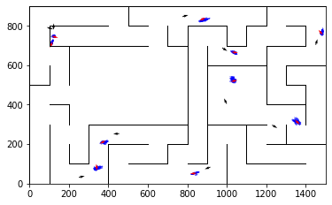

epoch 761 >> motion_mle: 10.65+-0.32/10.77+-0.20 --

epoch 762 == motion_mle: 10.86+-0.25/11.16+-0.20 --

epoch 763 == motion_mle: 10.93+-0.30/10.82+-0.23 --

epoch 764 == motion_mle: 11.20+-0.29/11.08+-0.21 --

epoch 765 == motion_mle: 10.90+-0.30/11.05+-0.21 --

epoch 766 == motion_mle: 10.66+-0.32/11.07+-0.22 --

epoch 767 == motion_mle: 10.65+-0.31/11.07+-0.22 --

epoch 768 == motion_mle: 10.81+-0.28/10.88+-0.21 --

epoch 769 == motion_mle: 10.96+-0.30/10.84+-0.21 --

epoch 770 == motion_mle: 10.50+-0.29/10.99+-0.23 --

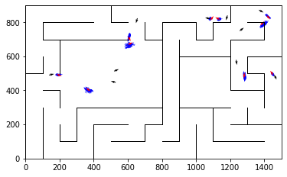

epoch 771 == motion_mle: 10.50+-0.27/10.99+-0.21 --

epoch 772 == motion_mle: 10.86+-0.32/10.78+-0.21 --

epoch 773 == motion_mle: 10.97+-0.36/11.07+-0.22 --

epoch 774 == motion_mle: 11.32+-0.36/10.91+-0.21 --

epoch 775 == motion_mle: 10.41+-0.33/10.83+-0.22 --

epoch 776 == motion_mle: 11.28+-0.34/10.99+-0.21 --

epoch 777 == motion_mle: 10.87+-0.34/11.00+-0.20 --

epoch 778 == motion_mle: 10.59+-0.25/10.92+-0.21 --

epoch 779 == motion_mle: 11.42+-0.33/11.14+-0.22 --

epoch 780 == motion_mle: 11.08+-0.29/11.12+-0.23 --

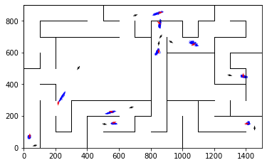

epoch 781 == motion_mle: 11.08+-0.27/10.97+-0.23 --

epoch 782 == motion_mle: 11.29+-0.27/10.97+-0.22 --

epoch 783 == motion_mle: 10.74+-0.32/11.12+-0.21 --

epoch 784 == motion_mle: 10.62+-0.25/10.84+-0.22 --

epoch 785 == motion_mle: 11.03+-0.32/10.88+-0.22 --

epoch 786 == motion_mle: 10.87+-0.29/11.05+-0.20 --

epoch 787 == motion_mle: 10.21+-0.27/10.97+-0.22 --

epoch 788 == motion_mle: 11.31+-0.34/10.87+-0.22 --

epoch 789 == motion_mle: 10.32+-0.28/11.04+-0.22 --

epoch 790 == motion_mle: 10.61+-0.28/10.93+-0.21 --

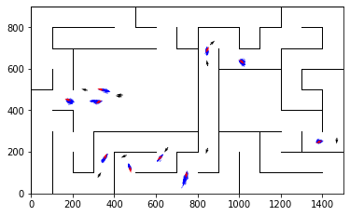

epoch 791 == motion_mle: 10.96+-0.33/11.07+-0.21 --

epoch 792 == motion_mle: 10.46+-0.31/10.89+-0.23 --

epoch 793 == motion_mle: 10.88+-0.32/10.90+-0.22 --

epoch 794 == motion_mle: 10.78+-0.28/11.03+-0.21 --

epoch 795 == motion_mle: 10.34+-0.28/10.99+-0.20 --

epoch 796 == motion_mle: 11.18+-0.30/11.16+-0.22 --

epoch 797 >> motion_mle: 10.70+-0.28/10.77+-0.22 --

epoch 798 == motion_mle: 10.61+-0.29/10.91+-0.21 --

epoch 799 == motion_mle: 10.83+-0.25/10.92+-0.23 --

epoch 800 == motion_mle: 10.42+-0.28/11.04+-0.22 --

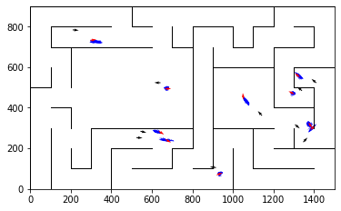

epoch 801 == motion_mle: 10.31+-0.32/11.05+-0.23 --

epoch 802 == motion_mle: 10.06+-0.28/10.81+-0.23 --

epoch 803 == motion_mle: 10.94+-0.25/10.81+-0.22 --

epoch 804 == motion_mle: 10.08+-0.26/10.96+-0.22 --

epoch 805 == motion_mle: 10.86+-0.32/10.88+-0.21 --

epoch 806 >> motion_mle: 10.76+-0.30/10.73+-0.20 --

epoch 807 == motion_mle: 10.68+-0.29/10.93+-0.22 --

epoch 808 == motion_mle: 10.83+-0.27/10.93+-0.23 --

epoch 809 == motion_mle: 10.86+-0.24/10.90+-0.22 --

epoch 810 == motion_mle: 10.94+-0.30/10.98+-0.21 --

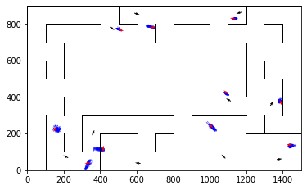

epoch 811 == motion_mle: 10.96+-0.28/10.86+-0.20 --

epoch 812 == motion_mle: 11.19+-0.29/10.80+-0.22 --

epoch 813 == motion_mle: 10.59+-0.31/11.03+-0.22 --

epoch 814 == motion_mle: 10.82+-0.32/10.87+-0.22 --

epoch 815 == motion_mle: 10.65+-0.32/11.11+-0.21 --

epoch 816 == motion_mle: 11.34+-0.27/10.91+-0.22 --

epoch 817 == motion_mle: 10.57+-0.33/11.03+-0.23 --

epoch 818 == motion_mle: 10.17+-0.24/11.04+-0.23 --

epoch 819 == motion_mle: 10.32+-0.27/10.80+-0.21 --

epoch 820 == motion_mle: 10.60+-0.33/10.81+-0.23 --

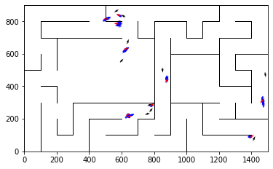

epoch 821 == motion_mle: 10.35+-0.28/10.86+-0.20 --

epoch 822 >> motion_mle: 10.89+-0.27/10.67+-0.23 --

epoch 823 == motion_mle: 10.55+-0.27/10.96+-0.22 --

epoch 824 == motion_mle: 10.58+-0.28/10.95+-0.21 --

epoch 825 == motion_mle: 10.94+-0.29/10.98+-0.22 --

epoch 826 == motion_mle: 10.17+-0.32/10.84+-0.23 --

epoch 827 == motion_mle: 11.06+-0.32/10.78+-0.20 --

epoch 828 >> motion_mle: 10.59+-0.29/10.65+-0.21 --

epoch 829 == motion_mle: 10.69+-0.29/10.89+-0.22 --

epoch 830 == motion_mle: 10.84+-0.32/10.87+-0.22 --

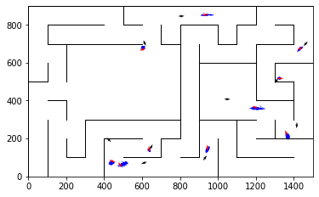

epoch 831 == motion_mle: 10.16+-0.24/10.69+-0.22 --

epoch 832 == motion_mle: 10.79+-0.24/10.82+-0.22 --

epoch 833 == motion_mle: 10.50+-0.33/10.75+-0.22 --

epoch 834 == motion_mle: 10.53+-0.29/10.69+-0.21 --

epoch 835 == motion_mle: 10.99+-0.28/10.71+-0.22 --

epoch 836 == motion_mle: 10.68+-0.29/10.70+-0.20 --

epoch 837 >> motion_mle: 10.49+-0.30/10.61+-0.22 --

epoch 838 == motion_mle: 10.23+-0.36/10.81+-0.24 --

epoch 839 == motion_mle: 10.81+-0.27/10.79+-0.22 --

epoch 840 == motion_mle: 10.49+-0.27/10.98+-0.22 --

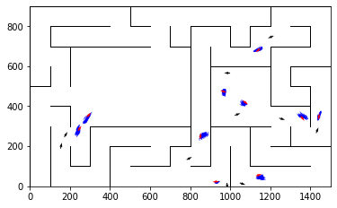

epoch 841 == motion_mle: 10.32+-0.28/10.97+-0.22 --

epoch 842 >> motion_mle: 10.63+-0.31/10.59+-0.20 --

epoch 843 == motion_mle: 10.54+-0.28/10.83+-0.24 --

epoch 844 == motion_mle: 10.38+-0.29/10.99+-0.23 --

epoch 845 == motion_mle: 10.89+-0.28/10.83+-0.21 --

epoch 846 == motion_mle: 11.36+-0.28/10.84+-0.22 --

epoch 847 == motion_mle: 10.69+-0.29/10.85+-0.22 --

epoch 848 == motion_mle: 10.73+-0.27/10.73+-0.22 --

epoch 849 == motion_mle: 10.77+-0.33/10.75+-0.22 --

epoch 850 == motion_mle: 10.53+-0.28/11.00+-0.22 --

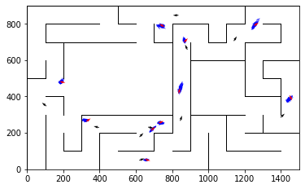

epoch 851 == motion_mle: 10.85+-0.30/10.85+-0.22 --

epoch 852 >> motion_mle: 10.68+-0.28/10.57+-0.21 --

epoch 853 == motion_mle: 10.17+-0.29/10.85+-0.22 --

epoch 854 == motion_mle: 11.39+-0.30/10.72+-0.24 --

epoch 855 == motion_mle: 10.85+-0.27/10.73+-0.22 --

epoch 856 == motion_mle: 10.60+-0.28/10.84+-0.22 --

epoch 857 == motion_mle: 10.55+-0.25/10.92+-0.20 --

epoch 858 == motion_mle: 10.90+-0.28/10.96+-0.22 --

epoch 859 == motion_mle: 11.03+-0.34/10.74+-0.23 --

epoch 860 == motion_mle: 10.70+-0.32/10.77+-0.21 --

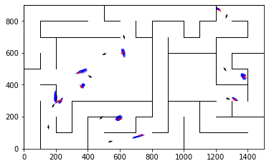

epoch 861 == motion_mle: 10.76+-0.35/11.01+-0.22 --

epoch 862 == motion_mle: 10.34+-0.29/10.67+-0.23 --

epoch 863 == motion_mle: 10.47+-0.28/10.93+-0.21 --

epoch 864 == motion_mle: 10.47+-0.26/10.89+-0.21 --

epoch 865 >> motion_mle: 10.71+-0.31/10.45+-0.21 --

epoch 866 == motion_mle: 10.49+-0.27/10.51+-0.20 --

epoch 867 == motion_mle: 10.74+-0.30/10.79+-0.22 --

epoch 868 == motion_mle: 10.28+-0.30/10.86+-0.21 --

epoch 869 == motion_mle: 10.76+-0.27/10.88+-0.21 --

epoch 870 == motion_mle: 10.83+-0.28/10.84+-0.20 --

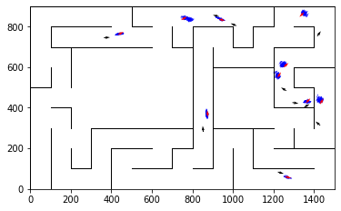

epoch 871 == motion_mle: 10.50+-0.29/10.62+-0.21 --

epoch 872 == motion_mle: 10.85+-0.30/10.68+-0.20 --

epoch 873 == motion_mle: 10.75+-0.31/10.75+-0.21 --

epoch 874 == motion_mle: 10.43+-0.30/10.91+-0.22 --

epoch 875 == motion_mle: 10.22+-0.29/10.75+-0.22 --

epoch 876 == motion_mle: 10.88+-0.27/10.89+-0.22 --

epoch 877 == motion_mle: 11.33+-0.29/10.72+-0.22 --

epoch 878 == motion_mle: 11.07+-0.29/10.82+-0.19 --

epoch 879 == motion_mle: 10.54+-0.33/10.95+-0.21 --

epoch 880 == motion_mle: 10.37+-0.26/10.84+-0.23 --

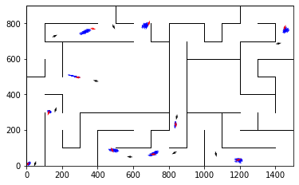

epoch 881 == motion_mle: 10.42+-0.26/10.73+-0.20 --

epoch 882 == motion_mle: 10.66+-0.30/10.81+-0.22 --

epoch 883 == motion_mle: 10.24+-0.26/10.65+-0.21 --

epoch 884 == motion_mle: 10.30+-0.29/10.76+-0.21 --

epoch 885 == motion_mle: 11.05+-0.27/10.65+-0.22 --

epoch 886 == motion_mle: 10.64+-0.30/10.65+-0.23 --

epoch 887 == motion_mle: 10.97+-0.32/10.82+-0.22 --

epoch 888 == motion_mle: 10.27+-0.29/10.92+-0.22 --

epoch 889 == motion_mle: 10.66+-0.29/10.71+-0.23 --

epoch 890 == motion_mle: 10.53+-0.30/10.66+-0.23 --

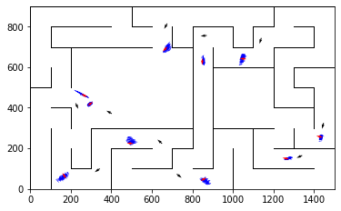

epoch 891 == motion_mle: 10.30+-0.28/10.63+-0.23 --

epoch 892 == motion_mle: 10.42+-0.31/10.62+-0.22 --

epoch 893 == motion_mle: 9.83+-0.30/10.69+-0.21 --

epoch 894 == motion_mle: 10.48+-0.33/10.70+-0.22 --

epoch 895 == motion_mle: 10.41+-0.30/10.65+-0.20 --

epoch 896 == motion_mle: 10.32+-0.26/10.66+-0.22 --

epoch 897 == motion_mle: 10.06+-0.31/10.66+-0.21 --

epoch 898 == motion_mle: 10.71+-0.28/10.70+-0.22 --

epoch 899 == motion_mle: 10.89+-0.35/10.69+-0.22 --

epoch 900 == motion_mle: 10.61+-0.26/10.80+-0.23 --

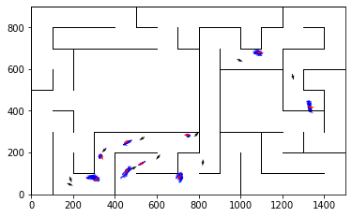

epoch 901 == motion_mle: 10.51+-0.26/10.80+-0.23 --

epoch 902 == motion_mle: 10.39+-0.31/10.76+-0.22 --

epoch 903 == motion_mle: 10.23+-0.28/10.80+-0.22 --

epoch 904 == motion_mle: 10.56+-0.29/10.76+-0.22 --

epoch 905 == motion_mle: 9.69+-0.27/10.79+-0.21 --

epoch 906 == motion_mle: 10.72+-0.28/10.78+-0.21 --

epoch 907 == motion_mle: 10.60+-0.30/10.59+-0.22 --

epoch 908 == motion_mle: 10.58+-0.30/10.78+-0.21 --

epoch 909 == motion_mle: 10.00+-0.25/10.69+-0.22 --

epoch 910 == motion_mle: 11.16+-0.30/10.48+-0.23 --

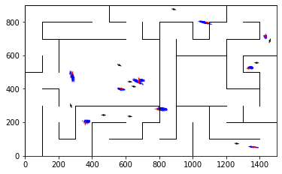

epoch 911 == motion_mle: 10.41+-0.24/10.73+-0.23 --

epoch 912 == motion_mle: 10.75+-0.30/10.65+-0.21 --

epoch 913 == motion_mle: 10.23+-0.23/10.87+-0.23 --

epoch 914 == motion_mle: 10.55+-0.23/10.73+-0.21 --

epoch 915 == motion_mle: 10.96+-0.32/10.72+-0.23 --

epoch 916 == motion_mle: 10.09+-0.26/10.74+-0.22 --

epoch 917 == motion_mle: 10.64+-0.31/10.90+-0.23 --

epoch 918 == motion_mle: 10.08+-0.28/10.55+-0.21 --

epoch 919 == motion_mle: 10.77+-0.29/10.70+-0.23 --

epoch 920 == motion_mle: 10.61+-0.30/10.77+-0.22 --

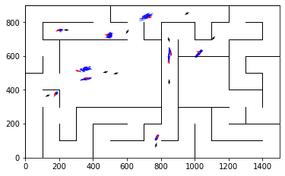

epoch 921 == motion_mle: 11.01+-0.32/10.92+-0.22 --

epoch 922 == motion_mle: 10.57+-0.29/10.70+-0.22 --

epoch 923 == motion_mle: 10.79+-0.27/10.69+-0.23 --

epoch 924 == motion_mle: 10.73+-0.32/10.76+-0.22 --

epoch 925 == motion_mle: 10.56+-0.28/10.75+-0.21 --

epoch 926 == motion_mle: 11.01+-0.29/10.73+-0.21 --

epoch 927 == motion_mle: 10.76+-0.30/11.00+-0.22 --

epoch 928 == motion_mle: 10.45+-0.29/10.88+-0.21 --

epoch 929 == motion_mle: 10.82+-0.33/10.75+-0.23 --

epoch 930 == motion_mle: 10.49+-0.36/10.88+-0.21 --

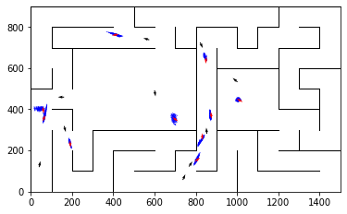

epoch 931 == motion_mle: 10.40+-0.28/10.68+-0.22 --

epoch 932 == motion_mle: 10.20+-0.31/10.64+-0.21 --

epoch 933 == motion_mle: 10.63+-0.24/10.67+-0.22 --

epoch 934 == motion_mle: 10.29+-0.29/10.90+-0.21 --

epoch 935 == motion_mle: 10.36+-0.32/10.75+-0.20 --

epoch 936 == motion_mle: 10.31+-0.37/10.78+-0.23 --

epoch 937 == motion_mle: 10.12+-0.25/10.62+-0.21 --

epoch 938 == motion_mle: 10.16+-0.31/10.82+-0.21 --

epoch 939 == motion_mle: 10.92+-0.32/10.70+-0.21 --

epoch 940 == motion_mle: 10.37+-0.30/10.87+-0.23 --

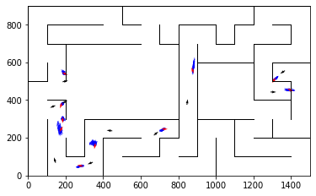

epoch 941 == motion_mle: 10.15+-0.31/10.85+-0.22 --

epoch 942 == motion_mle: 10.45+-0.29/10.92+-0.22 --

epoch 943 == motion_mle: 10.61+-0.28/10.84+-0.22 --

epoch 944 == motion_mle: 10.13+-0.27/10.68+-0.22 --

epoch 945 == motion_mle: 9.87+-0.29/10.67+-0.23 --

epoch 946 == motion_mle: 10.33+-0.23/10.70+-0.22 --

epoch 947 == motion_mle: 10.26+-0.33/10.71+-0.22 --

epoch 948 == motion_mle: 10.99+-0.28/10.77+-0.20 --

epoch 949 == motion_mle: 11.06+-0.34/10.79+-0.22 --

epoch 950 == motion_mle: 10.51+-0.37/10.46+-0.21 --

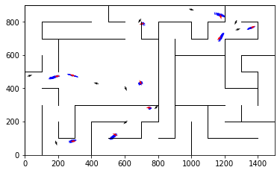

epoch 951 == motion_mle: 10.65+-0.29/10.87+-0.22 --

epoch 952 == motion_mle: 10.60+-0.30/10.68+-0.24 --

epoch 953 == motion_mle: 10.77+-0.31/10.71+-0.20 --

epoch 954 == motion_mle: 10.77+-0.33/10.54+-0.23 --

epoch 955 == motion_mle: 10.23+-0.28/10.76+-0.20 --

epoch 956 == motion_mle: 10.72+-0.30/10.61+-0.21 --

epoch 957 == motion_mle: 10.60+-0.27/10.81+-0.21 --

epoch 958 == motion_mle: 10.92+-0.28/10.61+-0.21 --

epoch 959 == motion_mle: 10.61+-0.32/10.89+-0.21 --

epoch 960 == motion_mle: 10.68+-0.31/10.83+-0.22 --

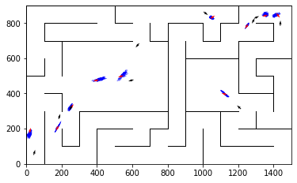

epoch 961 == motion_mle: 10.83+-0.24/10.59+-0.19 --

epoch 962 == motion_mle: 10.40+-0.32/10.70+-0.22 --

epoch 963 == motion_mle: 10.23+-0.27/10.58+-0.22 --

epoch 964 == motion_mle: 10.32+-0.26/10.68+-0.22 --

epoch 965 == motion_mle: 10.23+-0.32/10.68+-0.21 --

epoch 966 == motion_mle: 10.47+-0.27/10.60+-0.23 --

epoch 967 == motion_mle: 10.42+-0.26/10.72+-0.21 --

epoch 968 == motion_mle: 10.81+-0.27/10.72+-0.22 --

epoch 969 >> motion_mle: 10.55+-0.26/10.42+-0.22 --

epoch 970 == motion_mle: 10.46+-0.28/10.73+-0.22 --

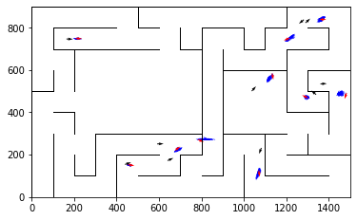

epoch 971 == motion_mle: 10.09+-0.28/10.78+-0.22 --

epoch 972 == motion_mle: 9.89+-0.28/10.95+-0.23 --

epoch 973 == motion_mle: 10.87+-0.27/10.68+-0.24 --

epoch 974 == motion_mle: 10.28+-0.28/10.64+-0.22 --

epoch 975 == motion_mle: 10.65+-0.28/10.65+-0.22 --

epoch 976 == motion_mle: 10.67+-0.27/10.66+-0.22 --

epoch 977 == motion_mle: 10.42+-0.32/10.77+-0.22 --

epoch 978 == motion_mle: 10.37+-0.26/10.70+-0.22 --

epoch 979 == motion_mle: 10.26+-0.27/10.66+-0.23 --

epoch 980 == motion_mle: 10.61+-0.30/10.58+-0.21 --

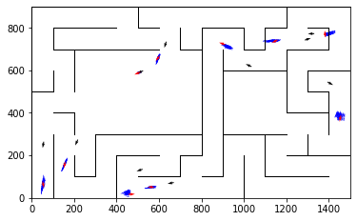

epoch 981 == motion_mle: 10.91+-0.25/10.66+-0.23 --

epoch 982 == motion_mle: 10.69+-0.26/10.54+-0.22 --

epoch 983 == motion_mle: 10.14+-0.32/10.84+-0.22 --

epoch 984 == motion_mle: 10.59+-0.25/10.58+-0.23 --

epoch 985 == motion_mle: 10.90+-0.27/10.78+-0.21 --

epoch 986 == motion_mle: 10.26+-0.30/10.68+-0.23 --

epoch 987 == motion_mle: 10.35+-0.33/10.60+-0.21 --

epoch 988 == motion_mle: 10.32+-0.29/10.64+-0.23 --

epoch 989 == motion_mle: 10.26+-0.23/10.52+-0.21 --

epoch 990 == motion_mle: 10.36+-0.28/10.57+-0.22 --

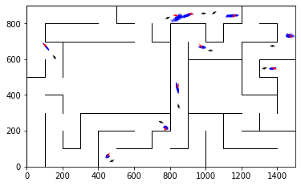

epoch 991 == motion_mle: 9.60+-0.26/10.59+-0.22 --

epoch 992 == motion_mle: 10.35+-0.27/10.59+-0.22 --

epoch 993 == motion_mle: 10.57+-0.32/10.54+-0.23 --

epoch 994 == motion_mle: 10.70+-0.27/10.67+-0.23 --

epoch 995 == motion_mle: 10.36+-0.31/10.73+-0.22 --

epoch 996 == motion_mle: 10.51+-0.28/10.61+-0.24 --

epoch 997 == motion_mle: 10.01+-0.31/10.86+-0.23 --

epoch 998 == motion_mle: 10.67+-0.30/10.45+-0.19 --

epoch 999 == motion_mle: 10.43+-0.29/10.62+-0.22 --

epoch 1000 >> motion_mle: 10.53+-0.31/10.25+-0.22 --

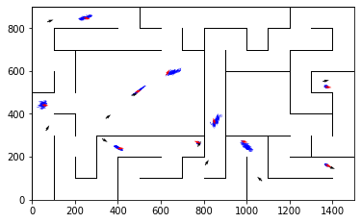

epoch 1001 == motion_mle: 10.77+-0.23/10.66+-0.22 --

epoch 1002 == motion_mle: 10.14+-0.32/10.55+-0.23 --

epoch 1003 == motion_mle: 10.13+-0.28/10.46+-0.23 --

epoch 1004 == motion_mle: 11.00+-0.30/10.52+-0.22 --

epoch 1005 == motion_mle: 10.42+-0.31/10.47+-0.22 --

epoch 1006 == motion_mle: 10.46+-0.25/10.54+-0.22 --

epoch 1007 == motion_mle: 10.48+-0.38/10.71+-0.21 --

epoch 1008 == motion_mle: 10.85+-0.33/10.71+-0.24 --

epoch 1009 == motion_mle: 10.60+-0.32/10.46+-0.22 --

epoch 1010 == motion_mle: 10.18+-0.31/10.49+-0.22 --

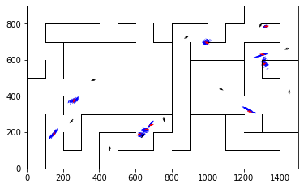

epoch 1011 == motion_mle: 10.61+-0.29/10.60+-0.22 --

epoch 1012 == motion_mle: 10.64+-0.28/10.77+-0.22 --

epoch 1013 == motion_mle: 10.34+-0.30/10.52+-0.21 --

epoch 1014 == motion_mle: 10.00+-0.24/10.80+-0.22 --

epoch 1015 == motion_mle: 10.31+-0.38/10.60+-0.22 --

epoch 1016 == motion_mle: 10.59+-0.29/10.70+-0.22 --

epoch 1017 == motion_mle: 10.25+-0.28/10.56+-0.21 --

epoch 1018 == motion_mle: 9.94+-0.30/10.50+-0.21 --

epoch 1019 == motion_mle: 11.05+-0.27/10.86+-0.20 --

epoch 1020 == motion_mle: 10.74+-0.26/10.79+-0.20 --

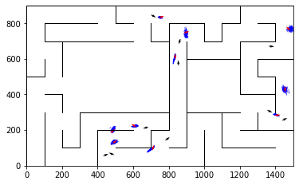

epoch 1021 == motion_mle: 9.79+-0.26/10.62+-0.22 --

epoch 1022 == motion_mle: 10.34+-0.30/10.75+-0.23 --

epoch 1023 == motion_mle: 10.44+-0.30/10.65+-0.22 --

epoch 1024 == motion_mle: 10.54+-0.30/10.51+-0.23 --

epoch 1025 == motion_mle: 10.11+-0.27/10.68+-0.22 --

epoch 1026 == motion_mle: 10.69+-0.33/10.69+-0.22 --

epoch 1027 == motion_mle: 10.70+-0.31/10.57+-0.23 --

epoch 1028 == motion_mle: 10.48+-0.25/10.59+-0.22 --

epoch 1029 == motion_mle: 10.79+-0.27/10.64+-0.22 --

epoch 1030 == motion_mle: 10.57+-0.28/10.61+-0.20 --

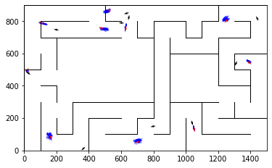

epoch 1031 == motion_mle: 10.29+-0.31/10.59+-0.22 --

epoch 1032 == motion_mle: 10.84+-0.36/10.51+-0.21 --

epoch 1033 == motion_mle: 10.23+-0.29/10.77+-0.22 --

epoch 1034 == motion_mle: 10.31+-0.34/10.46+-0.21 --

epoch 1035 == motion_mle: 10.10+-0.31/10.52+-0.22 --

epoch 1036 == motion_mle: 10.70+-0.25/10.59+-0.20 --

epoch 1037 == motion_mle: 10.19+-0.27/10.72+-0.21 --

epoch 1038 == motion_mle: 10.59+-0.27/10.46+-0.22 --

epoch 1039 == motion_mle: 10.36+-0.24/10.63+-0.21 --

epoch 1040 == motion_mle: 10.47+-0.28/10.66+-0.23 --

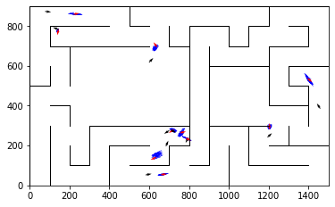

epoch 1041 == motion_mle: 10.20+-0.26/10.66+-0.23 --

epoch 1042 == motion_mle: 9.91+-0.28/10.49+-0.22 --

epoch 1043 == motion_mle: 9.94+-0.29/10.56+-0.22 --

epoch 1044 == motion_mle: 10.61+-0.30/10.57+-0.22 --

epoch 1045 == motion_mle: 10.47+-0.30/10.65+-0.22 --

epoch 1046 == motion_mle: 10.13+-0.31/10.51+-0.21 --

epoch 1047 == motion_mle: 10.66+-0.30/10.57+-0.23 --

epoch 1048 == motion_mle: 10.49+-0.27/10.75+-0.22 --

epoch 1049 == motion_mle: 10.25+-0.32/10.59+-0.22 --

epoch 1050 == motion_mle: 10.23+-0.26/10.43+-0.22 --

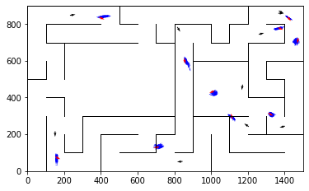

epoch 1051 == motion_mle: 9.86+-0.26/10.46+-0.23 --

epoch 1052 == motion_mle: 10.01+-0.26/10.47+-0.20 --

epoch 1053 == motion_mle: 10.14+-0.29/10.52+-0.22 --

epoch 1054 == motion_mle: 10.65+-0.29/10.56+-0.22 --

epoch 1055 == motion_mle: 10.55+-0.27/10.54+-0.20 --

epoch 1056 == motion_mle: 9.86+-0.28/10.59+-0.22 --

epoch 1057 == motion_mle: 10.33+-0.30/10.44+-0.21 --

epoch 1058 == motion_mle: 10.11+-0.29/10.47+-0.24 --

epoch 1059 == motion_mle: 10.16+-0.23/10.50+-0.21 --

epoch 1060 == motion_mle: 10.54+-0.32/10.65+-0.21 --

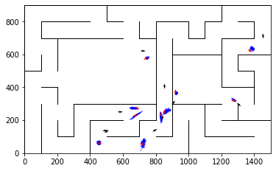

epoch 1061 == motion_mle: 10.12+-0.30/10.34+-0.22 --

epoch 1062 == motion_mle: 10.06+-0.25/10.65+-0.21 --

epoch 1063 == motion_mle: 10.40+-0.25/10.68+-0.22 --

epoch 1064 == motion_mle: 10.55+-0.33/10.58+-0.22 --

epoch 1065 == motion_mle: 9.81+-0.28/10.41+-0.23 --

epoch 1066 == motion_mle: 11.02+-0.35/10.72+-0.22 --

epoch 1067 == motion_mle: 10.59+-0.35/10.63+-0.22 --

epoch 1068 == motion_mle: 10.14+-0.29/10.51+-0.22 --

epoch 1069 == motion_mle: 10.50+-0.28/10.67+-0.21 --

epoch 1070 == motion_mle: 10.94+-0.24/10.59+-0.21 --

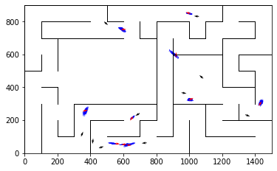

epoch 1071 == motion_mle: 10.02+-0.23/10.56+-0.23 --

epoch 1072 == motion_mle: 10.20+-0.25/10.61+-0.21 --

epoch 1073 == motion_mle: 10.53+-0.31/10.61+-0.21 --

epoch 1074 == motion_mle: 10.53+-0.28/10.45+-0.21 --

epoch 1075 == motion_mle: 10.49+-0.29/10.67+-0.20 --

epoch 1076 == motion_mle: 10.63+-0.27/10.48+-0.22 --

epoch 1077 == motion_mle: 10.39+-0.28/10.48+-0.22 --

epoch 1078 == motion_mle: 10.34+-0.27/10.45+-0.21 --

epoch 1079 == motion_mle: 10.50+-0.25/10.51+-0.20 --

epoch 1080 == motion_mle: 10.36+-0.29/10.72+-0.21 --

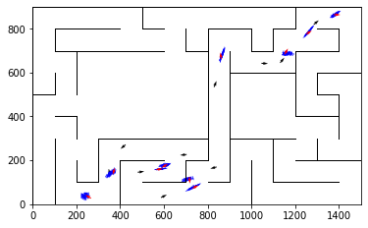

epoch 1081 == motion_mle: 10.79+-0.26/10.44+-0.22 --

epoch 1082 == motion_mle: 10.48+-0.27/10.71+-0.22 --

epoch 1083 == motion_mle: 9.79+-0.31/10.76+-0.21 --

epoch 1084 == motion_mle: 10.76+-0.31/10.60+-0.22 --

epoch 1085 == motion_mle: 10.00+-0.32/10.70+-0.22 --

epoch 1086 == motion_mle: 10.39+-0.23/10.53+-0.21 --

epoch 1087 == motion_mle: 10.56+-0.29/10.71+-0.21 --

epoch 1088 == motion_mle: 10.59+-0.30/10.41+-0.23 --

epoch 1089 == motion_mle: 10.31+-0.33/10.58+-0.22 --

epoch 1090 == motion_mle: 10.40+-0.32/10.65+-0.21 --

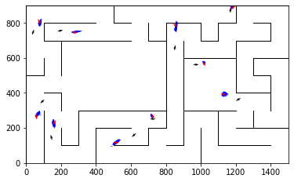

epoch 1091 == motion_mle: 10.39+-0.22/10.48+-0.23 --

epoch 1092 == motion_mle: 11.02+-0.29/10.38+-0.21 --

epoch 1093 == motion_mle: 10.27+-0.30/10.59+-0.23 --

epoch 1094 == motion_mle: 10.27+-0.31/10.65+-0.21 --

epoch 1095 == motion_mle: 10.49+-0.31/10.58+-0.24 --

epoch 1096 == motion_mle: 10.13+-0.25/10.49+-0.19 --

epoch 1097 == motion_mle: 10.24+-0.30/10.56+-0.22 --

epoch 1098 == motion_mle: 10.24+-0.31/10.53+-0.22 --

epoch 1099 == motion_mle: 10.03+-0.31/10.53+-0.22 --

epoch 1100 == motion_mle: 10.63+-0.25/10.55+-0.21 --

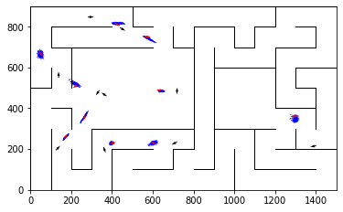

epoch 1101 == motion_mle: 10.44+-0.32/10.73+-0.21 --

epoch 1102 == motion_mle: 10.50+-0.27/10.47+-0.21 --

epoch 1103 == motion_mle: 10.11+-0.27/10.53+-0.21 --

epoch 1104 == motion_mle: 10.31+-0.28/10.59+-0.22 --

epoch 1105 == motion_mle: 10.20+-0.26/10.52+-0.21 --

epoch 1106 == motion_mle: 10.35+-0.25/10.29+-0.22 --

epoch 1107 == motion_mle: 10.12+-0.31/10.46+-0.22 --

epoch 1108 == motion_mle: 10.19+-0.29/10.52+-0.21 --

epoch 1109 == motion_mle: 10.39+-0.30/10.71+-0.21 --

epoch 1110 == motion_mle: 10.10+-0.27/10.53+-0.23 --

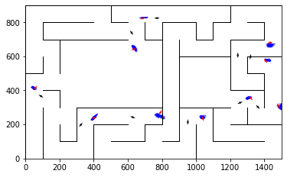

epoch 1111 == motion_mle: 10.64+-0.32/10.39+-0.22 --

epoch 1112 == motion_mle: 10.54+-0.35/10.69+-0.22 --

epoch 1113 == motion_mle: 9.96+-0.28/10.48+-0.21 --

epoch 1114 == motion_mle: 9.88+-0.23/10.33+-0.20 --

epoch 1115 == motion_mle: 10.70+-0.32/10.47+-0.20 --

epoch 1116 == motion_mle: 10.52+-0.31/10.32+-0.20 --

epoch 1117 == motion_mle: 10.15+-0.26/10.73+-0.21 --

epoch 1118 == motion_mle: 9.94+-0.27/10.47+-0.21 --

epoch 1119 == motion_mle: 10.14+-0.30/10.80+-0.21 --

epoch 1120 == motion_mle: 10.26+-0.30/10.59+-0.21 --

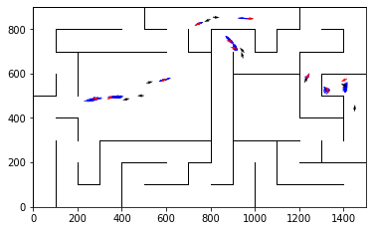

epoch 1121 == motion_mle: 10.61+-0.31/10.54+-0.21 --

epoch 1122 == motion_mle: 9.84+-0.29/10.52+-0.23 --

epoch 1123 == motion_mle: 10.15+-0.29/10.40+-0.23 --

epoch 1124 == motion_mle: 10.35+-0.30/10.54+-0.22 --

epoch 1125 == motion_mle: 9.96+-0.29/10.53+-0.21 --

epoch 1126 == motion_mle: 10.28+-0.32/10.48+-0.23 --

epoch 1127 == motion_mle: 9.76+-0.31/10.48+-0.22 --

epoch 1128 == motion_mle: 10.27+-0.31/10.41+-0.22 --

epoch 1129 == motion_mle: 10.04+-0.29/10.61+-0.21 --

epoch 1130 == motion_mle: 10.41+-0.28/10.65+-0.22 --

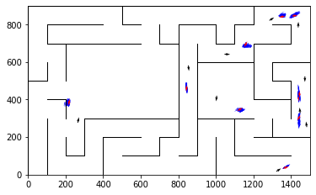

epoch 1131 == motion_mle: 10.75+-0.30/10.54+-0.21 --

epoch 1132 == motion_mle: 10.17+-0.25/10.36+-0.21 --

epoch 1133 == motion_mle: 10.50+-0.25/10.40+-0.22 --

epoch 1134 == motion_mle: 10.84+-0.26/10.51+-0.23 --

epoch 1135 == motion_mle: 10.22+-0.30/10.71+-0.20 --

epoch 1136 == motion_mle: 9.97+-0.33/10.53+-0.22 --

epoch 1137 == motion_mle: 10.09+-0.27/10.60+-0.22 --

epoch 1138 == motion_mle: 10.44+-0.30/10.42+-0.22 --

epoch 1139 == motion_mle: 10.48+-0.32/10.65+-0.19 --

epoch 1140 == motion_mle: 10.28+-0.33/10.52+-0.21 --

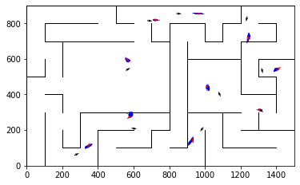

epoch 1141 == motion_mle: 10.30+-0.27/10.50+-0.21 --

epoch 1142 == motion_mle: 10.17+-0.23/10.53+-0.20 --

epoch 1143 == motion_mle: 10.60+-0.29/10.54+-0.19 --

epoch 1144 == motion_mle: 10.30+-0.30/10.57+-0.23 --

epoch 1145 == motion_mle: 10.85+-0.32/10.48+-0.21 --

epoch 1146 == motion_mle: 10.75+-0.33/10.44+-0.22 --

epoch 1147 == motion_mle: 9.98+-0.30/10.40+-0.23 --

epoch 1148 == motion_mle: 9.51+-0.32/10.48+-0.22 --

epoch 1149 == motion_mle: 10.48+-0.29/10.55+-0.20 --

epoch 1150 == motion_mle: 10.42+-0.29/10.49+-0.21 --

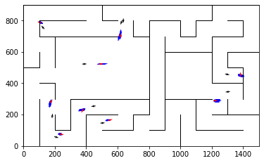

epoch 1151 == motion_mle: 10.67+-0.29/10.61+-0.22 --

epoch 1152 == motion_mle: 11.00+-0.30/10.61+-0.23 --

epoch 1153 == motion_mle: 10.63+-0.29/10.49+-0.22 --

epoch 1154 == motion_mle: 10.74+-0.32/10.46+-0.22 --

epoch 1155 == motion_mle: 9.85+-0.24/10.59+-0.22 --

epoch 1156 == motion_mle: 9.77+-0.29/10.38+-0.22 --

epoch 1157 == motion_mle: 10.50+-0.32/10.45+-0.22 --

epoch 1158 == motion_mle: 10.02+-0.23/10.33+-0.22 --

epoch 1159 == motion_mle: 10.62+-0.34/10.33+-0.22 --

epoch 1160 == motion_mle: 9.94+-0.28/10.56+-0.23 --

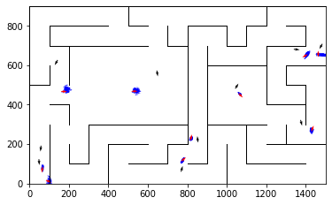

epoch 1161 == motion_mle: 10.13+-0.30/10.82+-0.23 --

epoch 1162 == motion_mle: 10.22+-0.35/10.64+-0.22 --

epoch 1163 == motion_mle: 10.24+-0.27/10.52+-0.23 --

epoch 1164 == motion_mle: 10.43+-0.26/10.49+-0.23 --

epoch 1165 == motion_mle: 10.51+-0.30/10.46+-0.23 --

epoch 1166 == motion_mle: 10.09+-0.25/10.57+-0.22 --

epoch 1167 == motion_mle: 9.96+-0.27/10.56+-0.22 --

epoch 1168 == motion_mle: 10.47+-0.32/10.76+-0.21 --

epoch 1169 == motion_mle: 9.86+-0.31/10.41+-0.22 --

epoch 1170 == motion_mle: 10.73+-0.23/10.36+-0.23 --

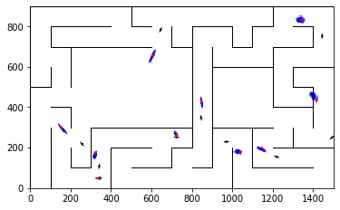

epoch 1171 == motion_mle: 10.35+-0.30/10.44+-0.21 --

epoch 1172 == motion_mle: 10.48+-0.30/10.70+-0.21 --

epoch 1173 == motion_mle: 10.69+-0.32/10.63+-0.21 --

epoch 1174 == motion_mle: 10.53+-0.27/10.53+-0.24 --

epoch 1175 == motion_mle: 10.09+-0.28/10.48+-0.24 --

epoch 1176 == motion_mle: 10.54+-0.29/10.44+-0.21 --

epoch 1177 == motion_mle: 10.63+-0.23/10.53+-0.20 --

epoch 1178 == motion_mle: 10.46+-0.24/10.47+-0.23 --

epoch 1179 == motion_mle: 10.62+-0.31/10.25+-0.20 --

epoch 1180 == motion_mle: 10.07+-0.30/10.27+-0.22 --

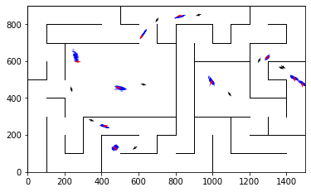

epoch 1181 == motion_mle: 10.55+-0.29/10.45+-0.21 --

epoch 1182 == motion_mle: 10.70+-0.27/10.46+-0.22 --

epoch 1183 == motion_mle: 10.24+-0.28/10.63+-0.21 --

epoch 1184 == motion_mle: 10.35+-0.26/10.48+-0.23 --

epoch 1185 == motion_mle: 10.28+-0.23/10.52+-0.21 --

epoch 1186 == motion_mle: 10.20+-0.24/10.28+-0.21 --

epoch 1187 == motion_mle: 9.93+-0.27/10.55+-0.20 --

epoch 1188 == motion_mle: 10.25+-0.24/10.46+-0.22 --

epoch 1189 == motion_mle: 10.27+-0.25/10.54+-0.23 --

epoch 1190 == motion_mle: 10.43+-0.22/10.56+-0.22 --

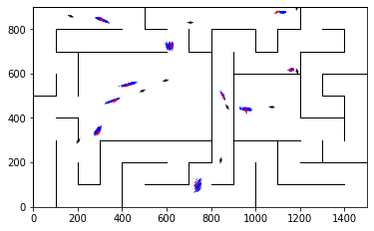

epoch 1191 == motion_mle: 10.09+-0.29/10.53+-0.20 --

epoch 1192 == motion_mle: 10.21+-0.28/10.64+-0.22 --

epoch 1193 == motion_mle: 10.74+-0.30/10.49+-0.22 --

epoch 1194 == motion_mle: 10.23+-0.31/10.34+-0.21 --

epoch 1195 == motion_mle: 10.12+-0.26/10.32+-0.21 --

epoch 1196 == motion_mle: 9.95+-0.29/10.51+-0.22 --

epoch 1197 == motion_mle: 10.70+-0.29/10.47+-0.22 --

epoch 1198 == motion_mle: 10.57+-0.29/10.29+-0.23 --

epoch 1199 == motion_mle: 10.09+-0.29/10.45+-0.21 --

INFO:tensorflow:Restoring parameters from ../models/tmp/best_validation

INFO:tensorflow:Restoring parameters from ../models/tmp/best_validation

epoch 0 >> measurement_heuristic: 1.39+-0.00 --

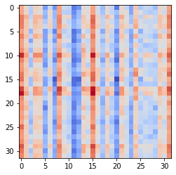

epoch 1 >> measurement_heuristic: 1.39+-0.00/1.38+-0.00 --

epoch 2 >> measurement_heuristic: 1.38+-0.00/1.38+-0.00 --

epoch 3 >> measurement_heuristic: 1.38+-0.00/1.37+-0.00 --

epoch 4 >> measurement_heuristic: 1.37+-0.00/1.35+-0.00 --

epoch 5 >> measurement_heuristic: 1.36+-0.00/1.34+-0.00 --

epoch 6 >> measurement_heuristic: 1.34+-0.00/1.33+-0.00 --

epoch 7 >> measurement_heuristic: 1.33+-0.00/1.31+-0.00 --

epoch 8 >> measurement_heuristic: 1.33+-0.00/1.30+-0.00 --

epoch 9 >> measurement_heuristic: 1.31+-0.00/1.30+-0.00 --

epoch 10 >> measurement_heuristic: 1.30+-0.01/1.29+-0.00 --

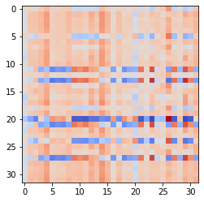

epoch 11 >> measurement_heuristic: 1.29+-0.01/1.28+-0.00 --

epoch 12 >> measurement_heuristic: 1.28+-0.01/1.27+-0.00 --

epoch 13 >> measurement_heuristic: 1.27+-0.01/1.26+-0.00 --

epoch 14 >> measurement_heuristic: 1.26+-0.01/1.25+-0.00 --

epoch 15 >> measurement_heuristic: 1.26+-0.01/1.24+-0.00 --

epoch 16 >> measurement_heuristic: 1.24+-0.01/1.23+-0.00 --

epoch 17 >> measurement_heuristic: 1.26+-0.01/1.22+-0.00 --

epoch 18 >> measurement_heuristic: 1.23+-0.01/1.21+-0.00 --

epoch 19 >> measurement_heuristic: 1.21+-0.01/1.20+-0.01 --

epoch 20 >> measurement_heuristic: 1.21+-0.01/1.20+-0.01 --

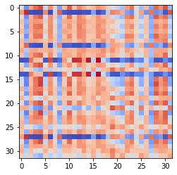

epoch 21 >> measurement_heuristic: 1.20+-0.01/1.19+-0.01 --

epoch 22 >> measurement_heuristic: 1.19+-0.01/1.17+-0.01 --

epoch 23 >> measurement_heuristic: 1.18+-0.01/1.17+-0.01 --

epoch 24 >> measurement_heuristic: 1.19+-0.01/1.17+-0.01 --

epoch 25 >> measurement_heuristic: 1.15+-0.01/1.15+-0.01 --

epoch 26 >> measurement_heuristic: 1.17+-0.01/1.14+-0.01 --

epoch 27 >> measurement_heuristic: 1.15+-0.01/1.14+-0.01 --

epoch 28 >> measurement_heuristic: 1.14+-0.01/1.13+-0.01 --

epoch 29 >> measurement_heuristic: 1.13+-0.01/1.13+-0.01 --

epoch 30 >> measurement_heuristic: 1.13+-0.01/1.12+-0.01 --

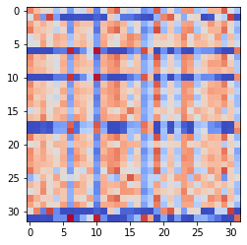

epoch 31 >> measurement_heuristic: 1.12+-0.01/1.12+-0.01 --

epoch 32 >> measurement_heuristic: 1.10+-0.01/1.11+-0.01 --

epoch 33 >> measurement_heuristic: 1.11+-0.01/1.10+-0.01 --

epoch 34 >> measurement_heuristic: 1.11+-0.01/1.09+-0.01 --

epoch 35 == measurement_heuristic: 1.09+-0.01/1.10+-0.01 --

epoch 36 >> measurement_heuristic: 1.09+-0.01/1.09+-0.01 --

epoch 37 >> measurement_heuristic: 1.11+-0.01/1.08+-0.01 --

epoch 38 >> measurement_heuristic: 1.09+-0.01/1.08+-0.01 --

epoch 39 >> measurement_heuristic: 1.09+-0.01/1.07+-0.01 --

epoch 40 == measurement_heuristic: 1.08+-0.01/1.07+-0.01 --

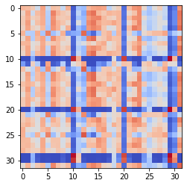

epoch 41 >> measurement_heuristic: 1.07+-0.01/1.07+-0.01 --

epoch 42 >> measurement_heuristic: 1.08+-0.01/1.07+-0.01 --

epoch 43 >> measurement_heuristic: 1.07+-0.01/1.05+-0.01 --

epoch 44 >> measurement_heuristic: 1.06+-0.01/1.05+-0.01 --

epoch 45 == measurement_heuristic: 1.06+-0.01/1.05+-0.01 --

epoch 46 >> measurement_heuristic: 1.05+-0.01/1.04+-0.01 --

epoch 47 == measurement_heuristic: 1.05+-0.01/1.04+-0.01 --

epoch 48 == measurement_heuristic: 1.06+-0.01/1.05+-0.01 --

epoch 49 >> measurement_heuristic: 1.05+-0.01/1.04+-0.01 --

epoch 50 == measurement_heuristic: 1.04+-0.01/1.04+-0.01 --

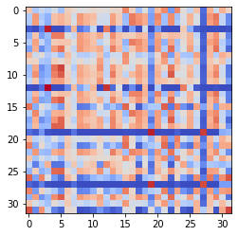

epoch 51 >> measurement_heuristic: 1.03+-0.01/1.03+-0.01 --

epoch 52 >> measurement_heuristic: 1.04+-0.01/1.03+-0.01 --

epoch 53 >> measurement_heuristic: 1.03+-0.01/1.02+-0.01 --

epoch 54 == measurement_heuristic: 1.02+-0.01/1.02+-0.01 --

epoch 55 == measurement_heuristic: 1.02+-0.01/1.02+-0.01 --

epoch 56 >> measurement_heuristic: 1.02+-0.01/1.01+-0.01 --

epoch 57 >> measurement_heuristic: 1.00+-0.01/1.01+-0.01 --

epoch 58 >> measurement_heuristic: 1.01+-0.01/1.00+-0.01 --

epoch 59 == measurement_heuristic: 1.02+-0.01/1.01+-0.01 --

epoch 60 >> measurement_heuristic: 1.00+-0.01/1.00+-0.01 --

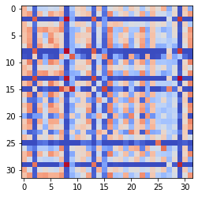

epoch 61 == measurement_heuristic: 0.99+-0.01/1.00+-0.01 --

epoch 62 >> measurement_heuristic: 1.00+-0.01/0.99+-0.01 --

epoch 63 == measurement_heuristic: 1.00+-0.01/1.01+-0.01 --

epoch 64 >> measurement_heuristic: 1.01+-0.01/0.99+-0.01 --

epoch 65 == measurement_heuristic: 0.99+-0.01/0.99+-0.01 --

epoch 66 >> measurement_heuristic: 0.99+-0.01/0.98+-0.01 --

epoch 67 >> measurement_heuristic: 0.98+-0.01/0.98+-0.01 --

epoch 68 >> measurement_heuristic: 0.97+-0.01/0.97+-0.01 --

epoch 69 >> measurement_heuristic: 0.98+-0.01/0.97+-0.01 --

epoch 70 >> measurement_heuristic: 1.00+-0.01/0.97+-0.01 --

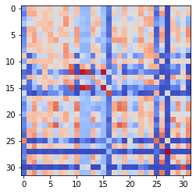

epoch 71 == measurement_heuristic: 1.01+-0.01/0.98+-0.01 --

epoch 72 == measurement_heuristic: 0.98+-0.01/0.97+-0.01 --

epoch 73 >> measurement_heuristic: 0.99+-0.01/0.97+-0.01 --

epoch 74 >> measurement_heuristic: 0.99+-0.01/0.96+-0.01 --

epoch 75 >> measurement_heuristic: 0.96+-0.01/0.95+-0.01 --

epoch 76 == measurement_heuristic: 0.97+-0.01/0.96+-0.01 --

epoch 77 == measurement_heuristic: 0.99+-0.01/0.96+-0.01 --

epoch 78 >> measurement_heuristic: 0.98+-0.01/0.95+-0.01 --

epoch 79 >> measurement_heuristic: 0.96+-0.01/0.95+-0.01 --

epoch 80 >> measurement_heuristic: 0.97+-0.01/0.95+-0.01 --

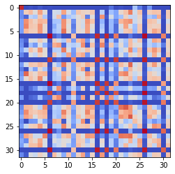

epoch 81 == measurement_heuristic: 0.96+-0.01/0.95+-0.01 --

epoch 82 == measurement_heuristic: 0.98+-0.01/0.95+-0.01 --

epoch 83 >> measurement_heuristic: 0.96+-0.01/0.94+-0.01 --

epoch 84 == measurement_heuristic: 0.97+-0.01/0.94+-0.01 --

epoch 85 >> measurement_heuristic: 0.95+-0.01/0.94+-0.01 --

epoch 86 >> measurement_heuristic: 0.97+-0.01/0.94+-0.01 --

epoch 87 >> measurement_heuristic: 0.92+-0.01/0.93+-0.01 --

epoch 88 >> measurement_heuristic: 0.94+-0.01/0.93+-0.01 --

epoch 89 == measurement_heuristic: 0.91+-0.01/0.94+-0.01 --

epoch 90 == measurement_heuristic: 0.93+-0.01/0.93+-0.01 --

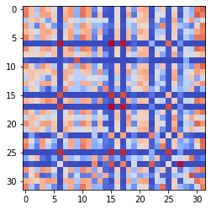

epoch 91 >> measurement_heuristic: 0.94+-0.01/0.93+-0.01 --

epoch 92 >> measurement_heuristic: 0.94+-0.01/0.92+-0.01 --

epoch 93 == measurement_heuristic: 0.92+-0.01/0.93+-0.01 --

epoch 94 == measurement_heuristic: 0.93+-0.01/0.92+-0.01 --

epoch 95 == measurement_heuristic: 0.93+-0.01/0.93+-0.01 --

epoch 96 >> measurement_heuristic: 0.92+-0.01/0.91+-0.01 --

epoch 97 == measurement_heuristic: 0.93+-0.01/0.91+-0.01 --

epoch 98 >> measurement_heuristic: 0.92+-0.01/0.90+-0.01 --

epoch 99 == measurement_heuristic: 0.92+-0.01/0.92+-0.01 --

epoch 100 == measurement_heuristic: 0.92+-0.01/0.91+-0.01 --

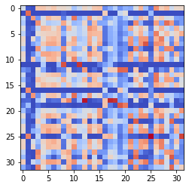

epoch 101 >> measurement_heuristic: 0.92+-0.01/0.90+-0.01 --

epoch 102 == measurement_heuristic: 0.90+-0.01/0.90+-0.01 --

epoch 103 >> measurement_heuristic: 0.92+-0.01/0.90+-0.01 --

epoch 104 >> measurement_heuristic: 0.91+-0.01/0.90+-0.01 --

epoch 105 == measurement_heuristic: 0.89+-0.01/0.90+-0.01 --

epoch 106 == measurement_heuristic: 0.91+-0.01/0.91+-0.01 --

epoch 107 >> measurement_heuristic: 0.89+-0.01/0.89+-0.01 --

epoch 108 == measurement_heuristic: 0.93+-0.01/0.90+-0.01 --

epoch 109 == measurement_heuristic: 0.89+-0.01/0.89+-0.01 --

epoch 110 == measurement_heuristic: 0.89+-0.01/0.90+-0.01 --

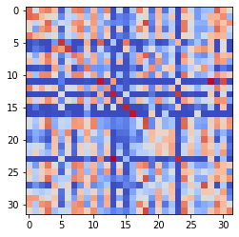

epoch 111 >> measurement_heuristic: 0.89+-0.01/0.88+-0.01 --

epoch 112 >> measurement_heuristic: 0.89+-0.01/0.88+-0.01 --

epoch 113 == measurement_heuristic: 0.88+-0.01/0.89+-0.01 --

epoch 114 == measurement_heuristic: 0.90+-0.01/0.91+-0.01 --

epoch 115 >> measurement_heuristic: 0.89+-0.01/0.88+-0.01 --

epoch 116 >> measurement_heuristic: 0.91+-0.01/0.88+-0.01 --

epoch 117 == measurement_heuristic: 0.85+-0.01/0.88+-0.01 --

epoch 118 >> measurement_heuristic: 0.89+-0.01/0.88+-0.01 --

epoch 119 >> measurement_heuristic: 0.89+-0.01/0.87+-0.01 --

epoch 120 == measurement_heuristic: 0.86+-0.01/0.88+-0.01 --

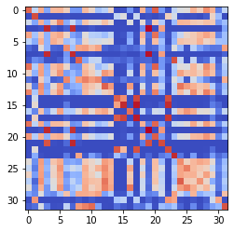

epoch 121 >> measurement_heuristic: 0.90+-0.01/0.87+-0.01 --

epoch 122 == measurement_heuristic: 0.88+-0.01/0.88+-0.01 --

epoch 123 == measurement_heuristic: 0.88+-0.01/0.87+-0.01 --

epoch 124 >> measurement_heuristic: 0.86+-0.01/0.87+-0.01 --

epoch 125 >> measurement_heuristic: 0.87+-0.01/0.86+-0.01 --

epoch 126 >> measurement_heuristic: 0.89+-0.01/0.86+-0.01 --

epoch 127 >> measurement_heuristic: 0.87+-0.01/0.86+-0.01 --

epoch 128 >> measurement_heuristic: 0.88+-0.01/0.86+-0.01 --

epoch 129 >> measurement_heuristic: 0.87+-0.01/0.85+-0.01 --

epoch 130 >> measurement_heuristic: 0.87+-0.01/0.85+-0.01 --

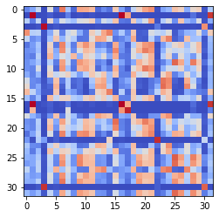

epoch 131 == measurement_heuristic: 0.87+-0.01/0.85+-0.01 --

epoch 132 == measurement_heuristic: 0.89+-0.01/0.85+-0.01 --

epoch 133 == measurement_heuristic: 0.86+-0.01/0.85+-0.01 --

epoch 134 == measurement_heuristic: 0.85+-0.01/0.86+-0.01 --

epoch 135 >> measurement_heuristic: 0.86+-0.01/0.85+-0.01 --

epoch 136 >> measurement_heuristic: 0.86+-0.01/0.85+-0.01 --

epoch 137 >> measurement_heuristic: 0.85+-0.01/0.84+-0.01 --

epoch 138 >> measurement_heuristic: 0.86+-0.01/0.84+-0.01 --

epoch 139 == measurement_heuristic: 0.87+-0.01/0.86+-0.01 --

epoch 140 >> measurement_heuristic: 0.85+-0.01/0.83+-0.01 --

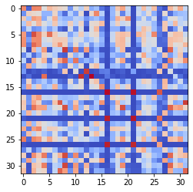

epoch 141 >> measurement_heuristic: 0.85+-0.01/0.83+-0.01 --

epoch 142 == measurement_heuristic: 0.85+-0.01/0.84+-0.01 --

epoch 143 == measurement_heuristic: 0.82+-0.01/0.83+-0.01 --

epoch 144 >> measurement_heuristic: 0.83+-0.01/0.83+-0.01 --

epoch 145 >> measurement_heuristic: 0.85+-0.01/0.83+-0.01 --

epoch 146 == measurement_heuristic: 0.83+-0.01/0.83+-0.01 --

epoch 147 == measurement_heuristic: 0.85+-0.01/0.83+-0.01 --

epoch 148 == measurement_heuristic: 0.84+-0.01/0.83+-0.01 --

epoch 149 == measurement_heuristic: 0.82+-0.01/0.83+-0.01 --

epoch 150 == measurement_heuristic: 0.84+-0.01/0.83+-0.01 --

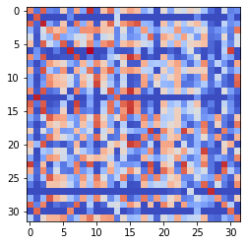

epoch 151 >> measurement_heuristic: 0.83+-0.01/0.82+-0.01 --

epoch 152 >> measurement_heuristic: 0.83+-0.01/0.81+-0.01 --

epoch 153 == measurement_heuristic: 0.82+-0.01/0.82+-0.01 --

epoch 154 == measurement_heuristic: 0.82+-0.01/0.82+-0.01 --

epoch 155 >> measurement_heuristic: 0.83+-0.01/0.81+-0.01 --

epoch 156 == measurement_heuristic: 0.84+-0.01/0.81+-0.01 --

epoch 157 == measurement_heuristic: 0.83+-0.01/0.82+-0.01 --

epoch 158 >> measurement_heuristic: 0.85+-0.01/0.81+-0.01 --

epoch 159 == measurement_heuristic: 0.84+-0.01/0.81+-0.01 --

epoch 160 == measurement_heuristic: 0.81+-0.01/0.81+-0.01 --

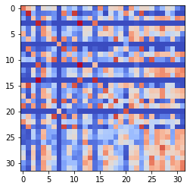

epoch 161 >> measurement_heuristic: 0.81+-0.01/0.80+-0.01 --

epoch 162 == measurement_heuristic: 0.82+-0.01/0.81+-0.01 --

epoch 163 == measurement_heuristic: 0.80+-0.01/0.81+-0.01 --

epoch 164 >> measurement_heuristic: 0.84+-0.01/0.80+-0.01 --

epoch 165 >> measurement_heuristic: 0.82+-0.01/0.79+-0.01 --

epoch 166 >> measurement_heuristic: 0.81+-0.01/0.79+-0.01 --

epoch 167 == measurement_heuristic: 0.82+-0.01/0.80+-0.01 --

epoch 168 >> measurement_heuristic: 0.79+-0.01/0.79+-0.01 --

epoch 169 >> measurement_heuristic: 0.82+-0.01/0.79+-0.01 --

epoch 170 >> measurement_heuristic: 0.80+-0.01/0.79+-0.01 --

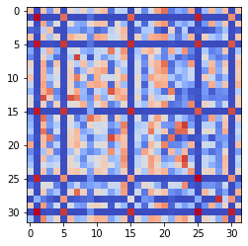

epoch 171 >> measurement_heuristic: 0.82+-0.01/0.78+-0.01 --

epoch 172 == measurement_heuristic: 0.83+-0.01/0.79+-0.01 --

epoch 173 == measurement_heuristic: 0.79+-0.01/0.79+-0.01 --

epoch 174 == measurement_heuristic: 0.79+-0.01/0.80+-0.01 --

epoch 175 == measurement_heuristic: 0.77+-0.01/0.79+-0.01 --

epoch 176 == measurement_heuristic: 0.79+-0.01/0.79+-0.01 --

epoch 177 == measurement_heuristic: 0.78+-0.01/0.79+-0.01 --

epoch 178 == measurement_heuristic: 0.81+-0.01/0.80+-0.01 --

epoch 179 >> measurement_heuristic: 0.81+-0.01/0.78+-0.01 --

epoch 180 >> measurement_heuristic: 0.79+-0.01/0.77+-0.01 --

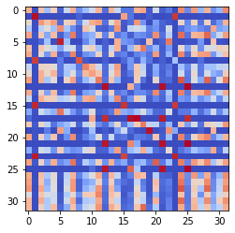

epoch 181 >> measurement_heuristic: 0.79+-0.01/0.77+-0.01 --

epoch 182 == measurement_heuristic: 0.80+-0.01/0.80+-0.01 --

epoch 183 >> measurement_heuristic: 0.79+-0.01/0.76+-0.01 --

epoch 184 == measurement_heuristic: 0.80+-0.01/0.77+-0.01 --

epoch 185 == measurement_heuristic: 0.77+-0.01/0.77+-0.01 --

epoch 186 == measurement_heuristic: 0.78+-0.01/0.82+-0.01 --

epoch 187 == measurement_heuristic: 0.79+-0.01/0.77+-0.01 --

epoch 188 == measurement_heuristic: 0.76+-0.01/0.77+-0.01 --

epoch 189 == measurement_heuristic: 0.77+-0.01/0.76+-0.01 --

epoch 190 == measurement_heuristic: 0.78+-0.01/0.77+-0.01 --

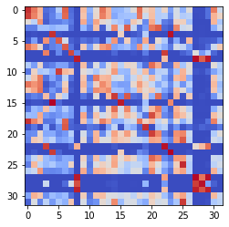

epoch 191 == measurement_heuristic: 0.79+-0.01/0.76+-0.01 --

epoch 192 >> measurement_heuristic: 0.77+-0.01/0.75+-0.01 --

epoch 193 == measurement_heuristic: 0.78+-0.01/0.76+-0.01 --

epoch 194 == measurement_heuristic: 0.77+-0.01/0.76+-0.01 --

epoch 195 == measurement_heuristic: 0.80+-0.01/0.75+-0.01 --

epoch 196 == measurement_heuristic: 0.77+-0.01/0.76+-0.01 --

epoch 197 >> measurement_heuristic: 0.76+-0.01/0.75+-0.01 --

epoch 198 == measurement_heuristic: 0.78+-0.01/0.75+-0.01 --

epoch 199 == measurement_heuristic: 0.76+-0.01/0.75+-0.01 --

epoch 200 >> measurement_heuristic: 0.76+-0.01/0.74+-0.01 --

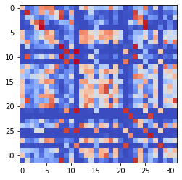

epoch 201 >> measurement_heuristic: 0.76+-0.01/0.73+-0.01 --

epoch 202 >> measurement_heuristic: 0.75+-0.01/0.73+-0.01 --

epoch 203 >> measurement_heuristic: 0.73+-0.01/0.73+-0.01 --

epoch 204 == measurement_heuristic: 0.74+-0.01/0.73+-0.01 --

epoch 205 == measurement_heuristic: 0.74+-0.01/0.73+-0.01 --

epoch 206 == measurement_heuristic: 0.76+-0.01/0.75+-0.01 --

epoch 207 == measurement_heuristic: 0.75+-0.01/0.73+-0.01 --

epoch 208 == measurement_heuristic: 0.75+-0.01/0.75+-0.01 --

epoch 209 == measurement_heuristic: 0.75+-0.01/0.73+-0.01 --

epoch 210 == measurement_heuristic: 0.76+-0.01/0.76+-0.01 --

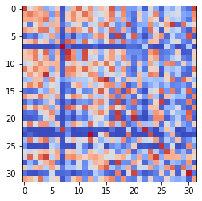

epoch 211 == measurement_heuristic: 0.76+-0.01/0.74+-0.01 --

epoch 212 >> measurement_heuristic: 0.74+-0.01/0.73+-0.01 --

epoch 213 == measurement_heuristic: 0.73+-0.01/0.74+-0.01 --

epoch 214 >> measurement_heuristic: 0.71+-0.01/0.72+-0.01 --

epoch 215 >> measurement_heuristic: 0.74+-0.01/0.72+-0.01 --

epoch 216 >> measurement_heuristic: 0.74+-0.01/0.72+-0.01 --

epoch 217 == measurement_heuristic: 0.75+-0.01/0.74+-0.01 --

epoch 218 >> measurement_heuristic: 0.75+-0.01/0.71+-0.01 --

epoch 219 >> measurement_heuristic: 0.74+-0.01/0.71+-0.01 --

epoch 220 == measurement_heuristic: 0.73+-0.01/0.71+-0.01 --

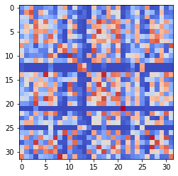

epoch 221 == measurement_heuristic: 0.74+-0.01/0.73+-0.01 --

epoch 222 == measurement_heuristic: 0.73+-0.01/0.73+-0.01 --

epoch 223 >> measurement_heuristic: 0.73+-0.01/0.70+-0.01 --

epoch 224 == measurement_heuristic: 0.71+-0.01/0.70+-0.01 --

epoch 225 == measurement_heuristic: 0.74+-0.01/0.70+-0.01 --

epoch 226 >> measurement_heuristic: 0.74+-0.01/0.69+-0.01 --

epoch 227 == measurement_heuristic: 0.72+-0.01/0.70+-0.01 --

epoch 228 == measurement_heuristic: 0.72+-0.01/0.70+-0.01 --

epoch 229 == measurement_heuristic: 0.71+-0.01/0.69+-0.01 --

epoch 230 >> measurement_heuristic: 0.69+-0.01/0.69+-0.01 --

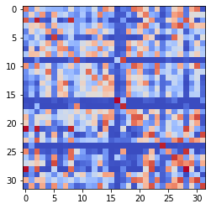

epoch 231 == measurement_heuristic: 0.71+-0.01/0.69+-0.01 --

epoch 232 >> measurement_heuristic: 0.70+-0.01/0.69+-0.01 --

epoch 233 == measurement_heuristic: 0.72+-0.01/0.69+-0.01 --

epoch 234 >> measurement_heuristic: 0.72+-0.01/0.68+-0.01 --

epoch 235 == measurement_heuristic: 0.71+-0.01/0.69+-0.01 --

epoch 236 == measurement_heuristic: 0.70+-0.01/0.69+-0.01 --

epoch 237 == measurement_heuristic: 0.71+-0.01/0.68+-0.01 --

epoch 238 == measurement_heuristic: 0.73+-0.01/0.68+-0.01 --

epoch 239 >> measurement_heuristic: 0.70+-0.01/0.68+-0.01 --

epoch 240 == measurement_heuristic: 0.70+-0.01/0.69+-0.01 --

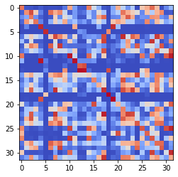

epoch 241 == measurement_heuristic: 0.71+-0.01/0.70+-0.01 --

epoch 242 == measurement_heuristic: 0.70+-0.01/0.69+-0.01 --

epoch 243 >> measurement_heuristic: 0.70+-0.01/0.67+-0.01 --

epoch 244 >> measurement_heuristic: 0.69+-0.01/0.67+-0.01 --

epoch 245 == measurement_heuristic: 0.71+-0.01/0.68+-0.01 --

epoch 246 >> measurement_heuristic: 0.70+-0.01/0.66+-0.01 --

epoch 247 >> measurement_heuristic: 0.70+-0.01/0.66+-0.01 --

epoch 248 == measurement_heuristic: 0.67+-0.01/0.67+-0.01 --

epoch 249 >> measurement_heuristic: 0.70+-0.01/0.65+-0.01 --

epoch 250 == measurement_heuristic: 0.71+-0.01/0.67+-0.01 --

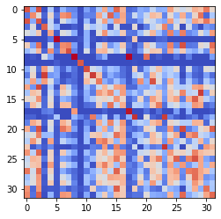

epoch 251 == measurement_heuristic: 0.65+-0.01/0.66+-0.01 --

epoch 252 == measurement_heuristic: 0.71+-0.01/0.66+-0.01 --

epoch 253 >> measurement_heuristic: 0.68+-0.01/0.64+-0.01 --

epoch 254 == measurement_heuristic: 0.70+-0.01/0.67+-0.01 --

epoch 255 == measurement_heuristic: 0.69+-0.01/0.66+-0.01 --

epoch 256 == measurement_heuristic: 0.67+-0.01/0.66+-0.01 --

epoch 257 == measurement_heuristic: 0.67+-0.01/0.65+-0.01 --

epoch 258 == measurement_heuristic: 0.68+-0.01/0.65+-0.01 --

epoch 259 == measurement_heuristic: 0.68+-0.01/0.64+-0.01 --

epoch 260 == measurement_heuristic: 0.66+-0.01/0.65+-0.01 --

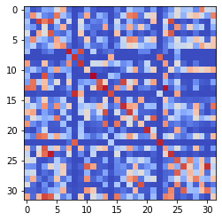

epoch 261 == measurement_heuristic: 0.68+-0.01/0.65+-0.01 --

epoch 262 >> measurement_heuristic: 0.68+-0.01/0.64+-0.01 --

epoch 263 >> measurement_heuristic: 0.67+-0.01/0.63+-0.01 --

epoch 264 == measurement_heuristic: 0.69+-0.01/0.64+-0.01 --

epoch 265 == measurement_heuristic: 0.67+-0.01/0.64+-0.01 --

epoch 266 == measurement_heuristic: 0.66+-0.01/0.64+-0.01 --

epoch 267 == measurement_heuristic: 0.67+-0.01/0.65+-0.01 --

epoch 268 == measurement_heuristic: 0.66+-0.01/0.65+-0.01 --

epoch 269 >> measurement_heuristic: 0.69+-0.01/0.63+-0.01 --

epoch 270 == measurement_heuristic: 0.65+-0.01/0.63+-0.01 --

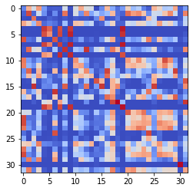

epoch 271 == measurement_heuristic: 0.66+-0.01/0.65+-0.01 --

epoch 272 == measurement_heuristic: 0.65+-0.01/0.63+-0.01 --

epoch 273 == measurement_heuristic: 0.68+-0.01/0.65+-0.01 --

epoch 274 >> measurement_heuristic: 0.65+-0.01/0.62+-0.01 --

epoch 275 == measurement_heuristic: 0.62+-0.01/0.62+-0.01 --

epoch 276 == measurement_heuristic: 0.66+-0.01/0.62+-0.01 --

epoch 277 == measurement_heuristic: 0.65+-0.01/0.63+-0.01 --

epoch 278 == measurement_heuristic: 0.67+-0.01/0.64+-0.01 --

epoch 279 == measurement_heuristic: 0.67+-0.01/0.62+-0.01 --

epoch 280 >> measurement_heuristic: 0.65+-0.01/0.62+-0.01 --

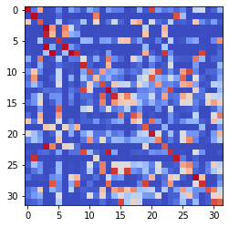

epoch 281 >> measurement_heuristic: 0.65+-0.01/0.61+-0.01 --

epoch 282 == measurement_heuristic: 0.63+-0.01/0.61+-0.01 --

epoch 283 >> measurement_heuristic: 0.65+-0.01/0.61+-0.01 --

epoch 284 == measurement_heuristic: 0.65+-0.01/0.61+-0.01 --

epoch 285 == measurement_heuristic: 0.68+-0.01/0.64+-0.01 --

epoch 286 == measurement_heuristic: 0.63+-0.01/0.61+-0.01 --

epoch 287 == measurement_heuristic: 0.63+-0.01/0.62+-0.01 --

epoch 288 == measurement_heuristic: 0.64+-0.01/0.61+-0.01 --

epoch 289 == measurement_heuristic: 0.67+-0.01/0.61+-0.01 --

epoch 290 == measurement_heuristic: 0.62+-0.01/0.63+-0.01 --

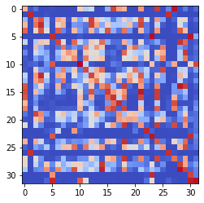

epoch 291 == measurement_heuristic: 0.64+-0.01/0.61+-0.01 --

epoch 292 >> measurement_heuristic: 0.65+-0.01/0.60+-0.01 --

epoch 293 == measurement_heuristic: 0.64+-0.01/0.60+-0.01 --

epoch 294 == measurement_heuristic: 0.65+-0.01/0.62+-0.01 --

epoch 295 == measurement_heuristic: 0.63+-0.01/0.61+-0.01 --

epoch 296 == measurement_heuristic: 0.63+-0.01/0.60+-0.01 --

epoch 297 == measurement_heuristic: 0.63+-0.01/0.61+-0.01 --

epoch 298 >> measurement_heuristic: 0.64+-0.01/0.58+-0.01 --

epoch 299 == measurement_heuristic: 0.62+-0.01/0.61+-0.01 --

epoch 300 == measurement_heuristic: 0.65+-0.01/0.60+-0.01 --

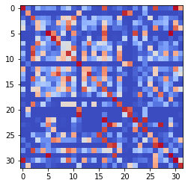

epoch 301 == measurement_heuristic: 0.62+-0.01/0.59+-0.01 --

epoch 302 == measurement_heuristic: 0.62+-0.01/0.59+-0.01 --

epoch 303 == measurement_heuristic: 0.65+-0.01/0.59+-0.01 --

epoch 304 == measurement_heuristic: 0.63+-0.01/0.59+-0.01 --

epoch 305 == measurement_heuristic: 0.60+-0.01/0.60+-0.01 --

epoch 306 == measurement_heuristic: 0.62+-0.01/0.59+-0.01 --

epoch 307 == measurement_heuristic: 0.61+-0.01/0.59+-0.01 --

epoch 308 == measurement_heuristic: 0.60+-0.01/0.59+-0.01 --

epoch 309 >> measurement_heuristic: 0.64+-0.01/0.58+-0.01 --

epoch 310 == measurement_heuristic: 0.61+-0.01/0.59+-0.01 --

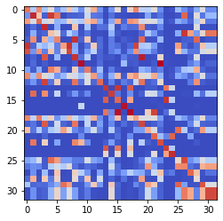

epoch 311 >> measurement_heuristic: 0.62+-0.01/0.58+-0.01 --

epoch 312 == measurement_heuristic: 0.63+-0.01/0.58+-0.01 --

epoch 313 == measurement_heuristic: 0.62+-0.01/0.59+-0.01 --

epoch 314 >> measurement_heuristic: 0.61+-0.01/0.57+-0.01 --

epoch 315 >> measurement_heuristic: 0.61+-0.01/0.57+-0.01 --

epoch 316 == measurement_heuristic: 0.62+-0.01/0.58+-0.01 --

epoch 317 == measurement_heuristic: 0.62+-0.01/0.58+-0.01 --

epoch 318 == measurement_heuristic: 0.62+-0.01/0.58+-0.01 --

epoch 319 == measurement_heuristic: 0.62+-0.01/0.60+-0.01 --

epoch 320 >> measurement_heuristic: 0.62+-0.01/0.57+-0.01 --

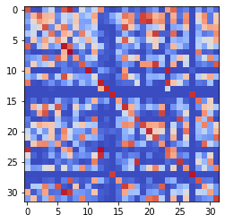

epoch 321 >> measurement_heuristic: 0.62+-0.01/0.56+-0.01 --

epoch 322 == measurement_heuristic: 0.61+-0.01/0.57+-0.01 --

epoch 323 >> measurement_heuristic: 0.61+-0.01/0.56+-0.01 --

epoch 324 == measurement_heuristic: 0.59+-0.01/0.57+-0.01 --

epoch 325 == measurement_heuristic: 0.59+-0.01/0.57+-0.01 --

epoch 326 == measurement_heuristic: 0.61+-0.01/0.56+-0.01 --

epoch 327 == measurement_heuristic: 0.59+-0.01/0.57+-0.01 --

epoch 328 == measurement_heuristic: 0.61+-0.01/0.58+-0.01 --

epoch 329 == measurement_heuristic: 0.59+-0.01/0.58+-0.01 --

epoch 330 == measurement_heuristic: 0.61+-0.01/0.58+-0.01 --

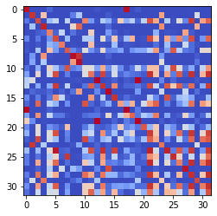

epoch 331 == measurement_heuristic: 0.61+-0.01/0.59+-0.01 --

epoch 332 == measurement_heuristic: 0.61+-0.01/0.58+-0.01 --

epoch 333 >> measurement_heuristic: 0.60+-0.01/0.56+-0.01 --

epoch 334 == measurement_heuristic: 0.62+-0.01/0.56+-0.01 --

epoch 335 >> measurement_heuristic: 0.61+-0.01/0.56+-0.01 --

epoch 336 == measurement_heuristic: 0.62+-0.01/0.56+-0.01 --

epoch 337 == measurement_heuristic: 0.61+-0.01/0.57+-0.01 --

epoch 338 >> measurement_heuristic: 0.61+-0.01/0.55+-0.01 --

epoch 339 == measurement_heuristic: 0.59+-0.01/0.56+-0.01 --

epoch 340 == measurement_heuristic: 0.61+-0.01/0.56+-0.01 --

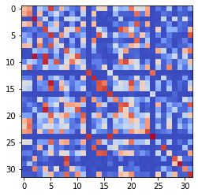

epoch 341 == measurement_heuristic: 0.58+-0.01/0.55+-0.01 --

epoch 342 == measurement_heuristic: 0.61+-0.01/0.56+-0.01 --

epoch 343 == measurement_heuristic: 0.60+-0.01/0.56+-0.01 --

epoch 344 >> measurement_heuristic: 0.60+-0.01/0.55+-0.01 --

epoch 345 == measurement_heuristic: 0.59+-0.01/0.55+-0.01 --

epoch 346 == measurement_heuristic: 0.59+-0.01/0.57+-0.01 --

epoch 347 == measurement_heuristic: 0.60+-0.01/0.57+-0.01 --

epoch 348 == measurement_heuristic: 0.58+-0.01/0.57+-0.01 --

epoch 349 == measurement_heuristic: 0.59+-0.01/0.56+-0.01 --

epoch 350 >> measurement_heuristic: 0.61+-0.01/0.55+-0.01 --

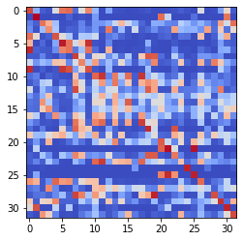

epoch 351 == measurement_heuristic: 0.58+-0.01/0.57+-0.01 --

epoch 352 == measurement_heuristic: 0.59+-0.01/0.56+-0.01 --

epoch 353 >> measurement_heuristic: 0.57+-0.01/0.54+-0.01 --

epoch 354 == measurement_heuristic: 0.57+-0.01/0.55+-0.01 --

epoch 355 == measurement_heuristic: 0.60+-0.01/0.55+-0.01 --

epoch 356 == measurement_heuristic: 0.59+-0.01/0.57+-0.01 --

epoch 357 == measurement_heuristic: 0.58+-0.01/0.54+-0.01 --

epoch 358 >> measurement_heuristic: 0.60+-0.01/0.54+-0.01 --

epoch 359 >> measurement_heuristic: 0.57+-0.01/0.53+-0.01 --

epoch 360 == measurement_heuristic: 0.58+-0.01/0.54+-0.01 --

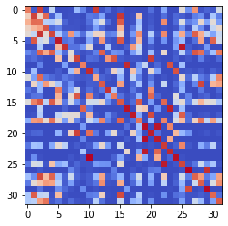

epoch 361 == measurement_heuristic: 0.59+-0.01/0.58+-0.01 --

epoch 362 == measurement_heuristic: 0.59+-0.01/0.55+-0.01 --

epoch 363 == measurement_heuristic: 0.62+-0.01/0.54+-0.01 --

epoch 364 == measurement_heuristic: 0.57+-0.01/0.54+-0.01 --

epoch 365 == measurement_heuristic: 0.58+-0.01/0.53+-0.01 --

epoch 366 >> measurement_heuristic: 0.59+-0.01/0.53+-0.01 --

epoch 367 == measurement_heuristic: 0.57+-0.01/0.54+-0.01 --

epoch 368 == measurement_heuristic: 0.55+-0.01/0.54+-0.01 --

epoch 369 == measurement_heuristic: 0.59+-0.01/0.55+-0.01 --

epoch 370 == measurement_heuristic: 0.58+-0.01/0.55+-0.01 --

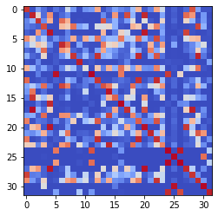

epoch 371 >> measurement_heuristic: 0.59+-0.01/0.53+-0.01 --

epoch 372 == measurement_heuristic: 0.57+-0.01/0.54+-0.01 --

epoch 373 >> measurement_heuristic: 0.56+-0.01/0.52+-0.01 --

epoch 374 == measurement_heuristic: 0.58+-0.01/0.53+-0.01 --

epoch 375 == measurement_heuristic: 0.58+-0.01/0.54+-0.01 --

epoch 376 == measurement_heuristic: 0.58+-0.01/0.53+-0.01 --

epoch 377 == measurement_heuristic: 0.57+-0.01/0.53+-0.01 --

epoch 378 == measurement_heuristic: 0.56+-0.01/0.53+-0.01 --

epoch 379 == measurement_heuristic: 0.56+-0.01/0.52+-0.01 --

epoch 380 == measurement_heuristic: 0.55+-0.01/0.53+-0.01 --

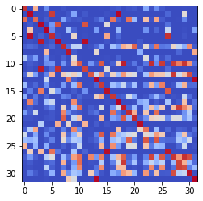

epoch 381 >> measurement_heuristic: 0.57+-0.01/0.52+-0.01 --

epoch 382 == measurement_heuristic: 0.59+-0.01/0.53+-0.01 --

epoch 383 == measurement_heuristic: 0.57+-0.01/0.53+-0.01 --

epoch 384 >> measurement_heuristic: 0.57+-0.01/0.52+-0.01 --

epoch 385 == measurement_heuristic: 0.57+-0.01/0.54+-0.01 --

epoch 386 >> measurement_heuristic: 0.56+-0.01/0.51+-0.01 --

epoch 387 == measurement_heuristic: 0.56+-0.01/0.52+-0.01 --

epoch 388 == measurement_heuristic: 0.58+-0.01/0.54+-0.01 --

epoch 389 == measurement_heuristic: 0.56+-0.01/0.53+-0.01 --

epoch 390 == measurement_heuristic: 0.57+-0.01/0.54+-0.01 --

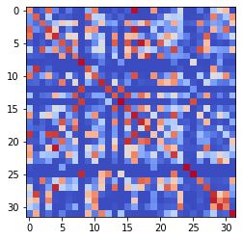

epoch 391 == measurement_heuristic: 0.55+-0.01/0.54+-0.01 --

epoch 392 >> measurement_heuristic: 0.56+-0.01/0.51+-0.01 --

epoch 393 == measurement_heuristic: 0.55+-0.01/0.54+-0.01 --

epoch 394 == measurement_heuristic: 0.56+-0.01/0.53+-0.01 --

epoch 395 == measurement_heuristic: 0.54+-0.01/0.53+-0.01 --

epoch 396 == measurement_heuristic: 0.57+-0.01/0.53+-0.01 --

epoch 397 == measurement_heuristic: 0.56+-0.01/0.55+-0.01 --

epoch 398 == measurement_heuristic: 0.55+-0.01/0.52+-0.01 --

epoch 399 == measurement_heuristic: 0.58+-0.01/0.53+-0.01 --

epoch 400 == measurement_heuristic: 0.55+-0.01/0.54+-0.01 --

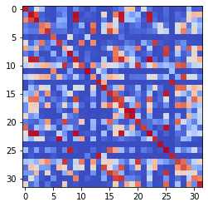

epoch 401 == measurement_heuristic: 0.56+-0.01/0.54+-0.01 --

epoch 402 == measurement_heuristic: 0.57+-0.01/0.54+-0.01 --

epoch 403 == measurement_heuristic: 0.57+-0.01/0.58+-0.01 --

epoch 404 >> measurement_heuristic: 0.56+-0.01/0.51+-0.01 --

epoch 405 == measurement_heuristic: 0.55+-0.01/0.52+-0.01 --

epoch 406 == measurement_heuristic: 0.56+-0.01/0.52+-0.01 --

epoch 407 == measurement_heuristic: 0.55+-0.01/0.52+-0.01 --

epoch 408 >> measurement_heuristic: 0.54+-0.01/0.50+-0.01 --

epoch 409 == measurement_heuristic: 0.54+-0.01/0.51+-0.01 --

epoch 410 == measurement_heuristic: 0.56+-0.01/0.51+-0.01 --

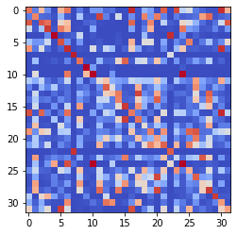

epoch 411 == measurement_heuristic: 0.56+-0.01/0.52+-0.01 --

epoch 412 == measurement_heuristic: 0.56+-0.01/0.52+-0.01 --

epoch 413 == measurement_heuristic: 0.55+-0.01/0.51+-0.01 --

epoch 414 == measurement_heuristic: 0.55+-0.01/0.52+-0.01 --

epoch 415 == measurement_heuristic: 0.52+-0.01/0.53+-0.01 --

epoch 416 == measurement_heuristic: 0.56+-0.01/0.50+-0.01 --

epoch 417 == measurement_heuristic: 0.56+-0.01/0.50+-0.01 --

epoch 418 == measurement_heuristic: 0.54+-0.01/0.50+-0.01 --

epoch 419 == measurement_heuristic: 0.57+-0.01/0.52+-0.01 --

epoch 420 >> measurement_heuristic: 0.55+-0.01/0.50+-0.01 --

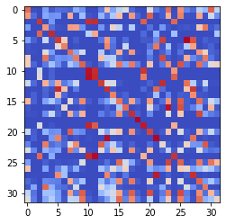

epoch 421 == measurement_heuristic: 0.55+-0.01/0.52+-0.01 --

epoch 422 == measurement_heuristic: 0.55+-0.01/0.50+-0.01 --

epoch 423 == measurement_heuristic: 0.54+-0.01/0.53+-0.01 --

epoch 424 == measurement_heuristic: 0.54+-0.01/0.51+-0.01 --

epoch 425 == measurement_heuristic: 0.54+-0.01/0.51+-0.01 --

epoch 426 >> measurement_heuristic: 0.52+-0.01/0.49+-0.01 --

epoch 427 == measurement_heuristic: 0.56+-0.01/0.51+-0.01 --

epoch 428 == measurement_heuristic: 0.56+-0.01/0.50+-0.01 --

epoch 429 == measurement_heuristic: 0.55+-0.01/0.51+-0.01 --

epoch 430 == measurement_heuristic: 0.55+-0.01/0.50+-0.01 --

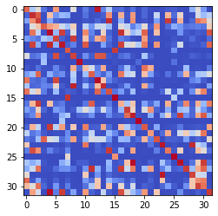

epoch 431 >> measurement_heuristic: 0.55+-0.01/0.49+-0.01 --

epoch 432 == measurement_heuristic: 0.54+-0.01/0.52+-0.01 --

epoch 433 == measurement_heuristic: 0.55+-0.01/0.51+-0.01 --

epoch 434 >> measurement_heuristic: 0.53+-0.01/0.49+-0.01 --

epoch 435 == measurement_heuristic: 0.54+-0.01/0.50+-0.01 --

epoch 436 == measurement_heuristic: 0.54+-0.01/0.52+-0.01 --

epoch 437 == measurement_heuristic: 0.55+-0.01/0.51+-0.01 --

epoch 438 == measurement_heuristic: 0.55+-0.01/0.50+-0.01 --

epoch 439 == measurement_heuristic: 0.52+-0.01/0.51+-0.01 --

epoch 440 == measurement_heuristic: 0.52+-0.01/0.50+-0.01 --

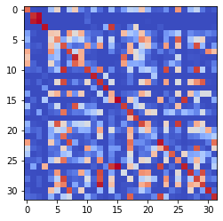

epoch 441 == measurement_heuristic: 0.55+-0.01/0.50+-0.01 --

epoch 442 >> measurement_heuristic: 0.53+-0.01/0.49+-0.01 --

epoch 443 == measurement_heuristic: 0.54+-0.01/0.51+-0.01 --

epoch 444 == measurement_heuristic: 0.52+-0.01/0.50+-0.01 --

epoch 445 == measurement_heuristic: 0.53+-0.01/0.51+-0.01 --

epoch 446 == measurement_heuristic: 0.53+-0.01/0.50+-0.01 --

epoch 447 == measurement_heuristic: 0.54+-0.01/0.49+-0.01 --

epoch 448 == measurement_heuristic: 0.52+-0.01/0.49+-0.01 --

epoch 449 == measurement_heuristic: 0.54+-0.01/0.49+-0.01 --

epoch 450 >> measurement_heuristic: 0.54+-0.01/0.48+-0.01 --

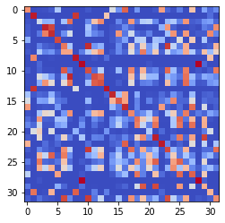

epoch 451 == measurement_heuristic: 0.56+-0.01/0.49+-0.01 --

epoch 452 == measurement_heuristic: 0.55+-0.01/0.51+-0.01 --

epoch 453 == measurement_heuristic: 0.53+-0.01/0.50+-0.01 --

epoch 454 == measurement_heuristic: 0.53+-0.01/0.49+-0.01 --

epoch 455 == measurement_heuristic: 0.51+-0.01/0.49+-0.01 --

epoch 456 == measurement_heuristic: 0.52+-0.01/0.49+-0.01 --

epoch 457 == measurement_heuristic: 0.53+-0.01/0.49+-0.01 --

epoch 458 == measurement_heuristic: 0.56+-0.01/0.51+-0.01 --

epoch 459 == measurement_heuristic: 0.55+-0.01/0.49+-0.01 --

epoch 460 == measurement_heuristic: 0.53+-0.01/0.49+-0.01 --

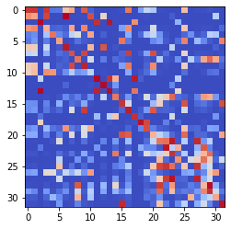

epoch 461 == measurement_heuristic: 0.53+-0.01/0.49+-0.01 --

epoch 462 == measurement_heuristic: 0.53+-0.01/0.51+-0.01 --

epoch 463 == measurement_heuristic: 0.53+-0.01/0.48+-0.01 --

epoch 464 >> measurement_heuristic: 0.54+-0.01/0.48+-0.01 --

epoch 465 == measurement_heuristic: 0.51+-0.01/0.48+-0.01 --

epoch 466 == measurement_heuristic: 0.52+-0.01/0.53+-0.01 --

epoch 467 == measurement_heuristic: 0.53+-0.01/0.50+-0.01 --

epoch 468 == measurement_heuristic: 0.51+-0.01/0.48+-0.01 --

epoch 469 == measurement_heuristic: 0.55+-0.01/0.49+-0.01 --

epoch 470 >> measurement_heuristic: 0.51+-0.01/0.48+-0.01 --

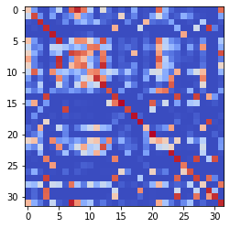

epoch 471 == measurement_heuristic: 0.52+-0.01/0.48+-0.01 --

epoch 472 == measurement_heuristic: 0.53+-0.01/0.49+-0.01 --

epoch 473 == measurement_heuristic: 0.55+-0.01/0.48+-0.01 --

epoch 474 == measurement_heuristic: 0.55+-0.01/0.48+-0.01 --

epoch 475 == measurement_heuristic: 0.55+-0.01/0.49+-0.01 --

epoch 476 == measurement_heuristic: 0.51+-0.01/0.48+-0.01 --

epoch 477 >> measurement_heuristic: 0.52+-0.01/0.47+-0.01 --

epoch 478 == measurement_heuristic: 0.52+-0.01/0.49+-0.01 --

epoch 479 == measurement_heuristic: 0.55+-0.01/0.48+-0.01 --

epoch 480 == measurement_heuristic: 0.51+-0.01/0.48+-0.01 --

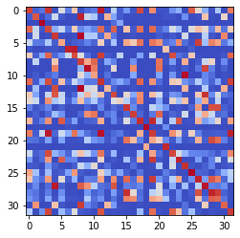

epoch 481 == measurement_heuristic: 0.52+-0.01/0.48+-0.01 --

epoch 482 == measurement_heuristic: 0.51+-0.01/0.49+-0.01 --

epoch 483 == measurement_heuristic: 0.51+-0.01/0.48+-0.01 --

epoch 484 == measurement_heuristic: 0.51+-0.01/0.48+-0.01 --

epoch 485 >> measurement_heuristic: 0.51+-0.01/0.46+-0.01 --

epoch 486 == measurement_heuristic: 0.51+-0.01/0.47+-0.01 --

epoch 487 == measurement_heuristic: 0.50+-0.01/0.47+-0.01 --

epoch 488 == measurement_heuristic: 0.51+-0.01/0.49+-0.01 --

epoch 489 == measurement_heuristic: 0.52+-0.01/0.48+-0.01 --

epoch 490 == measurement_heuristic: 0.51+-0.01/0.48+-0.01 --

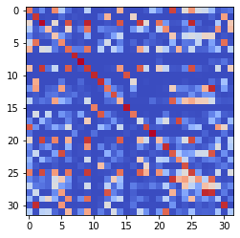

epoch 491 == measurement_heuristic: 0.52+-0.01/0.48+-0.01 --

epoch 492 == measurement_heuristic: 0.52+-0.01/0.53+-0.01 --

epoch 493 == measurement_heuristic: 0.54+-0.01/0.49+-0.01 --

epoch 494 == measurement_heuristic: 0.51+-0.01/0.49+-0.01 --

epoch 495 == measurement_heuristic: 0.51+-0.01/0.47+-0.01 --

epoch 496 == measurement_heuristic: 0.51+-0.01/0.46+-0.01 --

epoch 497 == measurement_heuristic: 0.52+-0.01/0.47+-0.01 --

epoch 498 == measurement_heuristic: 0.53+-0.01/0.48+-0.01 --

epoch 499 == measurement_heuristic: 0.50+-0.01/0.47+-0.01 --

epoch 500 == measurement_heuristic: 0.53+-0.01/0.46+-0.01 --

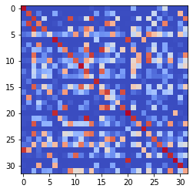

epoch 501 == measurement_heuristic: 0.53+-0.01/0.47+-0.01 --

epoch 502 == measurement_heuristic: 0.52+-0.01/0.46+-0.01 --

epoch 503 == measurement_heuristic: 0.51+-0.01/0.47+-0.01 --

epoch 504 >> measurement_heuristic: 0.53+-0.01/0.46+-0.01 --

epoch 505 >> measurement_heuristic: 0.52+-0.01/0.46+-0.01 --

epoch 506 == measurement_heuristic: 0.50+-0.01/0.48+-0.01 --

epoch 507 >> measurement_heuristic: 0.49+-0.01/0.46+-0.01 --

epoch 508 == measurement_heuristic: 0.52+-0.01/0.48+-0.01 --

epoch 509 == measurement_heuristic: 0.50+-0.01/0.51+-0.01 --

epoch 510 == measurement_heuristic: 0.51+-0.01/0.47+-0.01 --

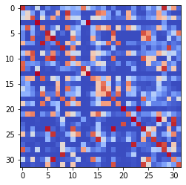

epoch 511 == measurement_heuristic: 0.51+-0.01/0.47+-0.01 --

epoch 512 == measurement_heuristic: 0.51+-0.01/0.46+-0.01 --

epoch 513 == measurement_heuristic: 0.52+-0.01/0.51+-0.01 --

epoch 514 == measurement_heuristic: 0.52+-0.01/0.49+-0.01 --

epoch 515 == measurement_heuristic: 0.51+-0.01/0.47+-0.01 --

epoch 516 == measurement_heuristic: 0.50+-0.01/0.48+-0.01 --

epoch 517 == measurement_heuristic: 0.52+-0.01/0.47+-0.01 --

epoch 518 == measurement_heuristic: 0.49+-0.01/0.46+-0.01 --

epoch 519 == measurement_heuristic: 0.51+-0.01/0.52+-0.01 --

epoch 520 == measurement_heuristic: 0.52+-0.01/0.47+-0.01 --

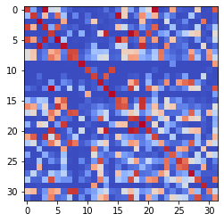

epoch 521 == measurement_heuristic: 0.52+-0.01/0.46+-0.01 --

epoch 522 == measurement_heuristic: 0.50+-0.01/0.46+-0.01 --

epoch 523 == measurement_heuristic: 0.50+-0.01/0.46+-0.01 --

epoch 524 == measurement_heuristic: 0.51+-0.01/0.48+-0.01 --

epoch 525 >> measurement_heuristic: 0.52+-0.01/0.45+-0.01 --

epoch 526 == measurement_heuristic: 0.50+-0.01/0.46+-0.01 --

epoch 527 == measurement_heuristic: 0.51+-0.01/0.47+-0.01 --

epoch 528 == measurement_heuristic: 0.50+-0.01/0.48+-0.01 --

epoch 529 == measurement_heuristic: 0.50+-0.01/0.47+-0.01 --

epoch 530 == measurement_heuristic: 0.52+-0.01/0.47+-0.01 --

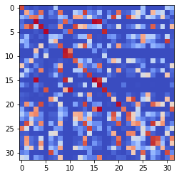

epoch 531 == measurement_heuristic: 0.53+-0.01/0.48+-0.01 --

epoch 532 == measurement_heuristic: 0.53+-0.01/0.47+-0.01 --

epoch 533 == measurement_heuristic: 0.53+-0.01/0.47+-0.01 --

epoch 534 >> measurement_heuristic: 0.52+-0.01/0.45+-0.01 --

epoch 535 == measurement_heuristic: 0.51+-0.01/0.46+-0.01 --

epoch 536 == measurement_heuristic: 0.49+-0.01/0.46+-0.01 --

epoch 537 == measurement_heuristic: 0.51+-0.01/0.46+-0.01 --

epoch 538 == measurement_heuristic: 0.51+-0.01/0.46+-0.01 --

epoch 539 == measurement_heuristic: 0.52+-0.01/0.46+-0.01 --

epoch 540 == measurement_heuristic: 0.51+-0.01/0.45+-0.01 --

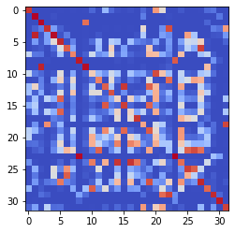

epoch 541 == measurement_heuristic: 0.53+-0.01/0.46+-0.01 --

epoch 542 == measurement_heuristic: 0.53+-0.01/0.45+-0.01 --

epoch 543 == measurement_heuristic: 0.50+-0.01/0.46+-0.01 --

epoch 544 == measurement_heuristic: 0.51+-0.01/0.48+-0.01 --

epoch 545 == measurement_heuristic: 0.52+-0.01/0.45+-0.01 --

epoch 546 == measurement_heuristic: 0.50+-0.01/0.46+-0.01 --

epoch 547 == measurement_heuristic: 0.49+-0.01/0.47+-0.01 --

epoch 548 == measurement_heuristic: 0.50+-0.01/0.46+-0.01 --

epoch 549 == measurement_heuristic: 0.51+-0.01/0.45+-0.01 --

epoch 550 == measurement_heuristic: 0.52+-0.01/0.47+-0.01 --

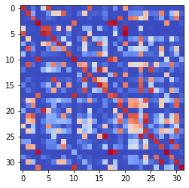

epoch 551 == measurement_heuristic: 0.48+-0.01/0.46+-0.01 --

epoch 552 == measurement_heuristic: 0.49+-0.01/0.47+-0.01 --

epoch 553 == measurement_heuristic: 0.49+-0.01/0.45+-0.01 --

epoch 554 == measurement_heuristic: 0.50+-0.01/0.45+-0.01 --

epoch 555 == measurement_heuristic: 0.50+-0.01/0.46+-0.01 --

epoch 556 == measurement_heuristic: 0.51+-0.01/0.46+-0.01 --

epoch 557 == measurement_heuristic: 0.48+-0.01/0.45+-0.01 --

epoch 558 == measurement_heuristic: 0.49+-0.01/0.46+-0.01 --

epoch 559 == measurement_heuristic: 0.52+-0.01/0.47+-0.01 --

epoch 560 >> measurement_heuristic: 0.49+-0.01/0.45+-0.01 --

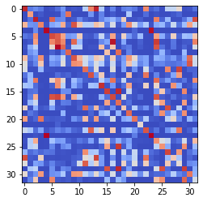

epoch 561 == measurement_heuristic: 0.50+-0.01/0.46+-0.01 --

epoch 562 == measurement_heuristic: 0.48+-0.01/0.48+-0.01 --

epoch 563 == measurement_heuristic: 0.51+-0.01/0.45+-0.01 --

epoch 564 == measurement_heuristic: 0.51+-0.01/0.45+-0.01 --

epoch 565 >> measurement_heuristic: 0.49+-0.01/0.44+-0.01 --

epoch 566 == measurement_heuristic: 0.49+-0.01/0.46+-0.01 --

epoch 567 == measurement_heuristic: 0.47+-0.01/0.45+-0.01 --

epoch 568 == measurement_heuristic: 0.50+-0.01/0.45+-0.01 --

epoch 569 >> measurement_heuristic: 0.49+-0.01/0.44+-0.01 --

epoch 570 == measurement_heuristic: 0.50+-0.01/0.44+-0.01 --

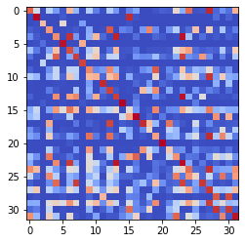

epoch 571 == measurement_heuristic: 0.50+-0.01/0.45+-0.01 --

epoch 572 == measurement_heuristic: 0.50+-0.01/0.45+-0.01 --

epoch 573 == measurement_heuristic: 0.51+-0.01/0.46+-0.01 --

epoch 574 == measurement_heuristic: 0.49+-0.01/0.45+-0.01 --

epoch 575 == measurement_heuristic: 0.49+-0.01/0.45+-0.01 --

epoch 576 == measurement_heuristic: 0.50+-0.01/0.46+-0.01 --

epoch 577 == measurement_heuristic: 0.49+-0.01/0.45+-0.01 --

epoch 578 == measurement_heuristic: 0.48+-0.01/0.45+-0.01 --

epoch 579 == measurement_heuristic: 0.49+-0.01/0.44+-0.01 --

epoch 580 == measurement_heuristic: 0.48+-0.01/0.45+-0.01 --

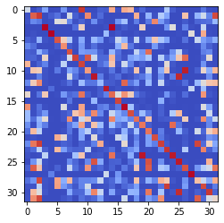

epoch 581 == measurement_heuristic: 0.50+-0.01/0.45+-0.01 --

epoch 582 >> measurement_heuristic: 0.47+-0.01/0.44+-0.01 --

epoch 583 == measurement_heuristic: 0.50+-0.01/0.46+-0.01 --

epoch 584 == measurement_heuristic: 0.51+-0.01/0.46+-0.01 --

epoch 585 == measurement_heuristic: 0.46+-0.01/0.44+-0.01 --

epoch 586 == measurement_heuristic: 0.48+-0.01/0.45+-0.01 --

epoch 587 == measurement_heuristic: 0.48+-0.01/0.44+-0.01 --

epoch 588 == measurement_heuristic: 0.50+-0.01/0.44+-0.01 --

epoch 589 == measurement_heuristic: 0.49+-0.01/0.50+-0.01 --

epoch 590 == measurement_heuristic: 0.48+-0.01/0.49+-0.01 --

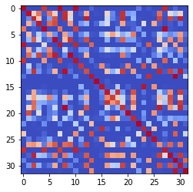

epoch 591 == measurement_heuristic: 0.51+-0.01/0.44+-0.01 --

epoch 592 == measurement_heuristic: 0.51+-0.01/0.46+-0.01 --

epoch 593 >> measurement_heuristic: 0.48+-0.01/0.44+-0.01 --

epoch 594 == measurement_heuristic: 0.50+-0.01/0.46+-0.01 --

epoch 595 == measurement_heuristic: 0.49+-0.01/0.45+-0.01 --

epoch 596 == measurement_heuristic: 0.48+-0.01/0.47+-0.01 --

epoch 597 == measurement_heuristic: 0.50+-0.01/0.45+-0.01 --

epoch 598 == measurement_heuristic: 0.48+-0.01/0.46+-0.01 --

epoch 599 == measurement_heuristic: 0.49+-0.01/0.46+-0.01 --

epoch 600 >> measurement_heuristic: 0.47+-0.01/0.43+-0.01 --

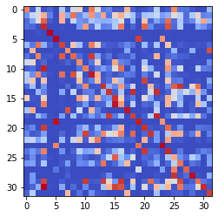

epoch 601 == measurement_heuristic: 0.48+-0.01/0.45+-0.01 --

epoch 602 == measurement_heuristic: 0.48+-0.01/0.45+-0.01 --

epoch 603 == measurement_heuristic: 0.50+-0.01/0.46+-0.01 --

epoch 604 == measurement_heuristic: 0.50+-0.01/0.45+-0.01 --

epoch 605 == measurement_heuristic: 0.48+-0.01/0.46+-0.01 --

epoch 606 == measurement_heuristic: 0.48+-0.01/0.44+-0.01 --

epoch 607 == measurement_heuristic: 0.50+-0.01/0.45+-0.01 --

epoch 608 >> measurement_heuristic: 0.49+-0.01/0.43+-0.01 --

epoch 609 == measurement_heuristic: 0.47+-0.01/0.45+-0.01 --

epoch 610 == measurement_heuristic: 0.50+-0.01/0.45+-0.01 --

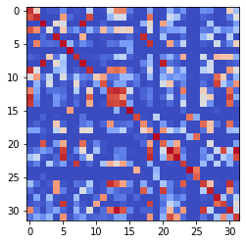

epoch 611 == measurement_heuristic: 0.47+-0.01/0.43+-0.01 --

epoch 612 == measurement_heuristic: 0.48+-0.01/0.47+-0.01 --

epoch 613 >> measurement_heuristic: 0.48+-0.01/0.43+-0.01 --

epoch 614 == measurement_heuristic: 0.50+-0.01/0.46+-0.01 --

epoch 615 == measurement_heuristic: 0.50+-0.01/0.45+-0.01 --

epoch 616 == measurement_heuristic: 0.49+-0.01/0.44+-0.01 --

epoch 617 == measurement_heuristic: 0.48+-0.01/0.44+-0.01 --

epoch 618 == measurement_heuristic: 0.49+-0.01/0.44+-0.01 --

epoch 619 == measurement_heuristic: 0.48+-0.01/0.44+-0.01 --

epoch 620 == measurement_heuristic: 0.49+-0.01/0.43+-0.01 --

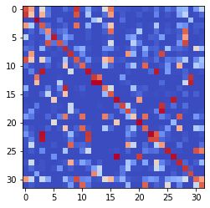

epoch 621 == measurement_heuristic: 0.46+-0.01/0.43+-0.01 --

epoch 622 == measurement_heuristic: 0.46+-0.01/0.44+-0.01 --

epoch 623 == measurement_heuristic: 0.48+-0.01/0.46+-0.01 --

epoch 624 >> measurement_heuristic: 0.47+-0.01/0.42+-0.01 --

epoch 625 == measurement_heuristic: 0.49+-0.01/0.44+-0.01 --

epoch 626 == measurement_heuristic: 0.46+-0.01/0.43+-0.01 --

epoch 627 == measurement_heuristic: 0.48+-0.01/0.44+-0.01 --

epoch 628 == measurement_heuristic: 0.46+-0.01/0.43+-0.01 --

epoch 629 == measurement_heuristic: 0.45+-0.01/0.43+-0.01 --

epoch 630 == measurement_heuristic: 0.46+-0.01/0.43+-0.01 --

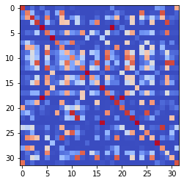

epoch 631 == measurement_heuristic: 0.47+-0.01/0.43+-0.01 --

epoch 632 == measurement_heuristic: 0.48+-0.01/0.49+-0.01 --

epoch 633 == measurement_heuristic: 0.49+-0.01/0.43+-0.01 --

epoch 634 == measurement_heuristic: 0.48+-0.01/0.44+-0.01 --

epoch 635 == measurement_heuristic: 0.48+-0.01/0.43+-0.01 --

epoch 636 == measurement_heuristic: 0.49+-0.01/0.44+-0.01 --

epoch 637 == measurement_heuristic: 0.49+-0.01/0.44+-0.01 --

epoch 638 == measurement_heuristic: 0.46+-0.01/0.43+-0.01 --

epoch 639 >> measurement_heuristic: 0.50+-0.01/0.42+-0.01 --

epoch 640 == measurement_heuristic: 0.48+-0.01/0.44+-0.01 --

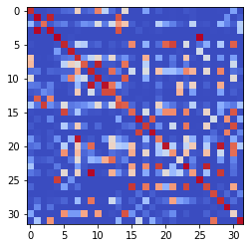

epoch 641 == measurement_heuristic: 0.48+-0.01/0.44+-0.01 --

epoch 642 == measurement_heuristic: 0.50+-0.01/0.43+-0.01 --

epoch 643 == measurement_heuristic: 0.47+-0.01/0.44+-0.01 --

epoch 644 == measurement_heuristic: 0.49+-0.01/0.43+-0.01 --

epoch 645 == measurement_heuristic: 0.46+-0.01/0.44+-0.01 --

epoch 646 == measurement_heuristic: 0.47+-0.01/0.44+-0.01 --

epoch 647 == measurement_heuristic: 0.47+-0.01/0.44+-0.01 --

epoch 648 == measurement_heuristic: 0.48+-0.01/0.43+-0.01 --

epoch 649 == measurement_heuristic: 0.47+-0.01/0.48+-0.01 --

epoch 650 == measurement_heuristic: 0.49+-0.01/0.44+-0.01 --

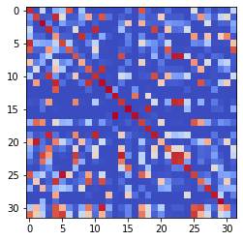

epoch 651 == measurement_heuristic: 0.46+-0.01/0.43+-0.01 --

epoch 652 == measurement_heuristic: 0.49+-0.01/0.43+-0.01 --

epoch 653 == measurement_heuristic: 0.46+-0.01/0.44+-0.01 --

epoch 654 == measurement_heuristic: 0.47+-0.01/0.43+-0.01 --

epoch 655 == measurement_heuristic: 0.48+-0.01/0.45+-0.01 --

epoch 656 == measurement_heuristic: 0.46+-0.01/0.43+-0.01 --

epoch 657 == measurement_heuristic: 0.48+-0.01/0.42+-0.01 --

epoch 658 >> measurement_heuristic: 0.47+-0.01/0.42+-0.01 --

epoch 659 == measurement_heuristic: 0.47+-0.01/0.45+-0.01 --

epoch 660 == measurement_heuristic: 0.47+-0.01/0.43+-0.01 --

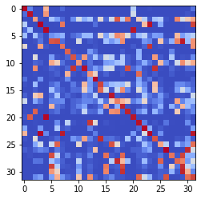

epoch 661 == measurement_heuristic: 0.47+-0.01/0.44+-0.01 --

epoch 662 == measurement_heuristic: 0.48+-0.01/0.42+-0.01 --

epoch 663 == measurement_heuristic: 0.46+-0.01/0.42+-0.01 --

epoch 664 == measurement_heuristic: 0.48+-0.01/0.42+-0.01 --

epoch 665 == measurement_heuristic: 0.47+-0.01/0.43+-0.01 --

epoch 666 == measurement_heuristic: 0.46+-0.01/0.43+-0.01 --

epoch 667 == measurement_heuristic: 0.46+-0.01/0.44+-0.01 --

epoch 668 == measurement_heuristic: 0.46+-0.01/0.43+-0.01 --

epoch 669 == measurement_heuristic: 0.49+-0.01/0.44+-0.01 --

epoch 670 == measurement_heuristic: 0.48+-0.01/0.43+-0.01 --

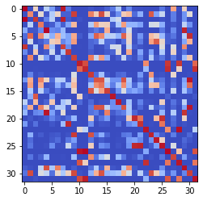

epoch 671 == measurement_heuristic: 0.45+-0.01/0.43+-0.01 --

epoch 672 == measurement_heuristic: 0.46+-0.01/0.43+-0.01 --

epoch 673 == measurement_heuristic: 0.48+-0.01/0.44+-0.01 --

epoch 674 == measurement_heuristic: 0.47+-0.01/0.42+-0.01 --

epoch 675 == measurement_heuristic: 0.45+-0.01/0.43+-0.01 --

epoch 676 == measurement_heuristic: 0.48+-0.01/0.43+-0.01 --

epoch 677 == measurement_heuristic: 0.47+-0.01/0.43+-0.01 --

epoch 678 == measurement_heuristic: 0.47+-0.01/0.42+-0.01 --

epoch 679 == measurement_heuristic: 0.47+-0.01/0.45+-0.01 --

epoch 680 == measurement_heuristic: 0.46+-0.01/0.44+-0.01 --

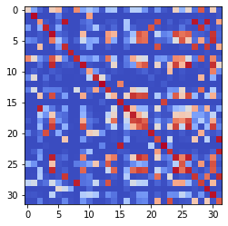

epoch 681 == measurement_heuristic: 0.47+-0.01/0.42+-0.01 --

epoch 682 == measurement_heuristic: 0.48+-0.01/0.42+-0.01 --

epoch 683 == measurement_heuristic: 0.47+-0.01/0.43+-0.01 --

epoch 684 == measurement_heuristic: 0.46+-0.01/0.42+-0.01 --

epoch 685 == measurement_heuristic: 0.47+-0.01/0.43+-0.01 --

epoch 686 == measurement_heuristic: 0.47+-0.01/0.43+-0.01 --

epoch 687 == measurement_heuristic: 0.46+-0.01/0.42+-0.01 --

epoch 688 == measurement_heuristic: 0.48+-0.01/0.42+-0.01 --

epoch 689 == measurement_heuristic: 0.47+-0.01/0.43+-0.01 --

epoch 690 == measurement_heuristic: 0.47+-0.01/0.42+-0.01 --

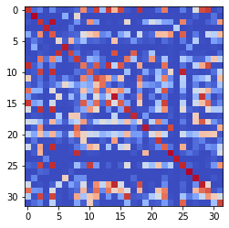

epoch 691 == measurement_heuristic: 0.47+-0.01/0.42+-0.01 --

epoch 692 == measurement_heuristic: 0.46+-0.01/0.43+-0.01 --

epoch 693 == measurement_heuristic: 0.46+-0.01/0.42+-0.01 --

epoch 694 == measurement_heuristic: 0.46+-0.01/0.44+-0.01 --

epoch 695 == measurement_heuristic: 0.45+-0.01/0.42+-0.01 --

epoch 696 == measurement_heuristic: 0.45+-0.01/0.42+-0.01 --

epoch 697 == measurement_heuristic: 0.45+-0.01/0.42+-0.01 --

epoch 698 == measurement_heuristic: 0.46+-0.01/0.42+-0.01 --

epoch 699 == measurement_heuristic: 0.47+-0.01/0.43+-0.01 --

epoch 700 == measurement_heuristic: 0.46+-0.01/0.42+-0.01 --

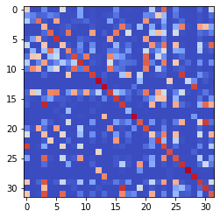

epoch 701 >> measurement_heuristic: 0.47+-0.01/0.41+-0.01 --

epoch 702 == measurement_heuristic: 0.47+-0.01/0.42+-0.01 --

epoch 703 == measurement_heuristic: 0.47+-0.01/0.42+-0.01 --

epoch 704 == measurement_heuristic: 0.47+-0.01/0.43+-0.01 --

epoch 705 >> measurement_heuristic: 0.45+-0.01/0.41+-0.01 --

epoch 706 == measurement_heuristic: 0.46+-0.01/0.42+-0.01 --

epoch 707 == measurement_heuristic: 0.44+-0.01/0.43+-0.01 --

epoch 708 == measurement_heuristic: 0.47+-0.01/0.44+-0.01 --

epoch 709 == measurement_heuristic: 0.45+-0.01/0.41+-0.01 --

epoch 710 == measurement_heuristic: 0.45+-0.01/0.42+-0.01 --

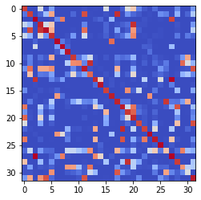

epoch 711 >> measurement_heuristic: 0.47+-0.01/0.41+-0.01 --

epoch 712 == measurement_heuristic: 0.44+-0.01/0.41+-0.01 --

epoch 713 == measurement_heuristic: 0.45+-0.01/0.42+-0.01 --

epoch 714 == measurement_heuristic: 0.44+-0.01/0.41+-0.01 --

epoch 715 == measurement_heuristic: 0.50+-0.01/0.41+-0.01 --

epoch 716 == measurement_heuristic: 0.46+-0.01/0.44+-0.01 --

epoch 717 == measurement_heuristic: 0.46+-0.01/0.45+-0.01 --

epoch 718 == measurement_heuristic: 0.43+-0.01/0.41+-0.01 --

epoch 719 >> measurement_heuristic: 0.46+-0.01/0.40+-0.01 --

epoch 720 == measurement_heuristic: 0.47+-0.01/0.41+-0.01 --

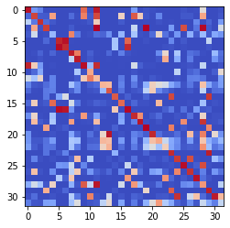

epoch 721 >> measurement_heuristic: 0.45+-0.01/0.40+-0.01 --

epoch 722 == measurement_heuristic: 0.46+-0.01/0.42+-0.01 --

epoch 723 == measurement_heuristic: 0.46+-0.01/0.46+-0.01 --

epoch 724 == measurement_heuristic: 0.46+-0.01/0.42+-0.01 --

epoch 725 == measurement_heuristic: 0.46+-0.01/0.41+-0.01 --

epoch 726 == measurement_heuristic: 0.45+-0.01/0.41+-0.01 --

epoch 727 == measurement_heuristic: 0.45+-0.01/0.40+-0.01 --

epoch 728 == measurement_heuristic: 0.43+-0.01/0.41+-0.01 --

epoch 729 == measurement_heuristic: 0.45+-0.01/0.42+-0.01 --

epoch 730 == measurement_heuristic: 0.46+-0.01/0.42+-0.01 --

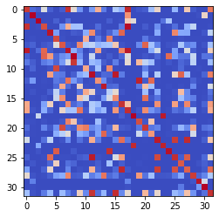

epoch 731 == measurement_heuristic: 0.45+-0.01/0.41+-0.01 --

epoch 732 >> measurement_heuristic: 0.45+-0.01/0.40+-0.01 --

epoch 733 == measurement_heuristic: 0.44+-0.01/0.42+-0.01 --

epoch 734 == measurement_heuristic: 0.45+-0.01/0.42+-0.01 --

epoch 735 == measurement_heuristic: 0.44+-0.01/0.40+-0.01 --

epoch 736 == measurement_heuristic: 0.45+-0.01/0.40+-0.01 --

epoch 737 == measurement_heuristic: 0.43+-0.01/0.41+-0.01 --

epoch 738 == measurement_heuristic: 0.46+-0.01/0.41+-0.01 --

epoch 739 == measurement_heuristic: 0.45+-0.01/0.42+-0.01 --

epoch 740 == measurement_heuristic: 0.45+-0.01/0.42+-0.01 --

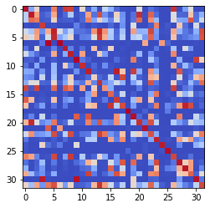

epoch 741 == measurement_heuristic: 0.44+-0.01/0.43+-0.01 --

epoch 742 == measurement_heuristic: 0.44+-0.01/0.41+-0.01 --

epoch 743 == measurement_heuristic: 0.47+-0.01/0.41+-0.01 --

epoch 744 == measurement_heuristic: 0.45+-0.01/0.42+-0.01 --

epoch 745 == measurement_heuristic: 0.46+-0.01/0.42+-0.01 --

epoch 746 == measurement_heuristic: 0.45+-0.01/0.41+-0.01 --

epoch 747 == measurement_heuristic: 0.44+-0.01/0.41+-0.01 --

epoch 748 == measurement_heuristic: 0.45+-0.01/0.41+-0.01 --

epoch 749 == measurement_heuristic: 0.46+-0.01/0.42+-0.01 --

epoch 750 == measurement_heuristic: 0.48+-0.01/0.41+-0.01 --

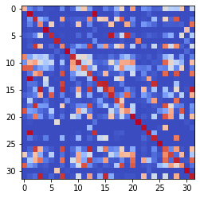

epoch 751 == measurement_heuristic: 0.46+-0.01/0.41+-0.01 --

epoch 752 == measurement_heuristic: 0.46+-0.01/0.42+-0.01 --

epoch 753 == measurement_heuristic: 0.46+-0.01/0.42+-0.01 --

epoch 754 == measurement_heuristic: 0.45+-0.01/0.41+-0.01 --

epoch 755 == measurement_heuristic: 0.46+-0.01/0.41+-0.01 --

epoch 756 == measurement_heuristic: 0.46+-0.01/0.40+-0.01 --

epoch 757 == measurement_heuristic: 0.45+-0.01/0.42+-0.01 --

epoch 758 == measurement_heuristic: 0.46+-0.01/0.41+-0.01 --

epoch 759 == measurement_heuristic: 0.45+-0.01/0.41+-0.01 --

epoch 760 == measurement_heuristic: 0.44+-0.01/0.42+-0.01 --

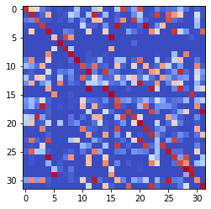

epoch 761 == measurement_heuristic: 0.45+-0.01/0.41+-0.01 --

epoch 762 == measurement_heuristic: 0.44+-0.01/0.42+-0.01 --

epoch 763 == measurement_heuristic: 0.43+-0.01/0.41+-0.01 --

epoch 764 == measurement_heuristic: 0.44+-0.01/0.41+-0.01 --

epoch 765 == measurement_heuristic: 0.46+-0.01/0.40+-0.01 --

epoch 766 == measurement_heuristic: 0.44+-0.01/0.40+-0.01 --

epoch 767 == measurement_heuristic: 0.46+-0.01/0.41+-0.01 --

epoch 768 == measurement_heuristic: 0.46+-0.01/0.43+-0.01 --

epoch 769 == measurement_heuristic: 0.45+-0.01/0.40+-0.01 --

epoch 770 >> measurement_heuristic: 0.45+-0.01/0.40+-0.01 --

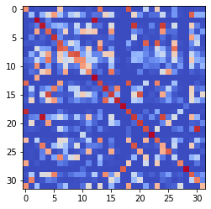

epoch 771 == measurement_heuristic: 0.43+-0.01/0.40+-0.01 --

epoch 772 == measurement_heuristic: 0.43+-0.01/0.40+-0.01 --

epoch 773 == measurement_heuristic: 0.47+-0.01/0.44+-0.01 --

epoch 774 == measurement_heuristic: 0.44+-0.01/0.40+-0.01 --

epoch 775 == measurement_heuristic: 0.45+-0.01/0.41+-0.01 --

epoch 776 == measurement_heuristic: 0.44+-0.01/0.41+-0.01 --

epoch 777 == measurement_heuristic: 0.44+-0.01/0.41+-0.01 --

epoch 778 == measurement_heuristic: 0.48+-0.01/0.41+-0.01 --

epoch 779 == measurement_heuristic: 0.45+-0.01/0.40+-0.01 --

epoch 780 == measurement_heuristic: 0.44+-0.01/0.42+-0.01 --

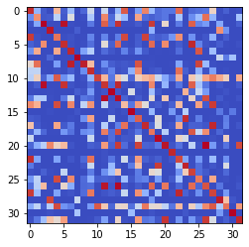

epoch 781 == measurement_heuristic: 0.47+-0.01/0.41+-0.01 --

epoch 782 == measurement_heuristic: 0.45+-0.01/0.41+-0.01 --

epoch 783 == measurement_heuristic: 0.45+-0.01/0.42+-0.01 --

epoch 784 == measurement_heuristic: 0.44+-0.01/0.40+-0.01 --

epoch 785 == measurement_heuristic: 0.46+-0.01/0.42+-0.01 --

epoch 786 == measurement_heuristic: 0.45+-0.01/0.40+-0.01 --

epoch 787 == measurement_heuristic: 0.46+-0.01/0.40+-0.01 --

epoch 788 == measurement_heuristic: 0.46+-0.01/0.42+-0.01 --

epoch 789 == measurement_heuristic: 0.44+-0.01/0.43+-0.01 --

epoch 790 == measurement_heuristic: 0.47+-0.01/0.43+-0.01 --

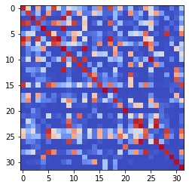

epoch 791 == measurement_heuristic: 0.45+-0.01/0.41+-0.01 --

epoch 792 == measurement_heuristic: 0.45+-0.01/0.41+-0.01 --

epoch 793 == measurement_heuristic: 0.44+-0.01/0.40+-0.01 --

epoch 794 == measurement_heuristic: 0.47+-0.01/0.41+-0.01 --

epoch 795 == measurement_heuristic: 0.45+-0.01/0.41+-0.01 --

epoch 796 == measurement_heuristic: 0.46+-0.01/0.40+-0.01 --

epoch 797 == measurement_heuristic: 0.44+-0.01/0.40+-0.01 --

epoch 798 == measurement_heuristic: 0.44+-0.01/0.41+-0.01 --

epoch 799 == measurement_heuristic: 0.44+-0.01/0.42+-0.01 --

epoch 800 == measurement_heuristic: 0.46+-0.01/0.40+-0.01 --

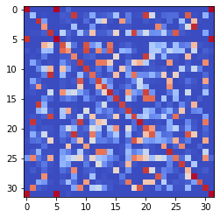

epoch 801 == measurement_heuristic: 0.44+-0.01/0.40+-0.01 --

epoch 802 == measurement_heuristic: 0.44+-0.01/0.40+-0.01 --

epoch 803 == measurement_heuristic: 0.47+-0.01/0.41+-0.01 --

epoch 804 == measurement_heuristic: 0.43+-0.01/0.41+-0.01 --

epoch 805 == measurement_heuristic: 0.45+-0.01/0.42+-0.01 --

epoch 806 == measurement_heuristic: 0.45+-0.01/0.40+-0.01 --

epoch 807 == measurement_heuristic: 0.43+-0.01/0.41+-0.01 --

epoch 808 == measurement_heuristic: 0.44+-0.01/0.40+-0.01 --

epoch 809 == measurement_heuristic: 0.44+-0.01/0.41+-0.01 --

epoch 810 == measurement_heuristic: 0.45+-0.01/0.40+-0.01 --

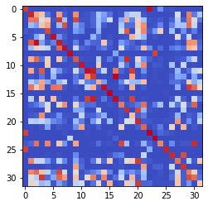

epoch 811 == measurement_heuristic: 0.44+-0.01/0.41+-0.01 --

epoch 812 == measurement_heuristic: 0.44+-0.01/0.41+-0.01 --

epoch 813 == measurement_heuristic: 0.44+-0.01/0.42+-0.01 --

epoch 814 == measurement_heuristic: 0.45+-0.01/0.40+-0.01 --

epoch 815 >> measurement_heuristic: 0.46+-0.01/0.39+-0.01 --

epoch 816 >> measurement_heuristic: 0.45+-0.01/0.39+-0.01 --

epoch 817 == measurement_heuristic: 0.44+-0.01/0.40+-0.01 --

epoch 818 >> measurement_heuristic: 0.43+-0.01/0.39+-0.01 --

epoch 819 >> measurement_heuristic: 0.45+-0.01/0.39+-0.01 --

epoch 820 == measurement_heuristic: 0.44+-0.01/0.41+-0.01 --

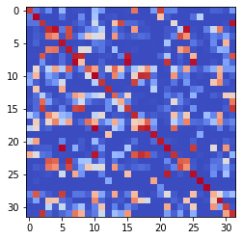

epoch 821 >> measurement_heuristic: 0.42+-0.01/0.38+-0.01 --

epoch 822 == measurement_heuristic: 0.45+-0.01/0.43+-0.01 --

epoch 823 == measurement_heuristic: 0.44+-0.01/0.39+-0.01 --

epoch 824 == measurement_heuristic: 0.44+-0.01/0.39+-0.01 --

epoch 825 == measurement_heuristic: 0.44+-0.01/0.42+-0.01 --

epoch 826 == measurement_heuristic: 0.44+-0.01/0.39+-0.01 --

epoch 827 == measurement_heuristic: 0.44+-0.01/0.39+-0.01 --

epoch 828 == measurement_heuristic: 0.45+-0.01/0.42+-0.01 --

epoch 829 == measurement_heuristic: 0.42+-0.01/0.39+-0.01 --

epoch 830 == measurement_heuristic: 0.42+-0.01/0.39+-0.01 --

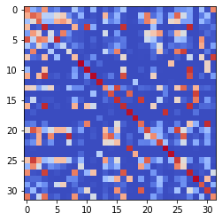

epoch 831 == measurement_heuristic: 0.44+-0.01/0.41+-0.01 --

epoch 832 == measurement_heuristic: 0.43+-0.01/0.40+-0.01 --

epoch 833 == measurement_heuristic: 0.45+-0.01/0.39+-0.01 --

epoch 834 == measurement_heuristic: 0.42+-0.01/0.39+-0.01 --

epoch 835 == measurement_heuristic: 0.44+-0.01/0.40+-0.01 --

epoch 836 == measurement_heuristic: 0.45+-0.01/0.41+-0.01 --

epoch 837 == measurement_heuristic: 0.44+-0.01/0.39+-0.01 --

epoch 838 == measurement_heuristic: 0.45+-0.01/0.39+-0.01 --

epoch 839 == measurement_heuristic: 0.44+-0.01/0.39+-0.01 --

epoch 840 == measurement_heuristic: 0.42+-0.01/0.42+-0.01 --

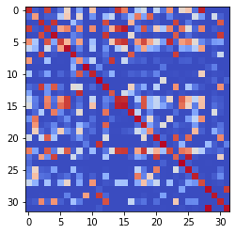

epoch 841 == measurement_heuristic: 0.44+-0.01/0.45+-0.01 --

epoch 842 == measurement_heuristic: 0.44+-0.01/0.39+-0.01 --

epoch 843 == measurement_heuristic: 0.43+-0.01/0.40+-0.01 --

epoch 844 == measurement_heuristic: 0.45+-0.01/0.39+-0.01 --

epoch 845 == measurement_heuristic: 0.44+-0.01/0.40+-0.01 --

epoch 846 == measurement_heuristic: 0.43+-0.01/0.39+-0.01 --

epoch 847 == measurement_heuristic: 0.43+-0.01/0.40+-0.01 --

epoch 848 == measurement_heuristic: 0.45+-0.01/0.40+-0.01 --

epoch 849 == measurement_heuristic: 0.43+-0.01/0.39+-0.01 --

epoch 850 == measurement_heuristic: 0.44+-0.01/0.43+-0.01 --

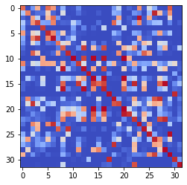

epoch 851 == measurement_heuristic: 0.45+-0.01/0.41+-0.01 --

epoch 852 == measurement_heuristic: 0.43+-0.01/0.39+-0.01 --

epoch 853 >> measurement_heuristic: 0.44+-0.01/0.38+-0.01 --

epoch 854 == measurement_heuristic: 0.43+-0.01/0.41+-0.01 --

epoch 855 == measurement_heuristic: 0.44+-0.01/0.39+-0.01 --

epoch 856 >> measurement_heuristic: 0.43+-0.01/0.38+-0.01 --

epoch 857 == measurement_heuristic: 0.45+-0.01/0.43+-0.01 --

epoch 858 == measurement_heuristic: 0.45+-0.01/0.42+-0.01 --

epoch 859 == measurement_heuristic: 0.44+-0.01/0.39+-0.01 --

epoch 860 == measurement_heuristic: 0.45+-0.01/0.39+-0.01 --

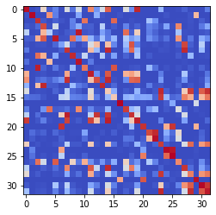

epoch 861 == measurement_heuristic: 0.44+-0.01/0.41+-0.01 --

epoch 862 == measurement_heuristic: 0.44+-0.01/0.40+-0.01 --

epoch 863 == measurement_heuristic: 0.42+-0.01/0.38+-0.01 --

epoch 864 == measurement_heuristic: 0.44+-0.01/0.40+-0.01 --

epoch 865 == measurement_heuristic: 0.45+-0.01/0.39+-0.01 --

epoch 866 == measurement_heuristic: 0.42+-0.01/0.40+-0.01 --

epoch 867 == measurement_heuristic: 0.44+-0.01/0.40+-0.01 --

epoch 868 == measurement_heuristic: 0.42+-0.01/0.39+-0.01 --

epoch 869 == measurement_heuristic: 0.41+-0.01/0.39+-0.01 --

epoch 870 >> measurement_heuristic: 0.43+-0.01/0.38+-0.01 --

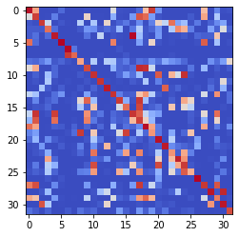

epoch 871 == measurement_heuristic: 0.43+-0.01/0.41+-0.01 --

epoch 872 == measurement_heuristic: 0.43+-0.01/0.44+-0.01 --

epoch 873 == measurement_heuristic: 0.44+-0.01/0.41+-0.01 --

epoch 874 == measurement_heuristic: 0.45+-0.01/0.39+-0.01 --

epoch 875 == measurement_heuristic: 0.44+-0.01/0.38+-0.01 --

epoch 876 == measurement_heuristic: 0.42+-0.01/0.40+-0.01 --

epoch 877 == measurement_heuristic: 0.44+-0.01/0.38+-0.01 --

epoch 878 == measurement_heuristic: 0.44+-0.01/0.44+-0.01 --

epoch 879 == measurement_heuristic: 0.43+-0.01/0.39+-0.01 --

epoch 880 == measurement_heuristic: 0.42+-0.01/0.41+-0.01 --

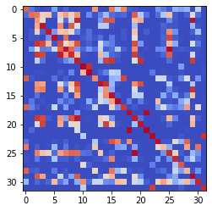

epoch 881 == measurement_heuristic: 0.45+-0.01/0.38+-0.01 --

epoch 882 == measurement_heuristic: 0.43+-0.01/0.38+-0.01 --

epoch 883 == measurement_heuristic: 0.42+-0.01/0.38+-0.01 --

epoch 884 == measurement_heuristic: 0.44+-0.01/0.39+-0.01 --

epoch 885 == measurement_heuristic: 0.43+-0.01/0.40+-0.01 --

epoch 886 == measurement_heuristic: 0.42+-0.01/0.40+-0.01 --

epoch 887 == measurement_heuristic: 0.42+-0.01/0.40+-0.01 --

epoch 888 == measurement_heuristic: 0.43+-0.01/0.40+-0.01 --

epoch 889 == measurement_heuristic: 0.41+-0.01/0.38+-0.01 --

epoch 890 == measurement_heuristic: 0.43+-0.01/0.41+-0.01 --

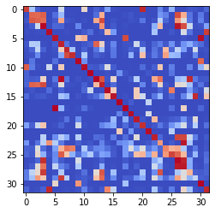

epoch 891 == measurement_heuristic: 0.43+-0.01/0.39+-0.01 --

epoch 892 == measurement_heuristic: 0.42+-0.01/0.39+-0.01 --

epoch 893 == measurement_heuristic: 0.42+-0.01/0.39+-0.01 --

epoch 894 == measurement_heuristic: 0.43+-0.01/0.38+-0.01 --

epoch 895 == measurement_heuristic: 0.42+-0.01/0.39+-0.01 --

epoch 896 >> measurement_heuristic: 0.42+-0.01/0.37+-0.01 --

epoch 897 == measurement_heuristic: 0.44+-0.01/0.38+-0.01 --

epoch 898 == measurement_heuristic: 0.43+-0.01/0.40+-0.01 --

epoch 899 == measurement_heuristic: 0.44+-0.01/0.38+-0.01 --

epoch 900 == measurement_heuristic: 0.43+-0.01/0.41+-0.01 --

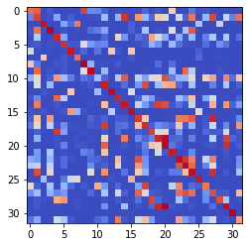

epoch 901 == measurement_heuristic: 0.41+-0.01/0.38+-0.01 --

epoch 902 == measurement_heuristic: 0.44+-0.01/0.38+-0.01 --

epoch 903 == measurement_heuristic: 0.43+-0.01/0.39+-0.01 --

epoch 904 == measurement_heuristic: 0.42+-0.01/0.42+-0.01 --

epoch 905 == measurement_heuristic: 0.43+-0.01/0.38+-0.01 --

epoch 906 == measurement_heuristic: 0.41+-0.01/0.39+-0.01 --

epoch 907 == measurement_heuristic: 0.44+-0.01/0.38+-0.01 --

epoch 908 == measurement_heuristic: 0.42+-0.01/0.40+-0.01 --

epoch 909 == measurement_heuristic: 0.44+-0.01/0.39+-0.01 --

epoch 910 == measurement_heuristic: 0.43+-0.01/0.38+-0.01 --

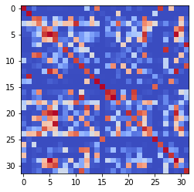

epoch 911 >> measurement_heuristic: 0.44+-0.01/0.37+-0.01 --

epoch 912 >> measurement_heuristic: 0.41+-0.01/0.37+-0.01 --

epoch 913 == measurement_heuristic: 0.43+-0.01/0.37+-0.01 --

epoch 914 == measurement_heuristic: 0.41+-0.01/0.39+-0.01 --

epoch 915 == measurement_heuristic: 0.42+-0.01/0.39+-0.01 --

epoch 916 == measurement_heuristic: 0.43+-0.01/0.40+-0.01 --

epoch 917 == measurement_heuristic: 0.42+-0.01/0.38+-0.01 --

epoch 918 == measurement_heuristic: 0.42+-0.01/0.41+-0.01 --

epoch 919 == measurement_heuristic: 0.45+-0.01/0.37+-0.01 --

epoch 920 == measurement_heuristic: 0.45+-0.01/0.41+-0.01 --

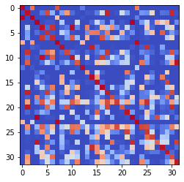

epoch 921 == measurement_heuristic: 0.42+-0.01/0.39+-0.01 --

epoch 922 == measurement_heuristic: 0.41+-0.01/0.38+-0.01 --

epoch 923 == measurement_heuristic: 0.45+-0.01/0.38+-0.01 --

epoch 924 == measurement_heuristic: 0.41+-0.01/0.41+-0.01 --

epoch 925 == measurement_heuristic: 0.41+-0.01/0.38+-0.01 --

epoch 926 == measurement_heuristic: 0.40+-0.01/0.37+-0.01 --

epoch 927 == measurement_heuristic: 0.44+-0.01/0.39+-0.01 --

epoch 928 == measurement_heuristic: 0.42+-0.01/0.39+-0.01 --

epoch 929 == measurement_heuristic: 0.43+-0.01/0.38+-0.01 --

epoch 930 == measurement_heuristic: 0.40+-0.01/0.39+-0.01 --

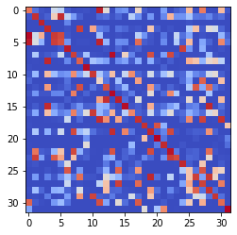

epoch 931 == measurement_heuristic: 0.42+-0.01/0.39+-0.01 --

epoch 932 == measurement_heuristic: 0.41+-0.01/0.38+-0.01 --

epoch 933 == measurement_heuristic: 0.43+-0.01/0.38+-0.01 --

epoch 934 == measurement_heuristic: 0.43+-0.01/0.39+-0.01 --

epoch 935 == measurement_heuristic: 0.42+-0.01/0.39+-0.01 --

epoch 936 == measurement_heuristic: 0.43+-0.01/0.38+-0.01 --

epoch 937 == measurement_heuristic: 0.42+-0.01/0.40+-0.01 --

epoch 938 == measurement_heuristic: 0.42+-0.01/0.38+-0.01 --

epoch 939 == measurement_heuristic: 0.42+-0.01/0.38+-0.01 --

epoch 940 == measurement_heuristic: 0.43+-0.01/0.38+-0.01 --

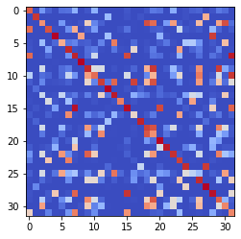

epoch 941 == measurement_heuristic: 0.40+-0.01/0.38+-0.01 --

epoch 942 == measurement_heuristic: 0.44+-0.01/0.41+-0.01 --

epoch 943 == measurement_heuristic: 0.42+-0.01/0.37+-0.01 --

epoch 944 == measurement_heuristic: 0.43+-0.01/0.39+-0.01 --

epoch 945 == measurement_heuristic: 0.42+-0.01/0.39+-0.01 --

epoch 946 == measurement_heuristic: 0.41+-0.01/0.39+-0.01 --

epoch 947 >> measurement_heuristic: 0.41+-0.01/0.37+-0.01 --

epoch 948 == measurement_heuristic: 0.41+-0.01/0.41+-0.01 --

epoch 949 == measurement_heuristic: 0.43+-0.01/0.37+-0.01 --

epoch 950 == measurement_heuristic: 0.41+-0.01/0.37+-0.01 --

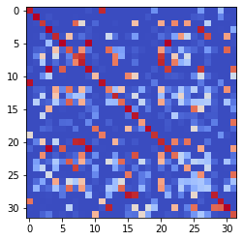

epoch 951 == measurement_heuristic: 0.42+-0.01/0.38+-0.01 --

epoch 952 == measurement_heuristic: 0.42+-0.01/0.39+-0.01 --

epoch 953 == measurement_heuristic: 0.42+-0.01/0.37+-0.01 --

epoch 954 == measurement_heuristic: 0.44+-0.01/0.41+-0.01 --

epoch 955 == measurement_heuristic: 0.42+-0.01/0.39+-0.01 --

epoch 956 == measurement_heuristic: 0.42+-0.01/0.38+-0.01 --

epoch 957 == measurement_heuristic: 0.42+-0.01/0.40+-0.01 --

epoch 958 == measurement_heuristic: 0.41+-0.01/0.37+-0.01 --

epoch 959 == measurement_heuristic: 0.43+-0.01/0.37+-0.01 --

epoch 960 == measurement_heuristic: 0.44+-0.01/0.40+-0.01 --

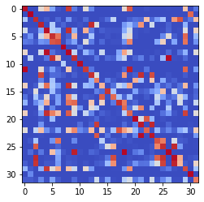

epoch 961 == measurement_heuristic: 0.41+-0.01/0.38+-0.01 --

epoch 962 == measurement_heuristic: 0.42+-0.01/0.39+-0.01 --

epoch 963 == measurement_heuristic: 0.42+-0.01/0.37+-0.01 --

epoch 964 == measurement_heuristic: 0.43+-0.01/0.38+-0.01 --

epoch 965 == measurement_heuristic: 0.42+-0.01/0.37+-0.01 --

epoch 966 == measurement_heuristic: 0.42+-0.01/0.39+-0.01 --

epoch 967 == measurement_heuristic: 0.42+-0.01/0.38+-0.01 --

epoch 968 == measurement_heuristic: 0.41+-0.01/0.39+-0.01 --

epoch 969 == measurement_heuristic: 0.42+-0.01/0.38+-0.01 --

epoch 970 == measurement_heuristic: 0.42+-0.01/0.40+-0.01 --

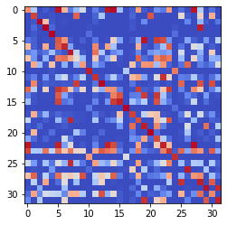

epoch 971 == measurement_heuristic: 0.45+-0.01/0.39+-0.01 --

epoch 972 == measurement_heuristic: 0.42+-0.01/0.38+-0.01 --

epoch 973 == measurement_heuristic: 0.42+-0.01/0.39+-0.01 --

epoch 974 == measurement_heuristic: 0.41+-0.01/0.38+-0.01 --

epoch 975 == measurement_heuristic: 0.40+-0.01/0.37+-0.01 --

epoch 976 == measurement_heuristic: 0.42+-0.01/0.37+-0.01 --

epoch 977 == measurement_heuristic: 0.41+-0.01/0.39+-0.01 --

epoch 978 == measurement_heuristic: 0.42+-0.01/0.38+-0.01 --

epoch 979 == measurement_heuristic: 0.42+-0.01/0.38+-0.01 --

epoch 980 == measurement_heuristic: 0.41+-0.01/0.37+-0.01 --

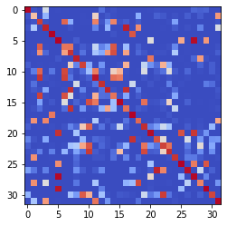

epoch 981 == measurement_heuristic: 0.42+-0.01/0.38+-0.01 --

epoch 982 == measurement_heuristic: 0.43+-0.01/0.38+-0.01 --

epoch 983 >> measurement_heuristic: 0.42+-0.01/0.37+-0.01 --

epoch 984 == measurement_heuristic: 0.43+-0.01/0.38+-0.01 --

epoch 985 == measurement_heuristic: 0.41+-0.01/0.37+-0.01 --

epoch 986 == measurement_heuristic: 0.41+-0.01/0.38+-0.01 --

epoch 987 == measurement_heuristic: 0.42+-0.01/0.40+-0.01 --

epoch 988 == measurement_heuristic: 0.40+-0.01/0.37+-0.01 --

epoch 989 == measurement_heuristic: 0.42+-0.01/0.37+-0.01 --

epoch 990 == measurement_heuristic: 0.42+-0.01/0.37+-0.01 --

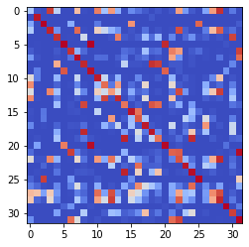

epoch 991 == measurement_heuristic: 0.40+-0.01/0.38+-0.01 --

epoch 992 == measurement_heuristic: 0.40+-0.01/0.37+-0.01 --

epoch 993 == measurement_heuristic: 0.42+-0.01/0.39+-0.01 --

epoch 994 >> measurement_heuristic: 0.41+-0.01/0.36+-0.01 --

epoch 995 >> measurement_heuristic: 0.40+-0.01/0.36+-0.01 --

epoch 996 == measurement_heuristic: 0.39+-0.01/0.39+-0.01 --

epoch 997 == measurement_heuristic: 0.41+-0.01/0.40+-0.01 --

epoch 998 == measurement_heuristic: 0.41+-0.01/0.37+-0.01 --

epoch 999 == measurement_heuristic: 0.42+-0.01/0.37+-0.01 --

epoch 1000 == measurement_heuristic: 0.43+-0.01/0.38+-0.01 --

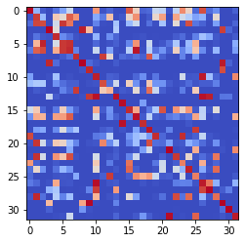

epoch 1001 == measurement_heuristic: 0.42+-0.01/0.38+-0.01 --

epoch 1002 == measurement_heuristic: 0.42+-0.01/0.37+-0.01 --

epoch 1003 == measurement_heuristic: 0.41+-0.01/0.39+-0.01 --

epoch 1004 == measurement_heuristic: 0.41+-0.01/0.37+-0.01 --

epoch 1005 == measurement_heuristic: 0.43+-0.01/0.39+-0.01 --

epoch 1006 == measurement_heuristic: 0.43+-0.01/0.37+-0.01 --

epoch 1007 == measurement_heuristic: 0.40+-0.01/0.37+-0.01 --

epoch 1008 == measurement_heuristic: 0.40+-0.01/0.38+-0.01 --

epoch 1009 == measurement_heuristic: 0.42+-0.01/0.38+-0.01 --

epoch 1010 == measurement_heuristic: 0.41+-0.01/0.37+-0.01 --

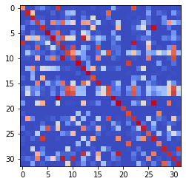

epoch 1011 == measurement_heuristic: 0.42+-0.01/0.36+-0.01 --

epoch 1012 == measurement_heuristic: 0.40+-0.01/0.39+-0.01 --

epoch 1013 == measurement_heuristic: 0.42+-0.01/0.38+-0.01 --

epoch 1014 >> measurement_heuristic: 0.41+-0.01/0.36+-0.01 --

epoch 1015 == measurement_heuristic: 0.40+-0.01/0.36+-0.01 --

epoch 1016 == measurement_heuristic: 0.42+-0.01/0.36+-0.01 --

epoch 1017 == measurement_heuristic: 0.39+-0.01/0.37+-0.01 --

epoch 1018 == measurement_heuristic: 0.41+-0.01/0.37+-0.01 --

epoch 1019 == measurement_heuristic: 0.41+-0.01/0.37+-0.01 --

epoch 1020 == measurement_heuristic: 0.41+-0.01/0.37+-0.01 --

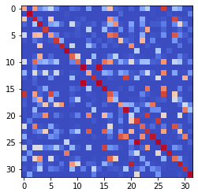

epoch 1021 == measurement_heuristic: 0.41+-0.01/0.38+-0.01 --

epoch 1022 == measurement_heuristic: 0.38+-0.01/0.37+-0.01 --

epoch 1023 == measurement_heuristic: 0.42+-0.01/0.36+-0.01 --

epoch 1024 >> measurement_heuristic: 0.44+-0.01/0.36+-0.01 --

epoch 1025 == measurement_heuristic: 0.39+-0.01/0.38+-0.01 --

epoch 1026 == measurement_heuristic: 0.42+-0.01/0.41+-0.01 --

epoch 1027 == measurement_heuristic: 0.39+-0.01/0.36+-0.01 --

epoch 1028 == measurement_heuristic: 0.42+-0.01/0.36+-0.01 --

epoch 1029 == measurement_heuristic: 0.42+-0.01/0.36+-0.01 --

epoch 1030 == measurement_heuristic: 0.41+-0.01/0.37+-0.01 --

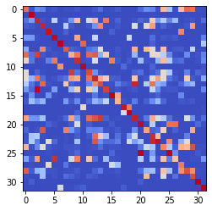

epoch 1031 == measurement_heuristic: 0.43+-0.01/0.38+-0.01 --

epoch 1032 == measurement_heuristic: 0.41+-0.01/0.37+-0.01 --

epoch 1033 == measurement_heuristic: 0.43+-0.01/0.36+-0.01 --

epoch 1034 == measurement_heuristic: 0.43+-0.01/0.37+-0.01 --

epoch 1035 == measurement_heuristic: 0.39+-0.01/0.37+-0.01 --

epoch 1036 == measurement_heuristic: 0.40+-0.01/0.37+-0.01 --

epoch 1037 == measurement_heuristic: 0.40+-0.01/0.38+-0.01 --

epoch 1038 == measurement_heuristic: 0.39+-0.01/0.37+-0.01 --

epoch 1039 == measurement_heuristic: 0.41+-0.01/0.37+-0.01 --

epoch 1040 == measurement_heuristic: 0.43+-0.01/0.38+-0.01 --

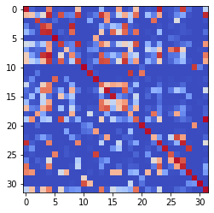

epoch 1041 == measurement_heuristic: 0.39+-0.01/0.36+-0.01 --

epoch 1042 == measurement_heuristic: 0.41+-0.01/0.38+-0.01 --

epoch 1043 == measurement_heuristic: 0.42+-0.01/0.37+-0.01 --

epoch 1044 == measurement_heuristic: 0.43+-0.01/0.40+-0.01 --

epoch 1045 == measurement_heuristic: 0.41+-0.01/0.37+-0.01 --

epoch 1046 == measurement_heuristic: 0.39+-0.01/0.37+-0.01 --

epoch 1047 == measurement_heuristic: 0.42+-0.01/0.38+-0.01 --

epoch 1048 == measurement_heuristic: 0.41+-0.01/0.39+-0.01 --

epoch 1049 == measurement_heuristic: 0.40+-0.01/0.39+-0.01 --

epoch 1050 == measurement_heuristic: 0.41+-0.01/0.36+-0.01 --

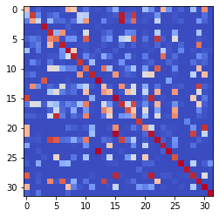

epoch 1051 == measurement_heuristic: 0.41+-0.01/0.37+-0.01 --

epoch 1052 == measurement_heuristic: 0.39+-0.01/0.36+-0.01 --

epoch 1053 == measurement_heuristic: 0.42+-0.01/0.37+-0.01 --

epoch 1054 == measurement_heuristic: 0.41+-0.01/0.36+-0.01 --

epoch 1055 == measurement_heuristic: 0.41+-0.01/0.37+-0.01 --

epoch 1056 == measurement_heuristic: 0.42+-0.01/0.36+-0.01 --

epoch 1057 == measurement_heuristic: 0.40+-0.01/0.38+-0.01 --

epoch 1058 >> measurement_heuristic: 0.41+-0.01/0.36+-0.01 --

epoch 1059 == measurement_heuristic: 0.41+-0.01/0.37+-0.01 --

epoch 1060 == measurement_heuristic: 0.42+-0.01/0.36+-0.01 --

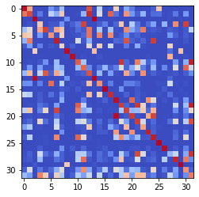

epoch 1061 == measurement_heuristic: 0.41+-0.01/0.37+-0.01 --

epoch 1062 == measurement_heuristic: 0.43+-0.02/0.38+-0.01 --

epoch 1063 == measurement_heuristic: 0.40+-0.01/0.39+-0.01 --

epoch 1064 == measurement_heuristic: 0.40+-0.01/0.38+-0.01 --

epoch 1065 == measurement_heuristic: 0.40+-0.01/0.38+-0.01 --

epoch 1066 == measurement_heuristic: 0.40+-0.01/0.38+-0.01 --

epoch 1067 == measurement_heuristic: 0.40+-0.01/0.36+-0.01 --

epoch 1068 == measurement_heuristic: 0.40+-0.01/0.37+-0.01 --

epoch 1069 == measurement_heuristic: 0.42+-0.01/0.37+-0.01 --

epoch 1070 == measurement_heuristic: 0.38+-0.01/0.39+-0.01 --

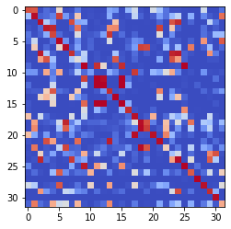

epoch 1071 == measurement_heuristic: 0.41+-0.01/0.37+-0.01 --

epoch 1072 >> measurement_heuristic: 0.39+-0.01/0.36+-0.01 --

epoch 1073 >> measurement_heuristic: 0.41+-0.01/0.35+-0.01 --

epoch 1074 == measurement_heuristic: 0.40+-0.01/0.38+-0.01 --

epoch 1075 == measurement_heuristic: 0.40+-0.01/0.36+-0.01 --

epoch 1076 == measurement_heuristic: 0.40+-0.01/0.36+-0.01 --

epoch 1077 == measurement_heuristic: 0.41+-0.01/0.39+-0.01 --

epoch 1078 == measurement_heuristic: 0.41+-0.01/0.36+-0.01 --

epoch 1079 == measurement_heuristic: 0.40+-0.01/0.37+-0.01 --

epoch 1080 == measurement_heuristic: 0.40+-0.01/0.36+-0.01 --

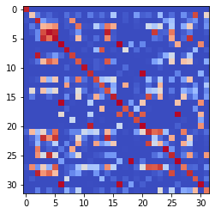

epoch 1081 == measurement_heuristic: 0.40+-0.01/0.36+-0.01 --

epoch 1082 == measurement_heuristic: 0.41+-0.01/0.36+-0.01 --

epoch 1083 == measurement_heuristic: 0.41+-0.01/0.35+-0.01 --

epoch 1084 == measurement_heuristic: 0.39+-0.01/0.37+-0.01 --

epoch 1085 == measurement_heuristic: 0.41+-0.01/0.38+-0.01 --

epoch 1086 == measurement_heuristic: 0.42+-0.01/0.36+-0.01 --

epoch 1087 == measurement_heuristic: 0.41+-0.01/0.36+-0.01 --

epoch 1088 == measurement_heuristic: 0.41+-0.01/0.36+-0.01 --

epoch 1089 == measurement_heuristic: 0.40+-0.01/0.36+-0.01 --

epoch 1090 == measurement_heuristic: 0.40+-0.01/0.38+-0.01 --

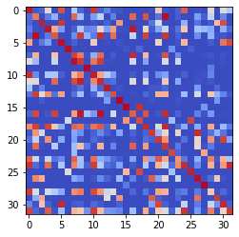

epoch 1091 == measurement_heuristic: 0.41+-0.01/0.37+-0.01 --

epoch 1092 == measurement_heuristic: 0.42+-0.01/0.36+-0.01 --

epoch 1093 == measurement_heuristic: 0.40+-0.01/0.36+-0.01 --

epoch 1094 == measurement_heuristic: 0.39+-0.01/0.36+-0.01 --

epoch 1095 == measurement_heuristic: 0.40+-0.01/0.38+-0.01 --

epoch 1096 == measurement_heuristic: 0.39+-0.01/0.36+-0.01 --

epoch 1097 >> measurement_heuristic: 0.41+-0.01/0.35+-0.01 --

epoch 1098 == measurement_heuristic: 0.40+-0.01/0.36+-0.01 --

epoch 1099 == measurement_heuristic: 0.41+-0.01/0.36+-0.01 --

epoch 1100 == measurement_heuristic: 0.39+-0.01/0.36+-0.01 --

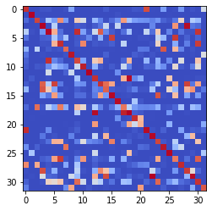

epoch 1101 == measurement_heuristic: 0.41+-0.01/0.39+-0.01 --

epoch 1102 == measurement_heuristic: 0.40+-0.01/0.37+-0.01 --

epoch 1103 == measurement_heuristic: 0.39+-0.01/0.38+-0.01 --

epoch 1104 == measurement_heuristic: 0.39+-0.01/0.36+-0.01 --

epoch 1105 == measurement_heuristic: 0.38+-0.01/0.35+-0.01 --

epoch 1106 == measurement_heuristic: 0.41+-0.01/0.38+-0.01 --

epoch 1107 == measurement_heuristic: 0.41+-0.01/0.37+-0.01 --

epoch 1108 == measurement_heuristic: 0.41+-0.01/0.37+-0.01 --

epoch 1109 == measurement_heuristic: 0.40+-0.01/0.36+-0.01 --

epoch 1110 == measurement_heuristic: 0.40+-0.01/0.36+-0.01 --

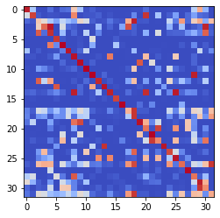

epoch 1111 == measurement_heuristic: 0.40+-0.01/0.37+-0.01 --

epoch 1112 == measurement_heuristic: 0.41+-0.01/0.36+-0.01 --

epoch 1113 == measurement_heuristic: 0.39+-0.01/0.37+-0.01 --

epoch 1114 == measurement_heuristic: 0.41+-0.01/0.36+-0.01 --

epoch 1115 == measurement_heuristic: 0.39+-0.01/0.37+-0.01 --

epoch 1116 == measurement_heuristic: 0.39+-0.01/0.35+-0.01 --

epoch 1117 == measurement_heuristic: 0.42+-0.01/0.36+-0.01 --

epoch 1118 == measurement_heuristic: 0.42+-0.01/0.37+-0.01 --

epoch 1119 == measurement_heuristic: 0.39+-0.01/0.35+-0.01 --

epoch 1120 >> measurement_heuristic: 0.40+-0.01/0.35+-0.01 --

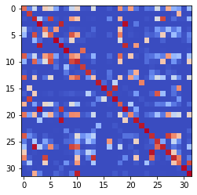

epoch 1121 == measurement_heuristic: 0.40+-0.01/0.35+-0.01 --

epoch 1122 == measurement_heuristic: 0.40+-0.01/0.36+-0.01 --

epoch 1123 == measurement_heuristic: 0.42+-0.01/0.36+-0.01 --

epoch 1124 == measurement_heuristic: 0.42+-0.01/0.38+-0.01 --

epoch 1125 == measurement_heuristic: 0.41+-0.01/0.36+-0.01 --

epoch 1126 >> measurement_heuristic: 0.39+-0.01/0.35+-0.01 --

epoch 1127 == measurement_heuristic: 0.38+-0.01/0.38+-0.01 --

epoch 1128 == measurement_heuristic: 0.39+-0.01/0.35+-0.01 --

epoch 1129 == measurement_heuristic: 0.39+-0.01/0.35+-0.01 --

epoch 1130 == measurement_heuristic: 0.39+-0.01/0.35+-0.01 --

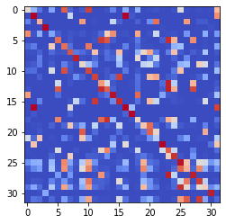

epoch 1131 == measurement_heuristic: 0.40+-0.01/0.36+-0.01 --

epoch 1132 == measurement_heuristic: 0.41+-0.01/0.36+-0.01 --

epoch 1133 == measurement_heuristic: 0.42+-0.01/0.35+-0.01 --

epoch 1134 == measurement_heuristic: 0.41+-0.01/0.36+-0.01 --

epoch 1135 == measurement_heuristic: 0.40+-0.01/0.35+-0.01 --

epoch 1136 == measurement_heuristic: 0.40+-0.01/0.36+-0.01 --

epoch 1137 == measurement_heuristic: 0.38+-0.01/0.37+-0.01 --

epoch 1138 == measurement_heuristic: 0.39+-0.01/0.36+-0.01 --

epoch 1139 == measurement_heuristic: 0.40+-0.01/0.36+-0.01 --

epoch 1140 == measurement_heuristic: 0.40+-0.01/0.36+-0.01 --

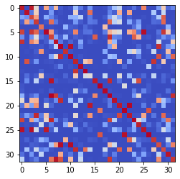

epoch 1141 == measurement_heuristic: 0.40+-0.01/0.38+-0.01 --

epoch 1142 == measurement_heuristic: 0.38+-0.01/0.35+-0.01 --

epoch 1143 == measurement_heuristic: 0.41+-0.01/0.36+-0.01 --

epoch 1144 == measurement_heuristic: 0.39+-0.01/0.36+-0.01 --

epoch 1145 == measurement_heuristic: 0.41+-0.01/0.36+-0.01 --

epoch 1146 == measurement_heuristic: 0.39+-0.01/0.37+-0.01 --

epoch 1147 == measurement_heuristic: 0.41+-0.01/0.35+-0.01 --

epoch 1148 == measurement_heuristic: 0.37+-0.01/0.39+-0.01 --

epoch 1149 == measurement_heuristic: 0.39+-0.01/0.36+-0.01 --

epoch 1150 == measurement_heuristic: 0.40+-0.01/0.37+-0.01 --

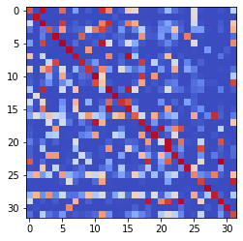

epoch 1151 == measurement_heuristic: 0.40+-0.01/0.39+-0.01 --

epoch 1152 == measurement_heuristic: 0.41+-0.01/0.37+-0.01 --

epoch 1153 == measurement_heuristic: 0.39+-0.01/0.35+-0.01 --

epoch 1154 == measurement_heuristic: 0.40+-0.01/0.36+-0.01 --

epoch 1155 >> measurement_heuristic: 0.40+-0.01/0.34+-0.01 --

epoch 1156 == measurement_heuristic: 0.40+-0.01/0.37+-0.01 --

epoch 1157 == measurement_heuristic: 0.39+-0.01/0.36+-0.01 --

epoch 1158 == measurement_heuristic: 0.42+-0.01/0.37+-0.01 --

epoch 1159 == measurement_heuristic: 0.40+-0.01/0.36+-0.01 --

epoch 1160 == measurement_heuristic: 0.39+-0.01/0.38+-0.01 --

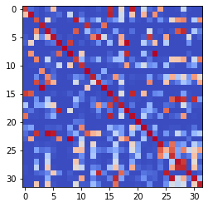

epoch 1161 == measurement_heuristic: 0.40+-0.01/0.35+-0.01 --

epoch 1162 == measurement_heuristic: 0.42+-0.01/0.36+-0.01 --

epoch 1163 == measurement_heuristic: 0.40+-0.01/0.35+-0.01 --

epoch 1164 == measurement_heuristic: 0.40+-0.01/0.37+-0.01 --

epoch 1165 == measurement_heuristic: 0.40+-0.01/0.35+-0.01 --

epoch 1166 == measurement_heuristic: 0.39+-0.01/0.36+-0.01 --

epoch 1167 == measurement_heuristic: 0.42+-0.01/0.36+-0.01 --

epoch 1168 == measurement_heuristic: 0.40+-0.01/0.35+-0.01 --

epoch 1169 == measurement_heuristic: 0.42+-0.01/0.36+-0.01 --

epoch 1170 == measurement_heuristic: 0.41+-0.01/0.35+-0.01 --

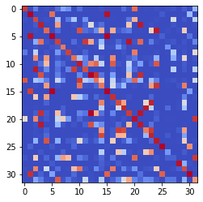

epoch 1171 == measurement_heuristic: 0.41+-0.01/0.37+-0.01 --

epoch 1172 == measurement_heuristic: 0.39+-0.01/0.36+-0.01 --

epoch 1173 == measurement_heuristic: 0.39+-0.01/0.36+-0.01 --

epoch 1174 == measurement_heuristic: 0.40+-0.01/0.39+-0.01 --

epoch 1175 == measurement_heuristic: 0.39+-0.01/0.37+-0.01 --

epoch 1176 == measurement_heuristic: 0.41+-0.01/0.39+-0.01 --

epoch 1177 == measurement_heuristic: 0.40+-0.01/0.35+-0.01 --

epoch 1178 == measurement_heuristic: 0.41+-0.01/0.35+-0.01 --

epoch 1179 == measurement_heuristic: 0.40+-0.01/0.36+-0.01 --

epoch 1180 == measurement_heuristic: 0.40+-0.01/0.36+-0.01 --

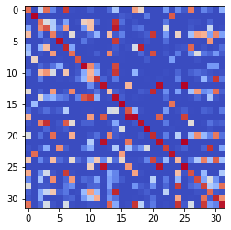

epoch 1181 >> measurement_heuristic: 0.39+-0.01/0.34+-0.01 --

epoch 1182 == measurement_heuristic: 0.40+-0.01/0.38+-0.01 --

epoch 1183 == measurement_heuristic: 0.42+-0.01/0.37+-0.01 --

epoch 1184 == measurement_heuristic: 0.40+-0.01/0.35+-0.01 --

epoch 1185 == measurement_heuristic: 0.39+-0.01/0.34+-0.01 --

epoch 1186 == measurement_heuristic: 0.38+-0.01/0.35+-0.01 --

epoch 1187 == measurement_heuristic: 0.38+-0.01/0.35+-0.01 --

epoch 1188 == measurement_heuristic: 0.40+-0.01/0.36+-0.01 --

epoch 1189 == measurement_heuristic: 0.41+-0.01/0.34+-0.01 --

epoch 1190 == measurement_heuristic: 0.40+-0.01/0.37+-0.01 --

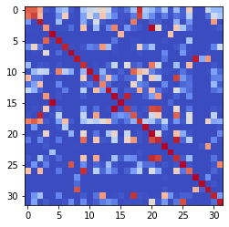

epoch 1191 == measurement_heuristic: 0.41+-0.01/0.36+-0.01 --

epoch 1192 == measurement_heuristic: 0.40+-0.01/0.36+-0.01 --

epoch 1193 == measurement_heuristic: 0.40+-0.01/0.34+-0.01 --

epoch 1194 == measurement_heuristic: 0.39+-0.01/0.35+-0.01 --

epoch 1195 == measurement_heuristic: 0.39+-0.01/0.35+-0.01 --

epoch 1196 == measurement_heuristic: 0.40+-0.01/0.38+-0.01 --

epoch 1197 == measurement_heuristic: 0.40+-0.01/0.37+-0.01 --

epoch 1198 == measurement_heuristic: 0.39+-0.01/0.36+-0.01 --

epoch 1199 == measurement_heuristic: 0.38+-0.01/0.36+-0.01 --

epoch 1200 == measurement_heuristic: 0.38+-0.01/0.35+-0.01 --

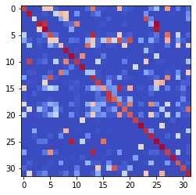

epoch 1201 == measurement_heuristic: 0.41+-0.01/0.36+-0.01 --

epoch 1202 == measurement_heuristic: 0.39+-0.01/0.36+-0.01 --

epoch 1203 == measurement_heuristic: 0.40+-0.01/0.35+-0.01 --

epoch 1204 == measurement_heuristic: 0.38+-0.01/0.35+-0.01 --

epoch 1205 == measurement_heuristic: 0.37+-0.01/0.35+-0.01 --

epoch 1206 == measurement_heuristic: 0.39+-0.01/0.34+-0.01 --

epoch 1207 == measurement_heuristic: 0.39+-0.01/0.35+-0.01 --

epoch 1208 == measurement_heuristic: 0.38+-0.01/0.34+-0.01 --

epoch 1209 == measurement_heuristic: 0.40+-0.01/0.34+-0.01 --

epoch 1210 == measurement_heuristic: 0.40+-0.01/0.35+-0.01 --

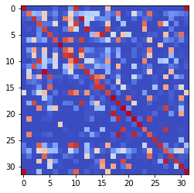

epoch 1211 == measurement_heuristic: 0.40+-0.01/0.35+-0.01 --

epoch 1212 == measurement_heuristic: 0.40+-0.01/0.35+-0.01 --

epoch 1213 == measurement_heuristic: 0.40+-0.01/0.35+-0.01 --

epoch 1214 == measurement_heuristic: 0.39+-0.01/0.37+-0.01 --

epoch 1215 == measurement_heuristic: 0.36+-0.01/0.38+-0.01 --

epoch 1216 >> measurement_heuristic: 0.39+-0.01/0.34+-0.01 --

epoch 1217 == measurement_heuristic: 0.39+-0.01/0.34+-0.01 --

epoch 1218 == measurement_heuristic: 0.39+-0.01/0.37+-0.01 --

epoch 1219 == measurement_heuristic: 0.37+-0.01/0.35+-0.01 --

epoch 1220 == measurement_heuristic: 0.38+-0.01/0.35+-0.01 --

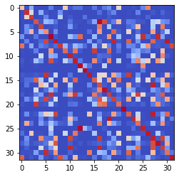

epoch 1221 == measurement_heuristic: 0.38+-0.01/0.37+-0.01 --

epoch 1222 == measurement_heuristic: 0.38+-0.01/0.34+-0.01 --

epoch 1223 == measurement_heuristic: 0.40+-0.01/0.36+-0.01 --

epoch 1224 == measurement_heuristic: 0.40+-0.01/0.35+-0.01 --

epoch 1225 == measurement_heuristic: 0.40+-0.01/0.35+-0.01 --

epoch 1226 == measurement_heuristic: 0.38+-0.01/0.34+-0.01 --

epoch 1227 == measurement_heuristic: 0.38+-0.01/0.34+-0.01 --

epoch 1228 == measurement_heuristic: 0.40+-0.01/0.36+-0.01 --

epoch 1229 == measurement_heuristic: 0.39+-0.01/0.35+-0.01 --

epoch 1230 == measurement_heuristic: 0.40+-0.01/0.37+-0.01 --

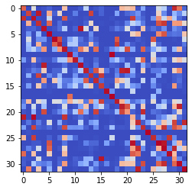

epoch 1231 == measurement_heuristic: 0.39+-0.01/0.35+-0.01 --

epoch 1232 == measurement_heuristic: 0.38+-0.01/0.35+-0.01 --

epoch 1233 == measurement_heuristic: 0.39+-0.01/0.35+-0.01 --

epoch 1234 == measurement_heuristic: 0.41+-0.01/0.36+-0.01 --

epoch 1235 == measurement_heuristic: 0.38+-0.01/0.34+-0.01 --

epoch 1236 == measurement_heuristic: 0.40+-0.01/0.37+-0.01 --

epoch 1237 == measurement_heuristic: 0.40+-0.01/0.34+-0.01 --

epoch 1238 == measurement_heuristic: 0.38+-0.01/0.35+-0.01 --

epoch 1239 == measurement_heuristic: 0.41+-0.01/0.35+-0.01 --

epoch 1240 >> measurement_heuristic: 0.38+-0.01/0.34+-0.01 --

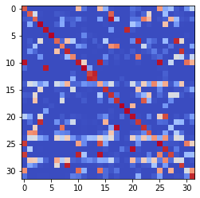

epoch 1241 == measurement_heuristic: 0.39+-0.01/0.38+-0.01 --

epoch 1242 == measurement_heuristic: 0.39+-0.01/0.35+-0.01 --

epoch 1243 == measurement_heuristic: 0.40+-0.01/0.34+-0.01 --

epoch 1244 == measurement_heuristic: 0.39+-0.01/0.35+-0.01 --

epoch 1245 == measurement_heuristic: 0.38+-0.01/0.35+-0.01 --

epoch 1246 == measurement_heuristic: 0.38+-0.01/0.37+-0.01 --

epoch 1247 == measurement_heuristic: 0.39+-0.01/0.36+-0.01 --

epoch 1248 == measurement_heuristic: 0.38+-0.01/0.35+-0.01 --

epoch 1249 == measurement_heuristic: 0.40+-0.01/0.36+-0.01 --

epoch 1250 == measurement_heuristic: 0.37+-0.01/0.35+-0.01 --

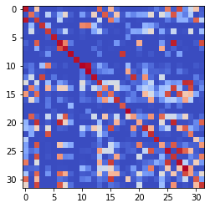

epoch 1251 == measurement_heuristic: 0.40+-0.01/0.34+-0.01 --

epoch 1252 == measurement_heuristic: 0.39+-0.01/0.35+-0.01 --

epoch 1253 == measurement_heuristic: 0.39+-0.01/0.34+-0.01 --

epoch 1254 == measurement_heuristic: 0.39+-0.01/0.35+-0.01 --

epoch 1255 == measurement_heuristic: 0.41+-0.01/0.34+-0.01 --

epoch 1256 == measurement_heuristic: 0.38+-0.01/0.35+-0.01 --

epoch 1257 == measurement_heuristic: 0.38+-0.01/0.34+-0.01 --

epoch 1258 == measurement_heuristic: 0.38+-0.01/0.35+-0.01 --

epoch 1259 == measurement_heuristic: 0.38+-0.01/0.37+-0.01 --

epoch 1260 == measurement_heuristic: 0.39+-0.01/0.36+-0.01 --

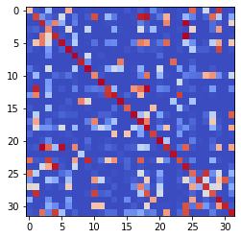

epoch 1261 == measurement_heuristic: 0.38+-0.01/0.34+-0.01 --

epoch 1262 == measurement_heuristic: 0.38+-0.01/0.34+-0.01 --

epoch 1263 == measurement_heuristic: 0.38+-0.01/0.34+-0.01 --

epoch 1264 == measurement_heuristic: 0.40+-0.01/0.35+-0.01 --

epoch 1265 == measurement_heuristic: 0.38+-0.01/0.35+-0.01 --

epoch 1266 == measurement_heuristic: 0.38+-0.01/0.35+-0.01 --

epoch 1267 == measurement_heuristic: 0.40+-0.01/0.35+-0.01 --

epoch 1268 == measurement_heuristic: 0.40+-0.01/0.35+-0.01 --

epoch 1269 >> measurement_heuristic: 0.38+-0.01/0.33+-0.01 --

epoch 1270 == measurement_heuristic: 0.38+-0.01/0.34+-0.01 --

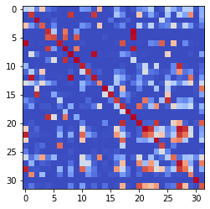

epoch 1271 == measurement_heuristic: 0.39+-0.01/0.35+-0.01 --

epoch 1272 == measurement_heuristic: 0.40+-0.01/0.34+-0.01 --

epoch 1273 == measurement_heuristic: 0.40+-0.01/0.36+-0.01 --

epoch 1274 == measurement_heuristic: 0.39+-0.01/0.34+-0.01 --

epoch 1275 == measurement_heuristic: 0.38+-0.01/0.35+-0.01 --

epoch 1276 == measurement_heuristic: 0.38+-0.01/0.34+-0.01 --

epoch 1277 == measurement_heuristic: 0.38+-0.01/0.37+-0.01 --

epoch 1278 == measurement_heuristic: 0.39+-0.01/0.34+-0.01 --

epoch 1279 == measurement_heuristic: 0.37+-0.01/0.34+-0.01 --

epoch 1280 == measurement_heuristic: 0.38+-0.01/0.35+-0.01 --

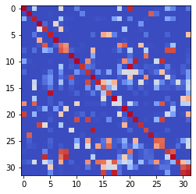

epoch 1281 == measurement_heuristic: 0.39+-0.01/0.35+-0.01 --

epoch 1282 == measurement_heuristic: 0.38+-0.01/0.34+-0.01 --

epoch 1283 == measurement_heuristic: 0.39+-0.01/0.33+-0.01 --

epoch 1284 == measurement_heuristic: 0.39+-0.01/0.36+-0.01 --

epoch 1285 == measurement_heuristic: 0.40+-0.01/0.34+-0.01 --

epoch 1286 == measurement_heuristic: 0.39+-0.01/0.34+-0.01 --

epoch 1287 == measurement_heuristic: 0.38+-0.01/0.35+-0.01 --

epoch 1288 == measurement_heuristic: 0.39+-0.01/0.34+-0.01 --

epoch 1289 == measurement_heuristic: 0.39+-0.01/0.34+-0.01 --

epoch 1290 == measurement_heuristic: 0.39+-0.01/0.35+-0.01 --

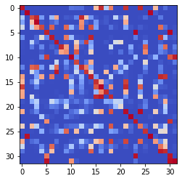

epoch 1291 == measurement_heuristic: 0.36+-0.01/0.34+-0.01 --

epoch 1292 == measurement_heuristic: 0.37+-0.01/0.35+-0.01 --

epoch 1293 == measurement_heuristic: 0.39+-0.01/0.34+-0.01 --

epoch 1294 >> measurement_heuristic: 0.37+-0.01/0.33+-0.01 --

epoch 1295 == measurement_heuristic: 0.38+-0.01/0.34+-0.01 --

epoch 1296 == measurement_heuristic: 0.39+-0.01/0.35+-0.01 --

epoch 1297 == measurement_heuristic: 0.41+-0.01/0.35+-0.01 --

epoch 1298 == measurement_heuristic: 0.38+-0.01/0.34+-0.01 --

epoch 1299 == measurement_heuristic: 0.39+-0.01/0.36+-0.01 --

epoch 1300 == measurement_heuristic: 0.40+-0.01/0.34+-0.01 --

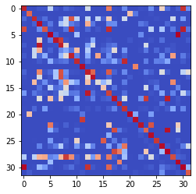

epoch 1301 == measurement_heuristic: 0.38+-0.01/0.34+-0.01 --

epoch 1302 == measurement_heuristic: 0.37+-0.01/0.34+-0.01 --

epoch 1303 == measurement_heuristic: 0.39+-0.01/0.34+-0.01 --

epoch 1304 == measurement_heuristic: 0.37+-0.01/0.34+-0.01 --

epoch 1305 >> measurement_heuristic: 0.38+-0.01/0.33+-0.01 --

epoch 1306 == measurement_heuristic: 0.39+-0.01/0.38+-0.01 --

epoch 1307 == measurement_heuristic: 0.38+-0.01/0.34+-0.01 --

epoch 1308 == measurement_heuristic: 0.40+-0.01/0.35+-0.01 --

epoch 1309 == measurement_heuristic: 0.39+-0.01/0.33+-0.01 --

epoch 1310 == measurement_heuristic: 0.39+-0.01/0.36+-0.01 --

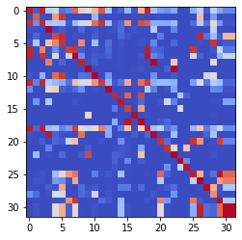

epoch 1311 == measurement_heuristic: 0.39+-0.01/0.34+-0.01 --

epoch 1312 == measurement_heuristic: 0.38+-0.01/0.36+-0.01 --

epoch 1313 == measurement_heuristic: 0.40+-0.01/0.34+-0.01 --

epoch 1314 == measurement_heuristic: 0.36+-0.01/0.34+-0.01 --

epoch 1315 == measurement_heuristic: 0.38+-0.01/0.33+-0.01 --

epoch 1316 == measurement_heuristic: 0.38+-0.01/0.34+-0.01 --

epoch 1317 >> measurement_heuristic: 0.38+-0.01/0.33+-0.01 --

epoch 1318 == measurement_heuristic: 0.39+-0.01/0.35+-0.01 --

epoch 1319 == measurement_heuristic: 0.37+-0.01/0.34+-0.01 --

epoch 1320 == measurement_heuristic: 0.38+-0.01/0.39+-0.01 --

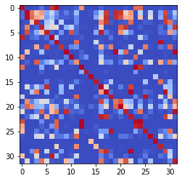

epoch 1321 == measurement_heuristic: 0.41+-0.01/0.36+-0.01 --

epoch 1322 == measurement_heuristic: 0.39+-0.01/0.33+-0.01 --

epoch 1323 == measurement_heuristic: 0.39+-0.01/0.34+-0.01 --

epoch 1324 == measurement_heuristic: 0.38+-0.01/0.34+-0.01 --

epoch 1325 == measurement_heuristic: 0.38+-0.01/0.35+-0.01 --

epoch 1326 == measurement_heuristic: 0.38+-0.01/0.35+-0.01 --

epoch 1327 == measurement_heuristic: 0.38+-0.01/0.34+-0.01 --

epoch 1328 == measurement_heuristic: 0.39+-0.01/0.36+-0.01 --

epoch 1329 == measurement_heuristic: 0.37+-0.01/0.34+-0.01 --

epoch 1330 == measurement_heuristic: 0.38+-0.01/0.35+-0.01 --

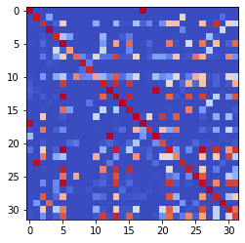

epoch 1331 == measurement_heuristic: 0.39+-0.01/0.34+-0.01 --

epoch 1332 == measurement_heuristic: 0.37+-0.01/0.35+-0.01 --

epoch 1333 == measurement_heuristic: 0.37+-0.01/0.34+-0.01 --

epoch 1334 == measurement_heuristic: 0.39+-0.01/0.34+-0.01 --

epoch 1335 == measurement_heuristic: 0.37+-0.01/0.34+-0.01 --

epoch 1336 == measurement_heuristic: 0.38+-0.01/0.36+-0.01 --

epoch 1337 == measurement_heuristic: 0.37+-0.01/0.34+-0.01 --

epoch 1338 == measurement_heuristic: 0.39+-0.01/0.35+-0.01 --

epoch 1339 == measurement_heuristic: 0.38+-0.01/0.35+-0.01 --

epoch 1340 == measurement_heuristic: 0.38+-0.01/0.33+-0.01 --

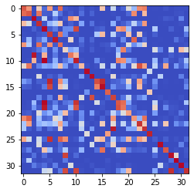

epoch 1341 == measurement_heuristic: 0.38+-0.01/0.35+-0.01 --

epoch 1342 == measurement_heuristic: 0.37+-0.01/0.33+-0.01 --

epoch 1343 == measurement_heuristic: 0.38+-0.01/0.34+-0.01 --

epoch 1344 >> measurement_heuristic: 0.37+-0.01/0.33+-0.01 --

epoch 1345 == measurement_heuristic: 0.38+-0.01/0.36+-0.01 --

epoch 1346 == measurement_heuristic: 0.40+-0.01/0.34+-0.01 --

epoch 1347 == measurement_heuristic: 0.37+-0.01/0.35+-0.01 --

epoch 1348 == measurement_heuristic: 0.38+-0.01/0.35+-0.01 --

epoch 1349 == measurement_heuristic: 0.41+-0.01/0.35+-0.01 --

epoch 1350 == measurement_heuristic: 0.36+-0.01/0.34+-0.01 --

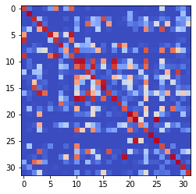

epoch 1351 == measurement_heuristic: 0.39+-0.01/0.34+-0.01 --

epoch 1352 == measurement_heuristic: 0.40+-0.01/0.34+-0.01 --

epoch 1353 == measurement_heuristic: 0.38+-0.01/0.33+-0.01 --

epoch 1354 == measurement_heuristic: 0.37+-0.01/0.35+-0.01 --

epoch 1355 == measurement_heuristic: 0.37+-0.01/0.35+-0.01 --

epoch 1356 == measurement_heuristic: 0.37+-0.01/0.34+-0.01 --

epoch 1357 >> measurement_heuristic: 0.36+-0.01/0.33+-0.01 --

epoch 1358 == measurement_heuristic: 0.37+-0.01/0.34+-0.01 --

epoch 1359 == measurement_heuristic: 0.37+-0.01/0.35+-0.01 --

epoch 1360 == measurement_heuristic: 0.35+-0.01/0.34+-0.01 --

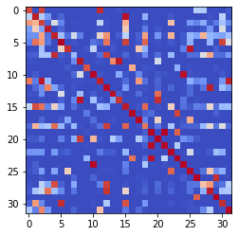

epoch 1361 == measurement_heuristic: 0.36+-0.01/0.33+-0.01 --

epoch 1362 >> measurement_heuristic: 0.39+-0.01/0.33+-0.01 --

epoch 1363 == measurement_heuristic: 0.36+-0.01/0.33+-0.01 --

epoch 1364 == measurement_heuristic: 0.38+-0.01/0.34+-0.01 --

epoch 1365 == measurement_heuristic: 0.37+-0.01/0.34+-0.01 --

epoch 1366 == measurement_heuristic: 0.38+-0.01/0.34+-0.01 --

epoch 1367 == measurement_heuristic: 0.36+-0.01/0.34+-0.01 --

epoch 1368 == measurement_heuristic: 0.39+-0.01/0.34+-0.01 --

epoch 1369 == measurement_heuristic: 0.37+-0.01/0.34+-0.01 --

epoch 1370 >> measurement_heuristic: 0.38+-0.01/0.33+-0.01 --

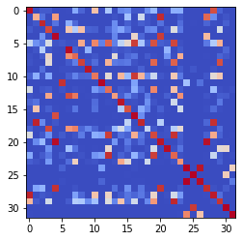

epoch 1371 == measurement_heuristic: 0.38+-0.01/0.34+-0.01 --

epoch 1372 == measurement_heuristic: 0.40+-0.01/0.35+-0.01 --

epoch 1373 == measurement_heuristic: 0.39+-0.01/0.34+-0.01 --

epoch 1374 == measurement_heuristic: 0.38+-0.01/0.34+-0.01 --

epoch 1375 == measurement_heuristic: 0.39+-0.01/0.34+-0.01 --

epoch 1376 == measurement_heuristic: 0.39+-0.01/0.35+-0.01 --

epoch 1377 == measurement_heuristic: 0.37+-0.01/0.34+-0.01 --

epoch 1378 == measurement_heuristic: 0.39+-0.01/0.35+-0.01 --

epoch 1379 == measurement_heuristic: 0.37+-0.01/0.34+-0.01 --

epoch 1380 == measurement_heuristic: 0.38+-0.01/0.33+-0.01 --

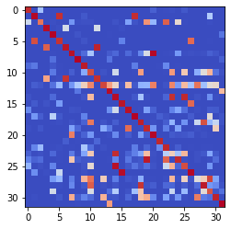

epoch 1381 == measurement_heuristic: 0.37+-0.01/0.33+-0.01 --

epoch 1382 == measurement_heuristic: 0.38+-0.01/0.33+-0.01 --

epoch 1383 == measurement_heuristic: 0.38+-0.01/0.33+-0.01 --

epoch 1384 == measurement_heuristic: 0.38+-0.01/0.33+-0.01 --

epoch 1385 == measurement_heuristic: 0.39+-0.01/0.35+-0.01 --

epoch 1386 == measurement_heuristic: 0.37+-0.01/0.34+-0.01 --

epoch 1387 == measurement_heuristic: 0.38+-0.01/0.34+-0.01 --

epoch 1388 == measurement_heuristic: 0.38+-0.01/0.34+-0.01 --

epoch 1389 == measurement_heuristic: 0.38+-0.01/0.35+-0.01 --

epoch 1390 == measurement_heuristic: 0.36+-0.01/0.33+-0.01 --

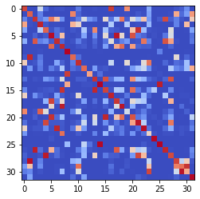

epoch 1391 == measurement_heuristic: 0.37+-0.01/0.34+-0.01 --

epoch 1392 == measurement_heuristic: 0.39+-0.01/0.33+-0.01 --

epoch 1393 == measurement_heuristic: 0.37+-0.01/0.35+-0.01 --

epoch 1394 == measurement_heuristic: 0.37+-0.01/0.33+-0.01 --

epoch 1395 == measurement_heuristic: 0.37+-0.01/0.33+-0.01 --

epoch 1396 == measurement_heuristic: 0.37+-0.01/0.34+-0.01 --

epoch 1397 == measurement_heuristic: 0.36+-0.01/0.35+-0.01 --

epoch 1398 == measurement_heuristic: 0.38+-0.01/0.33+-0.01 --

epoch 1399 == measurement_heuristic: 0.39+-0.01/0.33+-0.01 --

epoch 1400 == measurement_heuristic: 0.37+-0.01/0.34+-0.01 --

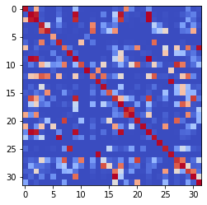

epoch 1401 == measurement_heuristic: 0.37+-0.01/0.34+-0.01 --

epoch 1402 == measurement_heuristic: 0.36+-0.01/0.34+-0.01 --

epoch 1403 == measurement_heuristic: 0.36+-0.01/0.33+-0.01 --

epoch 1404 == measurement_heuristic: 0.40+-0.01/0.33+-0.01 --

epoch 1405 >> measurement_heuristic: 0.36+-0.01/0.32+-0.01 --

epoch 1406 == measurement_heuristic: 0.37+-0.01/0.33+-0.01 --

epoch 1407 == measurement_heuristic: 0.39+-0.01/0.34+-0.01 --

epoch 1408 == measurement_heuristic: 0.37+-0.01/0.35+-0.01 --

epoch 1409 >> measurement_heuristic: 0.37+-0.01/0.32+-0.01 --

epoch 1410 == measurement_heuristic: 0.36+-0.01/0.33+-0.01 --

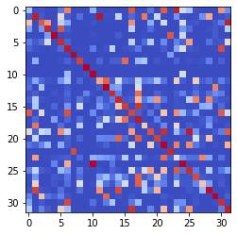

epoch 1411 == measurement_heuristic: 0.36+-0.01/0.32+-0.01 --

epoch 1412 == measurement_heuristic: 0.35+-0.01/0.34+-0.01 --

epoch 1413 == measurement_heuristic: 0.37+-0.01/0.33+-0.01 --

epoch 1414 == measurement_heuristic: 0.37+-0.01/0.34+-0.01 --

epoch 1415 == measurement_heuristic: 0.38+-0.01/0.33+-0.01 --

epoch 1416 == measurement_heuristic: 0.36+-0.01/0.33+-0.01 --

epoch 1417 == measurement_heuristic: 0.37+-0.01/0.35+-0.01 --

epoch 1418 == measurement_heuristic: 0.40+-0.01/0.34+-0.01 --

epoch 1419 == measurement_heuristic: 0.37+-0.01/0.33+-0.01 --

epoch 1420 == measurement_heuristic: 0.38+-0.01/0.35+-0.01 --

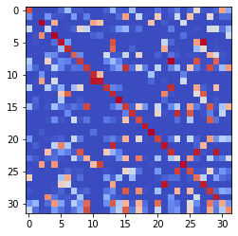

epoch 1421 == measurement_heuristic: 0.40+-0.01/0.34+-0.01 --

epoch 1422 == measurement_heuristic: 0.40+-0.01/0.35+-0.01 --

epoch 1423 == measurement_heuristic: 0.37+-0.01/0.34+-0.01 --

epoch 1424 == measurement_heuristic: 0.38+-0.01/0.34+-0.01 --

epoch 1425 == measurement_heuristic: 0.38+-0.01/0.34+-0.01 --

epoch 1426 == measurement_heuristic: 0.37+-0.01/0.33+-0.01 --

epoch 1427 == measurement_heuristic: 0.37+-0.01/0.33+-0.01 --

epoch 1428 == measurement_heuristic: 0.36+-0.01/0.33+-0.01 --

epoch 1429 == measurement_heuristic: 0.36+-0.01/0.33+-0.01 --

epoch 1430 == measurement_heuristic: 0.37+-0.01/0.34+-0.01 --

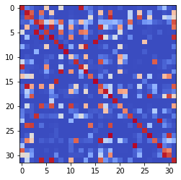

epoch 1431 == measurement_heuristic: 0.38+-0.01/0.33+-0.01 --

epoch 1432 == measurement_heuristic: 0.37+-0.01/0.33+-0.01 --

epoch 1433 == measurement_heuristic: 0.38+-0.01/0.34+-0.01 --

epoch 1434 == measurement_heuristic: 0.38+-0.01/0.33+-0.01 --

epoch 1435 == measurement_heuristic: 0.36+-0.01/0.33+-0.01 --

epoch 1436 == measurement_heuristic: 0.37+-0.01/0.33+-0.01 --

epoch 1437 == measurement_heuristic: 0.36+-0.01/0.33+-0.01 --

epoch 1438 == measurement_heuristic: 0.36+-0.01/0.33+-0.01 --

epoch 1439 >> measurement_heuristic: 0.37+-0.01/0.32+-0.01 --

epoch 1440 == measurement_heuristic: 0.38+-0.01/0.37+-0.01 --

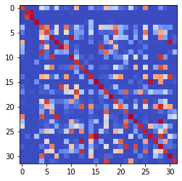

epoch 1441 >> measurement_heuristic: 0.37+-0.01/0.32+-0.01 --

epoch 1442 == measurement_heuristic: 0.36+-0.01/0.35+-0.01 --

epoch 1443 == measurement_heuristic: 0.36+-0.01/0.33+-0.01 --

epoch 1444 == measurement_heuristic: 0.36+-0.01/0.33+-0.01 --

epoch 1445 == measurement_heuristic: 0.39+-0.01/0.33+-0.01 --

epoch 1446 == measurement_heuristic: 0.37+-0.01/0.34+-0.01 --

epoch 1447 == measurement_heuristic: 0.38+-0.01/0.33+-0.01 --

epoch 1448 == measurement_heuristic: 0.38+-0.01/0.33+-0.01 --

epoch 1449 == measurement_heuristic: 0.39+-0.01/0.34+-0.01 --

epoch 1450 == measurement_heuristic: 0.37+-0.01/0.36+-0.01 --

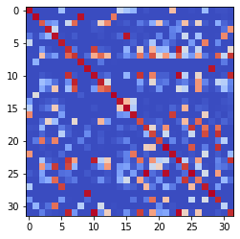

epoch 1451 == measurement_heuristic: 0.37+-0.01/0.33+-0.01 --

epoch 1452 == measurement_heuristic: 0.36+-0.01/0.34+-0.01 --

epoch 1453 == measurement_heuristic: 0.37+-0.01/0.33+-0.01 --

epoch 1454 == measurement_heuristic: 0.33+-0.01/0.33+-0.01 --

epoch 1455 == measurement_heuristic: 0.38+-0.01/0.35+-0.01 --

epoch 1456 == measurement_heuristic: 0.37+-0.01/0.33+-0.01 --

epoch 1457 >> measurement_heuristic: 0.39+-0.01/0.32+-0.01 --

epoch 1458 == measurement_heuristic: 0.35+-0.01/0.36+-0.01 --

epoch 1459 == measurement_heuristic: 0.37+-0.01/0.34+-0.01 --

epoch 1460 == measurement_heuristic: 0.36+-0.01/0.35+-0.01 --

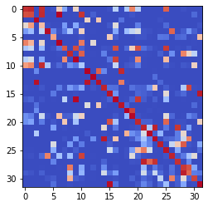

epoch 1461 == measurement_heuristic: 0.39+-0.01/0.34+-0.01 --

epoch 1462 == measurement_heuristic: 0.37+-0.01/0.33+-0.01 --

epoch 1463 == measurement_heuristic: 0.36+-0.01/0.33+-0.01 --

epoch 1464 == measurement_heuristic: 0.38+-0.01/0.33+-0.01 --

epoch 1465 == measurement_heuristic: 0.39+-0.01/0.35+-0.01 --

epoch 1466 == measurement_heuristic: 0.38+-0.01/0.32+-0.01 --

epoch 1467 == measurement_heuristic: 0.36+-0.01/0.33+-0.01 --

epoch 1468 == measurement_heuristic: 0.37+-0.01/0.34+-0.01 --

epoch 1469 == measurement_heuristic: 0.36+-0.01/0.33+-0.01 --

epoch 1470 == measurement_heuristic: 0.37+-0.01/0.33+-0.01 --

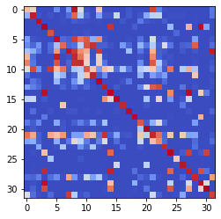

epoch 1471 == measurement_heuristic: 0.36+-0.01/0.33+-0.01 --

epoch 1472 == measurement_heuristic: 0.37+-0.01/0.34+-0.01 --

epoch 1473 == measurement_heuristic: 0.37+-0.01/0.35+-0.01 --

epoch 1474 == measurement_heuristic: 0.37+-0.01/0.33+-0.01 --

epoch 1475 == measurement_heuristic: 0.37+-0.01/0.33+-0.01 --

epoch 1476 == measurement_heuristic: 0.37+-0.01/0.33+-0.01 --

epoch 1477 == measurement_heuristic: 0.37+-0.01/0.32+-0.01 --

epoch 1478 == measurement_heuristic: 0.36+-0.01/0.34+-0.01 --

epoch 1479 == measurement_heuristic: 0.38+-0.01/0.35+-0.01 --

epoch 1480 == measurement_heuristic: 0.38+-0.01/0.33+-0.01 --

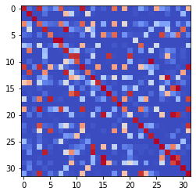

epoch 1481 == measurement_heuristic: 0.36+-0.01/0.32+-0.01 --

epoch 1482 == measurement_heuristic: 0.37+-0.01/0.33+-0.01 --

epoch 1483 == measurement_heuristic: 0.36+-0.01/0.33+-0.01 --

epoch 1484 == measurement_heuristic: 0.38+-0.01/0.33+-0.01 --

epoch 1485 == measurement_heuristic: 0.37+-0.01/0.33+-0.01 --

epoch 1486 == measurement_heuristic: 0.38+-0.01/0.35+-0.01 --

epoch 1487 == measurement_heuristic: 0.36+-0.01/0.33+-0.01 --

epoch 1488 == measurement_heuristic: 0.36+-0.01/0.33+-0.01 --

epoch 1489 == measurement_heuristic: 0.37+-0.01/0.33+-0.01 --

epoch 1490 == measurement_heuristic: 0.39+-0.01/0.33+-0.01 --

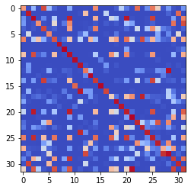

epoch 1491 == measurement_heuristic: 0.38+-0.01/0.32+-0.01 --

epoch 1492 == measurement_heuristic: 0.38+-0.01/0.34+-0.01 --

epoch 1493 == measurement_heuristic: 0.37+-0.01/0.35+-0.01 --

epoch 1494 == measurement_heuristic: 0.36+-0.01/0.33+-0.01 --

epoch 1495 == measurement_heuristic: 0.37+-0.01/0.33+-0.01 --

epoch 1496 == measurement_heuristic: 0.38+-0.01/0.34+-0.01 --

epoch 1497 == measurement_heuristic: 0.37+-0.01/0.33+-0.01 --

epoch 1498 == measurement_heuristic: 0.37+-0.01/0.37+-0.01 --

epoch 1499 == measurement_heuristic: 0.37+-0.01/0.33+-0.01 --

epoch 1500 == measurement_heuristic: 0.37+-0.01/0.34+-0.01 --

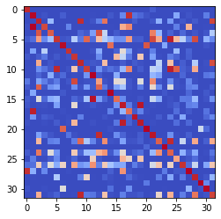

epoch 1501 == measurement_heuristic: 0.37+-0.01/0.33+-0.01 --

epoch 1502 == measurement_heuristic: 0.37+-0.01/0.34+-0.01 --

epoch 1503 == measurement_heuristic: 0.37+-0.01/0.32+-0.01 --

epoch 1504 == measurement_heuristic: 0.37+-0.01/0.34+-0.01 --

epoch 1505 == measurement_heuristic: 0.38+-0.01/0.33+-0.01 --

epoch 1506 >> measurement_heuristic: 0.37+-0.01/0.31+-0.01 --

epoch 1507 == measurement_heuristic: 0.36+-0.01/0.33+-0.01 --

epoch 1508 == measurement_heuristic: 0.37+-0.01/0.33+-0.01 --

epoch 1509 == measurement_heuristic: 0.37+-0.01/0.33+-0.01 --

epoch 1510 == measurement_heuristic: 0.37+-0.01/0.35+-0.01 --

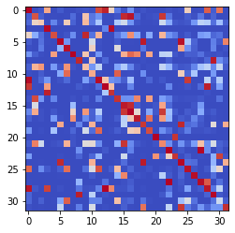

epoch 1511 == measurement_heuristic: 0.37+-0.01/0.33+-0.01 --

epoch 1512 == measurement_heuristic: 0.38+-0.01/0.33+-0.01 --

epoch 1513 == measurement_heuristic: 0.36+-0.01/0.32+-0.01 --

epoch 1514 == measurement_heuristic: 0.34+-0.01/0.32+-0.01 --

epoch 1515 == measurement_heuristic: 0.37+-0.01/0.32+-0.01 --

epoch 1516 == measurement_heuristic: 0.38+-0.01/0.32+-0.01 --

epoch 1517 == measurement_heuristic: 0.37+-0.01/0.35+-0.01 --

epoch 1518 == measurement_heuristic: 0.37+-0.01/0.33+-0.01 --

epoch 1519 == measurement_heuristic: 0.38+-0.01/0.34+-0.01 --

epoch 1520 == measurement_heuristic: 0.35+-0.01/0.33+-0.01 --

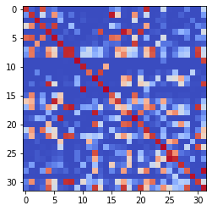

epoch 1521 == measurement_heuristic: 0.35+-0.01/0.33+-0.01 --

epoch 1522 == measurement_heuristic: 0.36+-0.01/0.32+-0.01 --

epoch 1523 == measurement_heuristic: 0.36+-0.01/0.33+-0.01 --

epoch 1524 == measurement_heuristic: 0.38+-0.01/0.33+-0.01 --

epoch 1525 == measurement_heuristic: 0.38+-0.01/0.35+-0.01 --

epoch 1526 == measurement_heuristic: 0.34+-0.01/0.32+-0.01 --

epoch 1527 == measurement_heuristic: 0.35+-0.01/0.33+-0.01 --

epoch 1528 == measurement_heuristic: 0.36+-0.01/0.32+-0.01 --

epoch 1529 == measurement_heuristic: 0.36+-0.01/0.34+-0.01 --

epoch 1530 == measurement_heuristic: 0.36+-0.01/0.34+-0.01 --

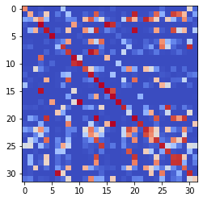

epoch 1531 >> measurement_heuristic: 0.38+-0.01/0.31+-0.01 --

epoch 1532 == measurement_heuristic: 0.37+-0.01/0.32+-0.01 --

epoch 1533 == measurement_heuristic: 0.36+-0.01/0.34+-0.01 --

epoch 1534 == measurement_heuristic: 0.36+-0.01/0.32+-0.01 --

epoch 1535 == measurement_heuristic: 0.34+-0.01/0.31+-0.01 --

epoch 1536 == measurement_heuristic: 0.36+-0.01/0.32+-0.01 --

epoch 1537 == measurement_heuristic: 0.38+-0.01/0.32+-0.01 --

epoch 1538 == measurement_heuristic: 0.34+-0.01/0.33+-0.01 --

epoch 1539 == measurement_heuristic: 0.36+-0.01/0.32+-0.01 --

epoch 1540 == measurement_heuristic: 0.36+-0.01/0.33+-0.01 --

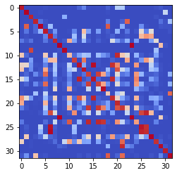

epoch 1541 == measurement_heuristic: 0.37+-0.01/0.32+-0.01 --

epoch 1542 == measurement_heuristic: 0.35+-0.01/0.33+-0.01 --

epoch 1543 == measurement_heuristic: 0.36+-0.01/0.32+-0.01 --

epoch 1544 == measurement_heuristic: 0.38+-0.01/0.35+-0.01 --

epoch 1545 == measurement_heuristic: 0.36+-0.01/0.33+-0.01 --

epoch 1546 == measurement_heuristic: 0.36+-0.01/0.32+-0.01 --

epoch 1547 == measurement_heuristic: 0.36+-0.01/0.32+-0.01 --

epoch 1548 == measurement_heuristic: 0.35+-0.01/0.35+-0.01 --

epoch 1549 == measurement_heuristic: 0.36+-0.01/0.32+-0.01 --

epoch 1550 == measurement_heuristic: 0.36+-0.01/0.32+-0.01 --

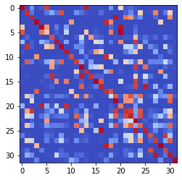

epoch 1551 == measurement_heuristic: 0.35+-0.01/0.35+-0.01 --

epoch 1552 == measurement_heuristic: 0.36+-0.01/0.33+-0.01 --

epoch 1553 == measurement_heuristic: 0.36+-0.01/0.32+-0.01 --

epoch 1554 == measurement_heuristic: 0.36+-0.01/0.33+-0.01 --

epoch 1555 == measurement_heuristic: 0.35+-0.01/0.32+-0.01 --

epoch 1556 == measurement_heuristic: 0.36+-0.01/0.31+-0.01 --

epoch 1557 == measurement_heuristic: 0.38+-0.01/0.38+-0.01 --

epoch 1558 == measurement_heuristic: 0.38+-0.01/0.32+-0.01 --

epoch 1559 >> measurement_heuristic: 0.36+-0.01/0.31+-0.01 --

epoch 1560 == measurement_heuristic: 0.37+-0.01/0.32+-0.01 --

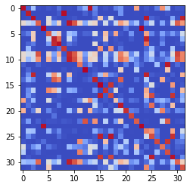

epoch 1561 == measurement_heuristic: 0.37+-0.01/0.32+-0.01 --

epoch 1562 == measurement_heuristic: 0.36+-0.01/0.36+-0.01 --

epoch 1563 == measurement_heuristic: 0.36+-0.01/0.31+-0.01 --

epoch 1564 == measurement_heuristic: 0.37+-0.01/0.31+-0.01 --

epoch 1565 == measurement_heuristic: 0.36+-0.01/0.33+-0.01 --

epoch 1566 == measurement_heuristic: 0.37+-0.01/0.32+-0.01 --

epoch 1567 == measurement_heuristic: 0.36+-0.01/0.32+-0.01 --

epoch 1568 == measurement_heuristic: 0.36+-0.01/0.34+-0.01 --

epoch 1569 == measurement_heuristic: 0.36+-0.01/0.32+-0.01 --

epoch 1570 == measurement_heuristic: 0.37+-0.01/0.32+-0.01 --

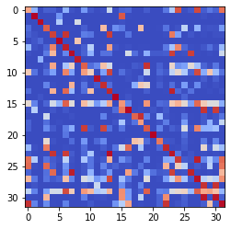

epoch 1571 == measurement_heuristic: 0.34+-0.01/0.32+-0.01 --

epoch 1572 == measurement_heuristic: 0.36+-0.01/0.32+-0.01 --

epoch 1573 == measurement_heuristic: 0.34+-0.01/0.32+-0.01 --

epoch 1574 == measurement_heuristic: 0.36+-0.01/0.37+-0.01 --

epoch 1575 == measurement_heuristic: 0.36+-0.01/0.33+-0.01 --

epoch 1576 == measurement_heuristic: 0.37+-0.01/0.33+-0.01 --

epoch 1577 == measurement_heuristic: 0.37+-0.01/0.32+-0.01 --

epoch 1578 == measurement_heuristic: 0.35+-0.01/0.33+-0.01 --

epoch 1579 == measurement_heuristic: 0.36+-0.01/0.34+-0.01 --

epoch 1580 == measurement_heuristic: 0.38+-0.01/0.32+-0.01 --

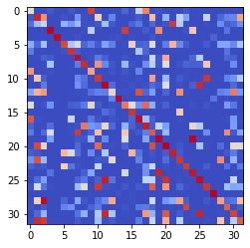

epoch 1581 == measurement_heuristic: 0.36+-0.01/0.32+-0.01 --

epoch 1582 == measurement_heuristic: 0.35+-0.01/0.34+-0.01 --

epoch 1583 == measurement_heuristic: 0.37+-0.01/0.33+-0.01 --

epoch 1584 == measurement_heuristic: 0.36+-0.01/0.31+-0.01 --

epoch 1585 == measurement_heuristic: 0.34+-0.01/0.32+-0.01 --

epoch 1586 == measurement_heuristic: 0.36+-0.01/0.32+-0.01 --

epoch 1587 == measurement_heuristic: 0.37+-0.01/0.31+-0.01 --

epoch 1588 == measurement_heuristic: 0.37+-0.01/0.36+-0.01 --

epoch 1589 == measurement_heuristic: 0.36+-0.01/0.31+-0.01 --

epoch 1590 == measurement_heuristic: 0.35+-0.01/0.32+-0.01 --

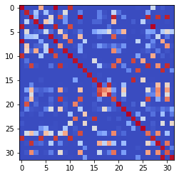

epoch 1591 == measurement_heuristic: 0.36+-0.01/0.37+-0.01 --

epoch 1592 == measurement_heuristic: 0.36+-0.01/0.32+-0.01 --

epoch 1593 == measurement_heuristic: 0.37+-0.01/0.34+-0.01 --

epoch 1594 == measurement_heuristic: 0.36+-0.01/0.34+-0.01 --

epoch 1595 == measurement_heuristic: 0.36+-0.01/0.32+-0.01 --

epoch 1596 == measurement_heuristic: 0.37+-0.01/0.32+-0.01 --

epoch 1597 == measurement_heuristic: 0.36+-0.01/0.34+-0.01 --

epoch 1598 == measurement_heuristic: 0.38+-0.01/0.32+-0.01 --

epoch 1599 >> measurement_heuristic: 0.35+-0.01/0.31+-0.01 --

epoch 1600 == measurement_heuristic: 0.35+-0.01/0.31+-0.01 --

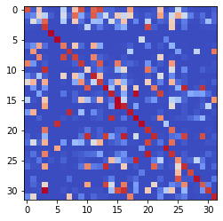

epoch 1601 == measurement_heuristic: 0.35+-0.01/0.32+-0.01 --

epoch 1602 == measurement_heuristic: 0.35+-0.01/0.31+-0.01 --

epoch 1603 == measurement_heuristic: 0.36+-0.01/0.32+-0.01 --

epoch 1604 == measurement_heuristic: 0.36+-0.01/0.31+-0.01 --

epoch 1605 == measurement_heuristic: 0.36+-0.01/0.32+-0.01 --

epoch 1606 == measurement_heuristic: 0.35+-0.01/0.36+-0.01 --

epoch 1607 == measurement_heuristic: 0.37+-0.01/0.33+-0.01 --

epoch 1608 == measurement_heuristic: 0.37+-0.01/0.31+-0.01 --

epoch 1609 == measurement_heuristic: 0.37+-0.01/0.31+-0.01 --

epoch 1610 == measurement_heuristic: 0.37+-0.01/0.34+-0.01 --

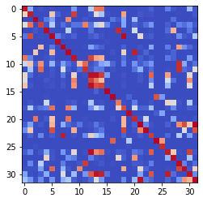

epoch 1611 == measurement_heuristic: 0.36+-0.01/0.32+-0.01 --

epoch 1612 == measurement_heuristic: 0.36+-0.01/0.31+-0.01 --

epoch 1613 == measurement_heuristic: 0.35+-0.01/0.32+-0.01 --

epoch 1614 == measurement_heuristic: 0.37+-0.01/0.31+-0.01 --

epoch 1615 == measurement_heuristic: 0.36+-0.01/0.32+-0.01 --

epoch 1616 == measurement_heuristic: 0.36+-0.01/0.32+-0.01 --

epoch 1617 == measurement_heuristic: 0.36+-0.01/0.32+-0.01 --

epoch 1618 == measurement_heuristic: 0.34+-0.01/0.33+-0.01 --

epoch 1619 == measurement_heuristic: 0.37+-0.01/0.34+-0.01 --

epoch 1620 == measurement_heuristic: 0.36+-0.01/0.32+-0.01 --

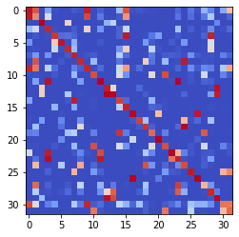

epoch 1621 == measurement_heuristic: 0.36+-0.01/0.32+-0.01 --

epoch 1622 == measurement_heuristic: 0.36+-0.01/0.38+-0.01 --

epoch 1623 == measurement_heuristic: 0.36+-0.01/0.33+-0.01 --

epoch 1624 == measurement_heuristic: 0.36+-0.01/0.31+-0.01 --

epoch 1625 == measurement_heuristic: 0.35+-0.01/0.33+-0.01 --

epoch 1626 == measurement_heuristic: 0.37+-0.01/0.33+-0.01 --

epoch 1627 == measurement_heuristic: 0.37+-0.01/0.32+-0.01 --

epoch 1628 == measurement_heuristic: 0.35+-0.01/0.32+-0.01 --

epoch 1629 == measurement_heuristic: 0.35+-0.01/0.32+-0.01 --

epoch 1630 == measurement_heuristic: 0.36+-0.01/0.34+-0.01 --

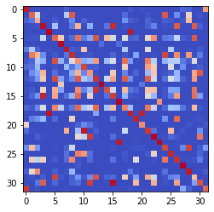

epoch 1631 == measurement_heuristic: 0.36+-0.01/0.32+-0.01 --

epoch 1632 == measurement_heuristic: 0.36+-0.01/0.32+-0.01 --

epoch 1633 == measurement_heuristic: 0.36+-0.01/0.31+-0.01 --

epoch 1634 == measurement_heuristic: 0.38+-0.01/0.32+-0.01 --

epoch 1635 == measurement_heuristic: 0.34+-0.01/0.31+-0.01 --

epoch 1636 == measurement_heuristic: 0.35+-0.01/0.33+-0.01 --

epoch 1637 == measurement_heuristic: 0.35+-0.01/0.32+-0.01 --

epoch 1638 == measurement_heuristic: 0.35+-0.01/0.32+-0.01 --

epoch 1639 == measurement_heuristic: 0.36+-0.01/0.33+-0.01 --

epoch 1640 == measurement_heuristic: 0.36+-0.01/0.32+-0.01 --

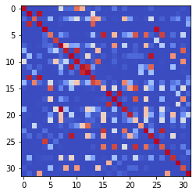

epoch 1641 == measurement_heuristic: 0.35+-0.01/0.35+-0.01 --

epoch 1642 == measurement_heuristic: 0.34+-0.01/0.31+-0.01 --

epoch 1643 == measurement_heuristic: 0.38+-0.01/0.33+-0.01 --

epoch 1644 == measurement_heuristic: 0.37+-0.01/0.32+-0.01 --

epoch 1645 == measurement_heuristic: 0.36+-0.01/0.31+-0.01 --

epoch 1646 == measurement_heuristic: 0.35+-0.01/0.32+-0.01 --

epoch 1647 == measurement_heuristic: 0.34+-0.01/0.33+-0.01 --

epoch 1648 == measurement_heuristic: 0.35+-0.01/0.32+-0.01 --

epoch 1649 == measurement_heuristic: 0.37+-0.01/0.33+-0.01 --

epoch 1650 == measurement_heuristic: 0.36+-0.01/0.32+-0.01 --

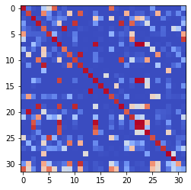

epoch 1651 == measurement_heuristic: 0.36+-0.01/0.32+-0.01 --

epoch 1652 == measurement_heuristic: 0.36+-0.01/0.33+-0.01 --

epoch 1653 == measurement_heuristic: 0.37+-0.01/0.32+-0.01 --

epoch 1654 == measurement_heuristic: 0.38+-0.01/0.32+-0.01 --

epoch 1655 == measurement_heuristic: 0.35+-0.01/0.31+-0.01 --

epoch 1656 >> measurement_heuristic: 0.35+-0.01/0.30+-0.01 --

epoch 1657 == measurement_heuristic: 0.35+-0.01/0.33+-0.01 --

epoch 1658 == measurement_heuristic: 0.36+-0.01/0.30+-0.01 --

epoch 1659 == measurement_heuristic: 0.35+-0.01/0.34+-0.01 --

epoch 1660 == measurement_heuristic: 0.35+-0.01/0.32+-0.01 --

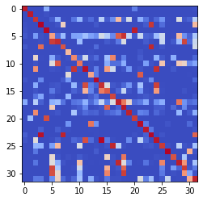

epoch 1661 == measurement_heuristic: 0.34+-0.01/0.32+-0.01 --

epoch 1662 == measurement_heuristic: 0.34+-0.01/0.30+-0.01 --

epoch 1663 == measurement_heuristic: 0.35+-0.01/0.33+-0.01 --

epoch 1664 == measurement_heuristic: 0.36+-0.01/0.34+-0.01 --

epoch 1665 == measurement_heuristic: 0.37+-0.01/0.31+-0.01 --

epoch 1666 == measurement_heuristic: 0.35+-0.01/0.32+-0.01 --

epoch 1667 == measurement_heuristic: 0.36+-0.01/0.33+-0.01 --

epoch 1668 == measurement_heuristic: 0.35+-0.01/0.32+-0.01 --

epoch 1669 == measurement_heuristic: 0.35+-0.01/0.31+-0.01 --

epoch 1670 == measurement_heuristic: 0.36+-0.01/0.32+-0.01 --

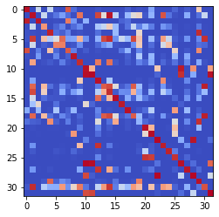

epoch 1671 == measurement_heuristic: 0.36+-0.01/0.32+-0.01 --

epoch 1672 == measurement_heuristic: 0.34+-0.01/0.34+-0.01 --

epoch 1673 == measurement_heuristic: 0.37+-0.01/0.30+-0.01 --

epoch 1674 == measurement_heuristic: 0.37+-0.01/0.30+-0.01 --

epoch 1675 >> measurement_heuristic: 0.35+-0.01/0.30+-0.01 --

epoch 1676 == measurement_heuristic: 0.35+-0.01/0.32+-0.01 --

epoch 1677 == measurement_heuristic: 0.36+-0.01/0.31+-0.01 --

epoch 1678 == measurement_heuristic: 0.35+-0.01/0.32+-0.01 --

epoch 1679 == measurement_heuristic: 0.34+-0.01/0.35+-0.01 --

epoch 1680 >> measurement_heuristic: 0.35+-0.01/0.30+-0.01 --

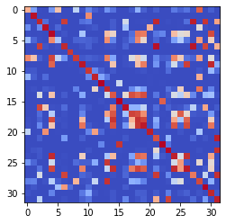

epoch 1681 == measurement_heuristic: 0.33+-0.01/0.33+-0.01 --

epoch 1682 == measurement_heuristic: 0.35+-0.01/0.31+-0.01 --

epoch 1683 == measurement_heuristic: 0.36+-0.01/0.34+-0.01 --

epoch 1684 == measurement_heuristic: 0.35+-0.01/0.31+-0.01 --

epoch 1685 == measurement_heuristic: 0.36+-0.01/0.32+-0.01 --

epoch 1686 == measurement_heuristic: 0.37+-0.01/0.32+-0.01 --

epoch 1687 == measurement_heuristic: 0.35+-0.01/0.30+-0.01 --

epoch 1688 == measurement_heuristic: 0.34+-0.01/0.32+-0.01 --

epoch 1689 == measurement_heuristic: 0.37+-0.01/0.33+-0.01 --

epoch 1690 == measurement_heuristic: 0.34+-0.01/0.31+-0.01 --

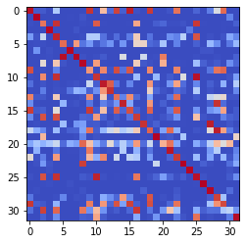

epoch 1691 == measurement_heuristic: 0.34+-0.01/0.31+-0.01 --

epoch 1692 == measurement_heuristic: 0.33+-0.01/0.34+-0.01 --

epoch 1693 == measurement_heuristic: 0.35+-0.01/0.32+-0.01 --

epoch 1694 == measurement_heuristic: 0.34+-0.01/0.34+-0.01 --

epoch 1695 == measurement_heuristic: 0.35+-0.01/0.31+-0.01 --

epoch 1696 == measurement_heuristic: 0.36+-0.01/0.32+-0.01 --

epoch 1697 == measurement_heuristic: 0.35+-0.01/0.30+-0.01 --

epoch 1698 >> measurement_heuristic: 0.35+-0.01/0.30+-0.01 --

epoch 1699 == measurement_heuristic: 0.35+-0.01/0.31+-0.01 --

epoch 1700 == measurement_heuristic: 0.36+-0.01/0.32+-0.01 --

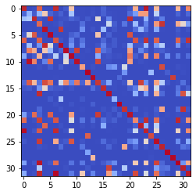

epoch 1701 == measurement_heuristic: 0.38+-0.01/0.32+-0.01 --

epoch 1702 == measurement_heuristic: 0.35+-0.01/0.31+-0.01 --

epoch 1703 == measurement_heuristic: 0.35+-0.01/0.33+-0.01 --

epoch 1704 == measurement_heuristic: 0.34+-0.01/0.31+-0.01 --

epoch 1705 >> measurement_heuristic: 0.34+-0.01/0.30+-0.01 --

epoch 1706 == measurement_heuristic: 0.36+-0.01/0.30+-0.01 --

epoch 1707 == measurement_heuristic: 0.36+-0.01/0.31+-0.01 --

epoch 1708 == measurement_heuristic: 0.36+-0.01/0.32+-0.01 --

epoch 1709 == measurement_heuristic: 0.36+-0.01/0.31+-0.01 --

epoch 1710 == measurement_heuristic: 0.35+-0.01/0.31+-0.01 --

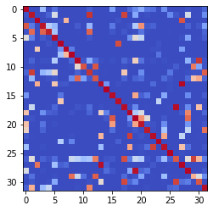

epoch 1711 == measurement_heuristic: 0.34+-0.01/0.32+-0.01 --

epoch 1712 == measurement_heuristic: 0.37+-0.01/0.32+-0.01 --

epoch 1713 == measurement_heuristic: 0.34+-0.01/0.31+-0.01 --

epoch 1714 == measurement_heuristic: 0.36+-0.01/0.32+-0.01 --

epoch 1715 == measurement_heuristic: 0.37+-0.01/0.30+-0.01 --

epoch 1716 == measurement_heuristic: 0.35+-0.01/0.31+-0.01 --

epoch 1717 == measurement_heuristic: 0.37+-0.01/0.31+-0.01 --

epoch 1718 == measurement_heuristic: 0.35+-0.01/0.32+-0.01 --

epoch 1719 == measurement_heuristic: 0.34+-0.01/0.32+-0.01 --

epoch 1720 == measurement_heuristic: 0.35+-0.01/0.30+-0.01 --

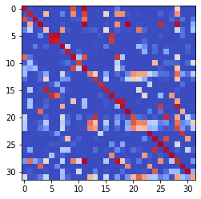

epoch 1721 >> measurement_heuristic: 0.35+-0.01/0.30+-0.01 --

epoch 1722 == measurement_heuristic: 0.34+-0.01/0.33+-0.01 --

epoch 1723 == measurement_heuristic: 0.36+-0.01/0.31+-0.01 --

epoch 1724 == measurement_heuristic: 0.34+-0.01/0.30+-0.01 --

epoch 1725 == measurement_heuristic: 0.36+-0.01/0.32+-0.01 --

epoch 1726 == measurement_heuristic: 0.34+-0.01/0.30+-0.01 --

epoch 1727 == measurement_heuristic: 0.35+-0.01/0.32+-0.01 --

epoch 1728 == measurement_heuristic: 0.35+-0.01/0.31+-0.01 --

epoch 1729 == measurement_heuristic: 0.37+-0.01/0.31+-0.01 --

epoch 1730 == measurement_heuristic: 0.36+-0.01/0.34+-0.01 --

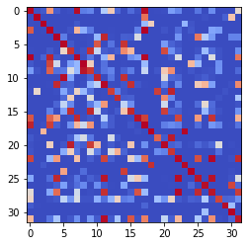

epoch 1731 == measurement_heuristic: 0.35+-0.01/0.32+-0.01 --

epoch 1732 == measurement_heuristic: 0.35+-0.01/0.31+-0.01 --

epoch 1733 == measurement_heuristic: 0.36+-0.01/0.33+-0.01 --

epoch 1734 == measurement_heuristic: 0.34+-0.01/0.32+-0.01 --

epoch 1735 == measurement_heuristic: 0.35+-0.01/0.34+-0.01 --

epoch 1736 == measurement_heuristic: 0.35+-0.01/0.31+-0.01 --

epoch 1737 == measurement_heuristic: 0.37+-0.01/0.31+-0.01 --

epoch 1738 == measurement_heuristic: 0.33+-0.01/0.32+-0.01 --

epoch 1739 == measurement_heuristic: 0.37+-0.01/0.31+-0.01 --

epoch 1740 == measurement_heuristic: 0.34+-0.01/0.32+-0.01 --

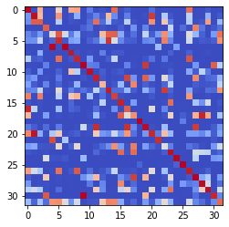

epoch 1741 == measurement_heuristic: 0.35+-0.01/0.30+-0.01 --

epoch 1742 == measurement_heuristic: 0.34+-0.01/0.32+-0.01 --

epoch 1743 == measurement_heuristic: 0.37+-0.01/0.32+-0.01 --

epoch 1744 == measurement_heuristic: 0.37+-0.01/0.33+-0.01 --

epoch 1745 == measurement_heuristic: 0.36+-0.01/0.32+-0.01 --

epoch 1746 == measurement_heuristic: 0.35+-0.01/0.35+-0.01 --

epoch 1747 == measurement_heuristic: 0.36+-0.01/0.33+-0.01 --

epoch 1748 == measurement_heuristic: 0.36+-0.01/0.31+-0.01 --

epoch 1749 == measurement_heuristic: 0.36+-0.01/0.31+-0.01 --

epoch 1750 == measurement_heuristic: 0.34+-0.01/0.30+-0.01 --

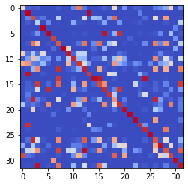

epoch 1751 == measurement_heuristic: 0.36+-0.01/0.32+-0.01 --

epoch 1752 == measurement_heuristic: 0.33+-0.01/0.32+-0.01 --

epoch 1753 == measurement_heuristic: 0.33+-0.01/0.31+-0.01 --

epoch 1754 == measurement_heuristic: 0.35+-0.01/0.31+-0.01 --

epoch 1755 == measurement_heuristic: 0.35+-0.01/0.31+-0.01 --

epoch 1756 == measurement_heuristic: 0.36+-0.01/0.31+-0.01 --

epoch 1757 == measurement_heuristic: 0.35+-0.01/0.30+-0.01 --

epoch 1758 == measurement_heuristic: 0.35+-0.01/0.35+-0.01 --

epoch 1759 == measurement_heuristic: 0.36+-0.01/0.31+-0.01 --

epoch 1760 == measurement_heuristic: 0.36+-0.01/0.31+-0.01 --

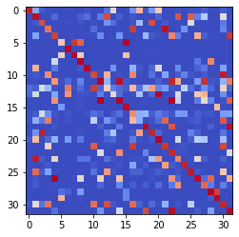

epoch 1761 == measurement_heuristic: 0.34+-0.01/0.30+-0.01 --

epoch 1762 == measurement_heuristic: 0.34+-0.01/0.32+-0.01 --

epoch 1763 == measurement_heuristic: 0.35+-0.01/0.31+-0.01 --

epoch 1764 == measurement_heuristic: 0.36+-0.01/0.31+-0.01 --

epoch 1765 == measurement_heuristic: 0.34+-0.01/0.32+-0.01 --

epoch 1766 == measurement_heuristic: 0.36+-0.01/0.31+-0.01 --

epoch 1767 == measurement_heuristic: 0.35+-0.01/0.30+-0.01 --

epoch 1768 == measurement_heuristic: 0.37+-0.01/0.30+-0.01 --

epoch 1769 == measurement_heuristic: 0.34+-0.01/0.31+-0.01 --

epoch 1770 == measurement_heuristic: 0.37+-0.01/0.31+-0.01 --

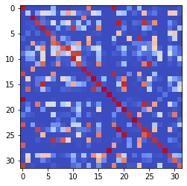

epoch 1771 == measurement_heuristic: 0.37+-0.01/0.33+-0.01 --

epoch 1772 == measurement_heuristic: 0.33+-0.01/0.31+-0.01 --

epoch 1773 == measurement_heuristic: 0.36+-0.01/0.31+-0.01 --

epoch 1774 == measurement_heuristic: 0.37+-0.01/0.31+-0.01 --

epoch 1775 == measurement_heuristic: 0.35+-0.01/0.31+-0.01 --

epoch 1776 == measurement_heuristic: 0.35+-0.01/0.31+-0.01 --

epoch 1777 == measurement_heuristic: 0.35+-0.01/0.34+-0.01 --

epoch 1778 == measurement_heuristic: 0.35+-0.01/0.30+-0.01 --

epoch 1779 == measurement_heuristic: 0.34+-0.01/0.32+-0.01 --

epoch 1780 == measurement_heuristic: 0.36+-0.01/0.32+-0.01 --

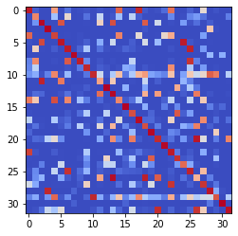

epoch 1781 == measurement_heuristic: 0.35+-0.01/0.30+-0.01 --

epoch 1782 == measurement_heuristic: 0.34+-0.01/0.32+-0.01 --

epoch 1783 == measurement_heuristic: 0.34+-0.01/0.34+-0.01 --

epoch 1784 == measurement_heuristic: 0.34+-0.01/0.30+-0.01 --

epoch 1785 == measurement_heuristic: 0.35+-0.01/0.31+-0.01 --

epoch 1786 == measurement_heuristic: 0.36+-0.01/0.30+-0.01 --

epoch 1787 == measurement_heuristic: 0.35+-0.01/0.32+-0.01 --

epoch 1788 == measurement_heuristic: 0.37+-0.01/0.33+-0.01 --

epoch 1789 == measurement_heuristic: 0.38+-0.01/0.32+-0.01 --

epoch 1790 == measurement_heuristic: 0.34+-0.01/0.31+-0.01 --

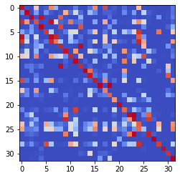

epoch 1791 == measurement_heuristic: 0.35+-0.01/0.30+-0.01 --

epoch 1792 == measurement_heuristic: 0.34+-0.01/0.30+-0.01 --

epoch 1793 == measurement_heuristic: 0.34+-0.01/0.30+-0.01 --

epoch 1794 == measurement_heuristic: 0.37+-0.01/0.36+-0.01 --

epoch 1795 == measurement_heuristic: 0.37+-0.01/0.30+-0.01 --

epoch 1796 == measurement_heuristic: 0.33+-0.01/0.32+-0.01 --

epoch 1797 == measurement_heuristic: 0.35+-0.01/0.31+-0.01 --

epoch 1798 == measurement_heuristic: 0.35+-0.01/0.30+-0.01 --

epoch 1799 == measurement_heuristic: 0.34+-0.01/0.30+-0.01 --

epoch 1800 == measurement_heuristic: 0.33+-0.01/0.30+-0.01 --

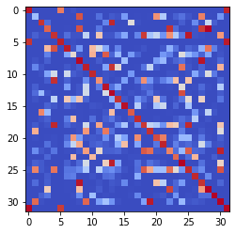

epoch 1801 == measurement_heuristic: 0.34+-0.01/0.34+-0.01 --

epoch 1802 == measurement_heuristic: 0.37+-0.01/0.30+-0.01 --

epoch 1803 == measurement_heuristic: 0.34+-0.01/0.30+-0.01 --

epoch 1804 == measurement_heuristic: 0.34+-0.01/0.31+-0.01 --

epoch 1805 == measurement_heuristic: 0.34+-0.01/0.31+-0.01 --

epoch 1806 == measurement_heuristic: 0.36+-0.01/0.30+-0.01 --

epoch 1807 == measurement_heuristic: 0.36+-0.01/0.30+-0.01 --

epoch 1808 == measurement_heuristic: 0.34+-0.01/0.31+-0.01 --

epoch 1809 == measurement_heuristic: 0.32+-0.01/0.30+-0.01 --

epoch 1810 == measurement_heuristic: 0.35+-0.01/0.32+-0.01 --

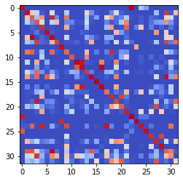

epoch 1811 == measurement_heuristic: 0.36+-0.01/0.31+-0.01 --

epoch 1812 == measurement_heuristic: 0.34+-0.01/0.30+-0.01 --

epoch 1813 == measurement_heuristic: 0.34+-0.01/0.30+-0.01 --

epoch 1814 == measurement_heuristic: 0.36+-0.01/0.30+-0.01 --

epoch 1815 == measurement_heuristic: 0.35+-0.01/0.31+-0.01 --

epoch 1816 == measurement_heuristic: 0.33+-0.01/0.31+-0.01 --

epoch 1817 == measurement_heuristic: 0.35+-0.01/0.31+-0.01 --

epoch 1818 >> measurement_heuristic: 0.34+-0.01/0.29+-0.01 --

epoch 1819 == measurement_heuristic: 0.35+-0.01/0.32+-0.01 --

epoch 1820 == measurement_heuristic: 0.37+-0.01/0.31+-0.01 --

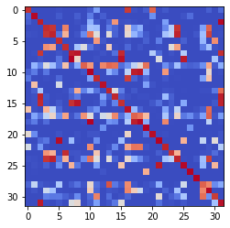

epoch 1821 == measurement_heuristic: 0.36+-0.01/0.30+-0.01 --

epoch 1822 == measurement_heuristic: 0.33+-0.01/0.30+-0.01 --

epoch 1823 == measurement_heuristic: 0.33+-0.01/0.31+-0.01 --

epoch 1824 == measurement_heuristic: 0.37+-0.01/0.31+-0.01 --

epoch 1825 == measurement_heuristic: 0.35+-0.01/0.31+-0.01 --

epoch 1826 == measurement_heuristic: 0.35+-0.01/0.30+-0.01 --

epoch 1827 == measurement_heuristic: 0.35+-0.01/0.31+-0.01 --

epoch 1828 == measurement_heuristic: 0.35+-0.01/0.32+-0.01 --

epoch 1829 == measurement_heuristic: 0.36+-0.01/0.32+-0.01 --

epoch 1830 == measurement_heuristic: 0.34+-0.01/0.30+-0.01 --

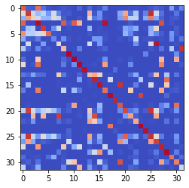

epoch 1831 == measurement_heuristic: 0.35+-0.01/0.31+-0.01 --

epoch 1832 == measurement_heuristic: 0.33+-0.01/0.31+-0.01 --

epoch 1833 == measurement_heuristic: 0.36+-0.01/0.31+-0.01 --

epoch 1834 == measurement_heuristic: 0.35+-0.01/0.31+-0.01 --

epoch 1835 == measurement_heuristic: 0.34+-0.01/0.31+-0.01 --

epoch 1836 == measurement_heuristic: 0.33+-0.01/0.34+-0.01 --

epoch 1837 == measurement_heuristic: 0.36+-0.01/0.32+-0.01 --

epoch 1838 == measurement_heuristic: 0.34+-0.01/0.33+-0.01 --

epoch 1839 == measurement_heuristic: 0.34+-0.01/0.30+-0.01 --

epoch 1840 == measurement_heuristic: 0.34+-0.01/0.33+-0.01 --

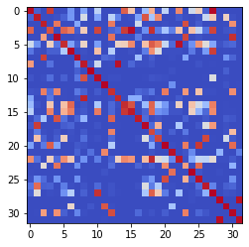

epoch 1841 == measurement_heuristic: 0.37+-0.01/0.33+-0.01 --

epoch 1842 == measurement_heuristic: 0.35+-0.01/0.31+-0.01 --

epoch 1843 == measurement_heuristic: 0.35+-0.01/0.32+-0.01 --

epoch 1844 == measurement_heuristic: 0.34+-0.01/0.30+-0.01 --

epoch 1845 == measurement_heuristic: 0.35+-0.01/0.33+-0.01 --

epoch 1846 == measurement_heuristic: 0.34+-0.01/0.30+-0.01 --

epoch 1847 == measurement_heuristic: 0.35+-0.01/0.31+-0.01 --

epoch 1848 == measurement_heuristic: 0.34+-0.01/0.30+-0.01 --

epoch 1849 == measurement_heuristic: 0.35+-0.01/0.31+-0.01 --

epoch 1850 == measurement_heuristic: 0.35+-0.01/0.30+-0.01 --

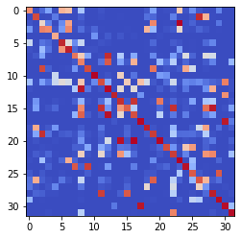

epoch 1851 == measurement_heuristic: 0.35+-0.01/0.31+-0.01 --

epoch 1852 == measurement_heuristic: 0.33+-0.01/0.30+-0.01 --

epoch 1853 == measurement_heuristic: 0.33+-0.01/0.30+-0.01 --

epoch 1854 == measurement_heuristic: 0.34+-0.01/0.30+-0.01 --

epoch 1855 == measurement_heuristic: 0.34+-0.01/0.33+-0.01 --

epoch 1856 == measurement_heuristic: 0.34+-0.01/0.31+-0.01 --

epoch 1857 == measurement_heuristic: 0.36+-0.01/0.34+-0.01 --

epoch 1858 == measurement_heuristic: 0.34+-0.01/0.30+-0.01 --

epoch 1859 == measurement_heuristic: 0.35+-0.01/0.30+-0.01 --

epoch 1860 == measurement_heuristic: 0.34+-0.01/0.30+-0.01 --

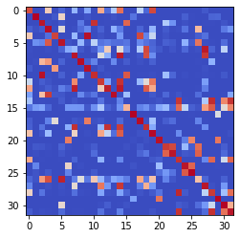

epoch 1861 == measurement_heuristic: 0.32+-0.01/0.30+-0.01 --

epoch 1862 == measurement_heuristic: 0.34+-0.01/0.33+-0.01 --

epoch 1863 == measurement_heuristic: 0.38+-0.01/0.30+-0.01 --

epoch 1864 == measurement_heuristic: 0.36+-0.01/0.32+-0.01 --

epoch 1865 == measurement_heuristic: 0.34+-0.01/0.31+-0.01 --

epoch 1866 == measurement_heuristic: 0.34+-0.01/0.30+-0.01 --

epoch 1867 == measurement_heuristic: 0.34+-0.01/0.33+-0.01 --

epoch 1868 == measurement_heuristic: 0.33+-0.01/0.30+-0.01 --

epoch 1869 == measurement_heuristic: 0.34+-0.01/0.32+-0.01 --

epoch 1870 == measurement_heuristic: 0.35+-0.01/0.31+-0.01 --

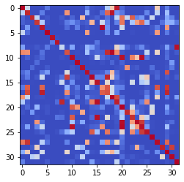

epoch 1871 == measurement_heuristic: 0.34+-0.01/0.31+-0.01 --

epoch 1872 == measurement_heuristic: 0.34+-0.01/0.31+-0.01 --

epoch 1873 == measurement_heuristic: 0.33+-0.01/0.29+-0.01 --

epoch 1874 == measurement_heuristic: 0.34+-0.01/0.30+-0.01 --

epoch 1875 == measurement_heuristic: 0.34+-0.01/0.29+-0.01 --

epoch 1876 == measurement_heuristic: 0.36+-0.01/0.30+-0.01 --

epoch 1877 == measurement_heuristic: 0.34+-0.01/0.31+-0.01 --

epoch 1878 == measurement_heuristic: 0.36+-0.01/0.32+-0.01 --

epoch 1879 == measurement_heuristic: 0.35+-0.01/0.30+-0.01 --

epoch 1880 == measurement_heuristic: 0.34+-0.01/0.31+-0.01 --

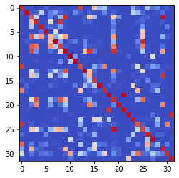

epoch 1881 == measurement_heuristic: 0.34+-0.01/0.31+-0.01 --

epoch 1882 >> measurement_heuristic: 0.33+-0.01/0.29+-0.01 --

epoch 1883 == measurement_heuristic: 0.34+-0.01/0.34+-0.01 --

epoch 1884 >> measurement_heuristic: 0.34+-0.01/0.29+-0.01 --

epoch 1885 == measurement_heuristic: 0.36+-0.01/0.33+-0.01 --

epoch 1886 == measurement_heuristic: 0.35+-0.01/0.32+-0.01 --

epoch 1887 == measurement_heuristic: 0.33+-0.01/0.31+-0.01 --

epoch 1888 >> measurement_heuristic: 0.34+-0.01/0.29+-0.01 --

epoch 1889 == measurement_heuristic: 0.34+-0.01/0.33+-0.01 --

epoch 1890 == measurement_heuristic: 0.34+-0.01/0.30+-0.01 --

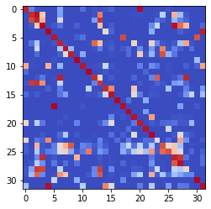

epoch 1891 == measurement_heuristic: 0.33+-0.01/0.35+-0.01 --

epoch 1892 == measurement_heuristic: 0.33+-0.01/0.29+-0.01 --

epoch 1893 == measurement_heuristic: 0.35+-0.01/0.30+-0.01 --

epoch 1894 == measurement_heuristic: 0.33+-0.01/0.30+-0.01 --

epoch 1895 == measurement_heuristic: 0.35+-0.01/0.32+-0.01 --

epoch 1896 == measurement_heuristic: 0.35+-0.01/0.30+-0.01 --

epoch 1897 == measurement_heuristic: 0.36+-0.01/0.32+-0.01 --

epoch 1898 == measurement_heuristic: 0.35+-0.01/0.30+-0.01 --

epoch 1899 == measurement_heuristic: 0.34+-0.01/0.32+-0.01 --

epoch 1900 == measurement_heuristic: 0.35+-0.01/0.30+-0.01 --

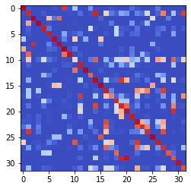

epoch 1901 == measurement_heuristic: 0.34+-0.01/0.30+-0.01 --

epoch 1902 == measurement_heuristic: 0.36+-0.01/0.30+-0.01 --

epoch 1903 == measurement_heuristic: 0.32+-0.01/0.31+-0.01 --

epoch 1904 == measurement_heuristic: 0.34+-0.01/0.30+-0.01 --

epoch 1905 == measurement_heuristic: 0.33+-0.01/0.30+-0.01 --

epoch 1906 == measurement_heuristic: 0.33+-0.01/0.31+-0.01 --

epoch 1907 == measurement_heuristic: 0.33+-0.01/0.30+-0.01 --

epoch 1908 == measurement_heuristic: 0.35+-0.01/0.29+-0.01 --

epoch 1909 == measurement_heuristic: 0.35+-0.01/0.33+-0.01 --

epoch 1910 == measurement_heuristic: 0.34+-0.01/0.29+-0.01 --

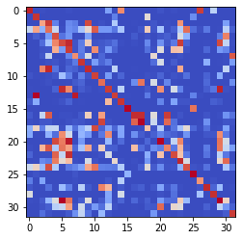

epoch 1911 == measurement_heuristic: 0.32+-0.01/0.32+-0.01 --

epoch 1912 == measurement_heuristic: 0.34+-0.01/0.30+-0.01 --

epoch 1913 == measurement_heuristic: 0.35+-0.01/0.30+-0.00 --

epoch 1914 == measurement_heuristic: 0.34+-0.01/0.29+-0.01 --

epoch 1915 == measurement_heuristic: 0.33+-0.01/0.29+-0.01 --

epoch 1916 == measurement_heuristic: 0.34+-0.01/0.33+-0.00 --

epoch 1917 == measurement_heuristic: 0.34+-0.01/0.31+-0.01 --

epoch 1918 == measurement_heuristic: 0.35+-0.01/0.31+-0.01 --

epoch 1919 == measurement_heuristic: 0.35+-0.01/0.30+-0.01 --

epoch 1920 == measurement_heuristic: 0.33+-0.01/0.29+-0.01 --

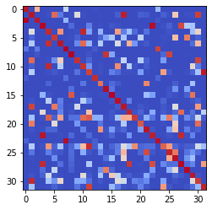

epoch 1921 == measurement_heuristic: 0.34+-0.01/0.29+-0.01 --

epoch 1922 == measurement_heuristic: 0.33+-0.01/0.29+-0.01 --

epoch 1923 == measurement_heuristic: 0.32+-0.01/0.29+-0.01 --

epoch 1924 == measurement_heuristic: 0.35+-0.01/0.30+-0.01 --

epoch 1925 == measurement_heuristic: 0.34+-0.01/0.33+-0.01 --

epoch 1926 == measurement_heuristic: 0.37+-0.01/0.29+-0.01 --

epoch 1927 == measurement_heuristic: 0.34+-0.01/0.30+-0.01 --

epoch 1928 == measurement_heuristic: 0.34+-0.01/0.30+-0.01 --

epoch 1929 == measurement_heuristic: 0.34+-0.01/0.33+-0.01 --

epoch 1930 == measurement_heuristic: 0.34+-0.01/0.32+-0.01 --

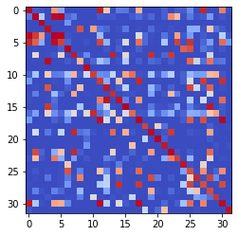

epoch 1931 == measurement_heuristic: 0.35+-0.01/0.34+-0.01 --

epoch 1932 == measurement_heuristic: 0.33+-0.01/0.31+-0.01 --

epoch 1933 == measurement_heuristic: 0.33+-0.01/0.31+-0.01 --

epoch 1934 == measurement_heuristic: 0.35+-0.01/0.29+-0.01 --

epoch 1935 == measurement_heuristic: 0.35+-0.01/0.31+-0.01 --

epoch 1936 == measurement_heuristic: 0.31+-0.01/0.29+-0.01 --

epoch 1937 == measurement_heuristic: 0.34+-0.01/0.30+-0.01 --

epoch 1938 == measurement_heuristic: 0.35+-0.01/0.30+-0.01 --

epoch 1939 == measurement_heuristic: 0.34+-0.01/0.30+-0.01 --

epoch 1940 == measurement_heuristic: 0.33+-0.01/0.29+-0.01 --

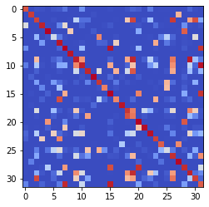

epoch 1941 == measurement_heuristic: 0.33+-0.01/0.29+-0.01 --

epoch 1942 == measurement_heuristic: 0.33+-0.01/0.30+-0.01 --

epoch 1943 == measurement_heuristic: 0.35+-0.01/0.30+-0.01 --

epoch 1944 == measurement_heuristic: 0.34+-0.01/0.33+-0.01 --

epoch 1945 == measurement_heuristic: 0.33+-0.01/0.29+-0.01 --

epoch 1946 == measurement_heuristic: 0.34+-0.01/0.30+-0.01 --

epoch 1947 == measurement_heuristic: 0.34+-0.01/0.29+-0.01 --

epoch 1948 == measurement_heuristic: 0.35+-0.01/0.30+-0.01 --

epoch 1949 == measurement_heuristic: 0.35+-0.01/0.30+-0.01 --

epoch 1950 == measurement_heuristic: 0.34+-0.01/0.30+-0.01 --

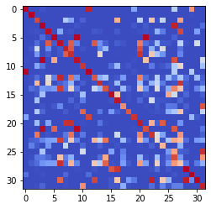

epoch 1951 == measurement_heuristic: 0.33+-0.01/0.30+-0.01 --

epoch 1952 == measurement_heuristic: 0.35+-0.01/0.31+-0.01 --

epoch 1953 == measurement_heuristic: 0.36+-0.01/0.31+-0.01 --

epoch 1954 == measurement_heuristic: 0.34+-0.01/0.29+-0.01 --

epoch 1955 == measurement_heuristic: 0.33+-0.01/0.30+-0.01 --

epoch 1956 == measurement_heuristic: 0.33+-0.01/0.30+-0.01 --

epoch 1957 == measurement_heuristic: 0.31+-0.01/0.30+-0.01 --

epoch 1958 == measurement_heuristic: 0.35+-0.01/0.32+-0.01 --

epoch 1959 == measurement_heuristic: 0.33+-0.01/0.29+-0.01 --

epoch 1960 == measurement_heuristic: 0.34+-0.01/0.31+-0.01 --

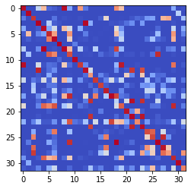

epoch 1961 == measurement_heuristic: 0.33+-0.01/0.30+-0.01 --

epoch 1962 == measurement_heuristic: 0.31+-0.01/0.29+-0.01 --

epoch 1963 == measurement_heuristic: 0.35+-0.01/0.31+-0.01 --

epoch 1964 == measurement_heuristic: 0.34+-0.01/0.30+-0.01 --

epoch 1965 == measurement_heuristic: 0.35+-0.01/0.30+-0.01 --

epoch 1966 == measurement_heuristic: 0.34+-0.01/0.30+-0.01 --

epoch 1967 == measurement_heuristic: 0.35+-0.01/0.30+-0.01 --

epoch 1968 == measurement_heuristic: 0.36+-0.01/0.30+-0.01 --

epoch 1969 == measurement_heuristic: 0.34+-0.01/0.32+-0.01 --

epoch 1970 == measurement_heuristic: 0.34+-0.01/0.30+-0.01 --

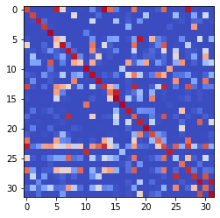

epoch 1971 == measurement_heuristic: 0.33+-0.01/0.29+-0.01 --

epoch 1972 == measurement_heuristic: 0.33+-0.01/0.31+-0.01 --

epoch 1973 == measurement_heuristic: 0.34+-0.01/0.30+-0.01 --

epoch 1974 == measurement_heuristic: 0.31+-0.01/0.31+-0.01 --

epoch 1975 == measurement_heuristic: 0.34+-0.01/0.33+-0.01 --

epoch 1976 == measurement_heuristic: 0.33+-0.01/0.30+-0.01 --

epoch 1977 >> measurement_heuristic: 0.33+-0.01/0.29+-0.01 --

epoch 1978 == measurement_heuristic: 0.34+-0.01/0.30+-0.01 --

epoch 1979 == measurement_heuristic: 0.34+-0.01/0.34+-0.01 --

epoch 1980 == measurement_heuristic: 0.32+-0.01/0.29+-0.01 --

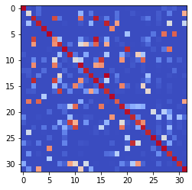

epoch 1981 == measurement_heuristic: 0.35+-0.01/0.32+-0.01 --

epoch 1982 == measurement_heuristic: 0.34+-0.01/0.29+-0.01 --

epoch 1983 == measurement_heuristic: 0.36+-0.01/0.30+-0.01 --

epoch 1984 == measurement_heuristic: 0.34+-0.01/0.29+-0.01 --

epoch 1985 == measurement_heuristic: 0.33+-0.01/0.34+-0.01 --

epoch 1986 == measurement_heuristic: 0.34+-0.01/0.31+-0.01 --

epoch 1987 == measurement_heuristic: 0.34+-0.01/0.35+-0.01 --

epoch 1988 == measurement_heuristic: 0.32+-0.01/0.30+-0.01 --

epoch 1989 == measurement_heuristic: 0.33+-0.01/0.30+-0.00 --

epoch 1990 == measurement_heuristic: 0.34+-0.01/0.29+-0.01 --

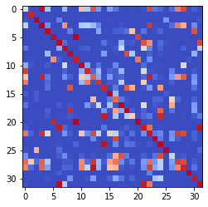

epoch 1991 == measurement_heuristic: 0.34+-0.01/0.29+-0.01 --

epoch 1992 == measurement_heuristic: 0.35+-0.01/0.30+-0.01 --

epoch 1993 == measurement_heuristic: 0.34+-0.01/0.30+-0.01 --

epoch 1994 == measurement_heuristic: 0.33+-0.01/0.30+-0.01 --

epoch 1995 == measurement_heuristic: 0.33+-0.01/0.29+-0.01 --

epoch 1996 == measurement_heuristic: 0.32+-0.01/0.32+-0.01 --

epoch 1997 == measurement_heuristic: 0.33+-0.01/0.31+-0.01 --

epoch 1998 == measurement_heuristic: 0.32+-0.01/0.30+-0.01 --

epoch 1999 == measurement_heuristic: 0.33+-0.01/0.30+-0.01 --

epoch 2000 == measurement_heuristic: 0.35+-0.01/0.30+-0.01 --

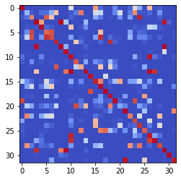

epoch 2001 == measurement_heuristic: 0.33+-0.01/0.29+-0.01 --

epoch 2002 == measurement_heuristic: 0.32+-0.01/0.30+-0.01 --

epoch 2003 == measurement_heuristic: 0.32+-0.01/0.29+-0.01 --

epoch 2004 == measurement_heuristic: 0.33+-0.01/0.31+-0.01 --

epoch 2005 >> measurement_heuristic: 0.36+-0.01/0.29+-0.01 --

epoch 2006 == measurement_heuristic: 0.34+-0.01/0.32+-0.01 --

epoch 2007 == measurement_heuristic: 0.35+-0.01/0.29+-0.01 --

epoch 2008 == measurement_heuristic: 0.32+-0.01/0.30+-0.00 --

epoch 2009 == measurement_heuristic: 0.33+-0.01/0.31+-0.01 --

epoch 2010 == measurement_heuristic: 0.34+-0.01/0.29+-0.01 --

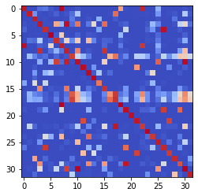

epoch 2011 == measurement_heuristic: 0.32+-0.01/0.30+-0.01 --

epoch 2012 == measurement_heuristic: 0.34+-0.01/0.30+-0.01 --

epoch 2013 == measurement_heuristic: 0.33+-0.01/0.30+-0.01 --

epoch 2014 == measurement_heuristic: 0.33+-0.01/0.29+-0.01 --

epoch 2015 == measurement_heuristic: 0.32+-0.01/0.29+-0.01 --

epoch 2016 == measurement_heuristic: 0.33+-0.01/0.29+-0.01 --

epoch 2017 == measurement_heuristic: 0.32+-0.01/0.30+-0.01 --

epoch 2018 == measurement_heuristic: 0.33+-0.01/0.30+-0.01 --

epoch 2019 == measurement_heuristic: 0.33+-0.01/0.29+-0.01 --

epoch 2020 == measurement_heuristic: 0.34+-0.01/0.30+-0.01 --

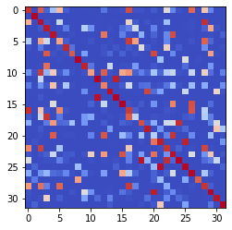

epoch 2021 == measurement_heuristic: 0.36+-0.01/0.31+-0.01 --

epoch 2022 == measurement_heuristic: 0.32+-0.01/0.30+-0.01 --

epoch 2023 == measurement_heuristic: 0.34+-0.01/0.29+-0.01 --

epoch 2024 == measurement_heuristic: 0.33+-0.01/0.30+-0.01 --

epoch 2025 == measurement_heuristic: 0.35+-0.01/0.32+-0.01 --

epoch 2026 == measurement_heuristic: 0.32+-0.01/0.29+-0.01 --

epoch 2027 == measurement_heuristic: 0.34+-0.01/0.30+-0.01 --

epoch 2028 == measurement_heuristic: 0.35+-0.01/0.31+-0.01 --

epoch 2029 == measurement_heuristic: 0.36+-0.01/0.30+-0.01 --

epoch 2030 == measurement_heuristic: 0.34+-0.01/0.30+-0.01 --

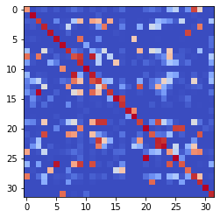

epoch 2031 == measurement_heuristic: 0.34+-0.01/0.30+-0.01 --

epoch 2032 == measurement_heuristic: 0.32+-0.01/0.30+-0.01 --

epoch 2033 == measurement_heuristic: 0.33+-0.01/0.30+-0.01 --

epoch 2034 == measurement_heuristic: 0.31+-0.01/0.29+-0.01 --

epoch 2035 == measurement_heuristic: 0.32+-0.01/0.29+-0.00 --

epoch 2036 == measurement_heuristic: 0.33+-0.01/0.29+-0.01 --

epoch 2037 == measurement_heuristic: 0.33+-0.01/0.29+-0.01 --

epoch 2038 == measurement_heuristic: 0.34+-0.01/0.29+-0.01 --

epoch 2039 == measurement_heuristic: 0.34+-0.01/0.32+-0.01 --

epoch 2040 == measurement_heuristic: 0.35+-0.01/0.30+-0.01 --

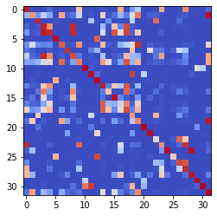

epoch 2041 == measurement_heuristic: 0.34+-0.01/0.30+-0.01 --

epoch 2042 == measurement_heuristic: 0.33+-0.01/0.29+-0.01 --

epoch 2043 == measurement_heuristic: 0.35+-0.01/0.31+-0.01 --

epoch 2044 == measurement_heuristic: 0.33+-0.01/0.30+-0.01 --

epoch 2045 == measurement_heuristic: 0.33+-0.01/0.31+-0.01 --

epoch 2046 == measurement_heuristic: 0.31+-0.01/0.31+-0.01 --

epoch 2047 == measurement_heuristic: 0.34+-0.01/0.29+-0.01 --

epoch 2048 == measurement_heuristic: 0.32+-0.01/0.30+-0.01 --

epoch 2049 == measurement_heuristic: 0.38+-0.01/0.34+-0.01 --

epoch 2050 == measurement_heuristic: 0.34+-0.01/0.29+-0.01 --

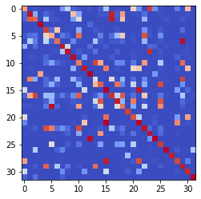

epoch 2051 == measurement_heuristic: 0.34+-0.01/0.29+-0.01 --

epoch 2052 == measurement_heuristic: 0.33+-0.01/0.30+-0.01 --

epoch 2053 == measurement_heuristic: 0.34+-0.01/0.30+-0.01 --

epoch 2054 == measurement_heuristic: 0.32+-0.01/0.29+-0.01 --

epoch 2055 == measurement_heuristic: 0.32+-0.01/0.29+-0.01 --

epoch 2056 == measurement_heuristic: 0.33+-0.01/0.29+-0.01 --

epoch 2057 == measurement_heuristic: 0.33+-0.01/0.30+-0.01 --

epoch 2058 == measurement_heuristic: 0.33+-0.01/0.29+-0.01 --

epoch 2059 == measurement_heuristic: 0.33+-0.01/0.29+-0.00 --

epoch 2060 == measurement_heuristic: 0.34+-0.01/0.31+-0.00 --

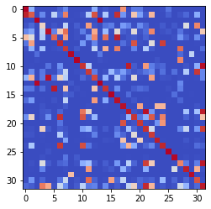

epoch 2061 == measurement_heuristic: 0.32+-0.01/0.32+-0.01 --

epoch 2062 == measurement_heuristic: 0.34+-0.01/0.29+-0.01 --

epoch 2063 == measurement_heuristic: 0.34+-0.01/0.29+-0.01 --

epoch 2064 == measurement_heuristic: 0.32+-0.01/0.29+-0.01 --

epoch 2065 == measurement_heuristic: 0.32+-0.01/0.29+-0.01 --

epoch 2066 >> measurement_heuristic: 0.34+-0.01/0.28+-0.01 --

epoch 2067 == measurement_heuristic: 0.33+-0.01/0.32+-0.01 --

epoch 2068 == measurement_heuristic: 0.35+-0.01/0.29+-0.01 --

epoch 2069 >> measurement_heuristic: 0.30+-0.01/0.28+-0.01 --

epoch 2070 == measurement_heuristic: 0.33+-0.01/0.29+-0.01 --

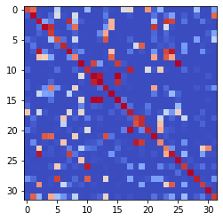

epoch 2071 == measurement_heuristic: 0.32+-0.01/0.28+-0.01 --

epoch 2072 == measurement_heuristic: 0.31+-0.01/0.28+-0.01 --

epoch 2073 == measurement_heuristic: 0.32+-0.01/0.30+-0.00 --

epoch 2074 == measurement_heuristic: 0.33+-0.01/0.28+-0.01 --

epoch 2075 == measurement_heuristic: 0.33+-0.01/0.29+-0.01 --

epoch 2076 == measurement_heuristic: 0.33+-0.01/0.32+-0.01 --

epoch 2077 == measurement_heuristic: 0.36+-0.01/0.30+-0.01 --

epoch 2078 == measurement_heuristic: 0.34+-0.01/0.30+-0.00 --

epoch 2079 == measurement_heuristic: 0.35+-0.01/0.29+-0.01 --

epoch 2080 == measurement_heuristic: 0.34+-0.01/0.31+-0.01 --

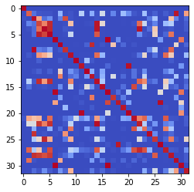

epoch 2081 == measurement_heuristic: 0.34+-0.01/0.29+-0.01 --

epoch 2082 == measurement_heuristic: 0.34+-0.01/0.30+-0.01 --

epoch 2083 == measurement_heuristic: 0.32+-0.01/0.29+-0.01 --

epoch 2084 == measurement_heuristic: 0.33+-0.01/0.31+-0.00 --

epoch 2085 == measurement_heuristic: 0.33+-0.01/0.29+-0.00 --

epoch 2086 == measurement_heuristic: 0.31+-0.01/0.29+-0.01 --

epoch 2087 == measurement_heuristic: 0.31+-0.01/0.28+-0.01 --

epoch 2088 == measurement_heuristic: 0.33+-0.01/0.29+-0.01 --

epoch 2089 == measurement_heuristic: 0.33+-0.01/0.28+-0.01 --

epoch 2090 == measurement_heuristic: 0.32+-0.01/0.29+-0.01 --

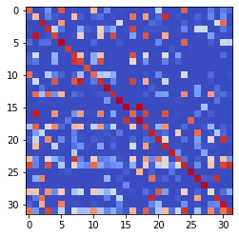

epoch 2091 == measurement_heuristic: 0.35+-0.01/0.30+-0.01 --

epoch 2092 == measurement_heuristic: 0.32+-0.01/0.29+-0.01 --

epoch 2093 == measurement_heuristic: 0.34+-0.01/0.28+-0.01 --

epoch 2094 == measurement_heuristic: 0.32+-0.01/0.28+-0.01 --

epoch 2095 == measurement_heuristic: 0.33+-0.01/0.31+-0.01 --

epoch 2096 == measurement_heuristic: 0.34+-0.01/0.28+-0.01 --

epoch 2097 == measurement_heuristic: 0.33+-0.01/0.30+-0.01 --

epoch 2098 == measurement_heuristic: 0.35+-0.01/0.29+-0.01 --

epoch 2099 == measurement_heuristic: 0.34+-0.01/0.30+-0.00 --

epoch 2100 == measurement_heuristic: 0.33+-0.01/0.29+-0.01 --

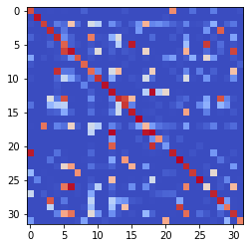

epoch 2101 == measurement_heuristic: 0.33+-0.01/0.29+-0.01 --

epoch 2102 == measurement_heuristic: 0.34+-0.01/0.29+-0.01 --

epoch 2103 == measurement_heuristic: 0.33+-0.01/0.31+-0.01 --

epoch 2104 == measurement_heuristic: 0.32+-0.01/0.29+-0.01 --

epoch 2105 == measurement_heuristic: 0.32+-0.01/0.31+-0.00 --

epoch 2106 == measurement_heuristic: 0.34+-0.01/0.29+-0.01 --

epoch 2107 == measurement_heuristic: 0.33+-0.01/0.29+-0.01 --

epoch 2108 == measurement_heuristic: 0.32+-0.01/0.31+-0.01 --

epoch 2109 == measurement_heuristic: 0.32+-0.01/0.31+-0.01 --

epoch 2110 == measurement_heuristic: 0.33+-0.01/0.35+-0.01 --

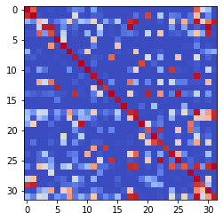

epoch 2111 == measurement_heuristic: 0.33+-0.01/0.29+-0.01 --

epoch 2112 == measurement_heuristic: 0.36+-0.01/0.30+-0.01 --

epoch 2113 == measurement_heuristic: 0.33+-0.01/0.30+-0.01 --

epoch 2114 == measurement_heuristic: 0.34+-0.01/0.31+-0.01 --

epoch 2115 == measurement_heuristic: 0.31+-0.01/0.29+-0.01 --

epoch 2116 == measurement_heuristic: 0.33+-0.01/0.30+-0.01 --

epoch 2117 == measurement_heuristic: 0.32+-0.01/0.29+-0.01 --

epoch 2118 == measurement_heuristic: 0.33+-0.01/0.29+-0.01 --

epoch 2119 == measurement_heuristic: 0.33+-0.01/0.28+-0.01 --

epoch 2120 == measurement_heuristic: 0.32+-0.01/0.29+-0.01 --

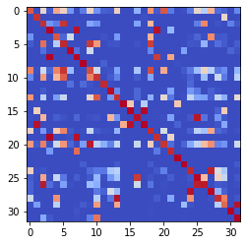

epoch 2121 == measurement_heuristic: 0.32+-0.01/0.31+-0.01 --

epoch 2122 == measurement_heuristic: 0.32+-0.01/0.31+-0.01 --

epoch 2123 == measurement_heuristic: 0.35+-0.01/0.29+-0.01 --

epoch 2124 == measurement_heuristic: 0.32+-0.01/0.29+-0.01 --

epoch 2125 == measurement_heuristic: 0.34+-0.01/0.28+-0.01 --

epoch 2126 == measurement_heuristic: 0.32+-0.01/0.28+-0.01 --

epoch 2127 == measurement_heuristic: 0.33+-0.01/0.28+-0.01 --

epoch 2128 >> measurement_heuristic: 0.33+-0.01/0.28+-0.01 --

epoch 2129 == measurement_heuristic: 0.32+-0.01/0.34+-0.01 --

epoch 2130 == measurement_heuristic: 0.33+-0.01/0.30+-0.01 --

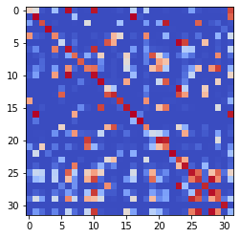

epoch 2131 == measurement_heuristic: 0.35+-0.01/0.31+-0.01 --

epoch 2132 == measurement_heuristic: 0.33+-0.01/0.30+-0.01 --

epoch 2133 == measurement_heuristic: 0.34+-0.01/0.29+-0.01 --

epoch 2134 == measurement_heuristic: 0.32+-0.01/0.30+-0.01 --

epoch 2135 == measurement_heuristic: 0.34+-0.01/0.31+-0.01 --

epoch 2136 == measurement_heuristic: 0.34+-0.01/0.29+-0.01 --

epoch 2137 == measurement_heuristic: 0.34+-0.01/0.31+-0.01 --

epoch 2138 == measurement_heuristic: 0.35+-0.01/0.29+-0.01 --

epoch 2139 == measurement_heuristic: 0.33+-0.01/0.29+-0.01 --

epoch 2140 == measurement_heuristic: 0.32+-0.01/0.30+-0.01 --

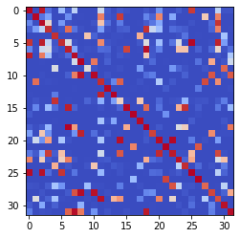

epoch 2141 == measurement_heuristic: 0.34+-0.01/0.30+-0.01 --

epoch 2142 == measurement_heuristic: 0.33+-0.01/0.28+-0.01 --

epoch 2143 == measurement_heuristic: 0.33+-0.01/0.30+-0.01 --

epoch 2144 == measurement_heuristic: 0.33+-0.01/0.30+-0.01 --

epoch 2145 == measurement_heuristic: 0.32+-0.01/0.30+-0.01 --

epoch 2146 == measurement_heuristic: 0.33+-0.01/0.32+-0.01 --

epoch 2147 == measurement_heuristic: 0.35+-0.01/0.31+-0.01 --

epoch 2148 == measurement_heuristic: 0.33+-0.01/0.28+-0.01 --

epoch 2149 == measurement_heuristic: 0.32+-0.01/0.28+-0.01 --

epoch 2150 == measurement_heuristic: 0.33+-0.01/0.30+-0.01 --

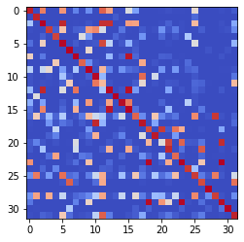

epoch 2151 == measurement_heuristic: 0.32+-0.01/0.31+-0.01 --

epoch 2152 == measurement_heuristic: 0.33+-0.01/0.28+-0.01 --

epoch 2153 == measurement_heuristic: 0.33+-0.01/0.29+-0.01 --

epoch 2154 == measurement_heuristic: 0.33+-0.01/0.29+-0.01 --

epoch 2155 == measurement_heuristic: 0.32+-0.01/0.29+-0.01 --

epoch 2156 == measurement_heuristic: 0.34+-0.01/0.29+-0.01 --

epoch 2157 == measurement_heuristic: 0.33+-0.01/0.29+-0.01 --

epoch 2158 == measurement_heuristic: 0.32+-0.01/0.28+-0.01 --

epoch 2159 >> measurement_heuristic: 0.33+-0.01/0.28+-0.01 --

epoch 2160 == measurement_heuristic: 0.34+-0.01/0.29+-0.01 --

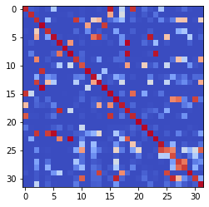

epoch 2161 == measurement_heuristic: 0.33+-0.01/0.28+-0.01 --

epoch 2162 == measurement_heuristic: 0.32+-0.01/0.28+-0.01 --

epoch 2163 == measurement_heuristic: 0.34+-0.01/0.34+-0.01 --

epoch 2164 == measurement_heuristic: 0.31+-0.01/0.29+-0.00 --

epoch 2165 == measurement_heuristic: 0.34+-0.01/0.30+-0.01 --

epoch 2166 == measurement_heuristic: 0.33+-0.01/0.29+-0.01 --

epoch 2167 == measurement_heuristic: 0.32+-0.01/0.29+-0.01 --

epoch 2168 == measurement_heuristic: 0.34+-0.01/0.31+-0.01 --

epoch 2169 == measurement_heuristic: 0.33+-0.01/0.33+-0.01 --

epoch 2170 == measurement_heuristic: 0.34+-0.01/0.30+-0.00 --

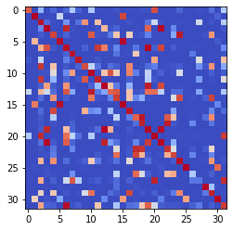

epoch 2171 == measurement_heuristic: 0.35+-0.01/0.31+-0.01 --

epoch 2172 == measurement_heuristic: 0.33+-0.01/0.29+-0.01 --

epoch 2173 == measurement_heuristic: 0.32+-0.01/0.28+-0.01 --

epoch 2174 == measurement_heuristic: 0.33+-0.01/0.28+-0.01 --

epoch 2175 == measurement_heuristic: 0.34+-0.01/0.31+-0.01 --

epoch 2176 == measurement_heuristic: 0.32+-0.01/0.28+-0.01 --

epoch 2177 == measurement_heuristic: 0.31+-0.01/0.29+-0.01 --

epoch 2178 == measurement_heuristic: 0.32+-0.01/0.30+-0.01 --

epoch 2179 == measurement_heuristic: 0.33+-0.01/0.29+-0.01 --

epoch 2180 == measurement_heuristic: 0.32+-0.01/0.29+-0.01 --

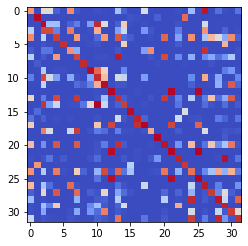

epoch 2181 == measurement_heuristic: 0.36+-0.01/0.29+-0.01 --

epoch 2182 == measurement_heuristic: 0.35+-0.01/0.28+-0.01 --

epoch 2183 == measurement_heuristic: 0.33+-0.01/0.31+-0.01 --

epoch 2184 == measurement_heuristic: 0.34+-0.01/0.29+-0.01 --

epoch 2185 == measurement_heuristic: 0.35+-0.01/0.28+-0.01 --

epoch 2186 == measurement_heuristic: 0.34+-0.01/0.29+-0.01 --

epoch 2187 == measurement_heuristic: 0.33+-0.01/0.30+-0.01 --

epoch 2188 == measurement_heuristic: 0.33+-0.01/0.29+-0.01 --

epoch 2189 >> measurement_heuristic: 0.32+-0.01/0.28+-0.01 --

epoch 2190 == measurement_heuristic: 0.31+-0.01/0.29+-0.01 --

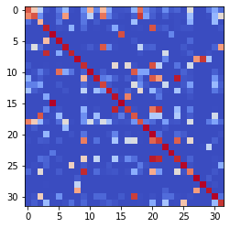

epoch 2191 == measurement_heuristic: 0.34+-0.01/0.31+-0.01 --

epoch 2192 == measurement_heuristic: 0.32+-0.01/0.29+-0.01 --

epoch 2193 == measurement_heuristic: 0.33+-0.01/0.29+-0.01 --

epoch 2194 == measurement_heuristic: 0.34+-0.01/0.30+-0.01 --

epoch 2195 == measurement_heuristic: 0.34+-0.01/0.30+-0.01 --

epoch 2196 == measurement_heuristic: 0.31+-0.01/0.29+-0.01 --

epoch 2197 == measurement_heuristic: 0.32+-0.01/0.31+-0.01 --

epoch 2198 == measurement_heuristic: 0.33+-0.01/0.28+-0.01 --

epoch 2199 == measurement_heuristic: 0.31+-0.01/0.28+-0.01 --

epoch 2200 == measurement_heuristic: 0.33+-0.01/0.29+-0.01 --

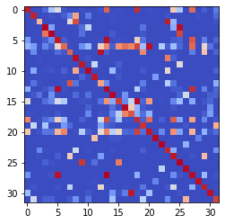

epoch 2201 == measurement_heuristic: 0.32+-0.01/0.30+-0.01 --

epoch 2202 == measurement_heuristic: 0.35+-0.01/0.30+-0.01 --

epoch 2203 == measurement_heuristic: 0.33+-0.01/0.28+-0.01 --

epoch 2204 == measurement_heuristic: 0.31+-0.01/0.29+-0.01 --

epoch 2205 >> measurement_heuristic: 0.31+-0.01/0.27+-0.01 --

epoch 2206 == measurement_heuristic: 0.32+-0.01/0.30+-0.01 --

epoch 2207 == measurement_heuristic: 0.33+-0.01/0.28+-0.01 --

epoch 2208 == measurement_heuristic: 0.34+-0.01/0.29+-0.01 --

epoch 2209 >> measurement_heuristic: 0.31+-0.01/0.27+-0.01 --

epoch 2210 == measurement_heuristic: 0.33+-0.01/0.28+-0.01 --

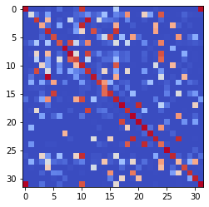

epoch 2211 == measurement_heuristic: 0.35+-0.01/0.30+-0.01 --

epoch 2212 == measurement_heuristic: 0.33+-0.01/0.29+-0.01 --

epoch 2213 == measurement_heuristic: 0.32+-0.01/0.28+-0.01 --

epoch 2214 == measurement_heuristic: 0.33+-0.01/0.28+-0.01 --

epoch 2215 == measurement_heuristic: 0.33+-0.01/0.28+-0.01 --

epoch 2216 == measurement_heuristic: 0.30+-0.01/0.27+-0.01 --

epoch 2217 == measurement_heuristic: 0.32+-0.01/0.28+-0.01 --

epoch 2218 == measurement_heuristic: 0.32+-0.01/0.28+-0.01 --

epoch 2219 == measurement_heuristic: 0.33+-0.01/0.28+-0.01 --

epoch 2220 == measurement_heuristic: 0.35+-0.01/0.30+-0.01 --

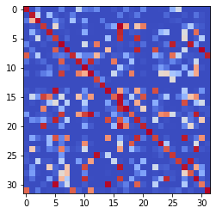

epoch 2221 == measurement_heuristic: 0.31+-0.01/0.30+-0.01 --

epoch 2222 == measurement_heuristic: 0.33+-0.01/0.30+-0.01 --

epoch 2223 == measurement_heuristic: 0.31+-0.01/0.29+-0.01 --

epoch 2224 == measurement_heuristic: 0.34+-0.01/0.29+-0.01 --

epoch 2225 == measurement_heuristic: 0.33+-0.01/0.28+-0.01 --

epoch 2226 == measurement_heuristic: 0.33+-0.01/0.28+-0.01 --

epoch 2227 == measurement_heuristic: 0.31+-0.01/0.29+-0.01 --

epoch 2228 == measurement_heuristic: 0.34+-0.01/0.33+-0.01 --

epoch 2229 == measurement_heuristic: 0.34+-0.01/0.28+-0.01 --

epoch 2230 == measurement_heuristic: 0.33+-0.01/0.30+-0.01 --

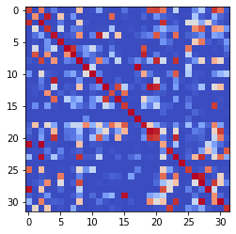

epoch 2231 == measurement_heuristic: 0.32+-0.01/0.28+-0.01 --

epoch 2232 == measurement_heuristic: 0.34+-0.01/0.29+-0.01 --

epoch 2233 == measurement_heuristic: 0.33+-0.01/0.28+-0.01 --

epoch 2234 == measurement_heuristic: 0.31+-0.01/0.30+-0.01 --

epoch 2235 == measurement_heuristic: 0.33+-0.01/0.32+-0.01 --

epoch 2236 == measurement_heuristic: 0.33+-0.01/0.28+-0.01 --

epoch 2237 == measurement_heuristic: 0.34+-0.01/0.30+-0.00 --

epoch 2238 == measurement_heuristic: 0.32+-0.01/0.28+-0.01 --

epoch 2239 == measurement_heuristic: 0.34+-0.01/0.31+-0.01 --

epoch 2240 == measurement_heuristic: 0.35+-0.01/0.30+-0.01 --

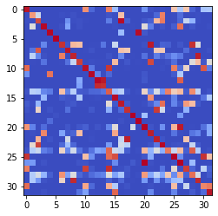

epoch 2241 == measurement_heuristic: 0.33+-0.01/0.28+-0.01 --

epoch 2242 == measurement_heuristic: 0.34+-0.01/0.28+-0.01 --

epoch 2243 == measurement_heuristic: 0.33+-0.01/0.30+-0.01 --

epoch 2244 == measurement_heuristic: 0.31+-0.01/0.27+-0.01 --

epoch 2245 == measurement_heuristic: 0.33+-0.01/0.31+-0.01 --

epoch 2246 == measurement_heuristic: 0.33+-0.01/0.30+-0.01 --

epoch 2247 == measurement_heuristic: 0.34+-0.01/0.31+-0.01 --

epoch 2248 == measurement_heuristic: 0.32+-0.01/0.29+-0.01 --

epoch 2249 == measurement_heuristic: 0.32+-0.01/0.28+-0.00 --

epoch 2250 == measurement_heuristic: 0.31+-0.01/0.28+-0.00 --

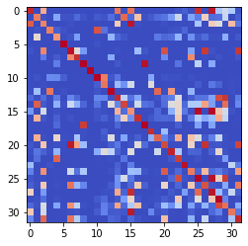

epoch 2251 == measurement_heuristic: 0.34+-0.01/0.28+-0.00 --

epoch 2252 == measurement_heuristic: 0.32+-0.01/0.29+-0.01 --

epoch 2253 == measurement_heuristic: 0.33+-0.01/0.30+-0.00 --

epoch 2254 == measurement_heuristic: 0.33+-0.01/0.28+-0.01 --

epoch 2255 == measurement_heuristic: 0.32+-0.01/0.28+-0.01 --

epoch 2256 == measurement_heuristic: 0.33+-0.01/0.27+-0.01 --

epoch 2257 == measurement_heuristic: 0.32+-0.01/0.28+-0.01 --

epoch 2258 == measurement_heuristic: 0.33+-0.01/0.29+-0.01 --

epoch 2259 == measurement_heuristic: 0.32+-0.01/0.33+-0.00 --

epoch 2260 == measurement_heuristic: 0.33+-0.01/0.29+-0.01 --

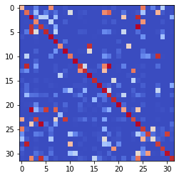

epoch 2261 == measurement_heuristic: 0.33+-0.01/0.29+-0.01 --

epoch 2262 == measurement_heuristic: 0.33+-0.01/0.29+-0.01 --

epoch 2263 == measurement_heuristic: 0.33+-0.01/0.27+-0.01 --

epoch 2264 == measurement_heuristic: 0.34+-0.01/0.28+-0.01 --

epoch 2265 == measurement_heuristic: 0.32+-0.01/0.29+-0.01 --

epoch 2266 == measurement_heuristic: 0.34+-0.01/0.29+-0.01 --

epoch 2267 == measurement_heuristic: 0.32+-0.01/0.29+-0.00 --

epoch 2268 == measurement_heuristic: 0.32+-0.01/0.29+-0.01 --

epoch 2269 == measurement_heuristic: 0.32+-0.01/0.28+-0.01 --

epoch 2270 == measurement_heuristic: 0.31+-0.01/0.28+-0.01 --

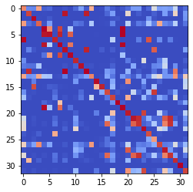

epoch 2271 == measurement_heuristic: 0.32+-0.01/0.28+-0.01 --

epoch 2272 == measurement_heuristic: 0.33+-0.01/0.31+-0.01 --

epoch 2273 == measurement_heuristic: 0.33+-0.01/0.30+-0.01 --

epoch 2274 == measurement_heuristic: 0.32+-0.01/0.28+-0.01 --

epoch 2275 == measurement_heuristic: 0.32+-0.01/0.29+-0.01 --

epoch 2276 == measurement_heuristic: 0.33+-0.01/0.29+-0.01 --

epoch 2277 == measurement_heuristic: 0.32+-0.01/0.28+-0.01 --

epoch 2278 == measurement_heuristic: 0.34+-0.01/0.29+-0.01 --

epoch 2279 == measurement_heuristic: 0.34+-0.01/0.29+-0.01 --

epoch 2280 == measurement_heuristic: 0.33+-0.01/0.29+-0.01 --

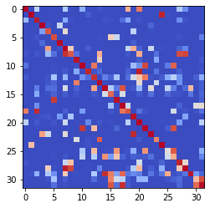

epoch 2281 == measurement_heuristic: 0.33+-0.01/0.29+-0.00 --

epoch 2282 == measurement_heuristic: 0.33+-0.01/0.28+-0.01 --

epoch 2283 == measurement_heuristic: 0.33+-0.01/0.29+-0.01 --

epoch 2284 == measurement_heuristic: 0.33+-0.01/0.29+-0.01 --

epoch 2285 == measurement_heuristic: 0.33+-0.01/0.29+-0.01 --

epoch 2286 == measurement_heuristic: 0.32+-0.01/0.28+-0.00 --

epoch 2287 == measurement_heuristic: 0.33+-0.01/0.28+-0.01 --

epoch 2288 == measurement_heuristic: 0.32+-0.01/0.28+-0.01 --

epoch 2289 == measurement_heuristic: 0.33+-0.01/0.29+-0.01 --

epoch 2290 == measurement_heuristic: 0.32+-0.01/0.28+-0.01 --

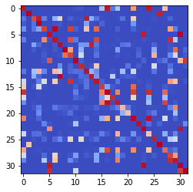

epoch 2291 == measurement_heuristic: 0.32+-0.01/0.33+-0.01 --

epoch 2292 == measurement_heuristic: 0.33+-0.01/0.28+-0.01 --

epoch 2293 == measurement_heuristic: 0.35+-0.01/0.34+-0.01 --

epoch 2294 == measurement_heuristic: 0.32+-0.01/0.29+-0.01 --

epoch 2295 == measurement_heuristic: 0.32+-0.01/0.29+-0.01 --

epoch 2296 == measurement_heuristic: 0.32+-0.01/0.30+-0.01 --

epoch 2297 == measurement_heuristic: 0.33+-0.01/0.29+-0.01 --

epoch 2298 == measurement_heuristic: 0.32+-0.01/0.28+-0.01 --

epoch 2299 == measurement_heuristic: 0.31+-0.01/0.28+-0.01 --

epoch 2300 == measurement_heuristic: 0.34+-0.01/0.29+-0.01 --

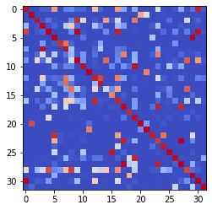

epoch 2301 == measurement_heuristic: 0.33+-0.01/0.29+-0.01 --

epoch 2302 == measurement_heuristic: 0.33+-0.01/0.28+-0.01 --

epoch 2303 == measurement_heuristic: 0.31+-0.01/0.30+-0.01 --

epoch 2304 == measurement_heuristic: 0.31+-0.01/0.28+-0.01 --

epoch 2305 == measurement_heuristic: 0.32+-0.01/0.28+-0.01 --

epoch 2306 == measurement_heuristic: 0.33+-0.01/0.28+-0.01 --

epoch 2307 == measurement_heuristic: 0.30+-0.01/0.28+-0.01 --

epoch 2308 == measurement_heuristic: 0.31+-0.01/0.28+-0.01 --

epoch 2309 == measurement_heuristic: 0.33+-0.01/0.28+-0.01 --

epoch 2310 == measurement_heuristic: 0.33+-0.01/0.29+-0.01 --

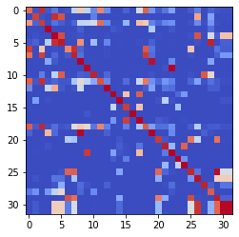

epoch 2311 == measurement_heuristic: 0.32+-0.01/0.29+-0.01 --

epoch 2312 == measurement_heuristic: 0.31+-0.01/0.30+-0.01 --

epoch 2313 == measurement_heuristic: 0.33+-0.01/0.28+-0.01 --

epoch 2314 == measurement_heuristic: 0.33+-0.01/0.27+-0.01 --

epoch 2315 == measurement_heuristic: 0.32+-0.01/0.29+-0.01 --

epoch 2316 == measurement_heuristic: 0.33+-0.01/0.28+-0.01 --

epoch 2317 == measurement_heuristic: 0.34+-0.01/0.32+-0.01 --

epoch 2318 == measurement_heuristic: 0.33+-0.01/0.29+-0.01 --

epoch 2319 == measurement_heuristic: 0.32+-0.01/0.30+-0.01 --

epoch 2320 == measurement_heuristic: 0.34+-0.01/0.30+-0.01 --

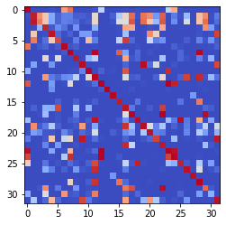

epoch 2321 == measurement_heuristic: 0.32+-0.01/0.27+-0.01 --

epoch 2322 == measurement_heuristic: 0.33+-0.01/0.31+-0.01 --

epoch 2323 == measurement_heuristic: 0.32+-0.01/0.27+-0.01 --

epoch 2324 == measurement_heuristic: 0.29+-0.01/0.27+-0.01 --

epoch 2325 == measurement_heuristic: 0.33+-0.01/0.28+-0.01 --

epoch 2326 == measurement_heuristic: 0.33+-0.01/0.28+-0.01 --

epoch 2327 == measurement_heuristic: 0.33+-0.01/0.29+-0.01 --

epoch 2328 == measurement_heuristic: 0.32+-0.01/0.28+-0.01 --

epoch 2329 == measurement_heuristic: 0.33+-0.01/0.28+-0.01 --

epoch 2330 == measurement_heuristic: 0.32+-0.01/0.28+-0.01 --

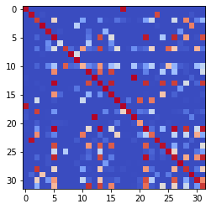

epoch 2331 == measurement_heuristic: 0.31+-0.01/0.29+-0.01 --

epoch 2332 == measurement_heuristic: 0.30+-0.01/0.27+-0.01 --

epoch 2333 == measurement_heuristic: 0.32+-0.01/0.29+-0.01 --

epoch 2334 == measurement_heuristic: 0.31+-0.01/0.28+-0.01 --

epoch 2335 == measurement_heuristic: 0.33+-0.01/0.28+-0.01 --

epoch 2336 == measurement_heuristic: 0.33+-0.01/0.28+-0.01 --

epoch 2337 == measurement_heuristic: 0.34+-0.01/0.28+-0.01 --

epoch 2338 == measurement_heuristic: 0.32+-0.01/0.29+-0.01 --

epoch 2339 == measurement_heuristic: 0.33+-0.01/0.28+-0.01 --

epoch 2340 == measurement_heuristic: 0.33+-0.01/0.28+-0.01 --

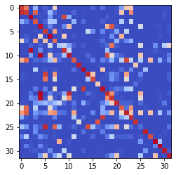

epoch 2341 == measurement_heuristic: 0.34+-0.01/0.28+-0.01 --

epoch 2342 == measurement_heuristic: 0.30+-0.01/0.28+-0.01 --

epoch 2343 == measurement_heuristic: 0.35+-0.01/0.28+-0.01 --

epoch 2344 == measurement_heuristic: 0.33+-0.01/0.30+-0.01 --

epoch 2345 == measurement_heuristic: 0.31+-0.01/0.29+-0.01 --

epoch 2346 == measurement_heuristic: 0.31+-0.01/0.30+-0.01 --

epoch 2347 == measurement_heuristic: 0.35+-0.01/0.30+-0.01 --

epoch 2348 == measurement_heuristic: 0.33+-0.01/0.30+-0.01 --

epoch 2349 == measurement_heuristic: 0.32+-0.01/0.30+-0.01 --

epoch 2350 == measurement_heuristic: 0.32+-0.01/0.29+-0.01 --

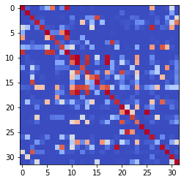

epoch 2351 == measurement_heuristic: 0.31+-0.01/0.32+-0.01 --

epoch 2352 == measurement_heuristic: 0.32+-0.01/0.29+-0.01 --

epoch 2353 == measurement_heuristic: 0.31+-0.01/0.28+-0.01 --

epoch 2354 == measurement_heuristic: 0.32+-0.01/0.28+-0.01 --

epoch 2355 == measurement_heuristic: 0.32+-0.01/0.28+-0.01 --

epoch 2356 == measurement_heuristic: 0.33+-0.01/0.30+-0.01 --

epoch 2357 == measurement_heuristic: 0.30+-0.01/0.28+-0.01 --

epoch 2358 == measurement_heuristic: 0.35+-0.01/0.31+-0.01 --

epoch 2359 == measurement_heuristic: 0.32+-0.01/0.29+-0.01 --

epoch 2360 == measurement_heuristic: 0.34+-0.01/0.30+-0.01 --

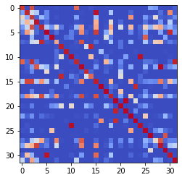

epoch 2361 == measurement_heuristic: 0.33+-0.01/0.29+-0.01 --

epoch 2362 == measurement_heuristic: 0.35+-0.01/0.29+-0.01 --

epoch 2363 == measurement_heuristic: 0.31+-0.01/0.28+-0.01 --

epoch 2364 == measurement_heuristic: 0.32+-0.01/0.29+-0.01 --

epoch 2365 == measurement_heuristic: 0.33+-0.01/0.28+-0.00 --

epoch 2366 == measurement_heuristic: 0.34+-0.01/0.32+-0.01 --

epoch 2367 == measurement_heuristic: 0.32+-0.01/0.29+-0.01 --

epoch 2368 == measurement_heuristic: 0.32+-0.01/0.29+-0.01 --

epoch 2369 == measurement_heuristic: 0.31+-0.01/0.29+-0.01 --

epoch 2370 == measurement_heuristic: 0.33+-0.01/0.30+-0.01 --

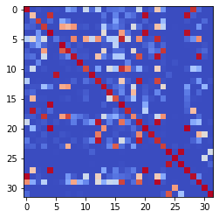

epoch 2371 == measurement_heuristic: 0.32+-0.01/0.28+-0.01 --

epoch 2372 == measurement_heuristic: 0.33+-0.01/0.29+-0.01 --

epoch 2373 == measurement_heuristic: 0.33+-0.01/0.29+-0.01 --

epoch 2374 == measurement_heuristic: 0.33+-0.01/0.29+-0.01 --

epoch 2375 == measurement_heuristic: 0.33+-0.01/0.28+-0.01 --

epoch 2376 == measurement_heuristic: 0.33+-0.01/0.28+-0.01 --

epoch 2377 == measurement_heuristic: 0.32+-0.01/0.29+-0.01 --

epoch 2378 == measurement_heuristic: 0.31+-0.01/0.28+-0.01 --

epoch 2379 == measurement_heuristic: 0.32+-0.01/0.32+-0.01 --

epoch 2380 == measurement_heuristic: 0.34+-0.01/0.29+-0.00 --

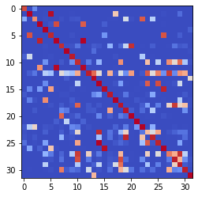

epoch 2381 == measurement_heuristic: 0.32+-0.01/0.29+-0.01 --

epoch 2382 == measurement_heuristic: 0.30+-0.01/0.30+-0.01 --

epoch 2383 == measurement_heuristic: 0.30+-0.01/0.28+-0.01 --

epoch 2384 == measurement_heuristic: 0.30+-0.01/0.30+-0.01 --

epoch 2385 == measurement_heuristic: 0.32+-0.01/0.28+-0.01 --

epoch 2386 == measurement_heuristic: 0.32+-0.01/0.30+-0.01 --

epoch 2387 == measurement_heuristic: 0.32+-0.01/0.29+-0.01 --

epoch 2388 == measurement_heuristic: 0.30+-0.01/0.31+-0.01 --

epoch 2389 == measurement_heuristic: 0.31+-0.01/0.27+-0.01 --

epoch 2390 == measurement_heuristic: 0.32+-0.01/0.28+-0.01 --

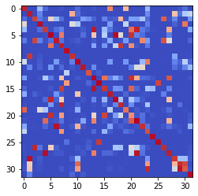

epoch 2391 == measurement_heuristic: 0.30+-0.01/0.29+-0.01 --

epoch 2392 == measurement_heuristic: 0.33+-0.01/0.28+-0.01 --

epoch 2393 == measurement_heuristic: 0.31+-0.01/0.28+-0.01 --

epoch 2394 == measurement_heuristic: 0.30+-0.01/0.28+-0.01 --

epoch 2395 == measurement_heuristic: 0.33+-0.01/0.30+-0.01 --

epoch 2396 == measurement_heuristic: 0.34+-0.01/0.31+-0.01 --

epoch 2397 == measurement_heuristic: 0.32+-0.01/0.28+-0.01 --

epoch 2398 == measurement_heuristic: 0.32+-0.01/0.29+-0.01 --

epoch 2399 == measurement_heuristic: 0.31+-0.01/0.28+-0.01 --

epoch 2400 == measurement_heuristic: 0.33+-0.01/0.28+-0.01 --

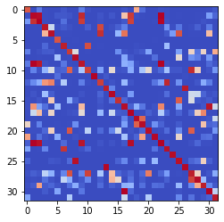

epoch 2401 == measurement_heuristic: 0.30+-0.01/0.27+-0.01 --

epoch 2402 == measurement_heuristic: 0.32+-0.01/0.28+-0.01 --

epoch 2403 == measurement_heuristic: 0.30+-0.01/0.29+-0.01 --

epoch 2404 == measurement_heuristic: 0.30+-0.01/0.28+-0.01 --

epoch 2405 == measurement_heuristic: 0.32+-0.01/0.32+-0.01 --

epoch 2406 == measurement_heuristic: 0.32+-0.01/0.27+-0.01 --

epoch 2407 == measurement_heuristic: 0.34+-0.01/0.29+-0.01 --

epoch 2408 == measurement_heuristic: 0.33+-0.01/0.28+-0.01 --

INFO:tensorflow:Restoring parameters from ../models/tmp/best_validation

INFO:tensorflow:Restoring parameters from ../models/tmp/best_validation

epoch 0 >> proposed_mle: 36.42+-0.06 --

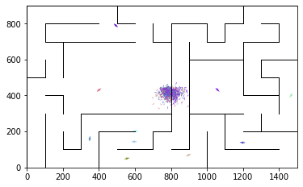

epoch 1 >> proposed_mle: 35.44+-0.15/34.49+-0.14 --

epoch 2 >> proposed_mle: 33.96+-0.21/33.45+-0.15 --

epoch 3 >> proposed_mle: 33.43+-0.26/32.93+-0.17 --

epoch 4 >> proposed_mle: 33.00+-0.23/31.69+-0.18 --

epoch 5 == proposed_mle: 31.54+-0.31/31.81+-0.19 --

epoch 6 >> proposed_mle: 31.40+-0.25/31.11+-0.19 --

epoch 7 >> proposed_mle: 31.21+-0.23/30.33+-0.18 --

epoch 8 == proposed_mle: 30.53+-0.26/30.57+-0.18 --

epoch 9 >> proposed_mle: 30.20+-0.24/29.37+-0.19 --

epoch 10 >> proposed_mle: 28.71+-0.29/28.54+-0.22 --

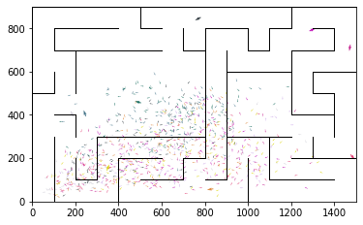

epoch 11 >> proposed_mle: 28.74+-0.31/27.95+-0.19 --

epoch 12 == proposed_mle: 27.41+-0.28/28.03+-0.17 --

epoch 13 >> proposed_mle: 26.83+-0.31/26.31+-0.22 --

epoch 14 >> proposed_mle: 26.78+-0.27/25.75+-0.22 --

epoch 15 >> proposed_mle: 25.92+-0.32/25.74+-0.20 --

epoch 16 >> proposed_mle: 25.51+-0.24/25.74+-0.22 --

epoch 17 == proposed_mle: 26.19+-0.24/25.87+-0.22 --

epoch 18 == proposed_mle: 26.24+-0.26/25.85+-0.21 --

epoch 19 >> proposed_mle: 25.61+-0.25/25.52+-0.21 --

epoch 20 == proposed_mle: 25.40+-0.33/25.54+-0.23 --

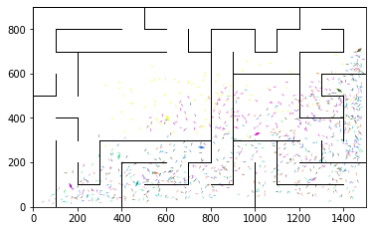

epoch 21 == proposed_mle: 25.15+-0.31/26.25+-0.20 --

epoch 22 == proposed_mle: 26.19+-0.31/25.98+-0.22 --

epoch 23 >> proposed_mle: 25.64+-0.28/25.13+-0.22 --

epoch 24 == proposed_mle: 25.45+-0.31/25.93+-0.23 --

epoch 25 >> proposed_mle: 25.82+-0.28/25.04+-0.20 --

epoch 26 == proposed_mle: 24.79+-0.28/25.07+-0.21 --

epoch 27 == proposed_mle: 25.18+-0.33/25.17+-0.21 --

epoch 28 == proposed_mle: 25.71+-0.28/25.10+-0.22 --

epoch 29 >> proposed_mle: 25.50+-0.29/24.80+-0.21 --

epoch 30 >> proposed_mle: 24.72+-0.32/24.78+-0.21 --

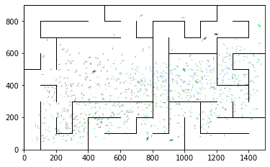

epoch 31 == proposed_mle: 24.14+-0.31/24.96+-0.21 --

epoch 32 == proposed_mle: 24.93+-0.33/25.20+-0.21 --

epoch 33 >> proposed_mle: 25.13+-0.32/24.65+-0.20 --

epoch 34 >> proposed_mle: 25.20+-0.34/24.28+-0.22 --

epoch 35 == proposed_mle: 24.20+-0.31/24.62+-0.19 --

epoch 36 == proposed_mle: 24.25+-0.34/24.63+-0.21 --

epoch 37 >> proposed_mle: 24.27+-0.24/24.22+-0.19 --

epoch 38 == proposed_mle: 24.42+-0.33/24.29+-0.22 --

epoch 39 == proposed_mle: 24.12+-0.30/24.24+-0.23 --

epoch 40 == proposed_mle: 24.01+-0.26/24.31+-0.20 --

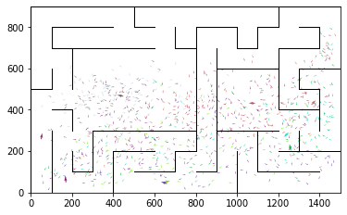

epoch 41 >> proposed_mle: 24.36+-0.30/23.91+-0.25 --

epoch 42 == proposed_mle: 24.08+-0.35/24.55+-0.20 --

epoch 43 >> proposed_mle: 24.52+-0.32/23.78+-0.22 --

epoch 44 == proposed_mle: 24.09+-0.35/24.02+-0.23 --

epoch 45 == proposed_mle: 24.62+-0.32/23.98+-0.22 --

epoch 46 >> proposed_mle: 24.44+-0.34/23.73+-0.23 --

epoch 47 == proposed_mle: 24.61+-0.34/23.91+-0.22 --

epoch 48 == proposed_mle: 24.22+-0.28/23.77+-0.21 --

epoch 49 == proposed_mle: 24.72+-0.37/24.57+-0.20 --

epoch 50 >> proposed_mle: 24.35+-0.29/23.68+-0.19 --

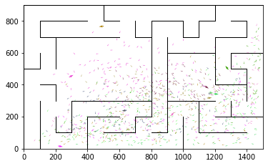

epoch 51 == proposed_mle: 24.18+-0.31/23.85+-0.24 --

epoch 52 == proposed_mle: 23.51+-0.34/23.87+-0.22 --

epoch 53 >> proposed_mle: 23.94+-0.33/23.40+-0.24 --

epoch 54 == proposed_mle: 23.46+-0.30/23.41+-0.22 --

epoch 55 == proposed_mle: 24.20+-0.30/23.54+-0.20 --

epoch 56 == proposed_mle: 24.27+-0.28/24.15+-0.22 --

epoch 57 >> proposed_mle: 24.06+-0.26/23.34+-0.20 --

epoch 58 >> proposed_mle: 23.94+-0.33/23.07+-0.21 --

epoch 59 >> proposed_mle: 23.64+-0.27/23.05+-0.21 --

epoch 60 == proposed_mle: 23.72+-0.31/23.33+-0.23 --

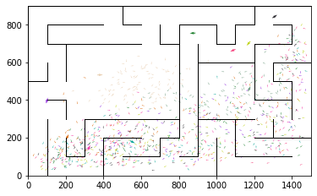

epoch 61 == proposed_mle: 23.71+-0.25/23.33+-0.22 --

epoch 62 == proposed_mle: 23.55+-0.33/23.68+-0.23 --

epoch 63 == proposed_mle: 23.75+-0.34/23.28+-0.24 --

epoch 64 == proposed_mle: 23.78+-0.29/23.11+-0.22 --

epoch 65 == proposed_mle: 23.83+-0.32/23.46+-0.21 --

epoch 66 >> proposed_mle: 23.31+-0.32/23.02+-0.21 --

epoch 67 >> proposed_mle: 22.86+-0.35/22.95+-0.21 --

epoch 68 == proposed_mle: 23.27+-0.28/23.15+-0.23 --

epoch 69 == proposed_mle: 23.47+-0.31/23.63+-0.21 --

epoch 70 == proposed_mle: 23.25+-0.33/23.01+-0.21 --

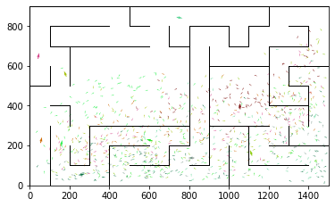

epoch 71 == proposed_mle: 23.40+-0.35/23.20+-0.22 --

epoch 72 == proposed_mle: 23.16+-0.31/23.15+-0.20 --

epoch 73 == proposed_mle: 23.19+-0.31/23.09+-0.21 --

epoch 74 >> proposed_mle: 23.11+-0.33/22.84+-0.22 --

epoch 75 == proposed_mle: 23.19+-0.29/23.01+-0.20 --

epoch 76 == proposed_mle: 23.48+-0.29/23.00+-0.20 --

epoch 77 >> proposed_mle: 23.34+-0.30/22.54+-0.23 --

epoch 78 >> proposed_mle: 22.77+-0.33/22.51+-0.24 --

epoch 79 == proposed_mle: 22.83+-0.35/23.08+-0.23 --

epoch 80 == proposed_mle: 22.63+-0.35/22.67+-0.21 --

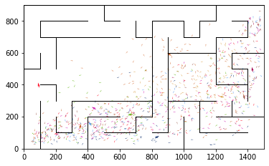

epoch 81 == proposed_mle: 23.29+-0.33/22.72+-0.21 --

epoch 82 == proposed_mle: 23.02+-0.32/22.66+-0.22 --

epoch 83 == proposed_mle: 22.71+-0.32/22.66+-0.23 --

epoch 84 == proposed_mle: 22.66+-0.26/22.56+-0.21 --

epoch 85 == proposed_mle: 23.26+-0.28/22.86+-0.22 --

epoch 86 == proposed_mle: 23.45+-0.35/22.53+-0.24 --

epoch 87 >> proposed_mle: 23.04+-0.34/22.45+-0.21 --

epoch 88 == proposed_mle: 22.26+-0.36/23.29+-0.21 --

epoch 89 == proposed_mle: 24.63+-0.38/23.37+-0.21 --

epoch 90 == proposed_mle: 23.28+-0.32/23.18+-0.22 --

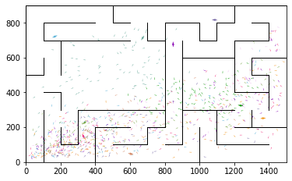

epoch 91 == proposed_mle: 22.25+-0.32/22.59+-0.24 --

epoch 92 == proposed_mle: 22.42+-0.34/23.20+-0.23 --

epoch 93 == proposed_mle: 23.50+-0.35/24.42+-0.24 --

epoch 94 == proposed_mle: 23.83+-0.31/22.47+-0.22 --

epoch 95 >> proposed_mle: 22.80+-0.32/22.38+-0.23 --

epoch 96 >> proposed_mle: 22.18+-0.33/22.16+-0.26 --

epoch 97 >> proposed_mle: 22.58+-0.29/22.09+-0.21 --

epoch 98 == proposed_mle: 22.33+-0.29/22.25+-0.23 --

epoch 99 == proposed_mle: 22.84+-0.27/22.20+-0.23 --

epoch 100 == proposed_mle: 22.15+-0.33/22.13+-0.23 --

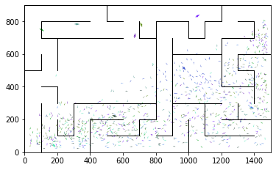

epoch 101 == proposed_mle: 22.25+-0.27/22.10+-0.24 --

epoch 102 == proposed_mle: 23.01+-0.32/23.47+-0.23 --

epoch 103 == proposed_mle: 24.12+-0.32/23.15+-0.22 --

epoch 104 == proposed_mle: 23.02+-0.27/22.42+-0.22 --

epoch 105 == proposed_mle: 22.73+-0.37/22.51+-0.23 --

epoch 106 == proposed_mle: 22.55+-0.37/22.46+-0.22 --

epoch 107 == proposed_mle: 22.35+-0.37/22.37+-0.22 --

epoch 108 >> proposed_mle: 22.24+-0.27/21.94+-0.24 --

epoch 109 == proposed_mle: 22.53+-0.31/22.43+-0.24 --

epoch 110 == proposed_mle: 22.16+-0.32/22.11+-0.25 --

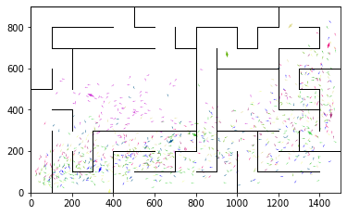

epoch 111 == proposed_mle: 22.76+-0.31/22.25+-0.22 --

epoch 112 == proposed_mle: 22.30+-0.32/22.03+-0.23 --

epoch 113 == proposed_mle: 22.28+-0.33/21.98+-0.23 --

epoch 114 == proposed_mle: 21.88+-0.32/22.05+-0.22 --

epoch 115 == proposed_mle: 22.08+-0.31/22.23+-0.22 --

epoch 116 >> proposed_mle: 21.94+-0.31/21.68+-0.22 --

epoch 117 == proposed_mle: 21.67+-0.36/21.81+-0.22 --

epoch 118 == proposed_mle: 22.13+-0.30/22.01+-0.24 --

epoch 119 == proposed_mle: 22.30+-0.29/21.70+-0.23 --

epoch 120 == proposed_mle: 22.07+-0.37/21.93+-0.23 --

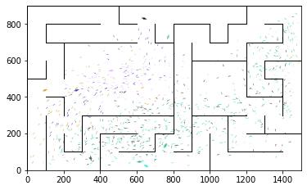

epoch 121 == proposed_mle: 21.98+-0.30/21.86+-0.21 --

epoch 122 >> proposed_mle: 22.34+-0.27/21.53+-0.22 --

epoch 123 == proposed_mle: 22.45+-0.37/21.73+-0.22 --

epoch 124 == proposed_mle: 21.75+-0.27/21.74+-0.22 --

epoch 125 == proposed_mle: 21.51+-0.35/21.78+-0.23 --

epoch 126 >> proposed_mle: 21.52+-0.32/21.40+-0.22 --

epoch 127 == proposed_mle: 22.27+-0.31/21.62+-0.23 --

epoch 128 == proposed_mle: 21.39+-0.30/21.80+-0.23 --

epoch 129 >> proposed_mle: 21.80+-0.36/21.25+-0.21 --

epoch 130 == proposed_mle: 21.52+-0.33/21.48+-0.22 --

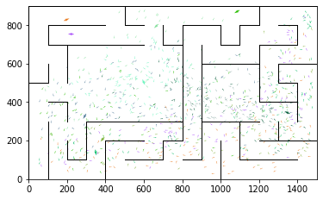

epoch 131 == proposed_mle: 22.34+-0.33/21.44+-0.22 --

epoch 132 == proposed_mle: 21.67+-0.35/21.69+-0.22 --

epoch 133 == proposed_mle: 22.12+-0.29/21.75+-0.21 --

epoch 134 == proposed_mle: 21.76+-0.29/21.34+-0.21 --

epoch 135 >> proposed_mle: 21.07+-0.27/20.95+-0.20 --

epoch 136 >> proposed_mle: 21.51+-0.32/20.88+-0.22 --

epoch 137 >> proposed_mle: 21.17+-0.35/20.62+-0.19 --

epoch 138 == proposed_mle: 20.50+-0.32/20.94+-0.21 --

epoch 139 == proposed_mle: 21.40+-0.34/20.91+-0.24 --

epoch 140 == proposed_mle: 21.41+-0.32/20.77+-0.23 --

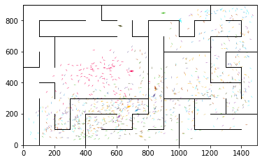

epoch 141 == proposed_mle: 21.73+-0.30/21.15+-0.22 --

epoch 142 == proposed_mle: 21.92+-0.34/21.12+-0.21 --

epoch 143 == proposed_mle: 21.07+-0.33/21.06+-0.21 --

epoch 144 == proposed_mle: 20.59+-0.29/20.97+-0.24 --

epoch 145 == proposed_mle: 20.80+-0.34/20.96+-0.24 --

epoch 146 >> proposed_mle: 21.14+-0.36/20.39+-0.22 --

epoch 147 == proposed_mle: 21.47+-0.35/20.70+-0.22 --

epoch 148 == proposed_mle: 20.66+-0.32/20.65+-0.23 --

epoch 149 == proposed_mle: 20.91+-0.34/20.59+-0.23 --

epoch 150 == proposed_mle: 19.68+-0.27/20.51+-0.21 --

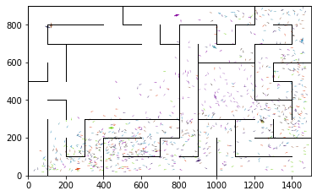

epoch 151 == proposed_mle: 20.00+-0.27/20.46+-0.20 --

epoch 152 == proposed_mle: 21.02+-0.32/20.74+-0.22 --

epoch 153 == proposed_mle: 20.57+-0.31/20.80+-0.22 --

epoch 154 >> proposed_mle: 20.62+-0.33/20.19+-0.23 --

epoch 155 == proposed_mle: 20.28+-0.33/20.53+-0.23 --

epoch 156 >> proposed_mle: 20.79+-0.31/20.08+-0.23 --

epoch 157 == proposed_mle: 20.20+-0.25/20.44+-0.21 --

epoch 158 >> proposed_mle: 20.06+-0.34/20.02+-0.20 --

epoch 159 >> proposed_mle: 20.86+-0.28/19.83+-0.23 --

epoch 160 == proposed_mle: 20.31+-0.32/20.43+-0.24 --

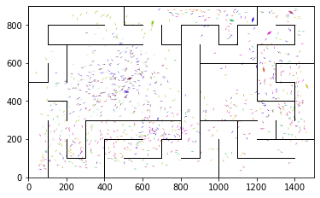

epoch 161 == proposed_mle: 20.29+-0.35/20.30+-0.22 --

epoch 162 == proposed_mle: 20.41+-0.35/19.93+-0.22 --

epoch 163 == proposed_mle: 20.56+-0.31/20.22+-0.23 --

epoch 164 == proposed_mle: 20.41+-0.28/19.95+-0.21 --

epoch 165 == proposed_mle: 19.55+-0.31/20.31+-0.21 --

epoch 166 == proposed_mle: 20.22+-0.27/20.03+-0.21 --

epoch 167 == proposed_mle: 19.72+-0.32/20.16+-0.21 --

epoch 168 == proposed_mle: 19.78+-0.33/20.48+-0.20 --

epoch 169 == proposed_mle: 20.23+-0.35/20.03+-0.21 --

epoch 170 == proposed_mle: 20.26+-0.27/20.04+-0.22 --

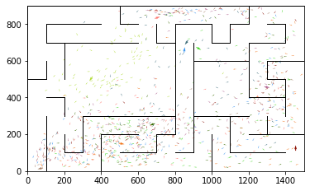

epoch 171 == proposed_mle: 19.81+-0.29/19.96+-0.22 --

epoch 172 >> proposed_mle: 19.84+-0.32/19.78+-0.23 --

epoch 173 == proposed_mle: 20.27+-0.34/20.28+-0.22 --

epoch 174 == proposed_mle: 20.20+-0.30/19.81+-0.21 --

epoch 175 == proposed_mle: 19.79+-0.26/20.39+-0.23 --

epoch 176 == proposed_mle: 19.74+-0.31/19.88+-0.22 --

epoch 177 >> proposed_mle: 19.31+-0.29/19.77+-0.22 --

epoch 178 >> proposed_mle: 19.50+-0.27/19.42+-0.21 --

epoch 179 == proposed_mle: 19.49+-0.27/19.88+-0.21 --

epoch 180 >> proposed_mle: 20.09+-0.31/19.36+-0.21 --

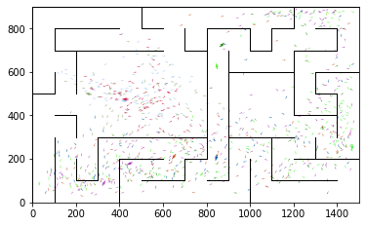

epoch 181 == proposed_mle: 18.91+-0.32/19.62+-0.20 --

epoch 182 >> proposed_mle: 19.27+-0.28/19.30+-0.21 --

epoch 183 == proposed_mle: 19.75+-0.28/19.49+-0.22 --

epoch 184 >> proposed_mle: 20.03+-0.29/19.14+-0.22 --

epoch 185 == proposed_mle: 19.10+-0.31/19.45+-0.21 --

epoch 186 == proposed_mle: 20.09+-0.28/19.29+-0.22 --

epoch 187 == proposed_mle: 19.58+-0.33/19.32+-0.21 --

epoch 188 == proposed_mle: 19.36+-0.27/19.17+-0.22 --

epoch 189 == proposed_mle: 19.20+-0.28/19.31+-0.22 --

epoch 190 == proposed_mle: 19.68+-0.30/19.26+-0.23 --

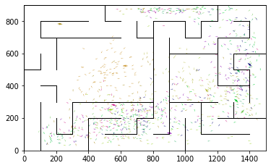

epoch 191 >> proposed_mle: 19.44+-0.33/19.08+-0.23 --

epoch 192 >> proposed_mle: 19.22+-0.35/18.65+-0.21 --

epoch 193 == proposed_mle: 19.70+-0.37/19.57+-0.21 --

epoch 194 == proposed_mle: 19.41+-0.33/18.83+-0.23 --

epoch 195 == proposed_mle: 19.56+-0.31/19.73+-0.20 --

epoch 196 == proposed_mle: 19.15+-0.32/18.98+-0.21 --

epoch 197 == proposed_mle: 19.27+-0.27/19.04+-0.23 --

epoch 198 == proposed_mle: 19.23+-0.29/18.90+-0.22 --

epoch 199 == proposed_mle: 18.70+-0.29/19.08+-0.19 --

epoch 200 == proposed_mle: 18.85+-0.31/19.37+-0.22 --

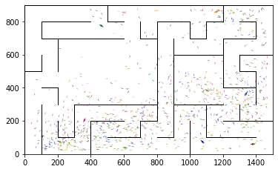

epoch 201 == proposed_mle: 19.10+-0.34/18.74+-0.23 --

epoch 202 >> proposed_mle: 19.19+-0.31/18.61+-0.21 --

epoch 203 >> proposed_mle: 19.16+-0.33/18.60+-0.22 --

epoch 204 == proposed_mle: 19.08+-0.25/19.03+-0.22 --

epoch 205 == proposed_mle: 19.10+-0.29/18.91+-0.23 --

epoch 206 >> proposed_mle: 18.88+-0.38/18.57+-0.21 --

epoch 207 == proposed_mle: 19.30+-0.31/18.79+-0.19 --

epoch 208 == proposed_mle: 19.28+-0.32/18.85+-0.21 --

epoch 209 >> proposed_mle: 18.21+-0.36/18.40+-0.19 --

epoch 210 >> proposed_mle: 18.52+-0.31/18.39+-0.20 --

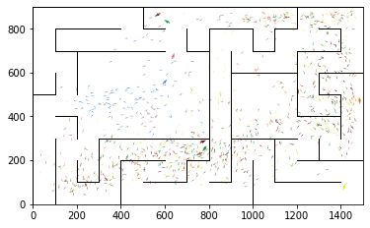

epoch 211 == proposed_mle: 18.86+-0.30/18.57+-0.23 --

epoch 212 == proposed_mle: 18.96+-0.30/18.53+-0.21 --

epoch 213 == proposed_mle: 18.87+-0.34/18.78+-0.20 --

epoch 214 >> proposed_mle: 18.70+-0.34/18.27+-0.21 --

epoch 215 == proposed_mle: 18.79+-0.27/18.57+-0.23 --

epoch 216 == proposed_mle: 18.79+-0.28/18.36+-0.23 --

epoch 217 == proposed_mle: 18.56+-0.24/18.66+-0.23 --

epoch 218 >> proposed_mle: 18.37+-0.33/18.01+-0.20 --

epoch 219 == proposed_mle: 18.56+-0.33/18.38+-0.20 --

epoch 220 == proposed_mle: 18.49+-0.31/18.37+-0.22 --

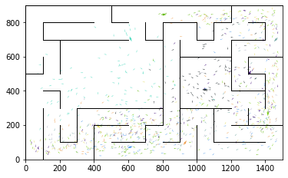

epoch 221 == proposed_mle: 17.72+-0.32/18.30+-0.21 --

epoch 222 == proposed_mle: 18.67+-0.28/18.22+-0.22 --

epoch 223 == proposed_mle: 18.50+-0.32/18.31+-0.19 --

epoch 224 == proposed_mle: 18.67+-0.24/18.30+-0.21 --

epoch 225 == proposed_mle: 18.39+-0.25/18.34+-0.20 --

epoch 226 >> proposed_mle: 17.60+-0.29/18.00+-0.20 --

epoch 227 == proposed_mle: 18.74+-0.34/18.15+-0.21 --

epoch 228 == proposed_mle: 18.24+-0.23/18.62+-0.21 --

epoch 229 >> proposed_mle: 18.63+-0.30/17.93+-0.22 --

epoch 230 == proposed_mle: 18.10+-0.29/17.97+-0.22 --

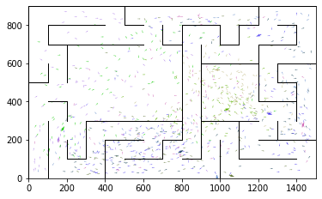

epoch 231 >> proposed_mle: 18.19+-0.28/17.82+-0.21 --

epoch 232 == proposed_mle: 18.36+-0.28/17.86+-0.21 --

epoch 233 >> proposed_mle: 18.11+-0.32/17.74+-0.21 --

epoch 234 == proposed_mle: 18.96+-0.32/17.93+-0.21 --

epoch 235 == proposed_mle: 18.37+-0.28/17.90+-0.21 --

epoch 236 == proposed_mle: 17.34+-0.27/17.74+-0.18 --

epoch 237 == proposed_mle: 17.89+-0.32/17.92+-0.22 --

epoch 238 == proposed_mle: 17.99+-0.29/17.96+-0.22 --

epoch 239 >> proposed_mle: 18.22+-0.33/17.70+-0.21 --

epoch 240 == proposed_mle: 18.10+-0.37/18.72+-0.21 --

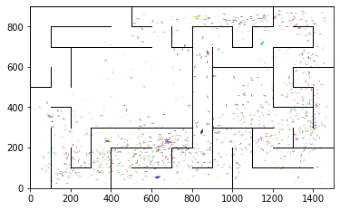

epoch 241 == proposed_mle: 18.88+-0.30/17.79+-0.22 --

epoch 242 == proposed_mle: 18.35+-0.35/17.73+-0.20 --

epoch 243 == proposed_mle: 18.44+-0.34/17.93+-0.23 --

epoch 244 >> proposed_mle: 18.23+-0.32/17.69+-0.21 --

epoch 245 == proposed_mle: 17.94+-0.34/17.76+-0.20 --

epoch 246 >> proposed_mle: 17.73+-0.27/17.44+-0.22 --

epoch 247 == proposed_mle: 17.88+-0.31/17.62+-0.21 --

epoch 248 == proposed_mle: 17.66+-0.28/17.61+-0.22 --

epoch 249 == proposed_mle: 18.27+-0.27/18.00+-0.22 --

epoch 250 == proposed_mle: 18.23+-0.30/17.63+-0.21 --

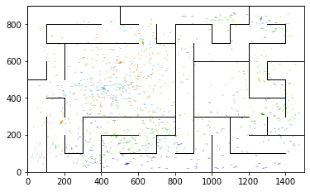

epoch 251 == proposed_mle: 17.80+-0.28/17.47+-0.21 --

epoch 252 == proposed_mle: 18.30+-0.33/17.49+-0.21 --

epoch 253 == proposed_mle: 18.51+-0.24/17.64+-0.21 --

epoch 254 == proposed_mle: 17.53+-0.22/17.45+-0.23 --

epoch 255 >> proposed_mle: 17.39+-0.29/17.38+-0.22 --

epoch 256 == proposed_mle: 17.71+-0.29/17.58+-0.23 --

epoch 257 == proposed_mle: 17.86+-0.34/17.48+-0.21 --

epoch 258 >> proposed_mle: 18.10+-0.34/17.24+-0.21 --

epoch 259 == proposed_mle: 17.91+-0.34/17.91+-0.19 --

epoch 260 == proposed_mle: 18.59+-0.27/17.42+-0.21 --

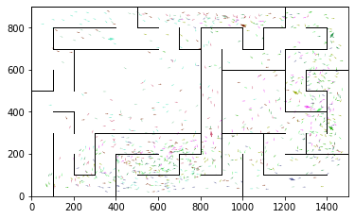

epoch 261 == proposed_mle: 17.93+-0.28/17.28+-0.20 --

epoch 262 >> proposed_mle: 17.54+-0.27/17.19+-0.22 --

epoch 263 == proposed_mle: 17.77+-0.29/17.31+-0.20 --

epoch 264 >> proposed_mle: 17.30+-0.30/17.06+-0.21 --

epoch 265 == proposed_mle: 18.08+-0.34/17.57+-0.20 --

epoch 266 == proposed_mle: 17.63+-0.33/17.06+-0.21 --

epoch 267 == proposed_mle: 17.61+-0.32/17.48+-0.22 --

epoch 268 == proposed_mle: 17.74+-0.29/17.26+-0.20 --

epoch 269 == proposed_mle: 17.32+-0.26/17.09+-0.22 --

epoch 270 == proposed_mle: 17.80+-0.34/17.81+-0.19 --

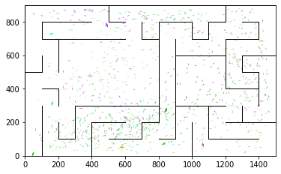

epoch 271 == proposed_mle: 17.77+-0.29/17.36+-0.19 --

epoch 272 == proposed_mle: 16.86+-0.26/17.18+-0.20 --

epoch 273 == proposed_mle: 17.56+-0.24/17.27+-0.20 --

epoch 274 == proposed_mle: 16.73+-0.26/17.13+-0.19 --

epoch 275 >> proposed_mle: 17.01+-0.32/16.77+-0.17 --

epoch 276 == proposed_mle: 17.09+-0.29/16.96+-0.20 --

epoch 277 == proposed_mle: 17.55+-0.24/17.35+-0.18 --

epoch 278 == proposed_mle: 17.43+-0.32/17.20+-0.20 --

epoch 279 == proposed_mle: 17.43+-0.34/17.11+-0.20 --

epoch 280 == proposed_mle: 17.26+-0.32/16.87+-0.19 --

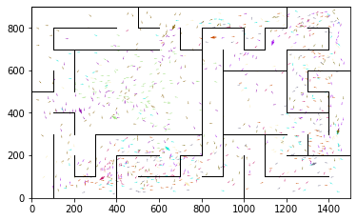

epoch 281 >> proposed_mle: 17.45+-0.29/16.64+-0.22 --

epoch 282 >> proposed_mle: 17.34+-0.30/16.61+-0.19 --

epoch 283 == proposed_mle: 17.43+-0.35/17.49+-0.21 --

epoch 284 == proposed_mle: 16.51+-0.28/16.97+-0.20 --

epoch 285 == proposed_mle: 16.90+-0.30/16.74+-0.22 --

epoch 286 == proposed_mle: 17.46+-0.27/16.95+-0.20 --

epoch 287 == proposed_mle: 17.36+-0.27/16.67+-0.18 --

epoch 288 == proposed_mle: 16.59+-0.29/16.70+-0.21 --

epoch 289 == proposed_mle: 17.12+-0.26/16.76+-0.19 --

epoch 290 >> proposed_mle: 17.01+-0.35/16.57+-0.21 --

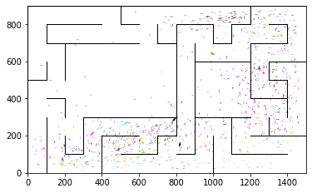

epoch 291 == proposed_mle: 17.64+-0.29/16.81+-0.19 --

epoch 292 == proposed_mle: 17.16+-0.26/17.14+-0.18 --

epoch 293 == proposed_mle: 17.46+-0.26/16.60+-0.19 --

epoch 294 == proposed_mle: 17.56+-0.34/17.00+-0.20 --

epoch 295 == proposed_mle: 17.14+-0.28/16.86+-0.19 --

epoch 296 == proposed_mle: 17.26+-0.31/16.89+-0.20 --

epoch 297 == proposed_mle: 17.36+-0.30/16.96+-0.21 --

epoch 298 >> proposed_mle: 16.90+-0.30/16.37+-0.20 --

epoch 299 == proposed_mle: 16.95+-0.28/16.67+-0.20 --

epoch 300 == proposed_mle: 17.31+-0.32/17.26+-0.20 --

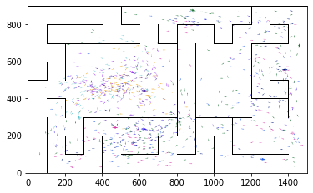

epoch 301 == proposed_mle: 17.02+-0.28/16.66+-0.21 --

epoch 302 == proposed_mle: 16.61+-0.30/16.75+-0.21 --

epoch 303 == proposed_mle: 16.69+-0.34/16.76+-0.21 --

epoch 304 == proposed_mle: 16.70+-0.29/16.55+-0.21 --

epoch 305 >> proposed_mle: 17.20+-0.30/16.35+-0.22 --

epoch 306 >> proposed_mle: 16.94+-0.33/16.33+-0.22 --

epoch 307 == proposed_mle: 16.89+-0.34/16.65+-0.22 --

epoch 308 == proposed_mle: 17.19+-0.29/16.50+-0.21 --

epoch 309 == proposed_mle: 16.99+-0.27/16.82+-0.19 --

epoch 310 == proposed_mle: 17.09+-0.28/16.63+-0.20 --

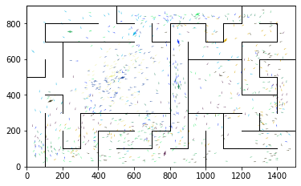

epoch 311 == proposed_mle: 17.00+-0.29/16.34+-0.20 --

epoch 312 == proposed_mle: 16.26+-0.26/16.47+-0.18 --

epoch 313 == proposed_mle: 16.49+-0.28/16.41+-0.20 --

epoch 314 >> proposed_mle: 16.64+-0.32/16.24+-0.21 --

epoch 315 == proposed_mle: 17.37+-0.36/16.90+-0.19 --

epoch 316 == proposed_mle: 17.28+-0.28/16.39+-0.19 --

epoch 317 == proposed_mle: 16.60+-0.32/16.26+-0.21 --

epoch 318 >> proposed_mle: 16.56+-0.29/16.17+-0.19 --

epoch 319 == proposed_mle: 16.17+-0.27/16.25+-0.20 --

epoch 320 >> proposed_mle: 16.49+-0.29/15.87+-0.19 --

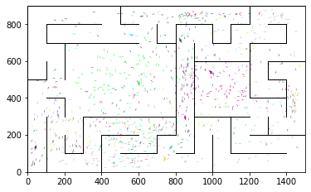

epoch 321 == proposed_mle: 16.79+-0.32/16.44+-0.20 --

epoch 322 == proposed_mle: 16.92+-0.32/16.02+-0.20 --

epoch 323 == proposed_mle: 16.58+-0.32/16.38+-0.20 --

epoch 324 == proposed_mle: 17.01+-0.27/16.24+-0.19 --

epoch 325 == proposed_mle: 16.99+-0.31/15.97+-0.21 --

epoch 326 >> proposed_mle: 16.18+-0.28/15.71+-0.19 --

epoch 327 == proposed_mle: 16.66+-0.33/16.00+-0.21 --

epoch 328 == proposed_mle: 16.76+-0.33/16.07+-0.18 --

epoch 329 == proposed_mle: 16.34+-0.34/16.22+-0.20 --

epoch 330 == proposed_mle: 16.50+-0.31/16.37+-0.22 --

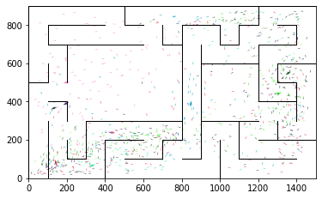

epoch 331 == proposed_mle: 16.90+-0.30/16.50+-0.21 --

epoch 332 == proposed_mle: 16.86+-0.28/16.42+-0.21 --

epoch 333 == proposed_mle: 16.46+-0.31/15.82+-0.22 --

epoch 334 == proposed_mle: 16.10+-0.28/15.94+-0.18 --

epoch 335 == proposed_mle: 16.04+-0.30/16.47+-0.20 --

epoch 336 == proposed_mle: 16.03+-0.33/16.17+-0.20 --

epoch 337 == proposed_mle: 16.19+-0.29/16.30+-0.19 --

epoch 338 == proposed_mle: 16.59+-0.24/16.19+-0.19 --

epoch 339 == proposed_mle: 15.93+-0.24/16.19+-0.22 --

epoch 340 == proposed_mle: 16.41+-0.25/16.01+-0.19 --

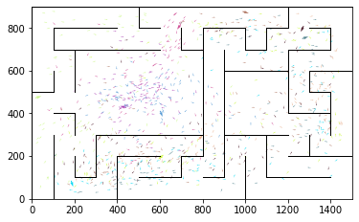

epoch 341 == proposed_mle: 16.28+-0.30/16.04+-0.24 --

epoch 342 == proposed_mle: 16.08+-0.37/15.94+-0.21 --

epoch 343 == proposed_mle: 16.73+-0.26/15.96+-0.20 --

epoch 344 == proposed_mle: 15.85+-0.25/16.04+-0.21 --

epoch 345 == proposed_mle: 15.83+-0.33/15.81+-0.20 --

epoch 346 == proposed_mle: 16.55+-0.34/15.85+-0.19 --

epoch 347 == proposed_mle: 16.30+-0.26/16.18+-0.20 --

epoch 348 == proposed_mle: 16.12+-0.27/15.88+-0.20 --

epoch 349 >> proposed_mle: 15.76+-0.26/15.70+-0.18 --

epoch 350 == proposed_mle: 15.99+-0.31/15.77+-0.20 --

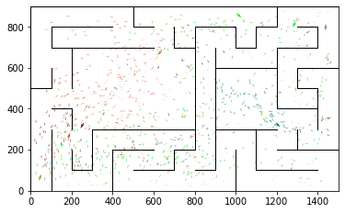

epoch 351 >> proposed_mle: 16.08+-0.30/15.67+-0.21 --

epoch 352 >> proposed_mle: 15.86+-0.30/15.59+-0.20 --

epoch 353 == proposed_mle: 15.95+-0.30/16.28+-0.20 --

epoch 354 == proposed_mle: 16.17+-0.28/15.88+-0.19 --

epoch 355 == proposed_mle: 15.60+-0.28/15.67+-0.21 --

epoch 356 == proposed_mle: 15.78+-0.27/15.91+-0.19 --

epoch 357 == proposed_mle: 16.32+-0.22/15.64+-0.20 --

epoch 358 == proposed_mle: 15.78+-0.31/16.14+-0.21 --

epoch 359 == proposed_mle: 16.26+-0.33/15.85+-0.20 --

epoch 360 == proposed_mle: 15.98+-0.29/15.79+-0.20 --

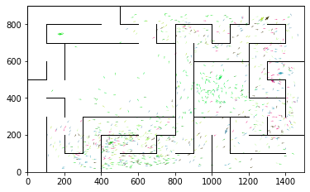

epoch 361 == proposed_mle: 16.67+-0.29/15.76+-0.19 --

epoch 362 >> proposed_mle: 16.35+-0.26/15.44+-0.21 --

epoch 363 == proposed_mle: 15.94+-0.31/15.83+-0.20 --

epoch 364 == proposed_mle: 15.90+-0.30/15.87+-0.21 --

epoch 365 == proposed_mle: 15.93+-0.27/15.60+-0.21 --

epoch 366 == proposed_mle: 16.26+-0.30/15.70+-0.19 --

epoch 367 == proposed_mle: 15.58+-0.23/15.67+-0.21 --

epoch 368 == proposed_mle: 15.48+-0.26/15.47+-0.18 --

epoch 369 == proposed_mle: 15.55+-0.30/15.86+-0.21 --

epoch 370 == proposed_mle: 16.11+-0.30/15.81+-0.19 --

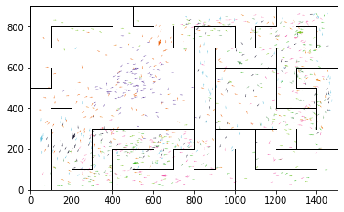

epoch 371 == proposed_mle: 16.49+-0.33/15.62+-0.20 --

epoch 372 == proposed_mle: 16.03+-0.30/16.06+-0.21 --

epoch 373 >> proposed_mle: 15.74+-0.26/15.33+-0.20 --

epoch 374 == proposed_mle: 15.89+-0.31/15.55+-0.19 --

epoch 375 == proposed_mle: 15.27+-0.24/15.63+-0.20 --

epoch 376 >> proposed_mle: 15.31+-0.30/15.09+-0.20 --

epoch 377 == proposed_mle: 16.00+-0.33/15.50+-0.17 --

epoch 378 == proposed_mle: 16.16+-0.26/15.45+-0.19 --

epoch 379 == proposed_mle: 15.26+-0.27/15.13+-0.19 --

epoch 380 == proposed_mle: 16.17+-0.22/15.59+-0.21 --

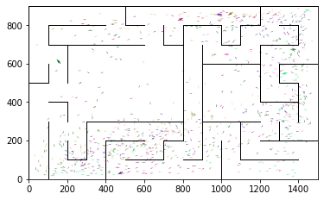

epoch 381 == proposed_mle: 16.13+-0.30/15.43+-0.21 --

epoch 382 == proposed_mle: 15.63+-0.28/15.79+-0.19 --

epoch 383 == proposed_mle: 16.07+-0.31/15.58+-0.20 --

epoch 384 == proposed_mle: 15.23+-0.30/15.18+-0.19 --

epoch 385 == proposed_mle: 15.75+-0.31/15.26+-0.19 --

epoch 386 == proposed_mle: 16.12+-0.25/15.51+-0.19 --

epoch 387 == proposed_mle: 16.08+-0.27/15.26+-0.20 --

epoch 388 == proposed_mle: 15.51+-0.31/15.38+-0.19 --

epoch 389 == proposed_mle: 15.33+-0.32/15.72+-0.20 --

epoch 390 == proposed_mle: 15.73+-0.30/15.74+-0.20 --

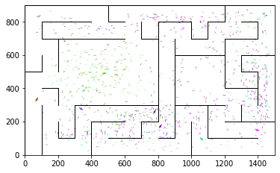

epoch 391 == proposed_mle: 15.60+-0.30/15.55+-0.20 --

epoch 392 == proposed_mle: 16.09+-0.27/15.30+-0.19 --

epoch 393 == proposed_mle: 15.57+-0.28/15.15+-0.20 --

epoch 394 == proposed_mle: 15.35+-0.26/15.26+-0.21 --

epoch 395 == proposed_mle: 15.37+-0.24/15.15+-0.19 --

epoch 396 == proposed_mle: 15.12+-0.29/15.28+-0.18 --

epoch 397 >> proposed_mle: 16.40+-0.30/15.04+-0.18 --

epoch 398 == proposed_mle: 15.70+-0.30/15.48+-0.17 --

epoch 399 == proposed_mle: 15.78+-0.30/15.15+-0.20 --

epoch 400 == proposed_mle: 16.08+-0.25/15.50+-0.20 --

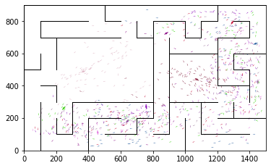

epoch 401 == proposed_mle: 15.46+-0.33/15.27+-0.20 --

epoch 402 >> proposed_mle: 15.79+-0.28/14.99+-0.19 --

epoch 403 == proposed_mle: 15.78+-0.25/15.35+-0.22 --

epoch 404 == proposed_mle: 15.99+-0.23/15.13+-0.18 --

epoch 405 == proposed_mle: 15.12+-0.22/15.19+-0.21 --

epoch 406 == proposed_mle: 15.82+-0.29/15.36+-0.21 --

epoch 407 == proposed_mle: 16.08+-0.28/15.12+-0.20 --

epoch 408 == proposed_mle: 15.44+-0.24/15.86+-0.20 --

epoch 409 == proposed_mle: 16.01+-0.32/15.22+-0.21 --

epoch 410 == proposed_mle: 15.01+-0.33/15.43+-0.19 --

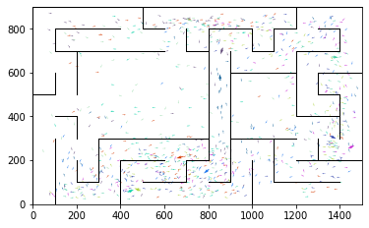

epoch 411 >> proposed_mle: 15.22+-0.28/14.95+-0.20 --

epoch 412 == proposed_mle: 16.30+-0.27/15.14+-0.20 --

epoch 413 == proposed_mle: 15.20+-0.32/14.99+-0.20 --

epoch 414 == proposed_mle: 15.56+-0.28/15.12+-0.21 --

epoch 415 == proposed_mle: 15.91+-0.27/15.29+-0.21 --

epoch 416 == proposed_mle: 15.59+-0.28/15.30+-0.19 --

epoch 417 >> proposed_mle: 14.84+-0.29/14.88+-0.20 --

epoch 418 == proposed_mle: 15.31+-0.29/15.11+-0.19 --

epoch 419 == proposed_mle: 15.05+-0.29/14.95+-0.19 --

epoch 420 >> proposed_mle: 15.40+-0.28/14.82+-0.19 --

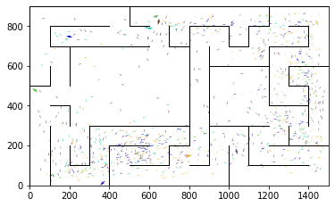

epoch 421 == proposed_mle: 15.60+-0.33/14.95+-0.18 --

epoch 422 == proposed_mle: 15.18+-0.29/15.16+-0.20 --

epoch 423 == proposed_mle: 15.42+-0.32/15.27+-0.19 --

epoch 424 == proposed_mle: 15.68+-0.28/15.34+-0.18 --

epoch 425 == proposed_mle: 15.00+-0.25/14.94+-0.19 --

epoch 426 == proposed_mle: 15.58+-0.30/15.13+-0.18 --

epoch 427 >> proposed_mle: 15.32+-0.33/14.82+-0.18 --

epoch 428 == proposed_mle: 15.35+-0.32/15.01+-0.19 --

epoch 429 == proposed_mle: 15.29+-0.29/14.89+-0.16 --

epoch 430 == proposed_mle: 15.09+-0.28/15.17+-0.20 --

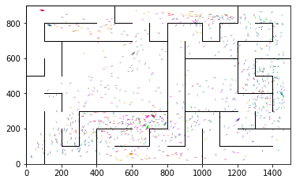

epoch 431 == proposed_mle: 15.11+-0.26/15.36+-0.17 --

epoch 432 == proposed_mle: 15.53+-0.26/15.01+-0.18 --

epoch 433 == proposed_mle: 15.35+-0.30/15.41+-0.18 --

epoch 434 == proposed_mle: 15.14+-0.29/15.11+-0.19 --

epoch 435 == proposed_mle: 15.59+-0.33/15.11+-0.20 --

epoch 436 >> proposed_mle: 14.80+-0.28/14.80+-0.18 --

epoch 437 >> proposed_mle: 15.21+-0.25/14.79+-0.19 --

epoch 438 == proposed_mle: 14.93+-0.27/15.00+-0.19 --

epoch 439 >> proposed_mle: 15.32+-0.30/14.73+-0.18 --

epoch 440 == proposed_mle: 15.56+-0.26/14.86+-0.18 --

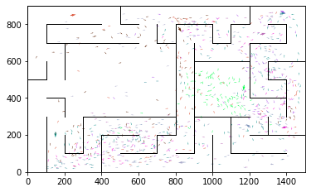

epoch 441 >> proposed_mle: 15.04+-0.32/14.61+-0.19 --

epoch 442 == proposed_mle: 14.97+-0.33/14.71+-0.18 --

epoch 443 == proposed_mle: 14.98+-0.29/14.67+-0.18 --

epoch 444 >> proposed_mle: 15.30+-0.26/14.59+-0.17 --

epoch 445 == proposed_mle: 14.69+-0.23/14.68+-0.20 --

epoch 446 == proposed_mle: 14.91+-0.30/14.61+-0.20 --

epoch 447 == proposed_mle: 15.15+-0.33/14.84+-0.19 --

epoch 448 == proposed_mle: 15.00+-0.31/14.75+-0.19 --

epoch 449 == proposed_mle: 15.21+-0.29/14.71+-0.20 --

epoch 450 == proposed_mle: 15.40+-0.31/14.99+-0.19 --

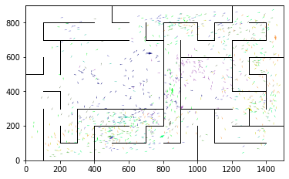

epoch 451 == proposed_mle: 14.56+-0.28/14.93+-0.21 --

epoch 452 == proposed_mle: 14.71+-0.35/15.09+-0.20 --

epoch 453 >> proposed_mle: 15.02+-0.29/14.54+-0.19 --

epoch 454 >> proposed_mle: 15.30+-0.33/14.53+-0.19 --

epoch 455 == proposed_mle: 14.67+-0.29/14.75+-0.18 --

epoch 456 == proposed_mle: 14.55+-0.30/14.59+-0.19 --

epoch 457 == proposed_mle: 14.58+-0.30/14.67+-0.20 --

epoch 458 == proposed_mle: 15.11+-0.32/14.67+-0.18 --

epoch 459 >> proposed_mle: 15.47+-0.32/14.35+-0.18 --

epoch 460 == proposed_mle: 14.40+-0.29/14.59+-0.19 --

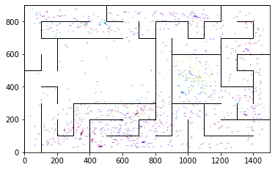

epoch 461 == proposed_mle: 14.84+-0.28/14.57+-0.19 --

epoch 462 == proposed_mle: 14.60+-0.32/14.61+-0.18 --

epoch 463 == proposed_mle: 14.76+-0.32/14.46+-0.18 --

epoch 464 == proposed_mle: 14.79+-0.31/14.81+-0.19 --

epoch 465 == proposed_mle: 15.19+-0.25/15.17+-0.20 --

epoch 466 == proposed_mle: 15.30+-0.27/14.38+-0.20 --

epoch 467 == proposed_mle: 14.60+-0.27/14.54+-0.19 --

epoch 468 == proposed_mle: 15.01+-0.29/14.74+-0.20 --

epoch 469 >> proposed_mle: 14.98+-0.33/14.32+-0.18 --

epoch 470 == proposed_mle: 14.64+-0.23/14.57+-0.19 --

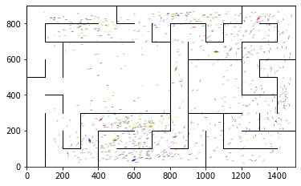

epoch 471 >> proposed_mle: 14.69+-0.24/14.07+-0.18 --

epoch 472 == proposed_mle: 15.16+-0.32/14.52+-0.20 --

epoch 473 == proposed_mle: 15.13+-0.27/14.11+-0.18 --

epoch 474 == proposed_mle: 14.60+-0.28/14.54+-0.19 --

epoch 475 == proposed_mle: 15.18+-0.31/14.36+-0.18 --

epoch 476 == proposed_mle: 14.55+-0.23/14.47+-0.19 --

epoch 477 == proposed_mle: 15.21+-0.23/14.46+-0.19 --

epoch 478 == proposed_mle: 14.87+-0.27/14.50+-0.21 --

epoch 479 == proposed_mle: 14.94+-0.29/14.40+-0.20 --

epoch 480 == proposed_mle: 14.60+-0.31/14.61+-0.20 --

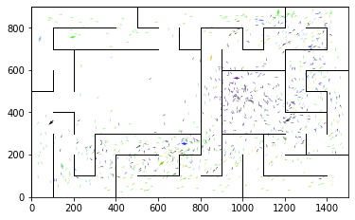

epoch 481 == proposed_mle: 14.46+-0.30/14.29+-0.19 --

epoch 482 == proposed_mle: 14.99+-0.27/14.45+-0.20 --

epoch 483 == proposed_mle: 14.98+-0.25/14.53+-0.18 --

epoch 484 == proposed_mle: 14.93+-0.28/14.22+-0.19 --

epoch 485 == proposed_mle: 14.69+-0.29/14.51+-0.17 --

epoch 486 == proposed_mle: 14.55+-0.27/14.47+-0.20 --

epoch 487 == proposed_mle: 14.50+-0.27/14.43+-0.21 --

epoch 488 == proposed_mle: 14.87+-0.25/14.40+-0.20 --

epoch 489 == proposed_mle: 14.28+-0.30/14.40+-0.20 --

epoch 490 == proposed_mle: 14.82+-0.27/14.63+-0.18 --

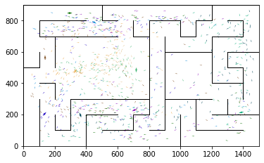

epoch 491 == proposed_mle: 14.93+-0.34/14.27+-0.20 --

epoch 492 == proposed_mle: 14.50+-0.23/14.46+-0.19 --

epoch 493 == proposed_mle: 14.65+-0.30/14.18+-0.19 --

epoch 494 == proposed_mle: 14.24+-0.24/14.20+-0.20 --

epoch 495 == proposed_mle: 14.53+-0.25/14.28+-0.20 --

epoch 496 == proposed_mle: 14.45+-0.28/14.34+-0.19 --

epoch 497 == proposed_mle: 14.29+-0.27/14.40+-0.19 --

epoch 498 == proposed_mle: 15.00+-0.26/14.30+-0.19 --

epoch 499 >> proposed_mle: 14.03+-0.30/13.91+-0.19 --

epoch 500 == proposed_mle: 14.65+-0.28/14.26+-0.20 --

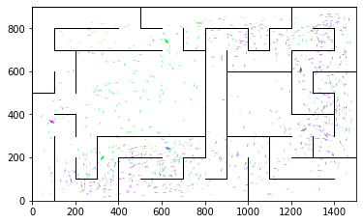

epoch 501 == proposed_mle: 14.15+-0.28/14.17+-0.18 --

epoch 502 == proposed_mle: 14.01+-0.22/14.07+-0.18 --

epoch 503 == proposed_mle: 14.46+-0.27/14.12+-0.18 --

epoch 504 == proposed_mle: 13.98+-0.30/14.13+-0.18 --

epoch 505 == proposed_mle: 14.31+-0.25/14.19+-0.17 --

epoch 506 == proposed_mle: 14.84+-0.27/14.52+-0.19 --

epoch 507 == proposed_mle: 14.58+-0.28/14.16+-0.20 --

epoch 508 >> proposed_mle: 14.30+-0.24/13.87+-0.20 --

epoch 509 == proposed_mle: 13.95+-0.23/14.49+-0.19 --

epoch 510 == proposed_mle: 15.00+-0.29/13.96+-0.19 --

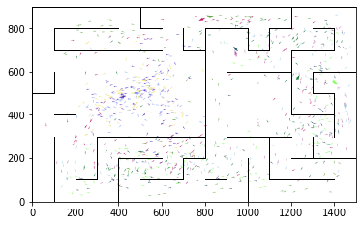

epoch 511 == proposed_mle: 14.20+-0.28/14.04+-0.19 --

epoch 512 == proposed_mle: 14.53+-0.25/14.22+-0.18 --

epoch 513 >> proposed_mle: 14.48+-0.28/13.76+-0.17 --

epoch 514 == proposed_mle: 14.00+-0.24/14.30+-0.16 --

epoch 515 == proposed_mle: 13.88+-0.34/13.86+-0.17 --

epoch 516 == proposed_mle: 14.24+-0.30/13.92+-0.16 --

epoch 517 == proposed_mle: 14.81+-0.27/13.97+-0.17 --

epoch 518 == proposed_mle: 13.78+-0.28/13.94+-0.17 --

epoch 519 >> proposed_mle: 14.24+-0.23/13.72+-0.17 --

epoch 520 == proposed_mle: 14.25+-0.35/13.94+-0.18 --

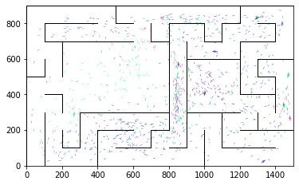

epoch 521 == proposed_mle: 14.43+-0.25/14.14+-0.18 --

epoch 522 == proposed_mle: 14.40+-0.22/13.99+-0.18 --

epoch 523 == proposed_mle: 14.67+-0.28/14.23+-0.20 --

epoch 524 == proposed_mle: 14.20+-0.26/14.39+-0.18 --

epoch 525 == proposed_mle: 14.72+-0.27/14.04+-0.19 --

epoch 526 == proposed_mle: 14.52+-0.25/14.22+-0.20 --

epoch 527 == proposed_mle: 14.35+-0.24/14.22+-0.20 --

epoch 528 == proposed_mle: 14.90+-0.28/14.41+-0.19 --

epoch 529 == proposed_mle: 14.83+-0.28/14.29+-0.19 --

epoch 530 == proposed_mle: 14.57+-0.30/14.06+-0.20 --

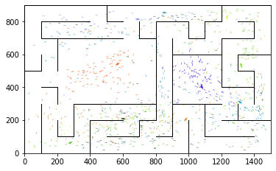

epoch 531 == proposed_mle: 13.94+-0.27/14.07+-0.17 --

epoch 532 == proposed_mle: 14.09+-0.27/13.75+-0.18 --

epoch 533 == proposed_mle: 14.76+-0.31/13.90+-0.19 --

epoch 534 == proposed_mle: 14.38+-0.28/13.78+-0.18 --

epoch 535 == proposed_mle: 14.01+-0.28/14.05+-0.19 --

epoch 536 == proposed_mle: 14.45+-0.26/13.96+-0.19 --

epoch 537 == proposed_mle: 14.68+-0.36/13.91+-0.19 --

epoch 538 == proposed_mle: 13.73+-0.31/13.80+-0.18 --

epoch 539 == proposed_mle: 14.16+-0.28/14.36+-0.19 --

epoch 540 == proposed_mle: 14.10+-0.24/14.12+-0.19 --

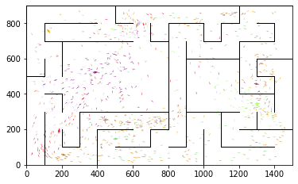

epoch 541 == proposed_mle: 14.64+-0.27/14.36+-0.18 --

epoch 542 == proposed_mle: 14.74+-0.29/14.26+-0.17 --

epoch 543 == proposed_mle: 14.36+-0.28/14.08+-0.18 --

epoch 544 == proposed_mle: 13.87+-0.29/14.01+-0.18 --

epoch 545 == proposed_mle: 14.40+-0.27/14.02+-0.18 --

epoch 546 == proposed_mle: 14.62+-0.28/13.88+-0.18 --

epoch 547 == proposed_mle: 14.32+-0.29/13.92+-0.17 --

epoch 548 == proposed_mle: 14.04+-0.24/14.18+-0.17 --

epoch 549 == proposed_mle: 14.02+-0.28/14.01+-0.18 --

epoch 550 == proposed_mle: 14.48+-0.27/13.88+-0.15 --

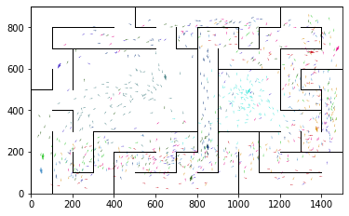

epoch 551 == proposed_mle: 14.55+-0.23/14.04+-0.18 --

epoch 552 == proposed_mle: 14.06+-0.29/13.74+-0.19 --

epoch 553 >> proposed_mle: 14.28+-0.23/13.63+-0.20 --

epoch 554 == proposed_mle: 14.94+-0.34/14.26+-0.20 --

epoch 555 == proposed_mle: 14.17+-0.30/13.92+-0.20 --

epoch 556 == proposed_mle: 13.78+-0.22/13.95+-0.19 --

epoch 557 == proposed_mle: 14.25+-0.26/13.79+-0.19 --

epoch 558 >> proposed_mle: 13.54+-0.28/13.56+-0.17 --

epoch 559 == proposed_mle: 13.73+-0.26/13.89+-0.17 --

epoch 560 == proposed_mle: 14.27+-0.30/14.05+-0.19 --

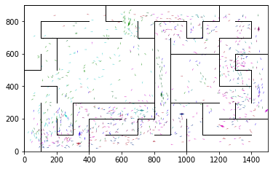

epoch 561 == proposed_mle: 14.24+-0.26/14.00+-0.17 --

epoch 562 == proposed_mle: 14.30+-0.25/13.93+-0.20 --

epoch 563 >> proposed_mle: 14.19+-0.24/13.55+-0.18 --

epoch 564 == proposed_mle: 14.18+-0.27/14.05+-0.20 --

epoch 565 == proposed_mle: 14.92+-0.30/14.01+-0.18 --

epoch 566 == proposed_mle: 14.06+-0.31/13.85+-0.17 --

epoch 567 == proposed_mle: 14.25+-0.26/13.97+-0.20 --

epoch 568 == proposed_mle: 14.26+-0.29/13.66+-0.17 --

epoch 569 == proposed_mle: 14.26+-0.27/13.86+-0.19 --

epoch 570 == proposed_mle: 14.09+-0.28/13.94+-0.18 --

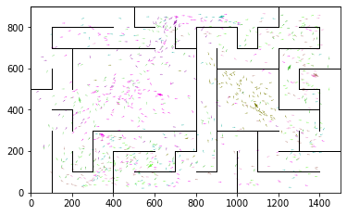

epoch 571 == proposed_mle: 13.97+-0.28/13.82+-0.20 --

epoch 572 == proposed_mle: 13.48+-0.22/13.89+-0.19 --

epoch 573 == proposed_mle: 14.19+-0.31/13.83+-0.19 --

epoch 574 == proposed_mle: 13.65+-0.25/13.91+-0.20 --

epoch 575 == proposed_mle: 13.76+-0.27/13.77+-0.20 --

epoch 576 == proposed_mle: 14.50+-0.29/13.86+-0.19 --

epoch 577 == proposed_mle: 14.79+-0.34/13.76+-0.17 --

epoch 578 == proposed_mle: 13.91+-0.30/14.00+-0.20 --

epoch 579 == proposed_mle: 13.91+-0.25/14.10+-0.21 --

epoch 580 == proposed_mle: 14.08+-0.22/13.61+-0.21 --

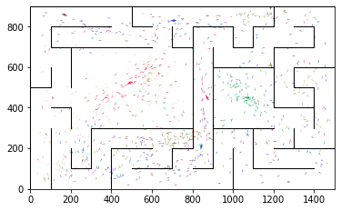

epoch 581 == proposed_mle: 14.03+-0.30/13.75+-0.19 --

epoch 582 == proposed_mle: 13.58+-0.28/13.93+-0.19 --

epoch 583 >> proposed_mle: 14.46+-0.31/13.34+-0.19 --

epoch 584 == proposed_mle: 13.46+-0.27/13.64+-0.18 --

epoch 585 == proposed_mle: 13.66+-0.29/13.58+-0.18 --

epoch 586 == proposed_mle: 13.78+-0.28/13.35+-0.18 --

epoch 587 == proposed_mle: 13.54+-0.26/13.61+-0.18 --

epoch 588 == proposed_mle: 14.13+-0.26/13.84+-0.19 --

epoch 589 == proposed_mle: 13.79+-0.28/13.71+-0.19 --

epoch 590 == proposed_mle: 14.37+-0.31/13.73+-0.19 --

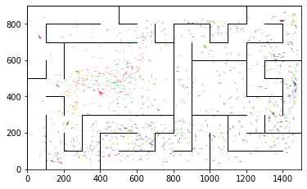

epoch 591 == proposed_mle: 14.05+-0.22/13.46+-0.19 --

epoch 592 == proposed_mle: 13.64+-0.25/13.50+-0.18 --

epoch 593 == proposed_mle: 13.98+-0.22/13.53+-0.18 --

epoch 594 == proposed_mle: 13.68+-0.24/13.54+-0.20 --

epoch 595 == proposed_mle: 13.57+-0.27/13.35+-0.18 --

epoch 596 == proposed_mle: 13.29+-0.27/13.42+-0.18 --

epoch 597 >> proposed_mle: 13.97+-0.26/13.30+-0.19 --

epoch 598 >> proposed_mle: 13.91+-0.28/13.22+-0.18 --

epoch 599 == proposed_mle: 13.80+-0.23/13.97+-0.18 --

epoch 600 >> proposed_mle: 14.05+-0.33/13.14+-0.19 --

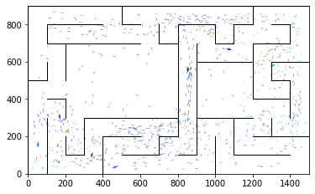

epoch 601 == proposed_mle: 13.50+-0.21/13.44+-0.18 --

epoch 602 == proposed_mle: 13.61+-0.28/13.29+-0.18 --

epoch 603 == proposed_mle: 13.56+-0.21/13.33+-0.17 --

epoch 604 == proposed_mle: 13.77+-0.28/13.59+-0.20 --

epoch 605 == proposed_mle: 13.89+-0.29/13.38+-0.19 --

epoch 606 == proposed_mle: 13.67+-0.27/13.47+-0.19 --

epoch 607 == proposed_mle: 13.95+-0.29/13.31+-0.19 --

epoch 608 == proposed_mle: 13.39+-0.27/13.56+-0.18 --

epoch 609 >> proposed_mle: 13.57+-0.26/13.05+-0.18 --

epoch 610 == proposed_mle: 13.66+-0.26/13.56+-0.20 --

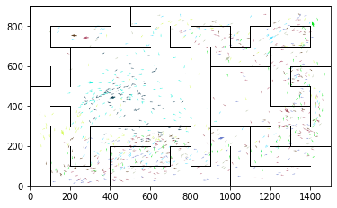

epoch 611 == proposed_mle: 14.29+-0.29/13.22+-0.20 --

epoch 612 == proposed_mle: 13.55+-0.24/13.49+-0.19 --

epoch 613 == proposed_mle: 13.11+-0.26/13.65+-0.20 --

epoch 614 == proposed_mle: 13.89+-0.22/13.22+-0.20 --

epoch 615 == proposed_mle: 14.03+-0.25/13.16+-0.18 --

epoch 616 == proposed_mle: 14.00+-0.31/13.31+-0.18 --

epoch 617 == proposed_mle: 13.83+-0.23/13.25+-0.19 --

epoch 618 == proposed_mle: 13.80+-0.25/13.66+-0.18 --

epoch 619 == proposed_mle: 13.84+-0.28/13.51+-0.17 --

epoch 620 == proposed_mle: 13.65+-0.25/13.49+-0.17 --

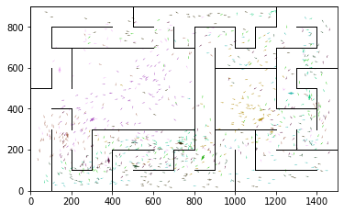

epoch 621 == proposed_mle: 13.70+-0.33/13.55+-0.19 --

epoch 622 == proposed_mle: 14.04+-0.27/13.47+-0.18 --

epoch 623 == proposed_mle: 14.14+-0.28/13.66+-0.17 --

epoch 624 == proposed_mle: 13.52+-0.27/13.33+-0.17 --

epoch 625 == proposed_mle: 13.88+-0.26/13.61+-0.19 --

epoch 626 == proposed_mle: 13.86+-0.29/13.50+-0.16 --

epoch 627 == proposed_mle: 14.10+-0.32/13.20+-0.19 --

epoch 628 == proposed_mle: 14.08+-0.27/13.95+-0.19 --

epoch 629 == proposed_mle: 13.79+-0.28/13.30+-0.17 --

epoch 630 == proposed_mle: 13.67+-0.27/13.62+-0.16 --

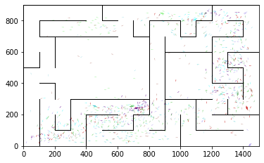

epoch 631 == proposed_mle: 13.67+-0.28/13.15+-0.20 --

epoch 632 == proposed_mle: 13.67+-0.24/13.70+-0.19 --

epoch 633 == proposed_mle: 13.73+-0.24/13.36+-0.18 --

epoch 634 == proposed_mle: 13.70+-0.27/13.79+-0.20 --

epoch 635 == proposed_mle: 13.76+-0.30/13.67+-0.18 --

epoch 636 == proposed_mle: 13.97+-0.29/13.53+-0.19 --

epoch 637 == proposed_mle: 13.38+-0.26/13.43+-0.17 --

epoch 638 == proposed_mle: 13.46+-0.29/13.19+-0.18 --

epoch 639 == proposed_mle: 13.65+-0.29/13.16+-0.17 --

epoch 640 == proposed_mle: 14.01+-0.23/13.38+-0.19 --

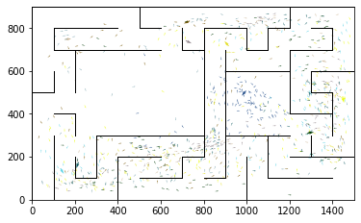

epoch 641 == proposed_mle: 13.67+-0.25/13.76+-0.19 --

epoch 642 == proposed_mle: 13.48+-0.25/13.36+-0.18 --

epoch 643 == proposed_mle: 13.39+-0.25/13.61+-0.16 --

epoch 644 == proposed_mle: 13.81+-0.30/13.29+-0.18 --

epoch 645 == proposed_mle: 13.86+-0.34/13.37+-0.19 --

epoch 646 == proposed_mle: 13.64+-0.27/13.66+-0.20 --

epoch 647 == proposed_mle: 14.33+-0.28/13.47+-0.17 --

epoch 648 == proposed_mle: 13.80+-0.25/13.16+-0.17 --

epoch 649 == proposed_mle: 13.64+-0.30/13.08+-0.17 --

epoch 650 == proposed_mle: 13.73+-0.27/13.11+-0.17 --

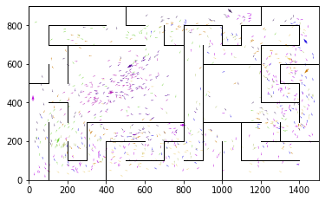

epoch 651 == proposed_mle: 13.22+-0.24/13.16+-0.19 --

epoch 652 == proposed_mle: 13.33+-0.28/13.19+-0.18 --

epoch 653 == proposed_mle: 13.74+-0.28/13.19+-0.18 --

epoch 654 == proposed_mle: 13.16+-0.27/13.29+-0.19 --

epoch 655 == proposed_mle: 13.38+-0.28/13.34+-0.19 --

epoch 656 == proposed_mle: 13.85+-0.29/13.11+-0.19 --

epoch 657 == proposed_mle: 13.57+-0.27/13.38+-0.17 --

epoch 658 == proposed_mle: 13.74+-0.22/13.30+-0.18 --

epoch 659 == proposed_mle: 14.14+-0.29/13.26+-0.19 --

epoch 660 == proposed_mle: 13.61+-0.29/13.18+-0.18 --

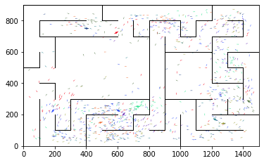

epoch 661 == proposed_mle: 13.98+-0.31/13.42+-0.18 --

epoch 662 == proposed_mle: 13.27+-0.27/13.35+-0.19 --

epoch 663 == proposed_mle: 13.26+-0.27/13.06+-0.18 --

epoch 664 == proposed_mle: 13.40+-0.26/13.07+-0.18 --

epoch 665 == proposed_mle: 13.36+-0.28/13.07+-0.18 --

epoch 666 >> proposed_mle: 12.84+-0.21/12.78+-0.18 --

epoch 667 == proposed_mle: 13.30+-0.32/12.87+-0.19 --

epoch 668 == proposed_mle: 13.35+-0.26/13.12+-0.17 --

epoch 669 == proposed_mle: 12.95+-0.26/12.97+-0.16 --

epoch 670 == proposed_mle: 13.43+-0.28/13.17+-0.16 --

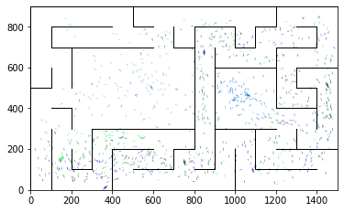

epoch 671 == proposed_mle: 13.83+-0.30/12.81+-0.16 --

epoch 672 == proposed_mle: 13.10+-0.32/12.99+-0.17 --

epoch 673 == proposed_mle: 13.38+-0.28/13.05+-0.17 --

epoch 674 == proposed_mle: 13.51+-0.25/12.89+-0.17 --

epoch 675 == proposed_mle: 13.07+-0.23/13.09+-0.17 --

epoch 676 == proposed_mle: 14.00+-0.27/12.98+-0.18 --

epoch 677 == proposed_mle: 13.32+-0.27/12.97+-0.18 --

epoch 678 == proposed_mle: 13.48+-0.26/13.05+-0.18 --

epoch 679 == proposed_mle: 13.93+-0.29/13.24+-0.20 --

epoch 680 == proposed_mle: 13.66+-0.24/12.92+-0.16 --

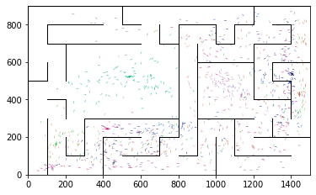

epoch 681 == proposed_mle: 13.57+-0.28/13.10+-0.17 --

epoch 682 == proposed_mle: 14.08+-0.28/12.85+-0.19 --

epoch 683 == proposed_mle: 13.08+-0.30/13.52+-0.18 --

epoch 684 == proposed_mle: 13.75+-0.27/12.88+-0.18 --

epoch 685 == proposed_mle: 13.65+-0.29/13.15+-0.18 --

epoch 686 == proposed_mle: 13.56+-0.24/13.01+-0.19 --

epoch 687 == proposed_mle: 13.61+-0.28/13.08+-0.16 --

epoch 688 == proposed_mle: 14.17+-0.29/13.10+-0.20 --

epoch 689 == proposed_mle: 13.57+-0.26/13.14+-0.18 --

epoch 690 == proposed_mle: 13.62+-0.22/13.10+-0.17 --

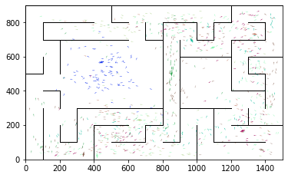

epoch 691 == proposed_mle: 13.77+-0.30/13.25+-0.17 --

epoch 692 == proposed_mle: 14.05+-0.29/12.93+-0.18 --

epoch 693 == proposed_mle: 13.40+-0.25/12.87+-0.15 --

epoch 694 == proposed_mle: 13.54+-0.32/13.51+-0.17 --

epoch 695 == proposed_mle: 14.45+-0.30/12.92+-0.18 --

epoch 696 == proposed_mle: 13.95+-0.31/13.48+-0.19 --

epoch 697 == proposed_mle: 13.58+-0.24/13.37+-0.17 --

epoch 698 == proposed_mle: 13.62+-0.29/13.21+-0.17 --

epoch 699 == proposed_mle: 13.49+-0.20/12.87+-0.18 --

epoch 700 == proposed_mle: 13.77+-0.26/13.08+-0.19 --

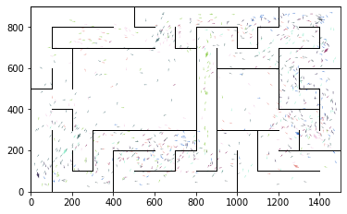

epoch 701 == proposed_mle: 13.85+-0.28/13.16+-0.16 --

epoch 702 == proposed_mle: 13.36+-0.30/12.96+-0.18 --

epoch 703 == proposed_mle: 13.32+-0.26/12.88+-0.16 --

epoch 704 == proposed_mle: 13.92+-0.25/12.90+-0.18 --

epoch 705 == proposed_mle: 13.10+-0.24/13.35+-0.19 --

epoch 706 == proposed_mle: 13.49+-0.26/13.04+-0.16 --

epoch 707 == proposed_mle: 13.74+-0.27/13.13+-0.16 --

epoch 708 == proposed_mle: 13.75+-0.28/13.08+-0.18 --

epoch 709 == proposed_mle: 13.47+-0.23/13.10+-0.20 --

epoch 710 == proposed_mle: 13.91+-0.25/13.49+-0.18 --

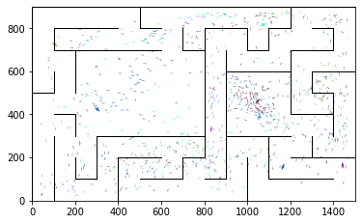

epoch 711 == proposed_mle: 13.84+-0.29/13.36+-0.19 --

epoch 712 == proposed_mle: 13.74+-0.25/13.04+-0.19 --

epoch 713 == proposed_mle: 13.48+-0.26/13.13+-0.17 --

epoch 714 == proposed_mle: 13.88+-0.27/13.17+-0.17 --

epoch 715 == proposed_mle: 12.93+-0.30/12.91+-0.19 --

epoch 716 == proposed_mle: 13.86+-0.27/12.96+-0.17 --

epoch 717 == proposed_mle: 13.85+-0.25/13.04+-0.17 --

epoch 718 == proposed_mle: 13.15+-0.27/12.91+-0.17 --

epoch 719 >> proposed_mle: 13.22+-0.26/12.70+-0.18 --

epoch 720 == proposed_mle: 13.57+-0.27/13.10+-0.18 --

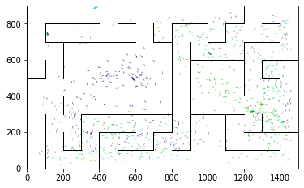

epoch 721 == proposed_mle: 13.50+-0.26/12.84+-0.16 --

epoch 722 == proposed_mle: 13.23+-0.28/12.89+-0.19 --

epoch 723 == proposed_mle: 13.17+-0.25/12.85+-0.19 --

epoch 724 == proposed_mle: 13.54+-0.25/12.87+-0.17 --

epoch 725 == proposed_mle: 13.45+-0.28/12.92+-0.17 --

epoch 726 == proposed_mle: 12.66+-0.25/12.86+-0.18 --

epoch 727 == proposed_mle: 12.96+-0.30/12.92+-0.18 --

epoch 728 == proposed_mle: 12.77+-0.27/12.78+-0.19 --

epoch 729 == proposed_mle: 13.28+-0.26/12.96+-0.17 --

epoch 730 == proposed_mle: 13.07+-0.25/12.96+-0.21 --

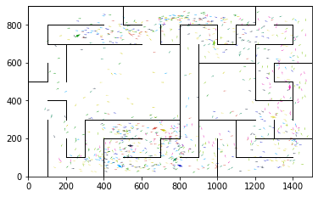

epoch 731 >> proposed_mle: 12.52+-0.25/12.59+-0.17 --

epoch 732 == proposed_mle: 13.26+-0.23/13.55+-0.19 --

epoch 733 == proposed_mle: 13.42+-0.28/12.76+-0.18 --

epoch 734 == proposed_mle: 12.92+-0.32/12.90+-0.19 --

epoch 735 == proposed_mle: 12.80+-0.29/12.61+-0.18 --

epoch 736 == proposed_mle: 12.99+-0.27/12.93+-0.19 --

epoch 737 == proposed_mle: 13.67+-0.28/12.87+-0.18 --

epoch 738 == proposed_mle: 13.14+-0.23/12.87+-0.20 --

epoch 739 == proposed_mle: 13.20+-0.24/12.79+-0.18 --

epoch 740 == proposed_mle: 13.14+-0.24/12.71+-0.19 --

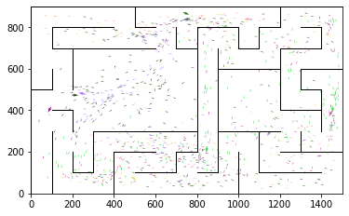

epoch 741 == proposed_mle: 13.32+-0.28/12.70+-0.19 --

epoch 742 == proposed_mle: 13.48+-0.23/12.75+-0.18 --

epoch 743 == proposed_mle: 13.17+-0.31/12.79+-0.17 --

epoch 744 == proposed_mle: 13.36+-0.23/12.90+-0.19 --

epoch 745 == proposed_mle: 12.98+-0.23/12.85+-0.17 --

epoch 746 == proposed_mle: 13.97+-0.31/12.91+-0.18 --

epoch 747 == proposed_mle: 13.51+-0.31/12.75+-0.19 --

epoch 748 == proposed_mle: 13.84+-0.26/12.67+-0.17 --

epoch 749 == proposed_mle: 13.39+-0.32/12.68+-0.20 --

epoch 750 == proposed_mle: 13.24+-0.24/12.79+-0.18 --

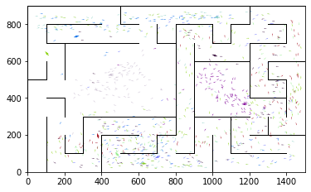

epoch 751 == proposed_mle: 13.45+-0.25/12.87+-0.19 --

epoch 752 >> proposed_mle: 12.92+-0.23/12.58+-0.18 --

epoch 753 == proposed_mle: 13.20+-0.28/12.74+-0.18 --

epoch 754 >> proposed_mle: 12.76+-0.22/12.50+-0.19 --

epoch 755 == proposed_mle: 13.00+-0.27/12.95+-0.17 --

epoch 756 == proposed_mle: 13.04+-0.27/12.84+-0.16 --

epoch 757 == proposed_mle: 12.88+-0.20/12.85+-0.21 --

epoch 758 == proposed_mle: 13.52+-0.29/13.04+-0.18 --

epoch 759 == proposed_mle: 13.15+-0.27/12.78+-0.19 --

epoch 760 == proposed_mle: 13.20+-0.29/12.80+-0.18 --

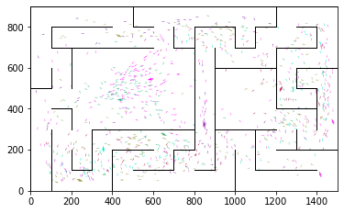

epoch 761 == proposed_mle: 13.10+-0.23/12.74+-0.18 --

epoch 762 == proposed_mle: 12.92+-0.25/12.83+-0.16 --

epoch 763 == proposed_mle: 13.10+-0.27/12.76+-0.18 --

epoch 764 == proposed_mle: 12.87+-0.26/12.97+-0.19 --

epoch 765 == proposed_mle: 13.55+-0.25/13.12+-0.20 --

epoch 766 == proposed_mle: 13.11+-0.27/12.80+-0.18 --

epoch 767 == proposed_mle: 13.54+-0.24/12.82+-0.17 --

epoch 768 == proposed_mle: 13.24+-0.26/12.85+-0.19 --

epoch 769 == proposed_mle: 13.16+-0.27/12.79+-0.15 --

epoch 770 == proposed_mle: 13.69+-0.30/12.73+-0.19 --

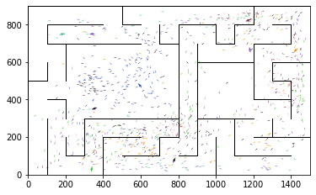

epoch 771 == proposed_mle: 13.33+-0.27/12.70+-0.16 --

epoch 772 == proposed_mle: 13.59+-0.31/12.89+-0.19 --

epoch 773 == proposed_mle: 13.22+-0.30/13.05+-0.19 --

epoch 774 == proposed_mle: 13.26+-0.28/12.86+-0.18 --

epoch 775 == proposed_mle: 13.25+-0.31/12.97+-0.18 --

epoch 776 == proposed_mle: 13.95+-0.31/13.00+-0.18 --

epoch 777 == proposed_mle: 13.25+-0.23/12.69+-0.18 --

epoch 778 == proposed_mle: 13.44+-0.27/12.73+-0.19 --

epoch 779 == proposed_mle: 13.07+-0.24/12.75+-0.17 --

epoch 780 == proposed_mle: 12.95+-0.27/12.52+-0.16 --

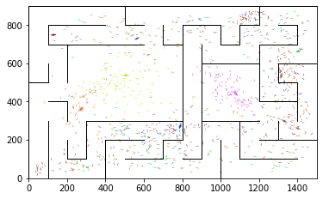

epoch 781 == proposed_mle: 12.95+-0.27/12.82+-0.17 --

epoch 782 == proposed_mle: 13.04+-0.28/12.72+-0.19 --

epoch 783 == proposed_mle: 12.87+-0.26/12.61+-0.18 --

epoch 784 == proposed_mle: 12.41+-0.26/12.65+-0.16 --

epoch 785 == proposed_mle: 13.12+-0.28/12.64+-0.18 --

epoch 786 == proposed_mle: 12.35+-0.27/12.75+-0.20 --

epoch 787 == proposed_mle: 12.54+-0.26/12.78+-0.18 --

epoch 788 == proposed_mle: 12.72+-0.28/12.53+-0.17 --

epoch 789 >> proposed_mle: 13.27+-0.25/12.33+-0.18 --

epoch 790 >> proposed_mle: 12.43+-0.31/12.27+-0.17 --

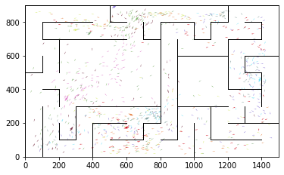

epoch 791 == proposed_mle: 12.67+-0.28/12.34+-0.18 --

epoch 792 == proposed_mle: 13.29+-0.25/12.39+-0.18 --

epoch 793 == proposed_mle: 12.61+-0.25/12.50+-0.19 --

epoch 794 == proposed_mle: 12.85+-0.23/12.57+-0.19 --

epoch 795 == proposed_mle: 12.70+-0.29/12.39+-0.18 --

epoch 796 == proposed_mle: 12.81+-0.25/12.45+-0.16 --

epoch 797 == proposed_mle: 12.28+-0.27/12.64+-0.17 --

epoch 798 == proposed_mle: 12.45+-0.20/12.58+-0.18 --

epoch 799 == proposed_mle: 13.17+-0.27/12.45+-0.17 --

epoch 800 == proposed_mle: 13.62+-0.32/12.81+-0.17 --

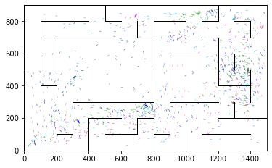

epoch 801 == proposed_mle: 12.84+-0.26/12.72+-0.18 --

epoch 802 == proposed_mle: 13.18+-0.26/12.79+-0.18 --

epoch 803 == proposed_mle: 13.41+-0.29/12.96+-0.18 --

epoch 804 == proposed_mle: 13.07+-0.29/12.69+-0.17 --

epoch 805 == proposed_mle: 13.01+-0.27/12.50+-0.18 --

epoch 806 == proposed_mle: 12.86+-0.26/12.34+-0.17 --

epoch 807 == proposed_mle: 13.18+-0.29/12.77+-0.19 --

epoch 808 == proposed_mle: 12.72+-0.21/12.66+-0.17 --

epoch 809 == proposed_mle: 13.70+-0.23/12.70+-0.18 --

epoch 810 == proposed_mle: 12.50+-0.25/12.67+-0.16 --

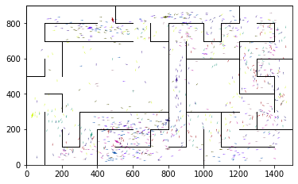

epoch 811 == proposed_mle: 13.04+-0.32/13.19+-0.17 --

epoch 812 == proposed_mle: 13.13+-0.22/12.52+-0.17 --

epoch 813 == proposed_mle: 13.11+-0.25/12.57+-0.18 --

epoch 814 == proposed_mle: 13.00+-0.24/12.69+-0.16 --

epoch 815 == proposed_mle: 13.07+-0.26/12.31+-0.17 --

epoch 816 == proposed_mle: 12.54+-0.28/13.06+-0.18 --

epoch 817 == proposed_mle: 13.21+-0.29/12.35+-0.18 --

epoch 818 == proposed_mle: 12.82+-0.27/12.62+-0.18 --

epoch 819 == proposed_mle: 12.75+-0.25/12.74+-0.18 --

epoch 820 == proposed_mle: 13.22+-0.24/12.38+-0.17 --

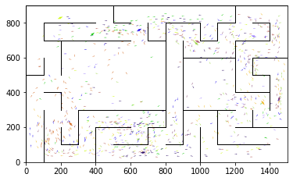

epoch 821 == proposed_mle: 13.26+-0.27/12.71+-0.18 --

epoch 822 == proposed_mle: 13.27+-0.25/12.72+-0.17 --

epoch 823 == proposed_mle: 12.84+-0.30/12.69+-0.20 --

epoch 824 == proposed_mle: 12.94+-0.28/12.49+-0.18 --

epoch 825 == proposed_mle: 12.81+-0.30/12.44+-0.16 --

epoch 826 == proposed_mle: 13.19+-0.25/12.56+-0.18 --

epoch 827 == proposed_mle: 13.40+-0.24/12.51+-0.16 --

epoch 828 == proposed_mle: 13.21+-0.27/12.61+-0.17 --

epoch 829 == proposed_mle: 13.12+-0.26/12.85+-0.20 --

epoch 830 == proposed_mle: 12.63+-0.23/12.54+-0.17 --

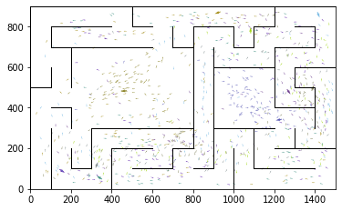

epoch 831 == proposed_mle: 12.94+-0.25/12.39+-0.17 --

epoch 832 == proposed_mle: 12.86+-0.23/12.41+-0.17 --

epoch 833 == proposed_mle: 12.97+-0.30/12.66+-0.18 --

epoch 834 == proposed_mle: 13.04+-0.25/12.49+-0.17 --

epoch 835 >> proposed_mle: 12.68+-0.27/12.24+-0.17 --

epoch 836 == proposed_mle: 13.07+-0.24/12.45+-0.17 --

epoch 837 >> proposed_mle: 12.72+-0.29/12.13+-0.18 --

epoch 838 == proposed_mle: 13.02+-0.28/12.42+-0.17 --

epoch 839 == proposed_mle: 12.52+-0.24/12.30+-0.18 --

epoch 840 == proposed_mle: 12.73+-0.26/12.31+-0.17 --

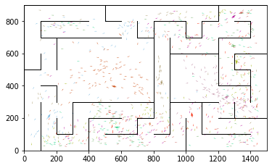

epoch 841 >> proposed_mle: 12.52+-0.26/12.04+-0.16 --

epoch 842 == proposed_mle: 12.92+-0.22/12.17+-0.16 --

epoch 843 == proposed_mle: 12.78+-0.26/12.25+-0.17 --

epoch 844 == proposed_mle: 12.80+-0.24/12.05+-0.15 --

epoch 845 == proposed_mle: 12.34+-0.25/12.25+-0.16 --

epoch 846 == proposed_mle: 12.52+-0.26/12.23+-0.18 --

epoch 847 == proposed_mle: 12.45+-0.27/12.32+-0.17 --

epoch 848 == proposed_mle: 13.10+-0.25/12.12+-0.17 --

epoch 849 == proposed_mle: 12.41+-0.28/12.14+-0.18 --

epoch 850 == proposed_mle: 12.53+-0.22/12.43+-0.18 --

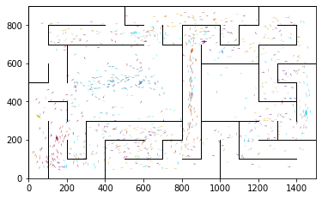

epoch 851 == proposed_mle: 12.98+-0.29/12.26+-0.17 --

epoch 852 == proposed_mle: 13.16+-0.24/12.28+-0.17 --

epoch 853 == proposed_mle: 12.30+-0.29/12.22+-0.17 --

epoch 854 == proposed_mle: 12.17+-0.26/12.27+-0.16 --

epoch 855 >> proposed_mle: 12.58+-0.24/12.03+-0.17 --

epoch 856 == proposed_mle: 12.94+-0.29/12.09+-0.16 --

epoch 857 == proposed_mle: 12.33+-0.26/12.35+-0.20 --

epoch 858 == proposed_mle: 12.78+-0.29/12.23+-0.16 --

epoch 859 >> proposed_mle: 12.44+-0.28/11.83+-0.16 --

epoch 860 == proposed_mle: 12.58+-0.26/12.15+-0.19 --

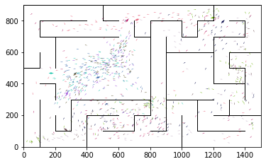

epoch 861 == proposed_mle: 12.48+-0.22/12.02+-0.17 --

epoch 862 == proposed_mle: 12.72+-0.24/12.00+-0.17 --

epoch 863 == proposed_mle: 12.86+-0.27/12.28+-0.17 --

epoch 864 == proposed_mle: 12.56+-0.27/12.31+-0.17 --

epoch 865 == proposed_mle: 12.66+-0.27/11.93+-0.19 --

epoch 866 == proposed_mle: 12.19+-0.22/11.94+-0.17 --

epoch 867 == proposed_mle: 12.91+-0.26/11.98+-0.17 --

epoch 868 == proposed_mle: 12.32+-0.23/12.12+-0.18 --

epoch 869 == proposed_mle: 12.50+-0.24/12.08+-0.17 --

epoch 870 == proposed_mle: 12.00+-0.26/11.93+-0.17 --

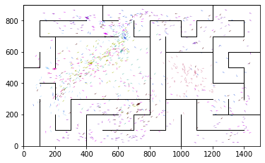

epoch 871 == proposed_mle: 12.09+-0.26/12.26+-0.17 --

epoch 872 == proposed_mle: 12.74+-0.24/12.08+-0.16 --

epoch 873 == proposed_mle: 12.35+-0.26/12.02+-0.17 --

epoch 874 == proposed_mle: 12.99+-0.25/11.89+-0.18 --

epoch 875 == proposed_mle: 12.71+-0.29/11.91+-0.18 --

epoch 876 == proposed_mle: 12.85+-0.27/12.30+-0.18 --

epoch 877 == proposed_mle: 12.45+-0.25/11.89+-0.17 --

epoch 878 == proposed_mle: 12.99+-0.30/12.39+-0.17 --

epoch 879 == proposed_mle: 12.84+-0.25/12.15+-0.17 --

epoch 880 == proposed_mle: 12.39+-0.24/12.07+-0.19 --

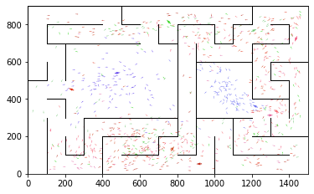

epoch 881 == proposed_mle: 12.51+-0.25/12.09+-0.16 --

epoch 882 >> proposed_mle: 12.32+-0.24/11.80+-0.16 --

epoch 883 == proposed_mle: 12.26+-0.29/11.91+-0.18 --

epoch 884 == proposed_mle: 12.45+-0.26/11.91+-0.17 --

epoch 885 >> proposed_mle: 12.07+-0.25/11.77+-0.15 --

epoch 886 == proposed_mle: 12.03+-0.22/12.15+-0.18 --

epoch 887 == proposed_mle: 12.22+-0.24/12.04+-0.18 --

epoch 888 == proposed_mle: 12.59+-0.24/12.27+-0.18 --

epoch 889 == proposed_mle: 13.07+-0.26/12.09+-0.16 --

epoch 890 == proposed_mle: 12.21+-0.21/12.10+-0.18 --

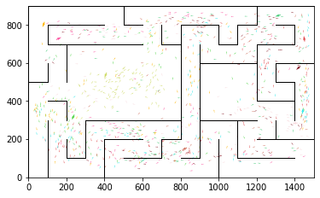

epoch 891 == proposed_mle: 12.29+-0.28/11.82+-0.16 --

epoch 892 == proposed_mle: 13.00+-0.23/11.89+-0.18 --

epoch 893 == proposed_mle: 12.94+-0.26/12.18+-0.16 --

epoch 894 == proposed_mle: 12.45+-0.24/12.01+-0.17 --

epoch 895 == proposed_mle: 12.60+-0.27/11.86+-0.17 --

epoch 896 == proposed_mle: 12.77+-0.32/11.80+-0.19 --

epoch 897 == proposed_mle: 12.38+-0.27/12.21+-0.17 --

epoch 898 == proposed_mle: 12.65+-0.23/12.25+-0.18 --

epoch 899 == proposed_mle: 13.09+-0.27/12.11+-0.20 --

epoch 900 == proposed_mle: 12.68+-0.27/12.38+-0.18 --

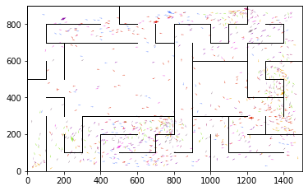

epoch 901 == proposed_mle: 12.75+-0.29/12.08+-0.17 --

epoch 902 == proposed_mle: 12.49+-0.26/12.22+-0.20 --

epoch 903 == proposed_mle: 12.44+-0.24/11.99+-0.18 --

epoch 904 == proposed_mle: 12.55+-0.24/12.20+-0.18 --

epoch 905 == proposed_mle: 12.87+-0.26/12.08+-0.16 --

epoch 906 == proposed_mle: 12.43+-0.24/12.05+-0.18 --

epoch 907 == proposed_mle: 12.43+-0.30/12.11+-0.19 --

epoch 908 == proposed_mle: 12.36+-0.26/12.02+-0.17 --

epoch 909 == proposed_mle: 12.63+-0.27/12.26+-0.19 --

epoch 910 == proposed_mle: 12.71+-0.23/12.12+-0.19 --

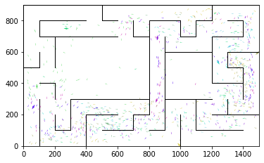

epoch 911 == proposed_mle: 12.39+-0.27/12.03+-0.18 --

epoch 912 == proposed_mle: 12.13+-0.22/12.40+-0.18 --

epoch 913 == proposed_mle: 12.52+-0.26/11.94+-0.15 --

epoch 914 == proposed_mle: 12.55+-0.34/11.87+-0.17 --

epoch 915 == proposed_mle: 12.44+-0.28/11.81+-0.18 --

epoch 916 == proposed_mle: 12.15+-0.26/11.96+-0.19 --

epoch 917 == proposed_mle: 12.22+-0.24/12.00+-0.18 --

epoch 918 == proposed_mle: 12.37+-0.26/12.11+-0.17 --

epoch 919 == proposed_mle: 12.85+-0.27/12.08+-0.16 --

epoch 920 == proposed_mle: 12.12+-0.25/12.10+-0.17 --

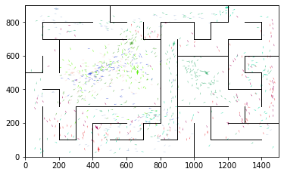

epoch 921 == proposed_mle: 12.70+-0.26/12.31+-0.18 --

epoch 922 == proposed_mle: 12.08+-0.23/12.14+-0.18 --

epoch 923 == proposed_mle: 12.34+-0.25/11.98+-0.18 --

epoch 924 == proposed_mle: 12.37+-0.22/11.85+-0.17 --

epoch 925 >> proposed_mle: 12.23+-0.24/11.74+-0.16 --

epoch 926 == proposed_mle: 12.76+-0.29/12.08+-0.17 --

epoch 927 == proposed_mle: 12.18+-0.25/11.95+-0.16 --

epoch 928 == proposed_mle: 12.05+-0.29/11.95+-0.18 --

epoch 929 == proposed_mle: 12.49+-0.25/12.14+-0.18 --

epoch 930 == proposed_mle: 12.18+-0.25/12.22+-0.18 --

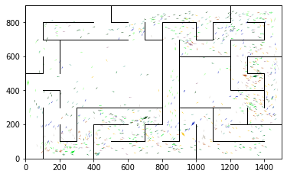

epoch 931 == proposed_mle: 12.52+-0.23/11.86+-0.15 --

epoch 932 == proposed_mle: 12.82+-0.27/12.03+-0.15 --

epoch 933 == proposed_mle: 12.63+-0.23/12.05+-0.17 --

epoch 934 == proposed_mle: 11.97+-0.27/12.02+-0.16 --

epoch 935 == proposed_mle: 12.72+-0.25/11.88+-0.17 --

epoch 936 == proposed_mle: 12.53+-0.26/11.82+-0.18 --

epoch 937 == proposed_mle: 12.31+-0.24/11.99+-0.17 --

epoch 938 == proposed_mle: 12.25+-0.26/12.16+-0.17 --

epoch 939 == proposed_mle: 12.39+-0.23/11.94+-0.17 --

epoch 940 == proposed_mle: 12.14+-0.27/12.08+-0.19 --

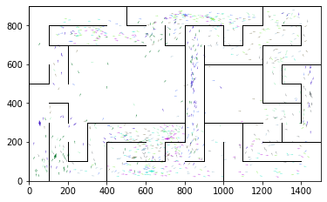

epoch 941 == proposed_mle: 12.40+-0.27/11.82+-0.18 --

epoch 942 == proposed_mle: 12.29+-0.23/12.03+-0.16 --

epoch 943 == proposed_mle: 12.40+-0.27/12.08+-0.18 --

epoch 944 == proposed_mle: 12.45+-0.27/12.15+-0.17 --

epoch 945 == proposed_mle: 12.97+-0.28/12.01+-0.19 --

epoch 946 == proposed_mle: 12.34+-0.21/11.87+-0.17 --

epoch 947 >> proposed_mle: 12.57+-0.24/11.71+-0.18 --

epoch 948 == proposed_mle: 12.29+-0.22/12.11+-0.19 --

epoch 949 == proposed_mle: 12.51+-0.22/12.17+-0.18 --

epoch 950 == proposed_mle: 12.51+-0.28/11.84+-0.18 --

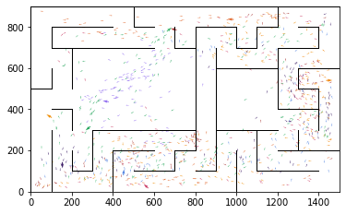

epoch 951 == proposed_mle: 12.03+-0.19/11.83+-0.19 --

epoch 952 == proposed_mle: 12.51+-0.23/12.16+-0.17 --

epoch 953 == proposed_mle: 12.73+-0.25/11.91+-0.17 --

epoch 954 == proposed_mle: 13.12+-0.30/11.99+-0.16 --

epoch 955 == proposed_mle: 12.19+-0.25/11.74+-0.17 --

epoch 956 == proposed_mle: 12.49+-0.31/11.79+-0.19 --

epoch 957 == proposed_mle: 12.37+-0.26/12.05+-0.17 --

epoch 958 == proposed_mle: 12.46+-0.28/11.98+-0.18 --

epoch 959 == proposed_mle: 12.28+-0.24/11.96+-0.18 --

epoch 960 == proposed_mle: 12.23+-0.22/11.91+-0.17 --

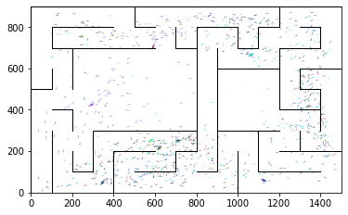

epoch 961 == proposed_mle: 12.18+-0.22/12.22+-0.18 --

epoch 962 == proposed_mle: 12.32+-0.26/11.83+-0.15 --

epoch 963 == proposed_mle: 12.34+-0.29/12.10+-0.16 --

epoch 964 == proposed_mle: 12.86+-0.21/11.97+-0.17 --

epoch 965 == proposed_mle: 12.60+-0.29/11.76+-0.17 --

epoch 966 == proposed_mle: 12.37+-0.26/11.90+-0.17 --

epoch 967 == proposed_mle: 12.14+-0.26/11.80+-0.15 --

epoch 968 == proposed_mle: 12.10+-0.25/11.79+-0.16 --

epoch 969 == proposed_mle: 12.63+-0.29/11.93+-0.17 --

epoch 970 == proposed_mle: 12.37+-0.26/11.75+-0.17 --

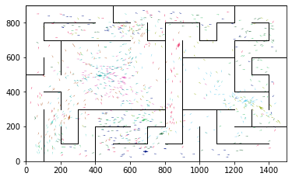

epoch 971 == proposed_mle: 12.39+-0.28/12.11+-0.20 --

epoch 972 == proposed_mle: 12.42+-0.25/12.10+-0.17 --

epoch 973 >> proposed_mle: 12.27+-0.26/11.64+-0.18 --

epoch 974 == proposed_mle: 11.78+-0.23/11.90+-0.17 --

epoch 975 == proposed_mle: 11.80+-0.23/11.75+-0.17 --

epoch 976 == proposed_mle: 11.80+-0.29/11.72+-0.18 --

epoch 977 == proposed_mle: 12.29+-0.24/11.79+-0.18 --

epoch 978 == proposed_mle: 12.73+-0.24/11.95+-0.15 --

epoch 979 == proposed_mle: 12.50+-0.26/11.77+-0.17 --

epoch 980 == proposed_mle: 12.45+-0.28/11.79+-0.17 --

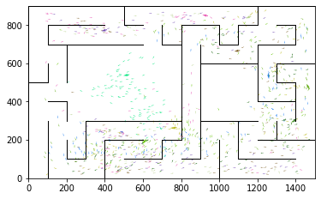

epoch 981 == proposed_mle: 12.48+-0.29/11.78+-0.17 --

epoch 982 == proposed_mle: 12.43+-0.26/11.85+-0.17 --

epoch 983 == proposed_mle: 12.12+-0.20/11.69+-0.18 --

epoch 984 == proposed_mle: 11.95+-0.24/11.88+-0.19 --

epoch 985 == proposed_mle: 12.27+-0.28/11.85+-0.16 --

epoch 986 == proposed_mle: 12.03+-0.30/11.93+-0.18 --

epoch 987 == proposed_mle: 12.11+-0.25/12.10+-0.17 --

epoch 988 == proposed_mle: 12.27+-0.25/11.82+-0.18 --

epoch 989 == proposed_mle: 12.48+-0.26/11.80+-0.19 --

epoch 990 >> proposed_mle: 12.32+-0.26/11.62+-0.18 --

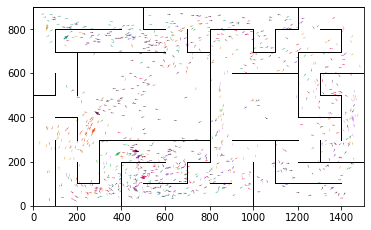

epoch 991 >> proposed_mle: 12.16+-0.21/11.50+-0.17 --

epoch 992 == proposed_mle: 12.45+-0.23/11.86+-0.16 --

epoch 993 == proposed_mle: 12.30+-0.23/11.97+-0.16 --

epoch 994 == proposed_mle: 12.05+-0.27/11.85+-0.18 --

epoch 995 == proposed_mle: 12.05+-0.25/11.70+-0.18 --

epoch 996 == proposed_mle: 11.87+-0.20/11.66+-0.16 --

epoch 997 == proposed_mle: 12.06+-0.25/11.68+-0.16 --

epoch 998 == proposed_mle: 12.00+-0.25/12.00+-0.18 --

epoch 999 == proposed_mle: 12.93+-0.25/11.90+-0.16 --

epoch 1000 == proposed_mle: 12.57+-0.24/11.77+-0.17 --

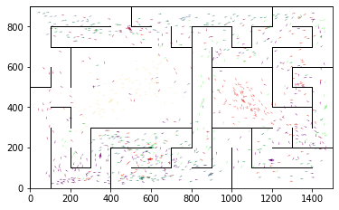

epoch 1001 == proposed_mle: 12.37+-0.29/11.87+-0.16 --

epoch 1002 == proposed_mle: 12.10+-0.26/11.71+-0.16 --

epoch 1003 == proposed_mle: 12.74+-0.23/11.88+-0.17 --

epoch 1004 == proposed_mle: 12.46+-0.27/11.81+-0.16 --

epoch 1005 == proposed_mle: 12.58+-0.27/12.03+-0.15 --

epoch 1006 == proposed_mle: 12.14+-0.24/11.76+-0.18 --

epoch 1007 == proposed_mle: 12.15+-0.25/11.83+-0.16 --

epoch 1008 == proposed_mle: 12.51+-0.23/11.88+-0.17 --

epoch 1009 == proposed_mle: 11.94+-0.26/12.12+-0.18 --

epoch 1010 == proposed_mle: 12.22+-0.23/11.92+-0.17 --

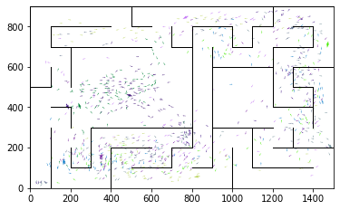

epoch 1011 == proposed_mle: 12.38+-0.28/11.71+-0.16 --

epoch 1012 == proposed_mle: 12.27+-0.23/11.76+-0.17 --

epoch 1013 == proposed_mle: 12.14+-0.24/11.60+-0.18 --

epoch 1014 == proposed_mle: 11.89+-0.29/11.69+-0.16 --

epoch 1015 == proposed_mle: 12.81+-0.27/11.73+-0.15 --

epoch 1016 == proposed_mle: 12.33+-0.25/11.67+-0.17 --

epoch 1017 == proposed_mle: 12.32+-0.22/12.04+-0.18 --

epoch 1018 == proposed_mle: 12.51+-0.27/12.03+-0.18 --

epoch 1019 == proposed_mle: 12.26+-0.23/11.92+-0.15 --

epoch 1020 == proposed_mle: 11.90+-0.26/11.90+-0.18 --

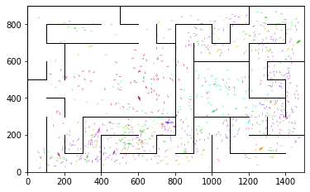

epoch 1021 == proposed_mle: 12.08+-0.27/11.86+-0.16 --

epoch 1022 == proposed_mle: 12.09+-0.24/11.88+-0.18 --

epoch 1023 == proposed_mle: 12.49+-0.24/11.65+-0.16 --

epoch 1024 == proposed_mle: 12.22+-0.26/11.83+-0.16 --

epoch 1025 == proposed_mle: 12.46+-0.26/11.65+-0.16 --

epoch 1026 == proposed_mle: 12.48+-0.25/11.52+-0.17 --

epoch 1027 == proposed_mle: 11.82+-0.26/11.56+-0.16 --

epoch 1028 == proposed_mle: 12.23+-0.27/11.58+-0.17 --

epoch 1029 >> proposed_mle: 11.95+-0.26/11.47+-0.16 --

epoch 1030 == proposed_mle: 11.95+-0.25/11.60+-0.17 --

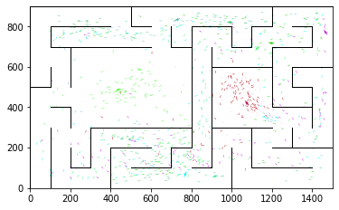

epoch 1031 == proposed_mle: 11.99+-0.22/11.95+-0.18 --

epoch 1032 == proposed_mle: 11.94+-0.24/11.65+-0.17 --

epoch 1033 == proposed_mle: 12.33+-0.23/11.55+-0.18 --

epoch 1034 == proposed_mle: 12.16+-0.26/11.79+-0.17 --

epoch 1035 == proposed_mle: 12.15+-0.24/12.05+-0.16 --

epoch 1036 == proposed_mle: 12.01+-0.20/11.66+-0.18 --

epoch 1037 == proposed_mle: 12.36+-0.24/11.58+-0.16 --

epoch 1038 == proposed_mle: 11.93+-0.27/11.59+-0.16 --

epoch 1039 == proposed_mle: 12.61+-0.23/11.50+-0.17 --

epoch 1040 == proposed_mle: 11.88+-0.25/12.07+-0.17 --

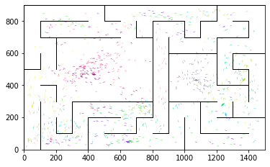

epoch 1041 == proposed_mle: 12.67+-0.24/11.59+-0.16 --

epoch 1042 == proposed_mle: 12.57+-0.29/11.68+-0.17 --

epoch 1043 == proposed_mle: 11.92+-0.19/11.77+-0.17 --

epoch 1044 == proposed_mle: 11.92+-0.25/11.58+-0.18 --

epoch 1045 == proposed_mle: 12.11+-0.30/11.89+-0.16 --

epoch 1046 == proposed_mle: 12.58+-0.26/11.58+-0.17 --

epoch 1047 == proposed_mle: 12.47+-0.22/11.48+-0.17 --

epoch 1048 == proposed_mle: 12.00+-0.22/11.55+-0.16 --

epoch 1049 == proposed_mle: 11.87+-0.26/11.70+-0.16 --

epoch 1050 == proposed_mle: 12.15+-0.23/11.63+-0.16 --

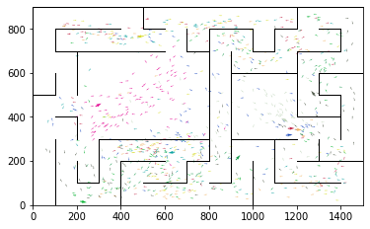

epoch 1051 == proposed_mle: 11.88+-0.25/11.47+-0.17 --

epoch 1052 == proposed_mle: 12.40+-0.28/11.51+-0.18 --

epoch 1053 == proposed_mle: 12.37+-0.21/11.95+-0.16 --

epoch 1054 == proposed_mle: 12.08+-0.22/11.57+-0.16 --

epoch 1055 == proposed_mle: 11.72+-0.26/11.65+-0.15 --

epoch 1056 == proposed_mle: 11.87+-0.27/11.92+-0.20 --

epoch 1057 == proposed_mle: 12.19+-0.25/11.59+-0.16 --

epoch 1058 == proposed_mle: 11.92+-0.22/11.49+-0.17 --

epoch 1059 == proposed_mle: 12.13+-0.22/11.51+-0.16 --

epoch 1060 == proposed_mle: 12.14+-0.26/11.55+-0.17 --

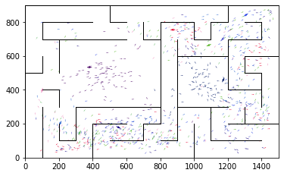

epoch 1061 == proposed_mle: 12.25+-0.26/11.58+-0.15 --

epoch 1062 == proposed_mle: 11.85+-0.25/11.52+-0.17 --

epoch 1063 == proposed_mle: 12.15+-0.26/11.49+-0.15 --

epoch 1064 == proposed_mle: 12.25+-0.25/11.54+-0.17 --

epoch 1065 == proposed_mle: 11.57+-0.20/11.47+-0.16 --

epoch 1066 == proposed_mle: 12.25+-0.24/11.78+-0.19 --

epoch 1067 >> proposed_mle: 12.19+-0.23/11.46+-0.17 --

epoch 1068 == proposed_mle: 11.47+-0.21/11.65+-0.18 --

epoch 1069 == proposed_mle: 11.69+-0.26/11.52+-0.16 --

epoch 1070 == proposed_mle: 12.21+-0.24/11.84+-0.18 --

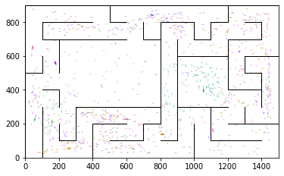

epoch 1071 == proposed_mle: 11.84+-0.23/11.77+-0.18 --

epoch 1072 == proposed_mle: 12.00+-0.27/11.99+-0.16 --

epoch 1073 == proposed_mle: 12.22+-0.27/11.60+-0.17 --

epoch 1074 >> proposed_mle: 11.87+-0.28/11.43+-0.16 --

epoch 1075 >> proposed_mle: 12.23+-0.27/11.43+-0.16 --

epoch 1076 == proposed_mle: 11.62+-0.24/11.44+-0.17 --

epoch 1077 == proposed_mle: 12.01+-0.28/11.66+-0.17 --

epoch 1078 == proposed_mle: 12.04+-0.25/11.68+-0.19 --

epoch 1079 == proposed_mle: 12.27+-0.25/11.59+-0.17 --

epoch 1080 == proposed_mle: 11.74+-0.26/11.47+-0.15 --

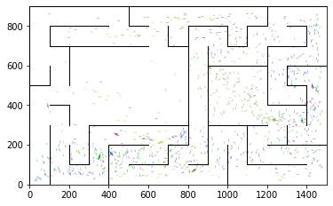

epoch 1081 == proposed_mle: 12.12+-0.25/11.53+-0.16 --

epoch 1082 == proposed_mle: 11.60+-0.28/11.81+-0.15 --

epoch 1083 == proposed_mle: 12.27+-0.25/11.52+-0.16 --

epoch 1084 == proposed_mle: 12.08+-0.23/11.95+-0.17 --

epoch 1085 == proposed_mle: 12.52+-0.24/11.60+-0.17 --

epoch 1086 >> proposed_mle: 12.08+-0.21/11.40+-0.17 --

epoch 1087 == proposed_mle: 11.88+-0.27/11.46+-0.16 --

epoch 1088 == proposed_mle: 12.32+-0.26/11.52+-0.16 --

epoch 1089 == proposed_mle: 12.23+-0.29/11.59+-0.18 --

epoch 1090 == proposed_mle: 12.17+-0.30/11.46+-0.17 --

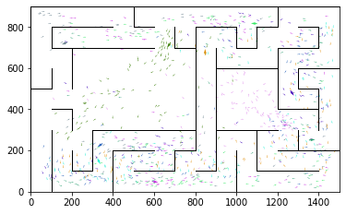

epoch 1091 >> proposed_mle: 12.40+-0.25/11.34+-0.17 --

epoch 1092 == proposed_mle: 11.62+-0.23/11.81+-0.18 --

epoch 1093 == proposed_mle: 12.01+-0.26/11.36+-0.15 --

epoch 1094 == proposed_mle: 12.24+-0.26/11.52+-0.18 --

epoch 1095 >> proposed_mle: 12.19+-0.24/11.33+-0.16 --

epoch 1096 == proposed_mle: 11.93+-0.27/11.69+-0.19 --

epoch 1097 == proposed_mle: 12.57+-0.31/11.48+-0.18 --

epoch 1098 >> proposed_mle: 11.95+-0.23/11.29+-0.17 --

epoch 1099 == proposed_mle: 11.59+-0.25/11.62+-0.16 --

epoch 1100 == proposed_mle: 11.70+-0.25/11.63+-0.18 --

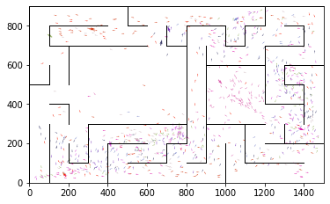

epoch 1101 == proposed_mle: 12.66+-0.27/11.37+-0.16 --

epoch 1102 == proposed_mle: 12.12+-0.26/11.76+-0.17 --

epoch 1103 == proposed_mle: 12.10+-0.26/11.39+-0.18 --

epoch 1104 == proposed_mle: 12.24+-0.27/11.50+-0.16 --

epoch 1105 == proposed_mle: 12.11+-0.23/11.41+-0.18 --

epoch 1106 == proposed_mle: 12.19+-0.21/11.52+-0.16 --

epoch 1107 == proposed_mle: 12.07+-0.20/11.76+-0.17 --

epoch 1108 == proposed_mle: 12.01+-0.27/11.83+-0.18 --

epoch 1109 == proposed_mle: 11.58+-0.28/11.54+-0.15 --

epoch 1110 == proposed_mle: 12.38+-0.28/11.42+-0.19 --

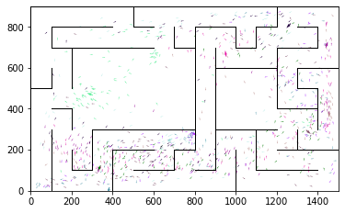

epoch 1111 == proposed_mle: 12.13+-0.23/11.51+-0.18 --

epoch 1112 == proposed_mle: 11.90+-0.29/11.47+-0.18 --

epoch 1113 == proposed_mle: 11.48+-0.23/11.38+-0.17 --

epoch 1114 == proposed_mle: 12.16+-0.26/11.69+-0.17 --

epoch 1115 == proposed_mle: 12.00+-0.25/11.51+-0.17 --

epoch 1116 == proposed_mle: 12.48+-0.27/11.58+-0.17 --

epoch 1117 == proposed_mle: 12.50+-0.30/11.43+-0.17 --

epoch 1118 == proposed_mle: 11.95+-0.25/11.47+-0.18 --

epoch 1119 >> proposed_mle: 11.73+-0.31/11.28+-0.17 --

epoch 1120 == proposed_mle: 12.32+-0.28/11.77+-0.17 --

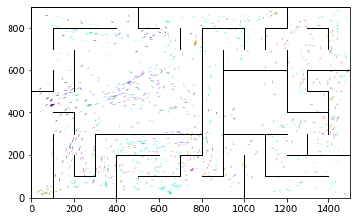

epoch 1121 == proposed_mle: 11.95+-0.24/11.58+-0.16 --

epoch 1122 == proposed_mle: 11.54+-0.22/11.52+-0.16 --

epoch 1123 == proposed_mle: 12.05+-0.25/11.46+-0.18 --

epoch 1124 == proposed_mle: 11.97+-0.27/11.30+-0.17 --

epoch 1125 == proposed_mle: 12.32+-0.26/11.51+-0.17 --

epoch 1126 == proposed_mle: 12.14+-0.21/11.60+-0.17 --

epoch 1127 == proposed_mle: 12.06+-0.28/11.44+-0.18 --

epoch 1128 == proposed_mle: 12.23+-0.22/11.84+-0.17 --

epoch 1129 == proposed_mle: 12.10+-0.24/11.61+-0.16 --

epoch 1130 == proposed_mle: 12.19+-0.27/11.76+-0.16 --

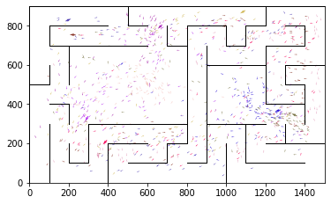

epoch 1131 == proposed_mle: 12.01+-0.22/11.33+-0.17 --

epoch 1132 == proposed_mle: 11.76+-0.28/11.71+-0.17 --

epoch 1133 == proposed_mle: 11.97+-0.23/11.47+-0.16 --

epoch 1134 == proposed_mle: 12.18+-0.26/11.29+-0.16 --

epoch 1135 == proposed_mle: 11.94+-0.24/11.51+-0.16 --

epoch 1136 == proposed_mle: 11.51+-0.23/11.47+-0.17 --

epoch 1137 >> proposed_mle: 11.56+-0.21/11.17+-0.16 --

epoch 1138 == proposed_mle: 12.04+-0.30/11.21+-0.17 --

epoch 1139 == proposed_mle: 11.82+-0.29/11.29+-0.16 --

epoch 1140 == proposed_mle: 11.75+-0.19/11.40+-0.17 --

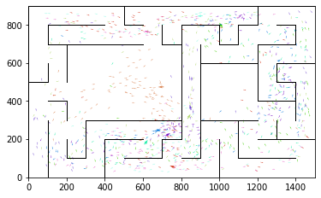

epoch 1141 == proposed_mle: 12.33+-0.27/11.23+-0.15 --

epoch 1142 == proposed_mle: 11.84+-0.24/11.32+-0.18 --

epoch 1143 == proposed_mle: 11.50+-0.24/11.35+-0.17 --

epoch 1144 == proposed_mle: 12.17+-0.32/11.29+-0.16 --

epoch 1145 == proposed_mle: 11.86+-0.23/11.38+-0.16 --

epoch 1146 == proposed_mle: 11.66+-0.24/11.40+-0.16 --

epoch 1147 == proposed_mle: 12.07+-0.27/11.32+-0.16 --

epoch 1148 == proposed_mle: 12.00+-0.28/11.39+-0.17 --

epoch 1149 == proposed_mle: 12.17+-0.26/11.44+-0.15 --

epoch 1150 == proposed_mle: 12.02+-0.22/11.33+-0.17 --

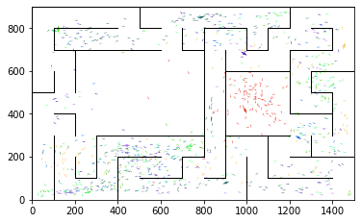

epoch 1151 == proposed_mle: 11.63+-0.29/11.23+-0.18 --

epoch 1152 == proposed_mle: 11.17+-0.22/11.19+-0.16 --

epoch 1153 >> proposed_mle: 11.88+-0.29/11.17+-0.16 --

epoch 1154 == proposed_mle: 11.58+-0.20/11.29+-0.16 --

epoch 1155 == proposed_mle: 11.14+-0.26/11.37+-0.18 --

epoch 1156 >> proposed_mle: 11.21+-0.21/11.00+-0.15 --

epoch 1157 == proposed_mle: 11.90+-0.25/11.32+-0.16 --

epoch 1158 == proposed_mle: 11.78+-0.23/11.54+-0.18 --

epoch 1159 == proposed_mle: 11.79+-0.23/11.13+-0.15 --

epoch 1160 == proposed_mle: 11.82+-0.26/11.46+-0.17 --

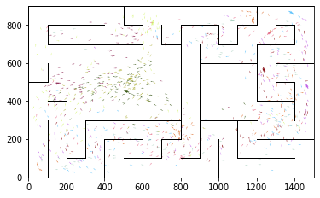

epoch 1161 == proposed_mle: 11.86+-0.25/11.50+-0.17 --

epoch 1162 == proposed_mle: 12.29+-0.29/11.66+-0.17 --

epoch 1163 == proposed_mle: 11.56+-0.27/11.14+-0.16 --

epoch 1164 == proposed_mle: 11.80+-0.22/11.28+-0.18 --

epoch 1165 == proposed_mle: 11.81+-0.27/11.17+-0.17 --

epoch 1166 == proposed_mle: 11.79+-0.24/11.34+-0.16 --

epoch 1167 == proposed_mle: 12.29+-0.24/11.27+-0.16 --

epoch 1168 == proposed_mle: 11.56+-0.24/11.39+-0.18 --

epoch 1169 == proposed_mle: 12.36+-0.28/11.38+-0.17 --

epoch 1170 == proposed_mle: 11.50+-0.31/11.31+-0.17 --

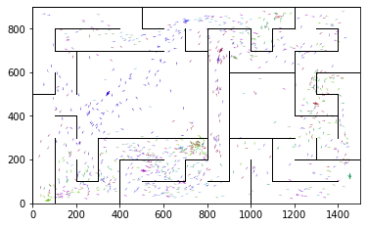

epoch 1171 == proposed_mle: 11.66+-0.26/11.09+-0.17 --

epoch 1172 == proposed_mle: 12.02+-0.24/11.27+-0.17 --

epoch 1173 == proposed_mle: 11.43+-0.21/11.48+-0.18 --

epoch 1174 == proposed_mle: 11.81+-0.27/11.07+-0.16 --

epoch 1175 == proposed_mle: 11.76+-0.25/11.25+-0.16 --

epoch 1176 == proposed_mle: 11.91+-0.19/11.12+-0.18 --

epoch 1177 == proposed_mle: 11.82+-0.23/11.20+-0.17 --

epoch 1178 == proposed_mle: 11.88+-0.24/11.45+-0.16 --

epoch 1179 == proposed_mle: 11.44+-0.20/11.20+-0.15 --

epoch 1180 == proposed_mle: 11.77+-0.24/11.29+-0.17 --

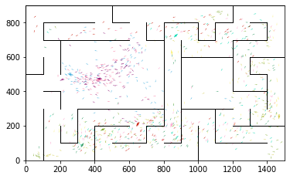

epoch 1181 == proposed_mle: 11.38+-0.24/11.26+-0.16 --

epoch 1182 == proposed_mle: 11.66+-0.26/11.05+-0.18 --

epoch 1183 >> proposed_mle: 11.41+-0.28/10.95+-0.16 --

epoch 1184 == proposed_mle: 11.80+-0.27/11.24+-0.16 --

epoch 1185 == proposed_mle: 11.85+-0.28/11.10+-0.16 --

epoch 1186 == proposed_mle: 11.85+-0.22/11.24+-0.16 --

epoch 1187 >> proposed_mle: 11.93+-0.27/10.92+-0.17 --

epoch 1188 == proposed_mle: 12.20+-0.28/11.17+-0.18 --

epoch 1189 == proposed_mle: 11.31+-0.24/11.09+-0.17 --

epoch 1190 == proposed_mle: 11.49+-0.22/11.13+-0.16 --

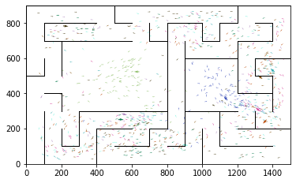

epoch 1191 == proposed_mle: 11.75+-0.25/11.59+-0.17 --

epoch 1192 == proposed_mle: 12.00+-0.24/11.11+-0.16 --

epoch 1193 == proposed_mle: 11.89+-0.23/11.29+-0.17 --

epoch 1194 == proposed_mle: 11.99+-0.25/11.20+-0.17 --

epoch 1195 == proposed_mle: 11.53+-0.25/11.29+-0.17 --

epoch 1196 == proposed_mle: 11.30+-0.21/11.09+-0.17 --

epoch 1197 == proposed_mle: 11.48+-0.22/11.44+-0.17 --

epoch 1198 >> proposed_mle: 11.33+-0.23/10.89+-0.16 --

epoch 1199 == proposed_mle: 12.10+-0.30/11.18+-0.15 --

epoch 1200 == proposed_mle: 11.65+-0.22/11.31+-0.17 --

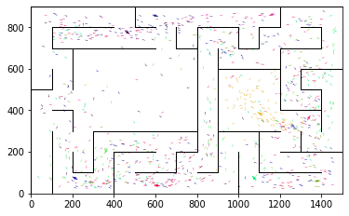

epoch 1201 == proposed_mle: 12.07+-0.28/11.22+-0.17 --

epoch 1202 == proposed_mle: 11.67+-0.25/11.05+-0.17 --

epoch 1203 == proposed_mle: 11.66+-0.25/11.03+-0.17 --

epoch 1204 == proposed_mle: 11.57+-0.25/11.37+-0.15 --

epoch 1205 == proposed_mle: 11.39+-0.21/11.01+-0.17 --

epoch 1206 == proposed_mle: 11.81+-0.22/11.16+-0.17 --

epoch 1207 == proposed_mle: 11.65+-0.21/11.06+-0.15 --

epoch 1208 == proposed_mle: 11.50+-0.23/11.03+-0.17 --

epoch 1209 == proposed_mle: 11.78+-0.23/11.17+-0.17 --

epoch 1210 == proposed_mle: 11.42+-0.25/11.00+-0.16 --

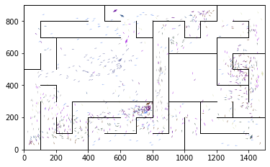

epoch 1211 >> proposed_mle: 11.45+-0.23/10.82+-0.15 --

epoch 1212 == proposed_mle: 11.40+-0.25/11.18+-0.17 --

epoch 1213 == proposed_mle: 11.36+-0.28/10.98+-0.16 --

epoch 1214 == proposed_mle: 11.39+-0.22/11.11+-0.15 --

epoch 1215 == proposed_mle: 11.48+-0.23/11.11+-0.17 --

epoch 1216 == proposed_mle: 11.75+-0.26/11.23+-0.15 --

epoch 1217 == proposed_mle: 11.42+-0.23/11.16+-0.15 --

epoch 1218 == proposed_mle: 11.47+-0.27/11.20+-0.16 --

epoch 1219 == proposed_mle: 11.39+-0.26/11.08+-0.16 --

epoch 1220 == proposed_mle: 11.87+-0.28/11.32+-0.16 --

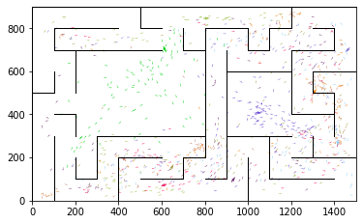

epoch 1221 == proposed_mle: 11.73+-0.24/11.21+-0.16 --

epoch 1222 == proposed_mle: 11.81+-0.28/11.20+-0.17 --

epoch 1223 == proposed_mle: 11.98+-0.29/11.22+-0.13 --

epoch 1224 == proposed_mle: 11.40+-0.27/11.22+-0.17 --

epoch 1225 == proposed_mle: 11.74+-0.26/11.25+-0.16 --

epoch 1226 == proposed_mle: 11.79+-0.23/11.16+-0.15 --

epoch 1227 == proposed_mle: 12.02+-0.29/11.04+-0.16 --

epoch 1228 == proposed_mle: 11.37+-0.22/11.13+-0.18 --

epoch 1229 >> proposed_mle: 11.39+-0.24/10.73+-0.16 --

epoch 1230 == proposed_mle: 11.74+-0.22/11.23+-0.18 --

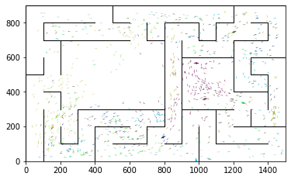

epoch 1231 == proposed_mle: 11.37+-0.23/11.02+-0.15 --

epoch 1232 == proposed_mle: 11.73+-0.24/11.05+-0.15 --

epoch 1233 == proposed_mle: 11.59+-0.26/11.05+-0.17 --

epoch 1234 == proposed_mle: 11.63+-0.26/10.90+-0.16 --

epoch 1235 == proposed_mle: 11.59+-0.23/10.96+-0.16 --

epoch 1236 == proposed_mle: 11.47+-0.23/10.95+-0.16 --

epoch 1237 == proposed_mle: 11.41+-0.25/10.97+-0.14 --

epoch 1238 == proposed_mle: 11.22+-0.21/10.85+-0.15 --

epoch 1239 == proposed_mle: 11.29+-0.20/10.90+-0.17 --

epoch 1240 == proposed_mle: 11.10+-0.23/11.16+-0.16 --

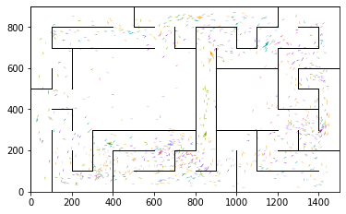

epoch 1241 == proposed_mle: 11.67+-0.22/11.08+-0.17 --

epoch 1242 == proposed_mle: 12.01+-0.28/11.28+-0.16 --

epoch 1243 == proposed_mle: 12.00+-0.26/11.13+-0.15 --

epoch 1244 == proposed_mle: 11.70+-0.24/11.05+-0.16 --

epoch 1245 == proposed_mle: 11.43+-0.26/11.24+-0.15 --

epoch 1246 == proposed_mle: 11.36+-0.20/11.26+-0.15 --

epoch 1247 == proposed_mle: 12.08+-0.30/11.18+-0.16 --

epoch 1248 == proposed_mle: 11.71+-0.30/11.21+-0.17 --

epoch 1249 == proposed_mle: 11.63+-0.27/11.14+-0.15 --

epoch 1250 == proposed_mle: 11.18+-0.21/11.10+-0.18 --

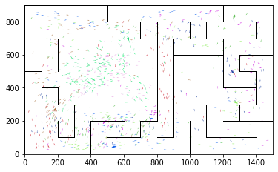

epoch 1251 == proposed_mle: 11.77+-0.28/11.03+-0.15 --

epoch 1252 == proposed_mle: 11.40+-0.24/11.41+-0.17 --

epoch 1253 == proposed_mle: 11.75+-0.28/11.22+-0.18 --

epoch 1254 == proposed_mle: 11.14+-0.25/10.93+-0.16 --

epoch 1255 == proposed_mle: 11.83+-0.21/11.06+-0.15 --

epoch 1256 == proposed_mle: 11.79+-0.28/11.04+-0.15 --

epoch 1257 == proposed_mle: 11.55+-0.29/10.85+-0.15 --

epoch 1258 == proposed_mle: 11.91+-0.26/11.09+-0.17 --

epoch 1259 == proposed_mle: 11.81+-0.30/11.02+-0.14 --

epoch 1260 == proposed_mle: 11.91+-0.23/10.98+-0.15 --

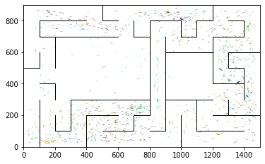

epoch 1261 == proposed_mle: 11.68+-0.22/10.86+-0.16 --

epoch 1262 == proposed_mle: 11.54+-0.23/11.07+-0.16 --

epoch 1263 == proposed_mle: 11.80+-0.26/11.16+-0.16 --

epoch 1264 == proposed_mle: 11.65+-0.25/11.37+-0.16 --

epoch 1265 == proposed_mle: 11.41+-0.24/10.95+-0.15 --

epoch 1266 == proposed_mle: 11.80+-0.19/11.15+-0.16 --

epoch 1267 == proposed_mle: 11.38+-0.22/11.16+-0.15 --

epoch 1268 == proposed_mle: 11.90+-0.26/11.09+-0.15 --

epoch 1269 == proposed_mle: 11.32+-0.23/11.08+-0.17 --

epoch 1270 == proposed_mle: 11.43+-0.28/11.16+-0.15 --

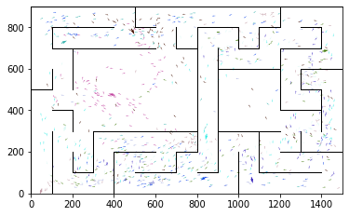

epoch 1271 == proposed_mle: 11.39+-0.25/10.98+-0.16 --

epoch 1272 == proposed_mle: 11.53+-0.22/10.98+-0.17 --

epoch 1273 == proposed_mle: 11.34+-0.22/11.22+-0.17 --

epoch 1274 == proposed_mle: 11.76+-0.23/10.94+-0.16 --

epoch 1275 == proposed_mle: 11.71+-0.24/10.91+-0.18 --

epoch 1276 == proposed_mle: 11.57+-0.28/11.14+-0.15 --

epoch 1277 == proposed_mle: 11.80+-0.27/10.84+-0.15 --

epoch 1278 == proposed_mle: 10.96+-0.25/11.08+-0.15 --

epoch 1279 == proposed_mle: 11.26+-0.19/11.12+-0.16 --

epoch 1280 == proposed_mle: 11.34+-0.20/11.06+-0.16 --

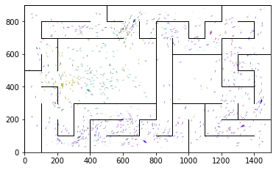

epoch 1281 == proposed_mle: 11.29+-0.23/10.95+-0.17 --

epoch 1282 == proposed_mle: 11.35+-0.28/11.16+-0.17 --

epoch 1283 == proposed_mle: 11.46+-0.22/11.17+-0.16 --

epoch 1284 == proposed_mle: 11.59+-0.27/11.28+-0.15 --

epoch 1285 == proposed_mle: 11.54+-0.23/11.29+-0.16 --

epoch 1286 == proposed_mle: 11.56+-0.24/11.33+-0.16 --

epoch 1287 == proposed_mle: 11.40+-0.20/10.79+-0.18 --

epoch 1288 == proposed_mle: 11.69+-0.26/10.89+-0.17 --

epoch 1289 == proposed_mle: 11.49+-0.28/11.34+-0.16 --

epoch 1290 == proposed_mle: 11.49+-0.22/11.15+-0.16 --

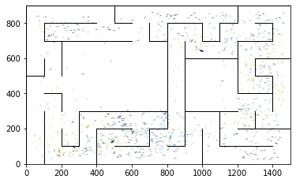

epoch 1291 == proposed_mle: 11.25+-0.23/10.97+-0.17 --

epoch 1292 == proposed_mle: 11.63+-0.27/10.94+-0.16 --

epoch 1293 == proposed_mle: 11.09+-0.24/10.96+-0.16 --

epoch 1294 == proposed_mle: 11.10+-0.22/10.81+-0.15 --

epoch 1295 == proposed_mle: 11.39+-0.25/11.35+-0.17 --

epoch 1296 == proposed_mle: 11.22+-0.20/10.92+-0.15 --

epoch 1297 == proposed_mle: 11.06+-0.27/10.88+-0.15 --

epoch 1298 == proposed_mle: 10.91+-0.19/10.96+-0.16 --

epoch 1299 == proposed_mle: 11.67+-0.25/11.00+-0.16 --

epoch 1300 == proposed_mle: 11.84+-0.28/10.95+-0.16 --

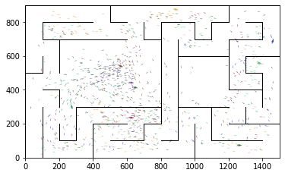

epoch 1301 == proposed_mle: 11.54+-0.28/11.13+-0.15 --

epoch 1302 == proposed_mle: 12.03+-0.24/10.78+-0.14 --

epoch 1303 == proposed_mle: 11.45+-0.26/10.90+-0.17 --

epoch 1304 == proposed_mle: 11.04+-0.17/11.05+-0.17 --

epoch 1305 == proposed_mle: 11.48+-0.26/10.90+-0.17 --

epoch 1306 == proposed_mle: 11.26+-0.25/11.03+-0.15 --

epoch 1307 == proposed_mle: 11.47+-0.25/11.01+-0.17 --

epoch 1308 == proposed_mle: 11.77+-0.25/10.77+-0.18 --

epoch 1309 == proposed_mle: 11.18+-0.24/10.74+-0.15 --

epoch 1310 == proposed_mle: 11.40+-0.26/10.81+-0.15 --

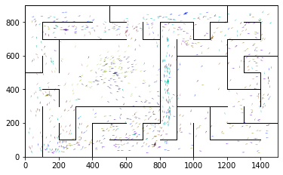

epoch 1311 == proposed_mle: 11.54+-0.24/10.91+-0.16 --

epoch 1312 == proposed_mle: 11.44+-0.25/10.82+-0.13 --

epoch 1313 >> proposed_mle: 11.00+-0.25/10.71+-0.16 --

epoch 1314 == proposed_mle: 11.56+-0.28/10.79+-0.16 --

epoch 1315 == proposed_mle: 11.25+-0.24/10.86+-0.18 --

epoch 1316 == proposed_mle: 11.39+-0.26/10.98+-0.16 --

epoch 1317 == proposed_mle: 11.28+-0.25/11.00+-0.18 --

epoch 1318 == proposed_mle: 10.73+-0.26/10.94+-0.16 --

epoch 1319 == proposed_mle: 11.32+-0.24/10.85+-0.17 --

epoch 1320 == proposed_mle: 11.39+-0.26/10.79+-0.15 --

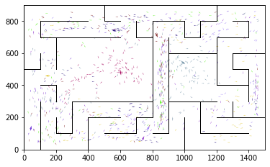

epoch 1321 == proposed_mle: 11.87+-0.27/11.12+-0.15 --

epoch 1322 == proposed_mle: 11.39+-0.21/11.03+-0.16 --

epoch 1323 == proposed_mle: 11.32+-0.21/10.95+-0.14 --

epoch 1324 == proposed_mle: 11.59+-0.25/10.99+-0.18 --

epoch 1325 == proposed_mle: 11.52+-0.22/11.22+-0.17 --

epoch 1326 == proposed_mle: 11.73+-0.24/11.27+-0.17 --

epoch 1327 == proposed_mle: 11.31+-0.15/11.17+-0.15 --

epoch 1328 == proposed_mle: 11.22+-0.28/11.20+-0.17 --

epoch 1329 == proposed_mle: 11.25+-0.26/10.84+-0.16 --

epoch 1330 == proposed_mle: 11.00+-0.24/10.96+-0.16 --

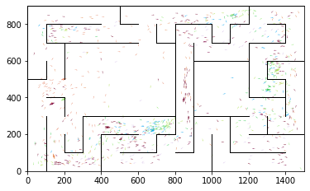

epoch 1331 == proposed_mle: 11.30+-0.28/10.96+-0.16 --

epoch 1332 == proposed_mle: 11.26+-0.27/11.01+-0.17 --

epoch 1333 == proposed_mle: 11.86+-0.23/10.97+-0.18 --

epoch 1334 == proposed_mle: 11.77+-0.24/10.83+-0.15 --

epoch 1335 == proposed_mle: 11.42+-0.22/11.22+-0.16 --

epoch 1336 == proposed_mle: 11.98+-0.28/11.00+-0.16 --

epoch 1337 == proposed_mle: 11.38+-0.32/11.13+-0.17 --

epoch 1338 == proposed_mle: 11.47+-0.26/11.28+-0.16 --

epoch 1339 == proposed_mle: 11.65+-0.22/11.19+-0.18 --

epoch 1340 == proposed_mle: 11.77+-0.23/11.06+-0.17 --

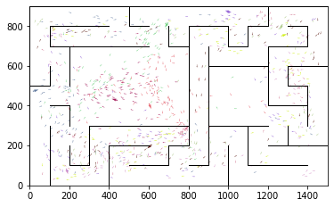

epoch 1341 == proposed_mle: 11.37+-0.24/11.05+-0.17 --

epoch 1342 == proposed_mle: 11.36+-0.21/11.27+-0.17 --

epoch 1343 == proposed_mle: 11.81+-0.23/11.04+-0.15 --

epoch 1344 >> proposed_mle: 10.94+-0.22/10.70+-0.16 --

epoch 1345 == proposed_mle: 11.90+-0.31/10.97+-0.16 --

epoch 1346 == proposed_mle: 11.73+-0.23/10.89+-0.16 --

epoch 1347 == proposed_mle: 11.34+-0.26/10.76+-0.16 --

epoch 1348 == proposed_mle: 11.61+-0.24/10.77+-0.15 --

epoch 1349 == proposed_mle: 11.49+-0.22/10.80+-0.15 --

epoch 1350 == proposed_mle: 11.32+-0.31/10.99+-0.17 --

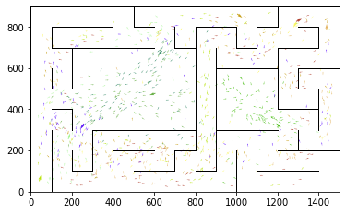

epoch 1351 == proposed_mle: 11.39+-0.24/11.11+-0.18 --

epoch 1352 == proposed_mle: 11.32+-0.24/10.74+-0.15 --

epoch 1353 == proposed_mle: 11.12+-0.22/11.18+-0.16 --

epoch 1354 == proposed_mle: 11.67+-0.26/11.09+-0.14 --

epoch 1355 == proposed_mle: 11.62+-0.27/10.97+-0.16 --

epoch 1356 == proposed_mle: 11.27+-0.22/11.02+-0.16 --

epoch 1357 == proposed_mle: 11.24+-0.23/11.08+-0.15 --

epoch 1358 == proposed_mle: 11.72+-0.27/10.97+-0.16 --

epoch 1359 == proposed_mle: 11.81+-0.24/10.83+-0.15 --

epoch 1360 == proposed_mle: 11.50+-0.23/11.11+-0.18 --

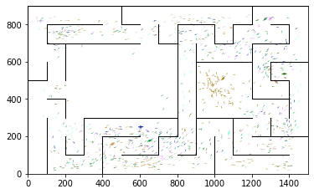

epoch 1361 == proposed_mle: 11.76+-0.26/10.96+-0.18 --

epoch 1362 == proposed_mle: 11.98+-0.24/11.26+-0.16 --

epoch 1363 == proposed_mle: 10.96+-0.23/10.99+-0.17 --

epoch 1364 == proposed_mle: 11.09+-0.22/11.02+-0.17 --

epoch 1365 == proposed_mle: 11.38+-0.24/10.93+-0.16 --

epoch 1366 == proposed_mle: 11.45+-0.25/10.80+-0.16 --

epoch 1367 == proposed_mle: 11.47+-0.23/10.92+-0.16 --

epoch 1368 == proposed_mle: 11.52+-0.21/10.99+-0.14 --

epoch 1369 == proposed_mle: 11.50+-0.22/10.83+-0.16 --

epoch 1370 == proposed_mle: 11.63+-0.22/11.00+-0.15 --

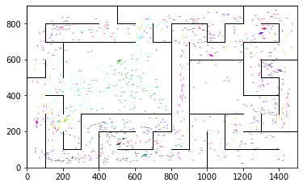

epoch 1371 == proposed_mle: 11.08+-0.26/10.95+-0.16 --

epoch 1372 == proposed_mle: 11.74+-0.25/10.83+-0.15 --

epoch 1373 == proposed_mle: 11.80+-0.24/10.88+-0.15 --

epoch 1374 == proposed_mle: 11.66+-0.26/10.85+-0.15 --

epoch 1375 == proposed_mle: 11.38+-0.27/10.96+-0.15 --

epoch 1376 == proposed_mle: 11.67+-0.22/10.87+-0.16 --

epoch 1377 == proposed_mle: 11.43+-0.22/11.02+-0.15 --

epoch 1378 == proposed_mle: 11.44+-0.25/10.87+-0.16 --

epoch 1379 == proposed_mle: 11.58+-0.23/10.72+-0.14 --

epoch 1380 == proposed_mle: 11.36+-0.23/11.07+-0.17 --

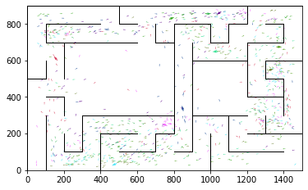

epoch 1381 >> proposed_mle: 11.26+-0.22/10.59+-0.16 --

epoch 1382 == proposed_mle: 10.88+-0.22/10.91+-0.16 --

epoch 1383 == proposed_mle: 11.15+-0.25/10.70+-0.15 --

epoch 1384 == proposed_mle: 11.56+-0.26/10.60+-0.14 --

epoch 1385 == proposed_mle: 11.35+-0.30/10.76+-0.15 --

epoch 1386 == proposed_mle: 11.02+-0.26/10.78+-0.15 --

epoch 1387 == proposed_mle: 11.66+-0.18/10.99+-0.16 --

epoch 1388 == proposed_mle: 11.12+-0.22/10.69+-0.15 --

epoch 1389 == proposed_mle: 11.21+-0.25/10.90+-0.17 --

epoch 1390 == proposed_mle: 11.21+-0.24/10.73+-0.16 --

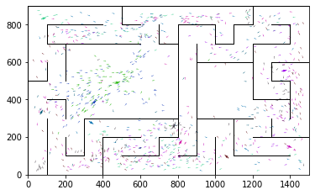

epoch 1391 == proposed_mle: 11.32+-0.23/10.74+-0.14 --

epoch 1392 >> proposed_mle: 11.23+-0.22/10.58+-0.14 --

epoch 1393 == proposed_mle: 11.34+-0.27/10.78+-0.15 --

epoch 1394 == proposed_mle: 11.01+-0.25/10.97+-0.16 --

epoch 1395 == proposed_mle: 11.49+-0.23/10.60+-0.16 --

epoch 1396 == proposed_mle: 11.26+-0.24/10.66+-0.16 --

epoch 1397 == proposed_mle: 11.10+-0.23/10.73+-0.16 --

epoch 1398 == proposed_mle: 11.32+-0.26/10.66+-0.15 --

epoch 1399 == proposed_mle: 11.25+-0.24/10.61+-0.13 --

epoch 1400 >> proposed_mle: 11.80+-0.25/10.54+-0.15 --

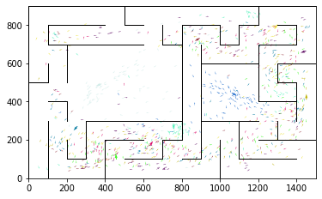

epoch 1401 == proposed_mle: 11.09+-0.20/10.58+-0.15 --

epoch 1402 == proposed_mle: 10.90+-0.20/10.80+-0.17 --

epoch 1403 == proposed_mle: 11.40+-0.25/10.93+-0.16 --

epoch 1404 == proposed_mle: 11.40+-0.23/10.91+-0.15 --

epoch 1405 == proposed_mle: 11.07+-0.25/10.63+-0.15 --

epoch 1406 == proposed_mle: 11.04+-0.24/10.79+-0.17 --

epoch 1407 == proposed_mle: 11.07+-0.24/10.71+-0.15 --

epoch 1408 >> proposed_mle: 11.33+-0.26/10.51+-0.15 --

epoch 1409 >> proposed_mle: 10.92+-0.21/10.45+-0.15 --

epoch 1410 == proposed_mle: 11.23+-0.23/10.62+-0.16 --

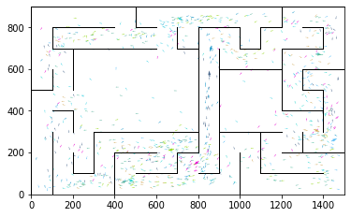

epoch 1411 == proposed_mle: 11.08+-0.23/10.68+-0.15 --

epoch 1412 == proposed_mle: 11.46+-0.24/10.83+-0.16 --

epoch 1413 == proposed_mle: 11.51+-0.25/10.81+-0.15 --

epoch 1414 == proposed_mle: 11.14+-0.26/10.78+-0.16 --

epoch 1415 == proposed_mle: 11.37+-0.23/10.80+-0.15 --

epoch 1416 == proposed_mle: 11.57+-0.27/10.73+-0.16 --

epoch 1417 == proposed_mle: 11.22+-0.25/10.71+-0.16 --

epoch 1418 == proposed_mle: 11.01+-0.24/10.80+-0.17 --

epoch 1419 == proposed_mle: 11.16+-0.26/10.84+-0.15 --

epoch 1420 == proposed_mle: 11.12+-0.24/10.63+-0.14 --

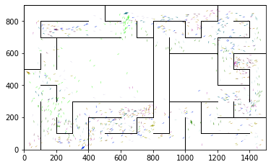

epoch 1421 == proposed_mle: 11.09+-0.21/10.82+-0.17 --

epoch 1422 == proposed_mle: 11.40+-0.28/10.82+-0.15 --

epoch 1423 == proposed_mle: 11.69+-0.25/10.70+-0.17 --

epoch 1424 == proposed_mle: 11.29+-0.26/10.75+-0.14 --

epoch 1425 == proposed_mle: 11.25+-0.25/10.95+-0.16 --

epoch 1426 == proposed_mle: 11.42+-0.27/10.53+-0.15 --

epoch 1427 == proposed_mle: 11.38+-0.24/10.60+-0.15 --

epoch 1428 == proposed_mle: 11.13+-0.21/10.69+-0.16 --

epoch 1429 == proposed_mle: 11.17+-0.26/10.69+-0.15 --

epoch 1430 == proposed_mle: 11.06+-0.24/10.80+-0.15 --

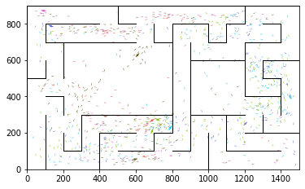

epoch 1431 == proposed_mle: 10.93+-0.24/10.61+-0.14 --

epoch 1432 == proposed_mle: 10.99+-0.18/10.53+-0.14 --

epoch 1433 == proposed_mle: 10.92+-0.23/10.76+-0.15 --

epoch 1434 == proposed_mle: 11.63+-0.23/10.82+-0.16 --

epoch 1435 == proposed_mle: 11.46+-0.22/11.09+-0.15 --

epoch 1436 == proposed_mle: 11.59+-0.24/11.06+-0.15 --

epoch 1437 == proposed_mle: 11.57+-0.26/10.87+-0.17 --

epoch 1438 == proposed_mle: 11.35+-0.24/10.75+-0.16 --

epoch 1439 == proposed_mle: 11.22+-0.26/10.75+-0.17 --

epoch 1440 == proposed_mle: 11.83+-0.28/10.71+-0.16 --

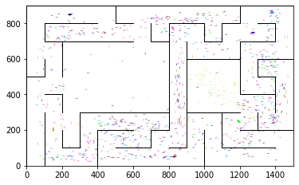

epoch 1441 == proposed_mle: 10.87+-0.24/10.67+-0.15 --

epoch 1442 == proposed_mle: 10.99+-0.25/10.57+-0.15 --

epoch 1443 == proposed_mle: 10.94+-0.24/10.59+-0.15 --

epoch 1444 == proposed_mle: 11.19+-0.22/10.89+-0.16 --

epoch 1445 == proposed_mle: 11.24+-0.22/10.86+-0.14 --

epoch 1446 == proposed_mle: 11.51+-0.25/10.98+-0.15 --

epoch 1447 == proposed_mle: 11.28+-0.19/10.85+-0.14 --

epoch 1448 == proposed_mle: 11.43+-0.28/10.75+-0.16 --

epoch 1449 == proposed_mle: 10.70+-0.25/10.77+-0.16 --

epoch 1450 == proposed_mle: 11.21+-0.24/10.74+-0.16 --

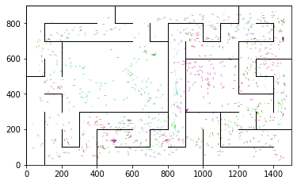

epoch 1451 == proposed_mle: 11.07+-0.23/10.59+-0.14 --

epoch 1452 == proposed_mle: 10.89+-0.22/10.64+-0.16 --

epoch 1453 == proposed_mle: 11.40+-0.24/10.58+-0.17 --

epoch 1454 == proposed_mle: 11.27+-0.22/10.72+-0.16 --

epoch 1455 == proposed_mle: 11.10+-0.21/10.47+-0.15 --

epoch 1456 == proposed_mle: 11.42+-0.23/10.88+-0.14 --

epoch 1457 == proposed_mle: 10.81+-0.22/10.57+-0.15 --

epoch 1458 == proposed_mle: 11.01+-0.24/10.59+-0.15 --

epoch 1459 == proposed_mle: 11.08+-0.25/10.57+-0.14 --

epoch 1460 == proposed_mle: 11.21+-0.22/10.55+-0.14 --

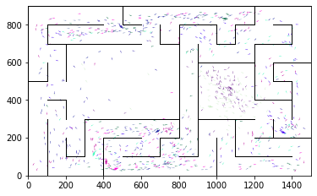

epoch 1461 == proposed_mle: 10.91+-0.25/10.82+-0.16 --

epoch 1462 == proposed_mle: 11.04+-0.24/10.65+-0.16 --

epoch 1463 == proposed_mle: 11.38+-0.26/10.77+-0.16 --

epoch 1464 == proposed_mle: 11.19+-0.22/10.66+-0.14 --

epoch 1465 == proposed_mle: 11.44+-0.28/10.85+-0.15 --

epoch 1466 == proposed_mle: 11.40+-0.22/10.92+-0.16 --

epoch 1467 == proposed_mle: 11.70+-0.22/10.82+-0.14 --

epoch 1468 == proposed_mle: 10.99+-0.21/10.85+-0.16 --

epoch 1469 == proposed_mle: 11.19+-0.20/10.86+-0.15 --

epoch 1470 >> proposed_mle: 11.18+-0.20/10.35+-0.15 --

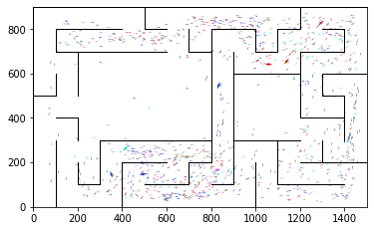

epoch 1471 == proposed_mle: 11.36+-0.24/11.07+-0.14 --

epoch 1472 == proposed_mle: 11.34+-0.19/10.85+-0.13 --

epoch 1473 == proposed_mle: 11.08+-0.22/10.71+-0.15 --

epoch 1474 == proposed_mle: 11.42+-0.26/10.82+-0.15 --

epoch 1475 == proposed_mle: 11.07+-0.19/10.76+-0.14 --

epoch 1476 == proposed_mle: 10.90+-0.21/10.64+-0.14 --

epoch 1477 == proposed_mle: 11.16+-0.24/10.68+-0.15 --

epoch 1478 == proposed_mle: 11.06+-0.22/10.87+-0.15 --

epoch 1479 == proposed_mle: 11.51+-0.26/10.83+-0.16 --

epoch 1480 == proposed_mle: 11.16+-0.26/10.46+-0.16 --

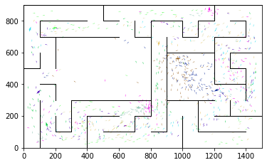

epoch 1481 == proposed_mle: 11.34+-0.23/10.77+-0.15 --

epoch 1482 == proposed_mle: 10.88+-0.27/10.68+-0.15 --

epoch 1483 == proposed_mle: 11.17+-0.24/10.94+-0.16 --

epoch 1484 == proposed_mle: 11.41+-0.23/10.95+-0.13 --

epoch 1485 == proposed_mle: 10.64+-0.27/10.60+-0.15 --

epoch 1486 == proposed_mle: 11.03+-0.21/10.84+-0.17 --

epoch 1487 == proposed_mle: 11.17+-0.20/10.69+-0.15 --

epoch 1488 == proposed_mle: 11.57+-0.24/10.67+-0.16 --

epoch 1489 == proposed_mle: 11.29+-0.22/10.54+-0.14 --

epoch 1490 == proposed_mle: 11.59+-0.24/10.59+-0.16 --

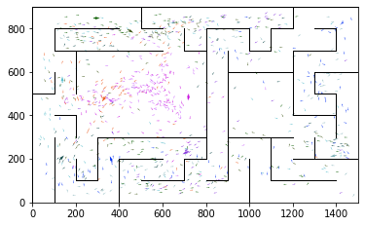

epoch 1491 >> proposed_mle: 10.91+-0.22/10.32+-0.16 --

epoch 1492 == proposed_mle: 11.00+-0.23/10.47+-0.14 --

epoch 1493 == proposed_mle: 11.22+-0.28/10.59+-0.15 --

epoch 1494 == proposed_mle: 10.84+-0.22/10.33+-0.15 --

epoch 1495 == proposed_mle: 10.86+-0.24/10.60+-0.13 --

epoch 1496 == proposed_mle: 10.95+-0.25/10.42+-0.15 --

epoch 1497 == proposed_mle: 11.11+-0.21/10.56+-0.14 --

epoch 1498 == proposed_mle: 10.61+-0.21/10.39+-0.15 --

epoch 1499 == proposed_mle: 11.65+-0.25/10.64+-0.16 --

epoch 1500 == proposed_mle: 10.94+-0.22/10.59+-0.15 --

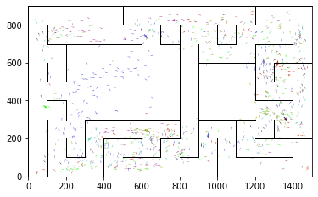

epoch 1501 == proposed_mle: 11.24+-0.21/10.33+-0.14 --

epoch 1502 == proposed_mle: 10.82+-0.22/10.65+-0.14 --

epoch 1503 == proposed_mle: 11.26+-0.22/10.76+-0.18 --

epoch 1504 == proposed_mle: 11.05+-0.22/10.48+-0.17 --

epoch 1505 == proposed_mle: 11.03+-0.22/10.60+-0.14 --

epoch 1506 == proposed_mle: 11.01+-0.24/10.62+-0.14 --

epoch 1507 == proposed_mle: 11.15+-0.23/10.60+-0.14 --

epoch 1508 == proposed_mle: 11.02+-0.21/10.79+-0.16 --

epoch 1509 == proposed_mle: 10.76+-0.21/10.46+-0.15 --

epoch 1510 == proposed_mle: 11.27+-0.25/10.43+-0.16 --

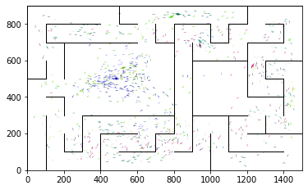

epoch 1511 == proposed_mle: 11.33+-0.25/10.63+-0.14 --

epoch 1512 == proposed_mle: 10.98+-0.26/10.60+-0.14 --

epoch 1513 == proposed_mle: 11.21+-0.24/10.49+-0.14 --

epoch 1514 == proposed_mle: 11.17+-0.26/10.43+-0.14 --

epoch 1515 == proposed_mle: 10.63+-0.23/10.34+-0.15 --

epoch 1516 == proposed_mle: 10.95+-0.21/10.40+-0.15 --

epoch 1517 == proposed_mle: 11.35+-0.25/10.39+-0.14 --

epoch 1518 >> proposed_mle: 10.72+-0.20/10.31+-0.14 --

epoch 1519 == proposed_mle: 11.43+-0.25/10.43+-0.15 --

epoch 1520 == proposed_mle: 11.26+-0.19/10.48+-0.16 --

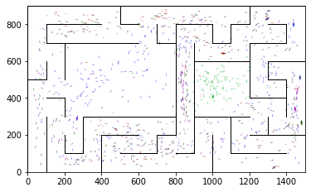

epoch 1521 == proposed_mle: 10.96+-0.24/10.48+-0.17 --

epoch 1522 == proposed_mle: 11.15+-0.26/10.47+-0.16 --

epoch 1523 >> proposed_mle: 11.29+-0.19/10.30+-0.14 --

epoch 1524 == proposed_mle: 11.25+-0.24/10.39+-0.15 --

epoch 1525 == proposed_mle: 11.07+-0.27/10.50+-0.14 --

epoch 1526 == proposed_mle: 11.01+-0.23/10.69+-0.16 --

epoch 1527 == proposed_mle: 11.15+-0.26/10.49+-0.13 --

epoch 1528 == proposed_mle: 11.09+-0.25/10.47+-0.15 --

epoch 1529 == proposed_mle: 10.73+-0.23/10.59+-0.17 --

epoch 1530 == proposed_mle: 11.33+-0.22/10.49+-0.16 --

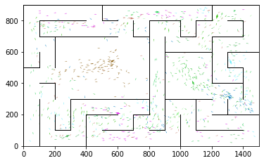

epoch 1531 == proposed_mle: 11.13+-0.23/10.65+-0.14 --

epoch 1532 == proposed_mle: 10.99+-0.27/10.52+-0.15 --

epoch 1533 == proposed_mle: 10.79+-0.26/10.44+-0.16 --

epoch 1534 == proposed_mle: 11.13+-0.25/10.36+-0.15 --

epoch 1535 == proposed_mle: 10.82+-0.27/10.53+-0.15 --

epoch 1536 == proposed_mle: 11.24+-0.20/10.43+-0.15 --

epoch 1537 == proposed_mle: 11.39+-0.28/10.32+-0.15 --

epoch 1538 == proposed_mle: 11.25+-0.23/10.33+-0.16 --

epoch 1539 == proposed_mle: 10.40+-0.26/10.55+-0.15 --

epoch 1540 == proposed_mle: 11.37+-0.26/10.42+-0.16 --

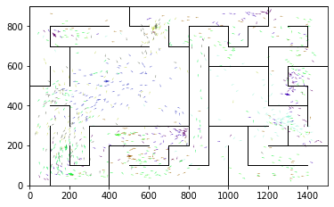

epoch 1541 == proposed_mle: 10.75+-0.25/10.40+-0.17 --

epoch 1542 == proposed_mle: 10.91+-0.28/10.37+-0.17 --

epoch 1543 == proposed_mle: 10.47+-0.22/10.62+-0.15 --

epoch 1544 >> proposed_mle: 11.29+-0.26/10.30+-0.15 --

epoch 1545 >> proposed_mle: 11.53+-0.29/10.23+-0.16 --

epoch 1546 == proposed_mle: 10.84+-0.23/10.37+-0.16 --

epoch 1547 == proposed_mle: 10.90+-0.24/10.61+-0.16 --

epoch 1548 == proposed_mle: 11.09+-0.24/10.56+-0.16 --

epoch 1549 == proposed_mle: 10.94+-0.24/10.42+-0.14 --

epoch 1550 == proposed_mle: 10.80+-0.24/10.39+-0.14 --

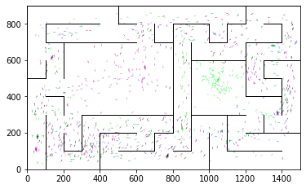

epoch 1551 == proposed_mle: 11.09+-0.24/10.56+-0.14 --

epoch 1552 == proposed_mle: 11.02+-0.22/10.31+-0.15 --

epoch 1553 == proposed_mle: 10.65+-0.23/10.36+-0.14 --

epoch 1554 == proposed_mle: 10.61+-0.19/10.67+-0.16 --

epoch 1555 == proposed_mle: 10.79+-0.22/10.59+-0.16 --

epoch 1556 == proposed_mle: 10.96+-0.25/10.39+-0.14 --

epoch 1557 == proposed_mle: 11.20+-0.26/10.60+-0.15 --

epoch 1558 == proposed_mle: 11.14+-0.21/10.50+-0.16 --

epoch 1559 == proposed_mle: 11.13+-0.23/10.36+-0.15 --

epoch 1560 == proposed_mle: 11.21+-0.25/10.58+-0.14 --

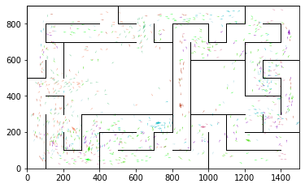

epoch 1561 == proposed_mle: 11.06+-0.23/10.42+-0.16 --

epoch 1562 == proposed_mle: 11.14+-0.18/10.34+-0.17 --

epoch 1563 == proposed_mle: 11.07+-0.31/10.32+-0.14 --

epoch 1564 >> proposed_mle: 10.50+-0.18/10.20+-0.14 --

epoch 1565 == proposed_mle: 11.33+-0.23/10.41+-0.15 --

epoch 1566 == proposed_mle: 10.96+-0.25/10.34+-0.15 --

epoch 1567 == proposed_mle: 11.36+-0.23/10.44+-0.14 --

epoch 1568 == proposed_mle: 11.15+-0.24/10.41+-0.15 --

epoch 1569 == proposed_mle: 11.17+-0.22/10.39+-0.16 --

epoch 1570 == proposed_mle: 11.08+-0.26/10.22+-0.17 --

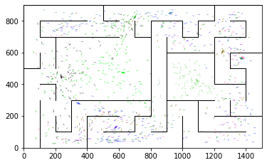

epoch 1571 == proposed_mle: 10.98+-0.25/10.34+-0.17 --

epoch 1572 == proposed_mle: 10.78+-0.23/10.57+-0.16 --

epoch 1573 == proposed_mle: 10.96+-0.25/10.30+-0.14 --

epoch 1574 == proposed_mle: 10.77+-0.23/10.40+-0.15 --

epoch 1575 >> proposed_mle: 10.62+-0.25/10.19+-0.15 --

epoch 1576 >> proposed_mle: 11.06+-0.21/10.10+-0.15 --

epoch 1577 == proposed_mle: 11.06+-0.23/10.40+-0.16 --

epoch 1578 == proposed_mle: 10.59+-0.18/10.41+-0.16 --

epoch 1579 == proposed_mle: 11.01+-0.25/10.51+-0.15 --

epoch 1580 == proposed_mle: 10.97+-0.24/10.53+-0.15 --

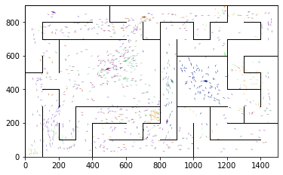

epoch 1581 == proposed_mle: 10.91+-0.20/10.57+-0.15 --

epoch 1582 == proposed_mle: 10.95+-0.25/10.49+-0.14 --

epoch 1583 == proposed_mle: 10.99+-0.22/10.69+-0.15 --

epoch 1584 == proposed_mle: 10.72+-0.24/10.45+-0.14 --

epoch 1585 == proposed_mle: 10.89+-0.20/10.36+-0.14 --

epoch 1586 == proposed_mle: 10.68+-0.22/10.52+-0.16 --

epoch 1587 == proposed_mle: 11.16+-0.23/10.56+-0.14 --

epoch 1588 == proposed_mle: 11.28+-0.23/10.35+-0.15 --

epoch 1589 == proposed_mle: 11.08+-0.26/10.31+-0.16 --

epoch 1590 == proposed_mle: 10.88+-0.23/10.45+-0.16 --

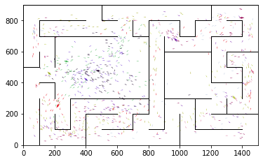

epoch 1591 == proposed_mle: 10.95+-0.28/10.63+-0.17 --

epoch 1592 == proposed_mle: 11.41+-0.22/10.28+-0.15 --

epoch 1593 == proposed_mle: 10.56+-0.20/10.28+-0.14 --

epoch 1594 == proposed_mle: 11.20+-0.28/10.43+-0.15 --

epoch 1595 == proposed_mle: 10.65+-0.22/10.36+-0.14 --

epoch 1596 == proposed_mle: 10.67+-0.23/10.51+-0.16 --

epoch 1597 == proposed_mle: 11.05+-0.20/10.63+-0.14 --

epoch 1598 == proposed_mle: 11.23+-0.23/10.53+-0.15 --

epoch 1599 == proposed_mle: 10.68+-0.19/10.54+-0.16 --

epoch 1600 == proposed_mle: 10.93+-0.22/10.20+-0.15 --

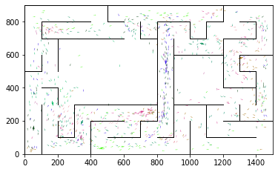

epoch 1601 == proposed_mle: 11.07+-0.24/10.63+-0.15 --

epoch 1602 == proposed_mle: 11.13+-0.24/10.54+-0.15 --

epoch 1603 == proposed_mle: 10.77+-0.29/10.46+-0.17 --

epoch 1604 == proposed_mle: 10.90+-0.23/10.38+-0.13 --

epoch 1605 == proposed_mle: 10.79+-0.23/10.53+-0.17 --

epoch 1606 == proposed_mle: 11.35+-0.23/10.17+-0.15 --

epoch 1607 == proposed_mle: 11.06+-0.23/10.40+-0.15 --

epoch 1608 == proposed_mle: 11.04+-0.21/10.35+-0.15 --

epoch 1609 == proposed_mle: 10.98+-0.22/10.49+-0.15 --

epoch 1610 == proposed_mle: 10.72+-0.22/10.47+-0.13 --

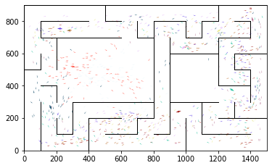

epoch 1611 >> proposed_mle: 11.03+-0.25/10.08+-0.14 --

epoch 1612 == proposed_mle: 10.85+-0.19/10.42+-0.15 --

epoch 1613 == proposed_mle: 10.90+-0.21/10.39+-0.14 --

epoch 1614 == proposed_mle: 10.95+-0.29/10.37+-0.13 --

epoch 1615 == proposed_mle: 10.83+-0.24/10.17+-0.14 --

epoch 1616 == proposed_mle: 10.70+-0.23/10.08+-0.14 --

epoch 1617 == proposed_mle: 10.82+-0.23/10.17+-0.14 --

epoch 1618 == proposed_mle: 10.87+-0.25/10.32+-0.15 --

epoch 1619 == proposed_mle: 10.96+-0.21/10.28+-0.14 --

epoch 1620 == proposed_mle: 11.06+-0.25/10.34+-0.13 --

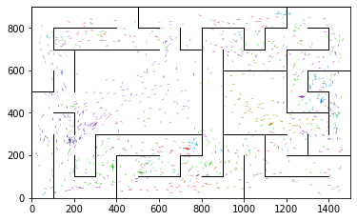

epoch 1621 == proposed_mle: 10.93+-0.23/10.54+-0.14 --

epoch 1622 == proposed_mle: 10.54+-0.24/10.26+-0.16 --

epoch 1623 == proposed_mle: 10.59+-0.22/10.65+-0.15 --

epoch 1624 == proposed_mle: 11.08+-0.24/10.42+-0.15 --

epoch 1625 == proposed_mle: 11.12+-0.25/10.43+-0.15 --

epoch 1626 == proposed_mle: 11.00+-0.24/10.45+-0.16 --

epoch 1627 == proposed_mle: 10.63+-0.19/10.38+-0.15 --

epoch 1628 == proposed_mle: 11.10+-0.22/10.35+-0.15 --

epoch 1629 == proposed_mle: 11.13+-0.21/10.47+-0.15 --

epoch 1630 == proposed_mle: 10.82+-0.23/10.31+-0.15 --

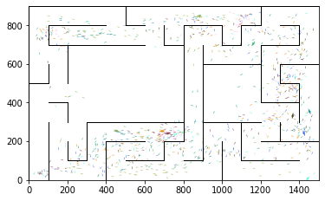

epoch 1631 == proposed_mle: 11.16+-0.24/10.35+-0.14 --

epoch 1632 == proposed_mle: 11.01+-0.26/10.46+-0.15 --

epoch 1633 == proposed_mle: 11.22+-0.22/10.35+-0.13 --

epoch 1634 == proposed_mle: 10.77+-0.22/10.51+-0.14 --

epoch 1635 == proposed_mle: 10.81+-0.23/10.46+-0.15 --

epoch 1636 == proposed_mle: 11.14+-0.26/10.28+-0.14 --

epoch 1637 == proposed_mle: 10.76+-0.23/10.52+-0.16 --

epoch 1638 == proposed_mle: 10.78+-0.23/10.56+-0.13 --

epoch 1639 == proposed_mle: 10.81+-0.22/10.35+-0.16 --

epoch 1640 == proposed_mle: 10.90+-0.31/10.34+-0.14 --

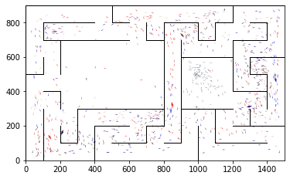

epoch 1641 == proposed_mle: 11.05+-0.24/10.36+-0.14 --

epoch 1642 == proposed_mle: 10.72+-0.22/10.39+-0.14 --

epoch 1643 == proposed_mle: 11.06+-0.22/10.18+-0.14 --

epoch 1644 == proposed_mle: 11.13+-0.20/10.23+-0.15 --

epoch 1645 == proposed_mle: 10.60+-0.20/10.27+-0.14 --

epoch 1646 == proposed_mle: 10.89+-0.22/10.26+-0.16 --

epoch 1647 == proposed_mle: 10.87+-0.23/10.48+-0.15 --

epoch 1648 >> proposed_mle: 10.90+-0.24/9.97+-0.13 --

epoch 1649 == proposed_mle: 10.71+-0.26/10.11+-0.12 --

epoch 1650 == proposed_mle: 10.29+-0.23/10.31+-0.13 --

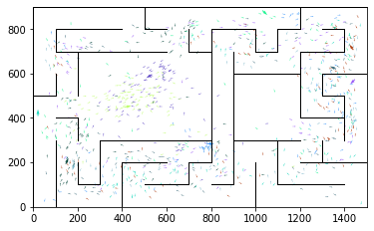

epoch 1651 == proposed_mle: 10.76+-0.23/10.16+-0.12 --

epoch 1652 == proposed_mle: 10.52+-0.21/10.22+-0.14 --

epoch 1653 == proposed_mle: 11.12+-0.27/10.32+-0.16 --

epoch 1654 == proposed_mle: 10.95+-0.26/10.16+-0.15 --

epoch 1655 == proposed_mle: 11.02+-0.26/10.13+-0.14 --

epoch 1656 == proposed_mle: 10.85+-0.26/10.07+-0.14 --

epoch 1657 == proposed_mle: 10.50+-0.19/10.08+-0.13 --

epoch 1658 == proposed_mle: 10.53+-0.20/10.42+-0.14 --

epoch 1659 == proposed_mle: 11.18+-0.23/10.55+-0.13 --

epoch 1660 == proposed_mle: 10.55+-0.23/10.07+-0.14 --

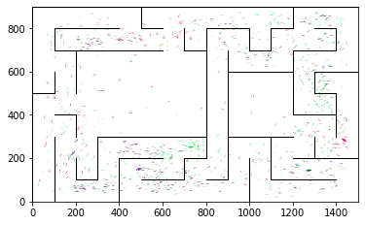

epoch 1661 == proposed_mle: 10.63+-0.21/10.10+-0.14 --

epoch 1662 == proposed_mle: 11.12+-0.22/10.22+-0.13 --

epoch 1663 == proposed_mle: 10.91+-0.23/10.21+-0.14 --

epoch 1664 == proposed_mle: 10.81+-0.25/10.11+-0.13 --

epoch 1665 == proposed_mle: 10.86+-0.24/10.33+-0.13 --

epoch 1666 == proposed_mle: 10.85+-0.25/10.13+-0.12 --

epoch 1667 == proposed_mle: 10.90+-0.28/10.39+-0.14 --

epoch 1668 == proposed_mle: 10.72+-0.25/10.18+-0.15 --

epoch 1669 == proposed_mle: 10.58+-0.26/10.34+-0.14 --

epoch 1670 == proposed_mle: 10.52+-0.25/10.22+-0.13 --

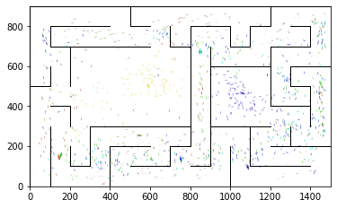

epoch 1671 == proposed_mle: 11.08+-0.23/10.24+-0.14 --

epoch 1672 == proposed_mle: 10.81+-0.20/10.30+-0.16 --

epoch 1673 == proposed_mle: 11.15+-0.23/10.06+-0.16 --

epoch 1674 == proposed_mle: 10.85+-0.23/10.26+-0.13 --

epoch 1675 == proposed_mle: 11.02+-0.24/10.19+-0.14 --

epoch 1676 == proposed_mle: 10.82+-0.26/10.18+-0.14 --

epoch 1677 == proposed_mle: 10.64+-0.19/10.26+-0.13 --

epoch 1678 == proposed_mle: 10.97+-0.24/10.11+-0.14 --

epoch 1679 == proposed_mle: 10.98+-0.26/10.25+-0.14 --

epoch 1680 >> proposed_mle: 10.79+-0.21/9.96+-0.14 --

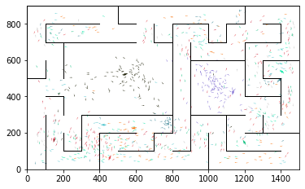

epoch 1681 == proposed_mle: 10.64+-0.22/10.10+-0.14 --

epoch 1682 == proposed_mle: 10.79+-0.22/10.30+-0.15 --

epoch 1683 == proposed_mle: 10.59+-0.21/10.11+-0.14 --

epoch 1684 == proposed_mle: 10.91+-0.21/10.14+-0.15 --

epoch 1685 == proposed_mle: 10.67+-0.27/10.18+-0.15 --

epoch 1686 == proposed_mle: 10.47+-0.22/10.04+-0.14 --

epoch 1687 == proposed_mle: 10.80+-0.21/10.19+-0.15 --

epoch 1688 == proposed_mle: 10.83+-0.22/10.59+-0.15 --

epoch 1689 == proposed_mle: 10.66+-0.22/10.27+-0.16 --

epoch 1690 == proposed_mle: 10.99+-0.21/10.14+-0.14 --

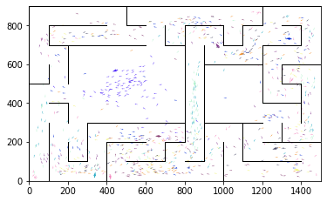

epoch 1691 == proposed_mle: 10.70+-0.23/10.23+-0.15 --

epoch 1692 == proposed_mle: 10.95+-0.23/10.17+-0.14 --

epoch 1693 == proposed_mle: 10.79+-0.17/10.34+-0.13 --

epoch 1694 == proposed_mle: 10.48+-0.19/10.34+-0.16 --

epoch 1695 == proposed_mle: 10.94+-0.26/10.29+-0.15 --

epoch 1696 == proposed_mle: 11.16+-0.27/10.33+-0.16 --

epoch 1697 == proposed_mle: 10.29+-0.24/10.10+-0.14 --

epoch 1698 == proposed_mle: 10.79+-0.23/10.33+-0.15 --

epoch 1699 == proposed_mle: 10.66+-0.18/10.37+-0.15 --

epoch 1700 == proposed_mle: 11.16+-0.26/10.15+-0.14 --

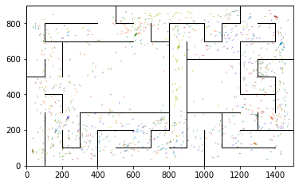

epoch 1701 == proposed_mle: 10.82+-0.27/10.20+-0.14 --

epoch 1702 == proposed_mle: 10.55+-0.23/10.17+-0.15 --

epoch 1703 == proposed_mle: 10.84+-0.22/10.31+-0.15 --

epoch 1704 == proposed_mle: 10.93+-0.23/10.32+-0.15 --

epoch 1705 == proposed_mle: 10.53+-0.25/10.20+-0.15 --

epoch 1706 == proposed_mle: 10.72+-0.28/10.15+-0.14 --

epoch 1707 == proposed_mle: 10.68+-0.25/10.13+-0.13 --

epoch 1708 == proposed_mle: 10.85+-0.20/10.42+-0.16 --

epoch 1709 == proposed_mle: 10.64+-0.21/10.19+-0.15 --

epoch 1710 == proposed_mle: 10.87+-0.25/10.16+-0.15 --

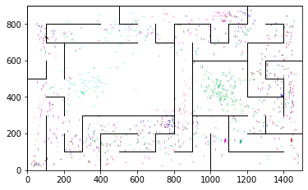

epoch 1711 == proposed_mle: 10.93+-0.23/10.02+-0.15 --

epoch 1712 == proposed_mle: 10.46+-0.20/10.13+-0.14 --

epoch 1713 == proposed_mle: 10.47+-0.22/10.14+-0.14 --

epoch 1714 == proposed_mle: 10.46+-0.22/10.02+-0.15 --

epoch 1715 == proposed_mle: 10.50+-0.21/10.08+-0.17 --

epoch 1716 == proposed_mle: 10.56+-0.25/10.18+-0.15 --

epoch 1717 == proposed_mle: 10.85+-0.25/10.38+-0.15 --

epoch 1718 == proposed_mle: 10.68+-0.22/10.23+-0.15 --

epoch 1719 == proposed_mle: 10.53+-0.19/10.35+-0.15 --

epoch 1720 == proposed_mle: 11.21+-0.24/10.40+-0.15 --

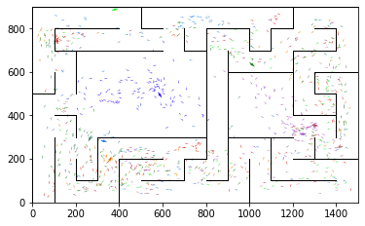

epoch 1721 == proposed_mle: 10.93+-0.23/10.30+-0.17 --

epoch 1722 == proposed_mle: 10.91+-0.22/10.45+-0.17 --

epoch 1723 == proposed_mle: 10.86+-0.25/10.08+-0.15 --

epoch 1724 == proposed_mle: 10.83+-0.24/10.19+-0.15 --

epoch 1725 == proposed_mle: 11.16+-0.25/10.18+-0.14 --

epoch 1726 == proposed_mle: 10.42+-0.20/10.13+-0.15 --

epoch 1727 == proposed_mle: 10.64+-0.24/10.06+-0.14 --

epoch 1728 == proposed_mle: 10.52+-0.24/10.32+-0.15 --

epoch 1729 == proposed_mle: 10.35+-0.19/10.25+-0.14 --

epoch 1730 == proposed_mle: 10.46+-0.19/10.14+-0.15 --

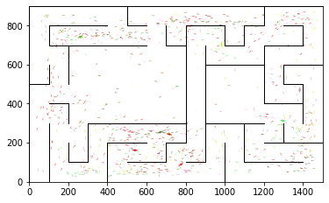

epoch 1731 == proposed_mle: 11.11+-0.25/10.15+-0.16 --

epoch 1732 == proposed_mle: 10.56+-0.17/10.23+-0.13 --

epoch 1733 == proposed_mle: 10.64+-0.23/10.03+-0.15 --

epoch 1734 == proposed_mle: 10.45+-0.23/10.06+-0.14 --

epoch 1735 == proposed_mle: 11.11+-0.21/9.99+-0.14 --

epoch 1736 == proposed_mle: 10.92+-0.28/10.21+-0.15 --

epoch 1737 == proposed_mle: 10.87+-0.24/10.06+-0.14 --

epoch 1738 == proposed_mle: 10.35+-0.22/10.01+-0.14 --

epoch 1739 >> proposed_mle: 10.57+-0.24/9.96+-0.14 --

epoch 1740 >> proposed_mle: 10.85+-0.23/9.86+-0.15 --

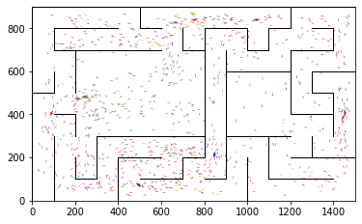

epoch 1741 == proposed_mle: 10.51+-0.21/10.02+-0.14 --

epoch 1742 == proposed_mle: 10.32+-0.27/10.17+-0.15 --

epoch 1743 == proposed_mle: 10.85+-0.24/10.13+-0.15 --

epoch 1744 == proposed_mle: 10.75+-0.20/10.19+-0.15 --

epoch 1745 == proposed_mle: 10.34+-0.24/9.86+-0.13 --

epoch 1746 == proposed_mle: 10.26+-0.22/10.00+-0.15 --

epoch 1747 == proposed_mle: 10.96+-0.23/10.00+-0.16 --

epoch 1748 == proposed_mle: 10.25+-0.23/10.16+-0.16 --

epoch 1749 == proposed_mle: 10.05+-0.23/10.19+-0.14 --

epoch 1750 == proposed_mle: 10.45+-0.18/10.08+-0.14 --

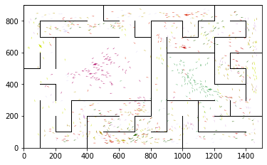

epoch 1751 == proposed_mle: 10.24+-0.24/10.11+-0.14 --

epoch 1752 == proposed_mle: 10.38+-0.23/10.01+-0.14 --

epoch 1753 == proposed_mle: 10.45+-0.25/9.87+-0.15 --

epoch 1754 == proposed_mle: 10.46+-0.21/9.98+-0.13 --

epoch 1755 == proposed_mle: 10.48+-0.21/10.24+-0.17 --

epoch 1756 == proposed_mle: 10.53+-0.23/10.15+-0.15 --

epoch 1757 == proposed_mle: 10.53+-0.23/9.93+-0.15 --

epoch 1758 == proposed_mle: 10.36+-0.21/10.11+-0.14 --

epoch 1759 == proposed_mle: 10.67+-0.23/9.88+-0.16 --

epoch 1760 == proposed_mle: 10.65+-0.24/10.18+-0.14 --

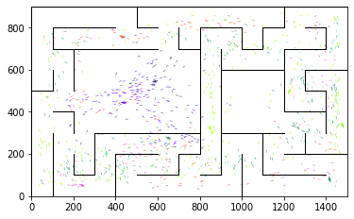

epoch 1761 == proposed_mle: 10.84+-0.22/10.24+-0.15 --

epoch 1762 == proposed_mle: 10.93+-0.24/10.45+-0.14 --

epoch 1763 == proposed_mle: 10.92+-0.22/10.17+-0.14 --

epoch 1764 == proposed_mle: 10.80+-0.22/10.07+-0.14 --

epoch 1765 == proposed_mle: 10.83+-0.28/10.23+-0.15 --

epoch 1766 == proposed_mle: 10.57+-0.23/10.42+-0.16 --

epoch 1767 == proposed_mle: 11.05+-0.23/10.25+-0.16 --

epoch 1768 == proposed_mle: 11.16+-0.24/10.37+-0.15 --

epoch 1769 == proposed_mle: 10.78+-0.24/10.11+-0.15 --

epoch 1770 == proposed_mle: 11.12+-0.23/10.20+-0.15 --

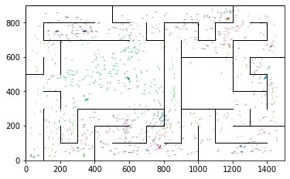

epoch 1771 == proposed_mle: 10.67+-0.26/10.36+-0.15 --

epoch 1772 == proposed_mle: 10.64+-0.26/10.53+-0.16 --

epoch 1773 == proposed_mle: 11.00+-0.28/10.00+-0.15 --

epoch 1774 == proposed_mle: 10.80+-0.22/10.14+-0.15 --

epoch 1775 == proposed_mle: 10.40+-0.24/10.00+-0.14 --

epoch 1776 == proposed_mle: 10.95+-0.25/10.02+-0.15 --

epoch 1777 == proposed_mle: 10.67+-0.21/10.04+-0.15 --

epoch 1778 == proposed_mle: 10.39+-0.18/10.05+-0.14 --

epoch 1779 == proposed_mle: 10.61+-0.24/10.03+-0.16 --

epoch 1780 == proposed_mle: 10.87+-0.24/10.01+-0.14 --

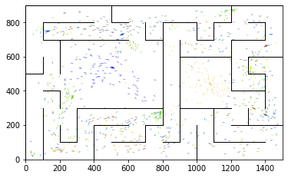

epoch 1781 == proposed_mle: 10.47+-0.21/10.12+-0.15 --

epoch 1782 == proposed_mle: 10.78+-0.26/10.22+-0.16 --

epoch 1783 == proposed_mle: 10.96+-0.21/10.26+-0.16 --

epoch 1784 == proposed_mle: 10.39+-0.20/10.39+-0.16 --

epoch 1785 == proposed_mle: 10.68+-0.19/10.30+-0.15 --

epoch 1786 == proposed_mle: 11.04+-0.27/10.15+-0.14 --

epoch 1787 == proposed_mle: 10.83+-0.21/10.10+-0.14 --

epoch 1788 == proposed_mle: 10.81+-0.18/10.21+-0.17 --

epoch 1789 == proposed_mle: 10.63+-0.25/10.18+-0.14 --

epoch 1790 == proposed_mle: 10.40+-0.23/10.27+-0.17 --

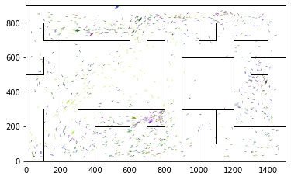

epoch 1791 == proposed_mle: 10.84+-0.26/10.06+-0.15 --

epoch 1792 == proposed_mle: 10.61+-0.24/10.16+-0.13 --

epoch 1793 == proposed_mle: 10.81+-0.27/10.10+-0.17 --

epoch 1794 == proposed_mle: 10.73+-0.21/10.05+-0.14 --

epoch 1795 == proposed_mle: 10.21+-0.21/10.24+-0.16 --

epoch 1796 == proposed_mle: 10.50+-0.23/10.30+-0.16 --

epoch 1797 == proposed_mle: 10.53+-0.22/10.20+-0.16 --

epoch 1798 == proposed_mle: 10.54+-0.18/10.15+-0.16 --

epoch 1799 == proposed_mle: 10.35+-0.24/9.92+-0.14 --

epoch 1800 == proposed_mle: 10.60+-0.22/10.24+-0.14 --

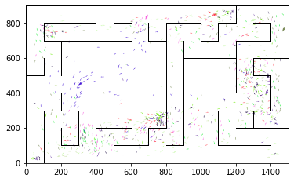

epoch 1801 == proposed_mle: 10.49+-0.23/9.92+-0.14 --

epoch 1802 == proposed_mle: 10.81+-0.23/10.21+-0.17 --

epoch 1803 == proposed_mle: 10.67+-0.27/10.18+-0.16 --

epoch 1804 == proposed_mle: 10.65+-0.23/10.06+-0.14 --

epoch 1805 == proposed_mle: 10.52+-0.23/10.15+-0.14 --

epoch 1806 == proposed_mle: 10.71+-0.23/10.00+-0.15 --

epoch 1807 == proposed_mle: 10.68+-0.23/10.21+-0.15 --

epoch 1808 == proposed_mle: 10.35+-0.25/10.05+-0.15 --

epoch 1809 == proposed_mle: 10.47+-0.21/10.25+-0.15 --

epoch 1810 == proposed_mle: 10.82+-0.25/10.33+-0.15 --

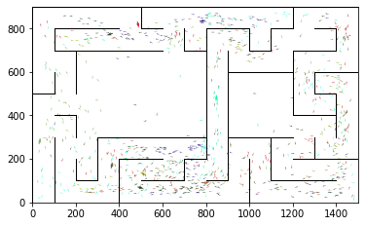

epoch 1811 == proposed_mle: 10.85+-0.26/10.14+-0.13 --

epoch 1812 == proposed_mle: 11.00+-0.23/10.14+-0.13 --

epoch 1813 == proposed_mle: 10.71+-0.23/10.33+-0.16 --

epoch 1814 == proposed_mle: 10.65+-0.26/9.92+-0.15 --

epoch 1815 == proposed_mle: 10.48+-0.24/9.88+-0.14 --

epoch 1816 == proposed_mle: 10.33+-0.24/10.36+-0.16 --

epoch 1817 == proposed_mle: 10.85+-0.20/10.10+-0.14 --

epoch 1818 == proposed_mle: 10.97+-0.26/10.38+-0.16 --

epoch 1819 == proposed_mle: 10.64+-0.23/10.14+-0.14 --

epoch 1820 == proposed_mle: 10.60+-0.24/9.92+-0.14 --

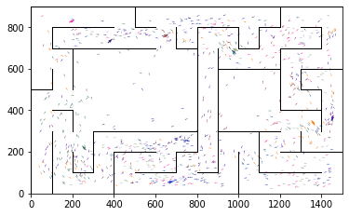

epoch 1821 == proposed_mle: 10.45+-0.21/9.96+-0.13 --

epoch 1822 == proposed_mle: 10.67+-0.22/10.17+-0.17 --

epoch 1823 >> proposed_mle: 10.73+-0.23/9.81+-0.14 --

epoch 1824 == proposed_mle: 10.47+-0.28/10.05+-0.15 --

epoch 1825 == proposed_mle: 10.74+-0.24/10.09+-0.16 --

epoch 1826 == proposed_mle: 10.37+-0.24/10.24+-0.18 --

epoch 1827 == proposed_mle: 10.43+-0.23/10.21+-0.15 --

epoch 1828 == proposed_mle: 11.01+-0.23/10.19+-0.16 --

epoch 1829 == proposed_mle: 10.88+-0.18/10.12+-0.15 --

epoch 1830 == proposed_mle: 10.50+-0.24/10.12+-0.16 --

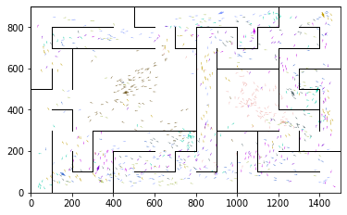

epoch 1831 == proposed_mle: 10.86+-0.26/10.10+-0.16 --

epoch 1832 == proposed_mle: 10.87+-0.23/10.16+-0.15 --

epoch 1833 == proposed_mle: 10.45+-0.20/10.41+-0.15 --

epoch 1834 == proposed_mle: 11.08+-0.24/10.22+-0.16 --

epoch 1835 == proposed_mle: 10.59+-0.20/9.92+-0.14 --

epoch 1836 == proposed_mle: 10.92+-0.21/10.20+-0.14 --

epoch 1837 == proposed_mle: 10.56+-0.22/9.95+-0.13 --

epoch 1838 == proposed_mle: 10.83+-0.24/10.03+-0.14 --

epoch 1839 == proposed_mle: 10.39+-0.20/10.12+-0.15 --

epoch 1840 == proposed_mle: 10.81+-0.22/10.01+-0.14 --

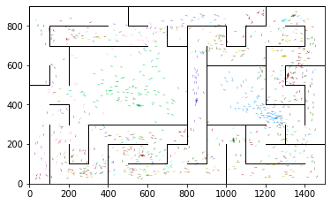

epoch 1841 == proposed_mle: 10.70+-0.21/10.18+-0.15 --

epoch 1842 == proposed_mle: 10.83+-0.26/10.19+-0.14 --

epoch 1843 == proposed_mle: 10.34+-0.22/10.03+-0.14 --

epoch 1844 == proposed_mle: 10.42+-0.23/10.05+-0.15 --

epoch 1845 == proposed_mle: 10.43+-0.23/9.98+-0.15 --

epoch 1846 == proposed_mle: 10.97+-0.22/9.91+-0.13 --

epoch 1847 == proposed_mle: 10.39+-0.23/10.09+-0.15 --

epoch 1848 == proposed_mle: 10.69+-0.22/10.01+-0.13 --

epoch 1849 == proposed_mle: 10.55+-0.21/9.93+-0.15 --

epoch 1850 == proposed_mle: 11.16+-0.23/9.99+-0.15 --

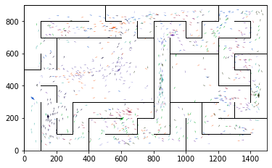

epoch 1851 >> proposed_mle: 11.18+-0.22/9.81+-0.14 --

epoch 1852 == proposed_mle: 10.61+-0.19/9.87+-0.15 --

epoch 1853 == proposed_mle: 10.62+-0.22/9.94+-0.14 --

epoch 1854 == proposed_mle: 10.40+-0.22/9.86+-0.14 --

epoch 1855 == proposed_mle: 10.93+-0.26/10.07+-0.15 --

epoch 1856 == proposed_mle: 10.60+-0.23/10.01+-0.16 --

epoch 1857 == proposed_mle: 10.09+-0.22/9.85+-0.14 --

epoch 1858 == proposed_mle: 10.88+-0.27/9.86+-0.16 --

epoch 1859 == proposed_mle: 10.49+-0.21/10.04+-0.15 --

epoch 1860 == proposed_mle: 10.36+-0.22/10.19+-0.14 --

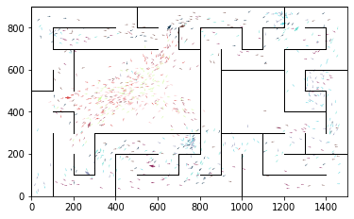

epoch 1861 == proposed_mle: 10.51+-0.23/10.30+-0.14 --

epoch 1862 == proposed_mle: 10.87+-0.24/9.86+-0.14 --

epoch 1863 == proposed_mle: 10.70+-0.20/9.87+-0.14 --

epoch 1864 == proposed_mle: 10.62+-0.21/10.08+-0.14 --

epoch 1865 >> proposed_mle: 10.37+-0.20/9.71+-0.13 --

epoch 1866 == proposed_mle: 10.39+-0.27/9.78+-0.15 --

epoch 1867 == proposed_mle: 10.42+-0.23/9.99+-0.16 --

epoch 1868 == proposed_mle: 10.77+-0.20/9.94+-0.15 --

epoch 1869 == proposed_mle: 10.23+-0.24/9.88+-0.15 --

epoch 1870 == proposed_mle: 10.00+-0.22/10.00+-0.15 --

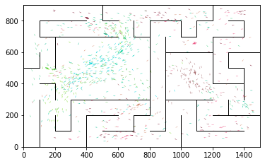

epoch 1871 == proposed_mle: 10.66+-0.21/9.89+-0.14 --

epoch 1872 == proposed_mle: 10.31+-0.20/10.01+-0.15 --

epoch 1873 == proposed_mle: 10.60+-0.21/9.96+-0.15 --

epoch 1874 == proposed_mle: 10.28+-0.23/9.88+-0.14 --

epoch 1875 == proposed_mle: 10.35+-0.18/9.82+-0.13 --

epoch 1876 == proposed_mle: 10.27+-0.20/9.96+-0.14 --

epoch 1877 == proposed_mle: 10.30+-0.21/9.95+-0.14 --

epoch 1878 == proposed_mle: 10.33+-0.22/10.04+-0.14 --

epoch 1879 == proposed_mle: 10.37+-0.24/10.15+-0.15 --

epoch 1880 == proposed_mle: 10.78+-0.24/10.08+-0.15 --

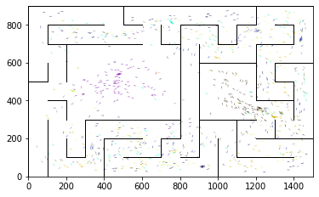

epoch 1881 == proposed_mle: 10.47+-0.20/9.92+-0.14 --

epoch 1882 == proposed_mle: 10.64+-0.25/10.08+-0.15 --

epoch 1883 == proposed_mle: 10.74+-0.22/10.08+-0.15 --

epoch 1884 == proposed_mle: 10.83+-0.18/9.86+-0.14 --

epoch 1885 == proposed_mle: 10.77+-0.21/10.01+-0.15 --

epoch 1886 == proposed_mle: 10.18+-0.21/10.00+-0.14 --

epoch 1887 == proposed_mle: 10.46+-0.25/9.95+-0.15 --

epoch 1888 == proposed_mle: 10.37+-0.23/9.96+-0.14 --

epoch 1889 == proposed_mle: 10.34+-0.22/10.03+-0.14 --

epoch 1890 == proposed_mle: 10.51+-0.21/9.78+-0.14 --

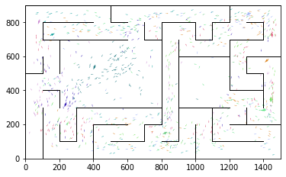

epoch 1891 == proposed_mle: 10.10+-0.21/9.87+-0.13 --

epoch 1892 == proposed_mle: 10.37+-0.20/9.82+-0.14 --

epoch 1893 >> proposed_mle: 10.28+-0.22/9.70+-0.14 --

epoch 1894 == proposed_mle: 10.38+-0.22/9.89+-0.14 --

epoch 1895 == proposed_mle: 10.57+-0.23/9.98+-0.17 --

epoch 1896 == proposed_mle: 10.43+-0.23/9.98+-0.14 --

epoch 1897 == proposed_mle: 10.59+-0.21/10.12+-0.16 --

epoch 1898 == proposed_mle: 10.70+-0.23/9.89+-0.15 --

epoch 1899 == proposed_mle: 10.35+-0.26/9.86+-0.15 --

epoch 1900 == proposed_mle: 10.17+-0.22/9.90+-0.14 --

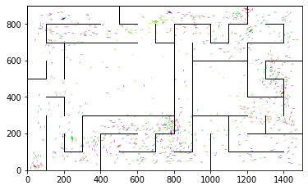

epoch 1901 == proposed_mle: 10.63+-0.24/9.96+-0.15 --

epoch 1902 == proposed_mle: 10.88+-0.23/10.01+-0.15 --

epoch 1903 == proposed_mle: 10.40+-0.20/9.95+-0.14 --

epoch 1904 == proposed_mle: 10.35+-0.20/10.13+-0.17 --

epoch 1905 == proposed_mle: 10.34+-0.22/10.00+-0.15 --

epoch 1906 == proposed_mle: 10.47+-0.22/9.95+-0.13 --

epoch 1907 == proposed_mle: 10.95+-0.22/9.99+-0.14 --

epoch 1908 == proposed_mle: 10.57+-0.20/9.85+-0.14 --

epoch 1909 >> proposed_mle: 10.47+-0.23/9.69+-0.14 --

epoch 1910 == proposed_mle: 10.49+-0.22/10.24+-0.15 --

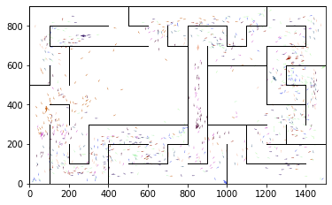

epoch 1911 == proposed_mle: 10.53+-0.20/10.12+-0.16 --

epoch 1912 == proposed_mle: 10.54+-0.26/10.06+-0.14 --

epoch 1913 == proposed_mle: 10.70+-0.22/10.00+-0.14 --

epoch 1914 == proposed_mle: 10.36+-0.22/9.85+-0.14 --

epoch 1915 == proposed_mle: 10.60+-0.19/10.34+-0.14 --

epoch 1916 == proposed_mle: 10.39+-0.23/9.89+-0.15 --

epoch 1917 == proposed_mle: 10.31+-0.25/10.15+-0.15 --

epoch 1918 == proposed_mle: 10.63+-0.22/10.28+-0.16 --

epoch 1919 == proposed_mle: 10.53+-0.20/10.28+-0.16 --

epoch 1920 == proposed_mle: 10.58+-0.25/10.05+-0.13 --

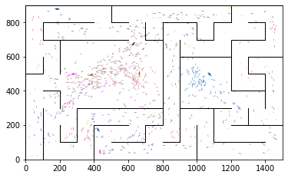

epoch 1921 == proposed_mle: 10.48+-0.22/10.24+-0.15 --

epoch 1922 == proposed_mle: 10.54+-0.21/10.00+-0.14 --

epoch 1923 == proposed_mle: 10.57+-0.24/10.27+-0.14 --

epoch 1924 == proposed_mle: 10.25+-0.26/10.13+-0.14 --

epoch 1925 == proposed_mle: 10.96+-0.25/10.26+-0.16 --

epoch 1926 == proposed_mle: 10.04+-0.19/10.21+-0.16 --

epoch 1927 == proposed_mle: 10.67+-0.25/10.12+-0.16 --

epoch 1928 == proposed_mle: 10.52+-0.22/10.21+-0.15 --

epoch 1929 == proposed_mle: 10.54+-0.20/10.10+-0.14 --

epoch 1930 == proposed_mle: 10.87+-0.26/10.14+-0.14 --

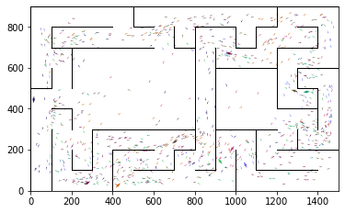

epoch 1931 == proposed_mle: 10.24+-0.21/10.00+-0.16 --

epoch 1932 == proposed_mle: 10.69+-0.25/9.90+-0.15 --

epoch 1933 == proposed_mle: 10.11+-0.18/10.09+-0.15 --

epoch 1934 == proposed_mle: 10.38+-0.23/9.97+-0.14 --

epoch 1935 == proposed_mle: 10.20+-0.21/9.85+-0.15 --

epoch 1936 == proposed_mle: 10.45+-0.19/9.97+-0.16 --

epoch 1937 == proposed_mle: 10.30+-0.23/9.96+-0.15 --

epoch 1938 == proposed_mle: 10.52+-0.24/9.90+-0.15 --

epoch 1939 == proposed_mle: 10.44+-0.23/9.86+-0.14 --

epoch 1940 == proposed_mle: 10.02+-0.20/9.93+-0.15 --

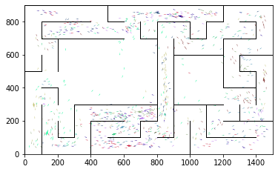

epoch 1941 == proposed_mle: 10.66+-0.22/9.91+-0.13 --

epoch 1942 == proposed_mle: 10.17+-0.24/9.87+-0.14 --

epoch 1943 == proposed_mle: 10.36+-0.23/10.13+-0.15 --

epoch 1944 == proposed_mle: 10.34+-0.17/9.85+-0.14 --

epoch 1945 == proposed_mle: 10.63+-0.25/10.10+-0.14 --

epoch 1946 == proposed_mle: 10.48+-0.21/9.86+-0.16 --

epoch 1947 == proposed_mle: 10.63+-0.20/9.96+-0.15 --

epoch 1948 == proposed_mle: 10.47+-0.20/10.04+-0.15 --

epoch 1949 == proposed_mle: 10.36+-0.26/10.04+-0.14 --

epoch 1950 == proposed_mle: 10.73+-0.23/9.84+-0.13 --

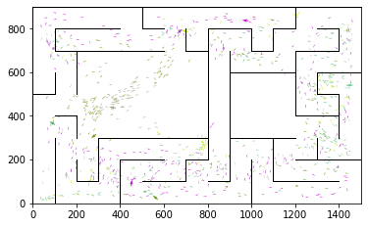

epoch 1951 == proposed_mle: 9.85+-0.18/9.83+-0.14 --

epoch 1952 == proposed_mle: 10.70+-0.24/10.18+-0.14 --

epoch 1953 == proposed_mle: 10.25+-0.27/9.96+-0.15 --

epoch 1954 == proposed_mle: 10.23+-0.21/9.81+-0.16 --

epoch 1955 == proposed_mle: 10.25+-0.24/9.75+-0.14 --

epoch 1956 == proposed_mle: 10.62+-0.22/9.74+-0.15 --

epoch 1957 == proposed_mle: 10.41+-0.21/9.91+-0.16 --

epoch 1958 == proposed_mle: 10.39+-0.22/9.78+-0.16 --

epoch 1959 == proposed_mle: 10.65+-0.21/9.85+-0.13 --

epoch 1960 == proposed_mle: 10.56+-0.23/9.72+-0.14 --

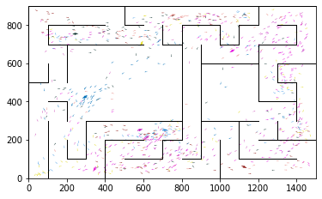

epoch 1961 == proposed_mle: 10.36+-0.21/10.00+-0.16 --

epoch 1962 == proposed_mle: 10.08+-0.21/9.97+-0.14 --

epoch 1963 == proposed_mle: 10.33+-0.30/9.81+-0.15 --

epoch 1964 == proposed_mle: 10.28+-0.21/9.89+-0.15 --

epoch 1965 == proposed_mle: 10.63+-0.23/9.91+-0.15 --

epoch 1966 == proposed_mle: 10.65+-0.24/10.17+-0.15 --

epoch 1967 == proposed_mle: 10.33+-0.25/9.98+-0.14 --

epoch 1968 == proposed_mle: 10.19+-0.26/9.91+-0.14 --

epoch 1969 == proposed_mle: 10.44+-0.25/9.84+-0.13 --

epoch 1970 >> proposed_mle: 10.13+-0.21/9.64+-0.14 --

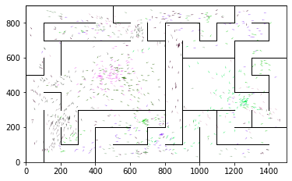

epoch 1971 == proposed_mle: 10.44+-0.20/10.02+-0.14 --

epoch 1972 == proposed_mle: 10.13+-0.25/9.76+-0.14 --

epoch 1973 == proposed_mle: 10.38+-0.25/9.94+-0.14 --

epoch 1974 == proposed_mle: 10.30+-0.23/9.99+-0.13 --

epoch 1975 == proposed_mle: 10.55+-0.22/9.87+-0.15 --

epoch 1976 == proposed_mle: 10.49+-0.21/10.04+-0.16 --

epoch 1977 == proposed_mle: 10.67+-0.19/9.94+-0.15 --

epoch 1978 == proposed_mle: 10.74+-0.20/10.01+-0.14 --

epoch 1979 == proposed_mle: 10.86+-0.22/9.80+-0.13 --

epoch 1980 == proposed_mle: 10.79+-0.22/9.90+-0.14 --

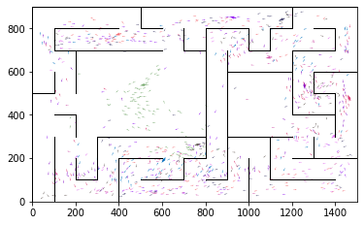

epoch 1981 == proposed_mle: 10.55+-0.25/9.98+-0.15 --

epoch 1982 == proposed_mle: 10.43+-0.20/10.10+-0.14 --

epoch 1983 == proposed_mle: 10.58+-0.21/9.92+-0.16 --

epoch 1984 == proposed_mle: 9.80+-0.19/9.81+-0.15 --

epoch 1985 == proposed_mle: 10.83+-0.25/9.74+-0.14 --

epoch 1986 == proposed_mle: 10.59+-0.22/10.10+-0.14 --

epoch 1987 == proposed_mle: 10.73+-0.24/9.77+-0.14 --

epoch 1988 == proposed_mle: 10.46+-0.20/9.71+-0.15 --

epoch 1989 == proposed_mle: 10.38+-0.24/9.80+-0.15 --

epoch 1990 >> proposed_mle: 10.40+-0.21/9.54+-0.14 --

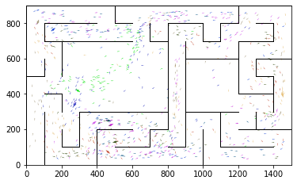

epoch 1991 == proposed_mle: 10.12+-0.22/9.91+-0.16 --

epoch 1992 == proposed_mle: 10.48+-0.24/9.95+-0.15 --

epoch 1993 == proposed_mle: 10.32+-0.22/9.82+-0.14 --

epoch 1994 == proposed_mle: 10.68+-0.24/9.75+-0.15 --

epoch 1995 == proposed_mle: 10.26+-0.25/9.76+-0.14 --

epoch 1996 == proposed_mle: 9.95+-0.20/9.84+-0.13 --

epoch 1997 == proposed_mle: 10.20+-0.21/9.78+-0.14 --

epoch 1998 == proposed_mle: 10.12+-0.21/9.80+-0.15 --

epoch 1999 == proposed_mle: 10.40+-0.25/9.93+-0.16 --

epoch 2000 == proposed_mle: 10.93+-0.22/9.95+-0.14 --

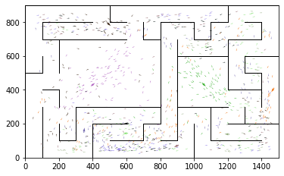

epoch 2001 == proposed_mle: 10.62+-0.22/9.75+-0.14 --

epoch 2002 == proposed_mle: 10.24+-0.22/9.90+-0.15 --

epoch 2003 == proposed_mle: 10.68+-0.21/9.82+-0.14 --

epoch 2004 == proposed_mle: 10.27+-0.22/9.84+-0.16 --

epoch 2005 == proposed_mle: 10.34+-0.21/9.78+-0.15 --

epoch 2006 == proposed_mle: 10.72+-0.22/9.82+-0.14 --

epoch 2007 == proposed_mle: 10.71+-0.21/10.04+-0.14 --

epoch 2008 == proposed_mle: 10.18+-0.25/10.13+-0.14 --

epoch 2009 == proposed_mle: 10.37+-0.23/9.84+-0.14 --

epoch 2010 == proposed_mle: 10.07+-0.20/9.75+-0.13 --

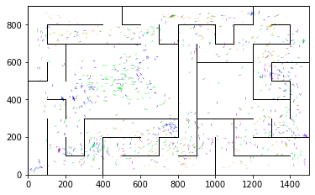

epoch 2011 == proposed_mle: 10.34+-0.25/9.77+-0.14 --

epoch 2012 == proposed_mle: 10.63+-0.21/9.58+-0.14 --

epoch 2013 == proposed_mle: 9.96+-0.18/9.79+-0.15 --

epoch 2014 == proposed_mle: 10.81+-0.19/9.82+-0.15 --

epoch 2015 == proposed_mle: 10.60+-0.21/9.81+-0.14 --

epoch 2016 == proposed_mle: 10.40+-0.21/9.81+-0.14 --

epoch 2017 == proposed_mle: 10.11+-0.21/9.60+-0.14 --

epoch 2018 == proposed_mle: 10.34+-0.26/9.86+-0.15 --

epoch 2019 == proposed_mle: 10.72+-0.24/9.83+-0.13 --

epoch 2020 == proposed_mle: 10.54+-0.19/9.69+-0.14 --

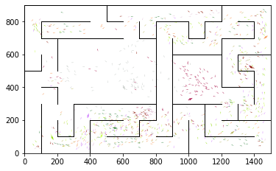

epoch 2021 == proposed_mle: 10.21+-0.18/9.89+-0.14 --

epoch 2022 == proposed_mle: 10.75+-0.23/10.20+-0.14 --

epoch 2023 == proposed_mle: 10.41+-0.23/9.92+-0.15 --

epoch 2024 == proposed_mle: 10.89+-0.31/9.75+-0.13 --

epoch 2025 == proposed_mle: 10.22+-0.18/9.76+-0.14 --

epoch 2026 == proposed_mle: 10.36+-0.22/9.63+-0.15 --

epoch 2027 == proposed_mle: 10.44+-0.21/9.64+-0.15 --

epoch 2028 == proposed_mle: 10.49+-0.24/9.67+-0.12 --

epoch 2029 == proposed_mle: 10.36+-0.23/9.71+-0.13 --

epoch 2030 == proposed_mle: 10.23+-0.20/9.90+-0.14 --

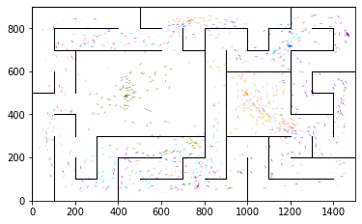

epoch 2031 == proposed_mle: 10.38+-0.22/9.54+-0.14 --

epoch 2032 == proposed_mle: 10.13+-0.21/9.76+-0.15 --

epoch 2033 == proposed_mle: 10.57+-0.24/9.87+-0.15 --

epoch 2034 == proposed_mle: 10.43+-0.24/9.69+-0.15 --

epoch 2035 == proposed_mle: 10.03+-0.21/9.85+-0.14 --

epoch 2036 == proposed_mle: 10.93+-0.24/9.54+-0.13 --

epoch 2037 == proposed_mle: 10.56+-0.25/9.88+-0.14 --

epoch 2038 == proposed_mle: 10.45+-0.23/10.03+-0.15 --

epoch 2039 == proposed_mle: 10.45+-0.22/9.93+-0.14 --

epoch 2040 == proposed_mle: 10.18+-0.24/9.73+-0.14 --

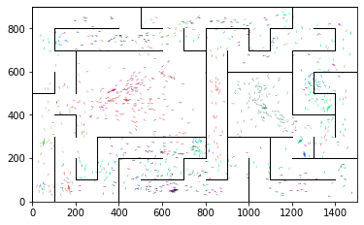

epoch 2041 == proposed_mle: 10.09+-0.24/9.81+-0.14 --

epoch 2042 == proposed_mle: 10.52+-0.24/9.87+-0.15 --

epoch 2043 == proposed_mle: 9.75+-0.21/9.79+-0.13 --

epoch 2044 == proposed_mle: 10.74+-0.21/9.83+-0.14 --

epoch 2045 == proposed_mle: 10.60+-0.17/9.89+-0.15 --

epoch 2046 == proposed_mle: 10.46+-0.20/9.68+-0.15 --

epoch 2047 == proposed_mle: 10.52+-0.21/9.76+-0.16 --

epoch 2048 == proposed_mle: 10.70+-0.26/9.64+-0.15 --

epoch 2049 == proposed_mle: 10.43+-0.26/9.85+-0.14 --

epoch 2050 == proposed_mle: 10.16+-0.21/9.88+-0.15 --

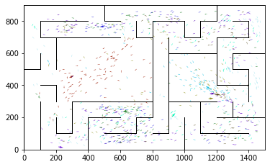

epoch 2051 == proposed_mle: 10.26+-0.22/9.63+-0.12 --

epoch 2052 == proposed_mle: 10.32+-0.22/9.92+-0.14 --

epoch 2053 == proposed_mle: 10.40+-0.21/9.96+-0.15 --

epoch 2054 == proposed_mle: 10.38+-0.20/9.81+-0.15 --

epoch 2055 == proposed_mle: 10.05+-0.20/9.82+-0.14 --

epoch 2056 == proposed_mle: 10.56+-0.21/9.99+-0.15 --

epoch 2057 == proposed_mle: 10.59+-0.22/10.02+-0.16 --

epoch 2058 == proposed_mle: 10.91+-0.28/9.90+-0.15 --

epoch 2059 == proposed_mle: 10.22+-0.21/9.76+-0.14 --

epoch 2060 == proposed_mle: 10.22+-0.23/9.66+-0.12 --

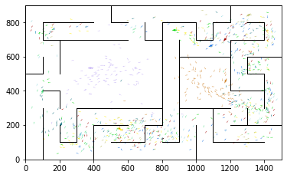

epoch 2061 == proposed_mle: 10.53+-0.20/9.84+-0.14 --

epoch 2062 == proposed_mle: 10.73+-0.24/9.73+-0.14 --

epoch 2063 == proposed_mle: 10.70+-0.25/9.76+-0.14 --

epoch 2064 == proposed_mle: 10.47+-0.25/9.78+-0.15 --

epoch 2065 == proposed_mle: 10.51+-0.21/9.83+-0.16 --

epoch 2066 == proposed_mle: 10.36+-0.20/9.67+-0.14 --

epoch 2067 == proposed_mle: 10.28+-0.24/9.66+-0.15 --

epoch 2068 == proposed_mle: 10.66+-0.26/9.81+-0.15 --

epoch 2069 == proposed_mle: 10.37+-0.19/9.60+-0.14 --

epoch 2070 == proposed_mle: 10.22+-0.22/9.76+-0.14 --

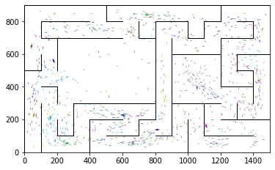

epoch 2071 == proposed_mle: 10.46+-0.22/9.74+-0.14 --

epoch 2072 == proposed_mle: 10.24+-0.26/9.75+-0.14 --

epoch 2073 == proposed_mle: 10.08+-0.22/9.94+-0.15 --

epoch 2074 == proposed_mle: 10.52+-0.27/9.80+-0.15 --

epoch 2075 == proposed_mle: 10.20+-0.22/9.67+-0.15 --

epoch 2076 == proposed_mle: 10.33+-0.21/9.94+-0.15 --

epoch 2077 == proposed_mle: 10.91+-0.25/9.74+-0.14 --

epoch 2078 == proposed_mle: 10.46+-0.22/9.83+-0.14 --

epoch 2079 == proposed_mle: 10.34+-0.22/9.83+-0.13 --

epoch 2080 == proposed_mle: 10.42+-0.26/10.03+-0.14 --

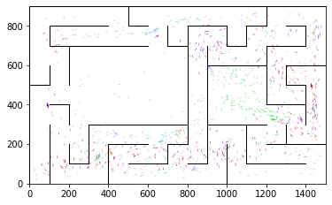

epoch 2081 == proposed_mle: 11.31+-0.21/10.06+-0.15 --

epoch 2082 == proposed_mle: 10.48+-0.24/9.84+-0.14 --

epoch 2083 == proposed_mle: 10.76+-0.23/9.83+-0.16 --

epoch 2084 == proposed_mle: 10.45+-0.21/9.90+-0.13 --

epoch 2085 == proposed_mle: 10.91+-0.27/9.94+-0.14 --

epoch 2086 == proposed_mle: 10.30+-0.16/9.95+-0.16 --

epoch 2087 == proposed_mle: 10.63+-0.25/9.75+-0.14 --

epoch 2088 == proposed_mle: 10.45+-0.24/10.01+-0.15 --

epoch 2089 == proposed_mle: 10.32+-0.23/9.86+-0.13 --

epoch 2090 == proposed_mle: 10.35+-0.20/9.86+-0.14 --

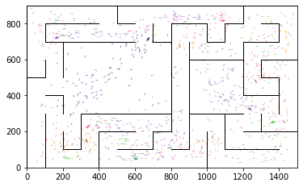

epoch 2091 == proposed_mle: 10.49+-0.22/9.81+-0.14 --

epoch 2092 == proposed_mle: 10.74+-0.22/9.73+-0.14 --

epoch 2093 == proposed_mle: 10.10+-0.22/9.92+-0.15 --

epoch 2094 == proposed_mle: 10.62+-0.25/10.27+-0.16 --

epoch 2095 == proposed_mle: 10.74+-0.22/10.27+-0.16 --

epoch 2096 == proposed_mle: 10.78+-0.25/10.39+-0.16 --

epoch 2097 == proposed_mle: 10.62+-0.25/10.13+-0.14 --

epoch 2098 == proposed_mle: 10.92+-0.19/9.84+-0.14 --

epoch 2099 == proposed_mle: 10.86+-0.23/9.95+-0.15 --

epoch 2100 == proposed_mle: 10.21+-0.19/10.01+-0.15 --

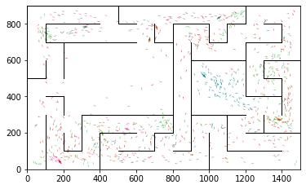

epoch 2101 == proposed_mle: 10.20+-0.22/10.13+-0.15 --

epoch 2102 == proposed_mle: 10.44+-0.24/10.00+-0.15 --

epoch 2103 == proposed_mle: 10.64+-0.22/9.98+-0.13 --

epoch 2104 == proposed_mle: 10.60+-0.20/10.09+-0.14 --

epoch 2105 == proposed_mle: 10.52+-0.26/10.07+-0.15 --

epoch 2106 == proposed_mle: 10.67+-0.23/9.86+-0.15 --

epoch 2107 == proposed_mle: 10.91+-0.27/9.90+-0.13 --

epoch 2108 == proposed_mle: 10.94+-0.20/10.02+-0.15 --

epoch 2109 == proposed_mle: 10.67+-0.26/9.77+-0.13 --

epoch 2110 == proposed_mle: 10.27+-0.25/9.84+-0.14 --

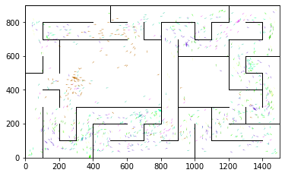

epoch 2111 == proposed_mle: 10.17+-0.23/10.04+-0.15 --

epoch 2112 == proposed_mle: 10.01+-0.19/9.78+-0.15 --

epoch 2113 == proposed_mle: 9.90+-0.25/9.89+-0.15 --

epoch 2114 == proposed_mle: 10.32+-0.21/9.71+-0.14 --

epoch 2115 == proposed_mle: 10.65+-0.24/9.83+-0.16 --

epoch 2116 == proposed_mle: 10.40+-0.24/9.80+-0.15 --

epoch 2117 == proposed_mle: 10.32+-0.25/9.76+-0.12 --

epoch 2118 == proposed_mle: 10.36+-0.19/9.75+-0.14 --

epoch 2119 == proposed_mle: 10.18+-0.21/9.99+-0.15 --

epoch 2120 == proposed_mle: 10.76+-0.25/9.71+-0.16 --

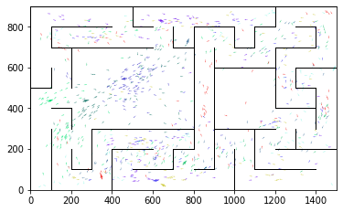

epoch 2121 == proposed_mle: 10.57+-0.26/9.86+-0.15 --

epoch 2122 == proposed_mle: 10.49+-0.18/9.60+-0.15 --

epoch 2123 == proposed_mle: 10.67+-0.21/9.73+-0.16 --

epoch 2124 == proposed_mle: 10.51+-0.18/9.72+-0.15 --

epoch 2125 == proposed_mle: 10.34+-0.24/9.60+-0.13 --

epoch 2126 == proposed_mle: 10.22+-0.21/9.71+-0.15 --

epoch 2127 == proposed_mle: 10.11+-0.25/9.67+-0.15 --

epoch 2128 == proposed_mle: 10.26+-0.17/9.54+-0.14 --

epoch 2129 == proposed_mle: 10.40+-0.21/9.78+-0.15 --

epoch 2130 == proposed_mle: 10.13+-0.22/9.67+-0.14 --

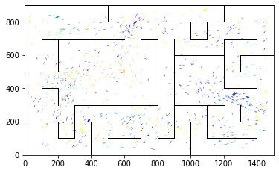

epoch 2131 == proposed_mle: 9.91+-0.17/9.77+-0.15 --

epoch 2132 == proposed_mle: 9.93+-0.18/9.66+-0.14 --

epoch 2133 == proposed_mle: 10.32+-0.25/9.94+-0.14 --

epoch 2134 == proposed_mle: 10.14+-0.20/9.58+-0.12 --

epoch 2135 == proposed_mle: 10.06+-0.26/9.79+-0.15 --

epoch 2136 == proposed_mle: 10.15+-0.21/9.72+-0.15 --

epoch 2137 == proposed_mle: 10.17+-0.21/9.61+-0.14 --

epoch 2138 >> proposed_mle: 10.14+-0.20/9.52+-0.14 --

epoch 2139 == proposed_mle: 10.38+-0.25/9.91+-0.14 --

epoch 2140 == proposed_mle: 10.62+-0.25/9.86+-0.15 --

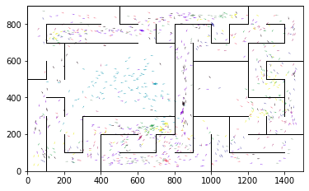

epoch 2141 == proposed_mle: 10.34+-0.20/9.84+-0.15 --

epoch 2142 == proposed_mle: 10.53+-0.23/9.94+-0.15 --

epoch 2143 == proposed_mle: 9.91+-0.21/9.72+-0.15 --

epoch 2144 == proposed_mle: 10.25+-0.18/9.77+-0.14 --

epoch 2145 == proposed_mle: 10.10+-0.20/9.77+-0.15 --

epoch 2146 == proposed_mle: 10.22+-0.23/9.60+-0.13 --

epoch 2147 == proposed_mle: 10.41+-0.22/9.66+-0.14 --

epoch 2148 == proposed_mle: 10.07+-0.24/9.79+-0.13 --

epoch 2149 == proposed_mle: 10.24+-0.23/9.64+-0.13 --

epoch 2150 == proposed_mle: 10.29+-0.25/9.80+-0.14 --

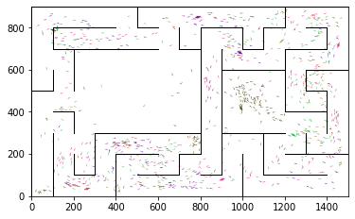

epoch 2151 == proposed_mle: 10.45+-0.22/9.83+-0.14 --

epoch 2152 == proposed_mle: 9.96+-0.25/9.58+-0.14 --

epoch 2153 == proposed_mle: 10.17+-0.23/9.61+-0.13 --

epoch 2154 == proposed_mle: 10.20+-0.24/9.66+-0.15 --

epoch 2155 == proposed_mle: 10.10+-0.24/9.57+-0.15 --

epoch 2156 == proposed_mle: 10.36+-0.26/9.73+-0.14 --

epoch 2157 == proposed_mle: 9.97+-0.19/9.55+-0.13 --

epoch 2158 == proposed_mle: 9.75+-0.22/9.72+-0.15 --

epoch 2159 == proposed_mle: 10.44+-0.24/9.59+-0.16 --

epoch 2160 == proposed_mle: 10.14+-0.22/9.64+-0.15 --

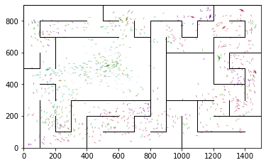

epoch 2161 == proposed_mle: 10.42+-0.21/9.54+-0.15 --

epoch 2162 == proposed_mle: 10.15+-0.18/9.71+-0.16 --

epoch 2163 == proposed_mle: 9.80+-0.21/9.81+-0.16 --

epoch 2164 == proposed_mle: 10.29+-0.23/9.83+-0.16 --

epoch 2165 == proposed_mle: 10.33+-0.23/9.80+-0.16 --

epoch 2166 == proposed_mle: 10.18+-0.21/9.53+-0.14 --

epoch 2167 >> proposed_mle: 10.60+-0.22/9.51+-0.15 --

epoch 2168 == proposed_mle: 10.31+-0.26/9.67+-0.15 --

epoch 2169 == proposed_mle: 10.20+-0.20/9.54+-0.14 --

epoch 2170 == proposed_mle: 10.00+-0.26/9.66+-0.14 --

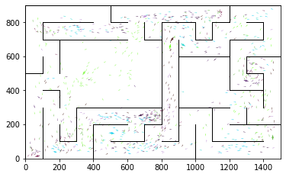

epoch 2171 == proposed_mle: 10.07+-0.25/9.64+-0.14 --

epoch 2172 == proposed_mle: 10.60+-0.27/9.61+-0.14 --

epoch 2173 == proposed_mle: 10.70+-0.25/9.63+-0.14 --

epoch 2174 >> proposed_mle: 10.29+-0.25/9.46+-0.13 --

epoch 2175 == proposed_mle: 10.36+-0.27/9.67+-0.15 --

epoch 2176 == proposed_mle: 10.10+-0.24/9.71+-0.15 --

epoch 2177 == proposed_mle: 9.88+-0.24/9.60+-0.13 --

epoch 2178 == proposed_mle: 10.06+-0.22/9.51+-0.13 --

epoch 2179 == proposed_mle: 9.97+-0.19/9.52+-0.15 --

epoch 2180 == proposed_mle: 10.42+-0.22/9.62+-0.16 --

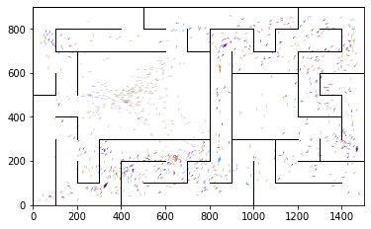

epoch 2181 >> proposed_mle: 10.30+-0.20/9.34+-0.13 --

epoch 2182 == proposed_mle: 10.08+-0.26/9.79+-0.14 --

epoch 2183 == proposed_mle: 10.14+-0.24/9.44+-0.14 --

epoch 2184 == proposed_mle: 10.17+-0.24/9.63+-0.14 --

epoch 2185 == proposed_mle: 10.23+-0.22/9.62+-0.15 --

epoch 2186 >> proposed_mle: 9.95+-0.20/9.33+-0.14 --

epoch 2187 == proposed_mle: 10.06+-0.24/9.42+-0.14 --

epoch 2188 == proposed_mle: 10.03+-0.21/9.71+-0.15 --

epoch 2189 == proposed_mle: 10.26+-0.24/9.43+-0.15 --

epoch 2190 == proposed_mle: 10.01+-0.21/9.67+-0.15 --

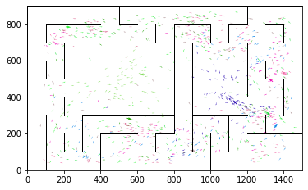

epoch 2191 == proposed_mle: 10.85+-0.25/9.68+-0.15 --

epoch 2192 == proposed_mle: 10.70+-0.22/9.73+-0.15 --

epoch 2193 == proposed_mle: 10.36+-0.25/9.66+-0.14 --

epoch 2194 == proposed_mle: 10.25+-0.21/9.42+-0.14 --

epoch 2195 == proposed_mle: 10.36+-0.21/9.50+-0.15 --

epoch 2196 == proposed_mle: 10.14+-0.24/9.58+-0.14 --

epoch 2197 == proposed_mle: 10.42+-0.22/9.60+-0.13 --

epoch 2198 == proposed_mle: 9.79+-0.23/9.52+-0.13 --

epoch 2199 == proposed_mle: 10.02+-0.18/9.69+-0.14 --

epoch 2200 == proposed_mle: 9.78+-0.18/9.52+-0.15 --

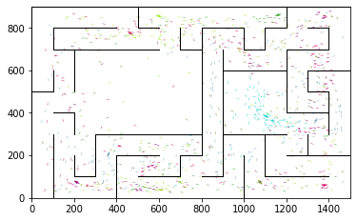

epoch 2201 == proposed_mle: 10.40+-0.24/9.59+-0.15 --

epoch 2202 == proposed_mle: 10.33+-0.23/9.65+-0.14 --

epoch 2203 == proposed_mle: 10.02+-0.24/9.37+-0.15 --

epoch 2204 == proposed_mle: 9.90+-0.17/9.36+-0.14 --

epoch 2205 >> proposed_mle: 10.14+-0.22/9.22+-0.13 --

epoch 2206 == proposed_mle: 9.97+-0.23/9.69+-0.14 --

epoch 2207 == proposed_mle: 10.35+-0.24/9.62+-0.15 --

epoch 2208 == proposed_mle: 10.20+-0.18/9.62+-0.13 --

epoch 2209 == proposed_mle: 10.01+-0.21/9.57+-0.13 --

epoch 2210 == proposed_mle: 10.48+-0.22/9.48+-0.16 --

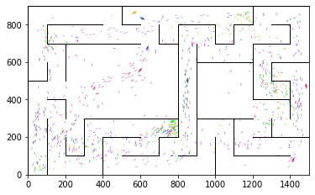

epoch 2211 == proposed_mle: 10.02+-0.22/9.54+-0.15 --

epoch 2212 == proposed_mle: 10.43+-0.23/9.58+-0.14 --

epoch 2213 == proposed_mle: 10.02+-0.21/9.34+-0.13 --

epoch 2214 == proposed_mle: 10.15+-0.24/9.37+-0.13 --

epoch 2215 == proposed_mle: 10.20+-0.24/9.41+-0.12 --

epoch 2216 == proposed_mle: 9.69+-0.22/9.41+-0.14 --

epoch 2217 == proposed_mle: 10.47+-0.22/9.53+-0.14 --

epoch 2218 == proposed_mle: 10.26+-0.22/9.56+-0.14 --

epoch 2219 == proposed_mle: 10.15+-0.27/9.58+-0.14 --

epoch 2220 == proposed_mle: 10.30+-0.25/9.45+-0.15 --

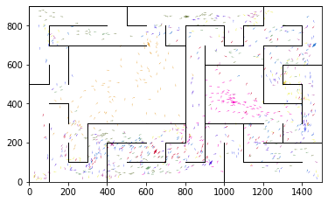

epoch 2221 == proposed_mle: 9.51+-0.22/9.59+-0.14 --

epoch 2222 == proposed_mle: 10.12+-0.21/9.52+-0.15 --

epoch 2223 == proposed_mle: 10.16+-0.24/9.52+-0.13 --

epoch 2224 == proposed_mle: 9.91+-0.21/9.54+-0.13 --

epoch 2225 == proposed_mle: 10.37+-0.20/9.35+-0.13 --

epoch 2226 == proposed_mle: 10.22+-0.23/9.51+-0.14 --

epoch 2227 == proposed_mle: 9.82+-0.23/9.59+-0.14 --

epoch 2228 == proposed_mle: 10.53+-0.24/9.44+-0.14 --

epoch 2229 == proposed_mle: 10.51+-0.24/9.48+-0.15 --

epoch 2230 == proposed_mle: 10.30+-0.22/9.60+-0.15 --

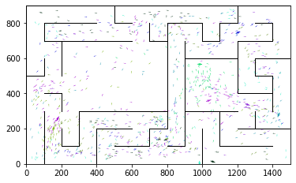

epoch 2231 == proposed_mle: 10.18+-0.22/9.66+-0.15 --

epoch 2232 == proposed_mle: 10.02+-0.21/9.72+-0.15 --

epoch 2233 == proposed_mle: 10.39+-0.24/9.47+-0.14 --

epoch 2234 == proposed_mle: 10.45+-0.24/9.46+-0.13 --

epoch 2235 == proposed_mle: 10.37+-0.24/9.69+-0.14 --

epoch 2236 == proposed_mle: 10.20+-0.22/9.56+-0.16 --

epoch 2237 == proposed_mle: 10.36+-0.24/9.41+-0.13 --

epoch 2238 == proposed_mle: 10.13+-0.24/9.75+-0.16 --

epoch 2239 == proposed_mle: 10.26+-0.22/9.34+-0.13 --

epoch 2240 == proposed_mle: 10.36+-0.24/9.54+-0.14 --

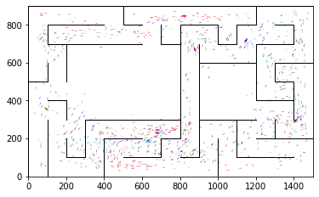

epoch 2241 == proposed_mle: 10.33+-0.26/9.42+-0.14 --

epoch 2242 == proposed_mle: 10.26+-0.21/9.59+-0.15 --

epoch 2243 == proposed_mle: 10.15+-0.24/9.52+-0.13 --

epoch 2244 == proposed_mle: 10.19+-0.24/9.45+-0.16 --

epoch 2245 == proposed_mle: 10.40+-0.22/9.52+-0.14 --

epoch 2246 == proposed_mle: 10.32+-0.23/9.59+-0.14 --

epoch 2247 == proposed_mle: 10.22+-0.24/9.73+-0.13 --

epoch 2248 == proposed_mle: 10.35+-0.22/9.68+-0.14 --

epoch 2249 == proposed_mle: 10.48+-0.23/9.69+-0.14 --

epoch 2250 == proposed_mle: 9.67+-0.21/9.82+-0.13 --

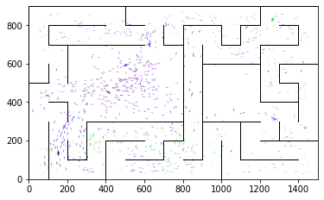

epoch 2251 == proposed_mle: 10.37+-0.18/9.91+-0.15 --

epoch 2252 == proposed_mle: 10.16+-0.21/9.61+-0.13 --

epoch 2253 == proposed_mle: 10.14+-0.24/9.58+-0.13 --

epoch 2254 == proposed_mle: 10.62+-0.22/9.80+-0.15 --

epoch 2255 == proposed_mle: 10.40+-0.21/9.84+-0.15 --

epoch 2256 == proposed_mle: 10.12+-0.28/9.66+-0.13 --

epoch 2257 == proposed_mle: 10.00+-0.21/9.41+-0.14 --

epoch 2258 == proposed_mle: 9.92+-0.22/9.33+-0.12 --

epoch 2259 == proposed_mle: 10.13+-0.24/9.58+-0.13 --

epoch 2260 == proposed_mle: 10.38+-0.21/9.45+-0.13 --

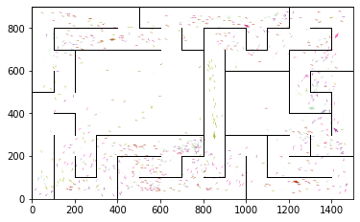

epoch 2261 == proposed_mle: 9.97+-0.21/9.51+-0.15 --

epoch 2262 == proposed_mle: 10.04+-0.20/9.88+-0.14 --

epoch 2263 == proposed_mle: 10.13+-0.22/9.69+-0.14 --

epoch 2264 == proposed_mle: 10.10+-0.21/9.75+-0.13 --

epoch 2265 == proposed_mle: 10.37+-0.23/9.51+-0.14 --

epoch 2266 == proposed_mle: 9.98+-0.22/9.52+-0.15 --

epoch 2267 == proposed_mle: 10.62+-0.22/9.55+-0.11 --

epoch 2268 == proposed_mle: 9.97+-0.20/9.62+-0.15 --

epoch 2269 == proposed_mle: 10.29+-0.25/9.54+-0.15 --

epoch 2270 == proposed_mle: 10.26+-0.23/9.59+-0.15 --

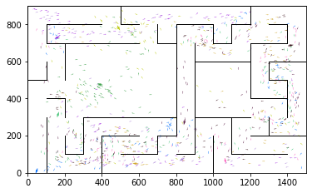

epoch 2271 == proposed_mle: 10.16+-0.23/9.42+-0.14 --

epoch 2272 == proposed_mle: 10.46+-0.21/9.42+-0.14 --

epoch 2273 == proposed_mle: 10.15+-0.23/9.36+-0.14 --

epoch 2274 == proposed_mle: 10.22+-0.23/9.40+-0.14 --

epoch 2275 == proposed_mle: 10.03+-0.19/9.36+-0.13 --

epoch 2276 == proposed_mle: 10.34+-0.23/9.46+-0.13 --

epoch 2277 == proposed_mle: 10.74+-0.23/9.55+-0.13 --

epoch 2278 == proposed_mle: 10.52+-0.26/9.64+-0.14 --

epoch 2279 == proposed_mle: 10.19+-0.23/9.38+-0.13 --

epoch 2280 == proposed_mle: 10.38+-0.23/9.55+-0.15 --

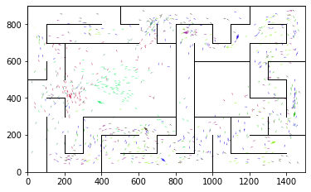

epoch 2281 == proposed_mle: 10.01+-0.23/9.45+-0.13 --

epoch 2282 == proposed_mle: 10.33+-0.18/9.50+-0.15 --

epoch 2283 == proposed_mle: 10.14+-0.23/9.54+-0.14 --

epoch 2284 == proposed_mle: 10.32+-0.23/9.48+-0.14 --

epoch 2285 == proposed_mle: 10.26+-0.23/9.52+-0.14 --

epoch 2286 == proposed_mle: 10.29+-0.23/9.59+-0.14 --

epoch 2287 == proposed_mle: 10.13+-0.22/9.34+-0.14 --

epoch 2288 == proposed_mle: 9.94+-0.23/9.61+-0.15 --

epoch 2289 == proposed_mle: 10.00+-0.24/9.37+-0.13 --

epoch 2290 == proposed_mle: 9.87+-0.21/9.49+-0.14 --

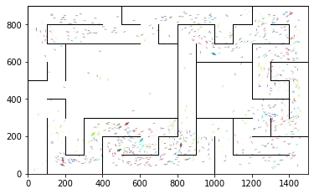

epoch 2291 == proposed_mle: 10.17+-0.24/9.26+-0.14 --

epoch 2292 == proposed_mle: 10.09+-0.23/9.47+-0.13 --

epoch 2293 == proposed_mle: 9.79+-0.22/9.36+-0.13 --

epoch 2294 == proposed_mle: 9.91+-0.22/9.43+-0.13 --

epoch 2295 == proposed_mle: 10.06+-0.24/9.39+-0.13 --

epoch 2296 == proposed_mle: 10.06+-0.23/9.40+-0.14 --

epoch 2297 == proposed_mle: 10.34+-0.23/9.43+-0.13 --

epoch 2298 == proposed_mle: 10.06+-0.17/9.40+-0.13 --

epoch 2299 == proposed_mle: 10.11+-0.23/9.43+-0.13 --

epoch 2300 == proposed_mle: 9.98+-0.21/9.43+-0.14 --

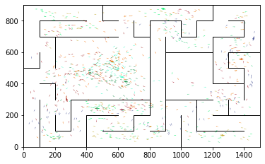

epoch 2301 == proposed_mle: 10.04+-0.24/9.56+-0.13 --

epoch 2302 == proposed_mle: 10.27+-0.20/9.50+-0.15 --

epoch 2303 == proposed_mle: 10.28+-0.22/9.43+-0.14 --

epoch 2304 == proposed_mle: 10.06+-0.21/9.39+-0.13 --

epoch 2305 == proposed_mle: 10.18+-0.24/9.57+-0.14 --

epoch 2306 == proposed_mle: 10.06+-0.20/9.51+-0.13 --

epoch 2307 == proposed_mle: 10.22+-0.22/9.56+-0.16 --

epoch 2308 == proposed_mle: 9.96+-0.18/9.61+-0.14 --

epoch 2309 == proposed_mle: 10.25+-0.20/9.82+-0.14 --

epoch 2310 == proposed_mle: 9.98+-0.22/9.88+-0.15 --

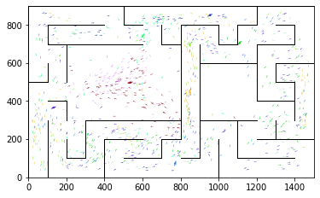

epoch 2311 == proposed_mle: 10.36+-0.25/9.61+-0.14 --

epoch 2312 == proposed_mle: 10.07+-0.24/9.54+-0.15 --

epoch 2313 == proposed_mle: 9.99+-0.22/9.48+-0.14 --

epoch 2314 == proposed_mle: 10.14+-0.21/9.57+-0.15 --

epoch 2315 == proposed_mle: 9.99+-0.22/9.34+-0.13 --

epoch 2316 == proposed_mle: 10.10+-0.22/9.42+-0.13 --

epoch 2317 == proposed_mle: 9.91+-0.22/9.41+-0.14 --

epoch 2318 == proposed_mle: 10.06+-0.25/9.43+-0.13 --

epoch 2319 == proposed_mle: 9.45+-0.20/9.47+-0.14 --

epoch 2320 == proposed_mle: 9.99+-0.25/9.64+-0.14 --

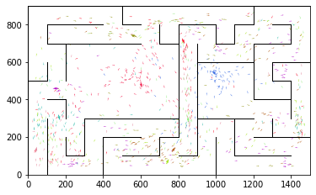

epoch 2321 == proposed_mle: 10.22+-0.25/9.57+-0.14 --

epoch 2322 == proposed_mle: 10.05+-0.19/9.38+-0.14 --

epoch 2323 == proposed_mle: 10.25+-0.21/9.37+-0.13 --

epoch 2324 == proposed_mle: 10.25+-0.24/9.39+-0.15 --

epoch 2325 == proposed_mle: 9.60+-0.20/9.36+-0.14 --

epoch 2326 == proposed_mle: 10.26+-0.21/9.41+-0.13 --

epoch 2327 == proposed_mle: 10.00+-0.19/9.39+-0.15 --

epoch 2328 == proposed_mle: 9.48+-0.16/9.41+-0.15 --

epoch 2329 == proposed_mle: 10.14+-0.21/9.65+-0.15 --

epoch 2330 == proposed_mle: 9.69+-0.23/9.45+-0.13 --

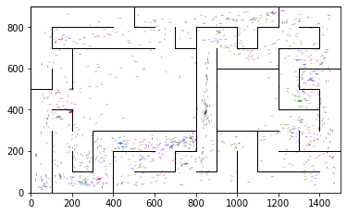

epoch 2331 == proposed_mle: 10.29+-0.21/9.57+-0.14 --

epoch 2332 == proposed_mle: 10.02+-0.26/9.52+-0.16 --

epoch 2333 == proposed_mle: 9.84+-0.22/9.46+-0.15 --

epoch 2334 == proposed_mle: 9.59+-0.20/9.69+-0.15 --

epoch 2335 == proposed_mle: 9.78+-0.20/9.43+-0.17 --

epoch 2336 == proposed_mle: 10.34+-0.20/9.48+-0.13 --

epoch 2337 == proposed_mle: 10.40+-0.21/9.33+-0.14 --

epoch 2338 == proposed_mle: 10.07+-0.23/9.61+-0.15 --

epoch 2339 == proposed_mle: 9.96+-0.22/9.57+-0.15 --

epoch 2340 == proposed_mle: 10.16+-0.21/9.76+-0.16 --

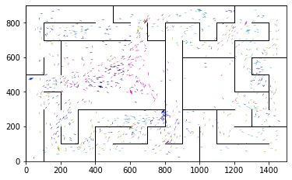

epoch 2341 == proposed_mle: 10.04+-0.21/9.59+-0.14 --

epoch 2342 == proposed_mle: 10.49+-0.24/9.52+-0.15 --

epoch 2343 == proposed_mle: 10.45+-0.26/9.59+-0.13 --

epoch 2344 == proposed_mle: 10.14+-0.22/9.48+-0.14 --

epoch 2345 == proposed_mle: 10.26+-0.23/9.52+-0.14 --

epoch 2346 == proposed_mle: 10.28+-0.23/9.58+-0.14 --

epoch 2347 == proposed_mle: 10.03+-0.23/9.66+-0.14 --

epoch 2348 == proposed_mle: 10.24+-0.21/9.61+-0.15 --

epoch 2349 == proposed_mle: 10.19+-0.20/9.72+-0.13 --

epoch 2350 == proposed_mle: 9.64+-0.21/9.42+-0.14 --

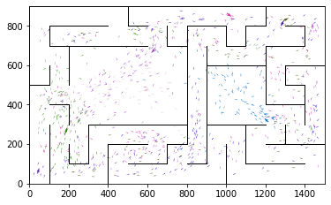

epoch 2351 == proposed_mle: 10.58+-0.21/9.44+-0.15 --

epoch 2352 == proposed_mle: 10.04+-0.25/9.47+-0.14 --

epoch 2353 == proposed_mle: 10.28+-0.24/9.58+-0.12 --

epoch 2354 == proposed_mle: 9.56+-0.20/9.49+-0.14 --

epoch 2355 == proposed_mle: 9.59+-0.22/9.32+-0.14 --

epoch 2356 == proposed_mle: 9.95+-0.19/9.41+-0.14 --

epoch 2357 == proposed_mle: 10.35+-0.19/9.56+-0.14 --

epoch 2358 == proposed_mle: 9.91+-0.18/9.57+-0.16 --

epoch 2359 == proposed_mle: 9.93+-0.19/9.41+-0.15 --

epoch 2360 == proposed_mle: 10.21+-0.23/9.43+-0.13 --

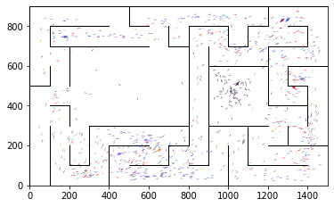

epoch 2361 == proposed_mle: 10.12+-0.18/9.54+-0.13 --

epoch 2362 == proposed_mle: 10.15+-0.24/9.48+-0.14 --

epoch 2363 == proposed_mle: 10.05+-0.17/9.58+-0.13 --

epoch 2364 == proposed_mle: 10.00+-0.20/9.38+-0.13 --

epoch 2365 == proposed_mle: 10.34+-0.23/9.34+-0.15 --

epoch 2366 == proposed_mle: 10.19+-0.22/9.67+-0.16 --

epoch 2367 == proposed_mle: 10.04+-0.20/9.40+-0.14 --

epoch 2368 == proposed_mle: 9.93+-0.20/9.66+-0.15 --

epoch 2369 == proposed_mle: 9.95+-0.19/9.65+-0.14 --

epoch 2370 == proposed_mle: 9.83+-0.20/9.43+-0.14 --

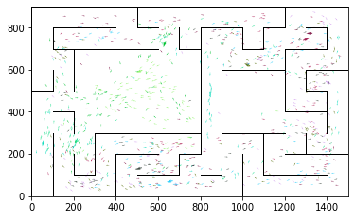

epoch 2371 == proposed_mle: 9.96+-0.25/9.55+-0.13 --

epoch 2372 == proposed_mle: 9.86+-0.23/9.51+-0.15 --

epoch 2373 == proposed_mle: 9.72+-0.19/9.40+-0.14 --

epoch 2374 == proposed_mle: 10.30+-0.20/9.39+-0.13 --

epoch 2375 == proposed_mle: 10.32+-0.22/9.46+-0.15 --

epoch 2376 == proposed_mle: 10.16+-0.22/9.43+-0.14 --

epoch 2377 == proposed_mle: 9.77+-0.20/9.76+-0.16 --

epoch 2378 == proposed_mle: 9.80+-0.21/9.50+-0.14 --

epoch 2379 == proposed_mle: 9.53+-0.27/9.64+-0.14 --

epoch 2380 == proposed_mle: 10.29+-0.21/9.70+-0.13 --

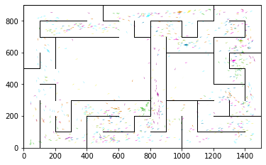

epoch 2381 == proposed_mle: 10.13+-0.30/9.67+-0.15 --

epoch 2382 == proposed_mle: 10.35+-0.22/9.59+-0.14 --

epoch 2383 == proposed_mle: 9.74+-0.22/9.58+-0.15 --

epoch 2384 == proposed_mle: 10.30+-0.23/9.55+-0.14 --

epoch 2385 == proposed_mle: 10.06+-0.21/9.56+-0.15 --

epoch 2386 == proposed_mle: 9.70+-0.19/9.58+-0.15 --

epoch 2387 == proposed_mle: 10.06+-0.22/9.77+-0.15 --

epoch 2388 == proposed_mle: 9.92+-0.26/9.55+-0.14 --

epoch 2389 == proposed_mle: 10.11+-0.23/9.69+-0.15 --

epoch 2390 == proposed_mle: 9.93+-0.24/9.61+-0.15 --

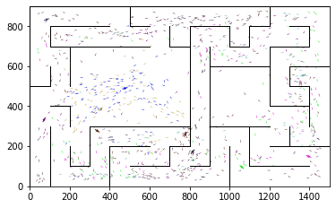

epoch 2391 == proposed_mle: 10.08+-0.18/9.79+-0.15 --

epoch 2392 == proposed_mle: 10.29+-0.22/9.52+-0.15 --

epoch 2393 == proposed_mle: 10.25+-0.22/9.73+-0.14 --

epoch 2394 == proposed_mle: 9.88+-0.20/9.48+-0.14 --

epoch 2395 == proposed_mle: 10.07+-0.23/9.53+-0.14 --

epoch 2396 == proposed_mle: 10.17+-0.20/9.57+-0.13 --

epoch 2397 == proposed_mle: 9.75+-0.18/9.54+-0.16 --

epoch 2398 == proposed_mle: 10.33+-0.20/9.79+-0.15 --

epoch 2399 == proposed_mle: 9.89+-0.22/9.79+-0.15 --

epoch 2400 == proposed_mle: 9.93+-0.24/9.48+-0.16 --

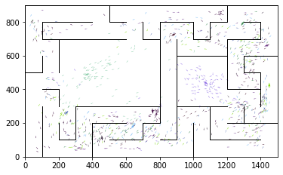

epoch 2401 == proposed_mle: 10.18+-0.19/9.66+-0.15 --

epoch 2402 == proposed_mle: 9.63+-0.21/9.61+-0.16 --

epoch 2403 == proposed_mle: 10.00+-0.20/9.48+-0.14 --

epoch 2404 == proposed_mle: 10.04+-0.22/9.48+-0.14 --

INFO:tensorflow:Restoring parameters from ../models/tmp/best_validation

INFO:tensorflow:Restoring parameters from ../models/tmp/best_validation

epoch 0 >> mse_last: 1.52+-0.23 -- mle: 4.93+-0.05 --

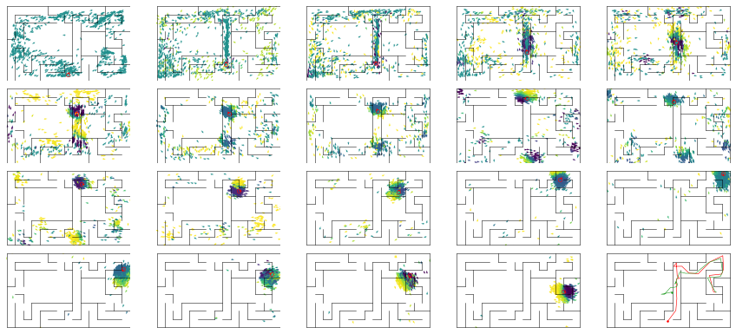

epoch 1 == mse_last: 3.34+-0.60/4.95+-0.51 -- mle: 5.39+-0.11/5.01+-0.09 --

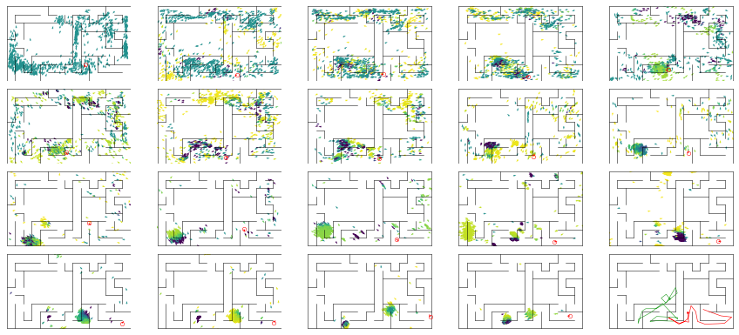

epoch 2 == mse_last: 3.54+-0.70/1.98+-0.31 -- mle: 5.31+-0.12/4.31+-0.07 --

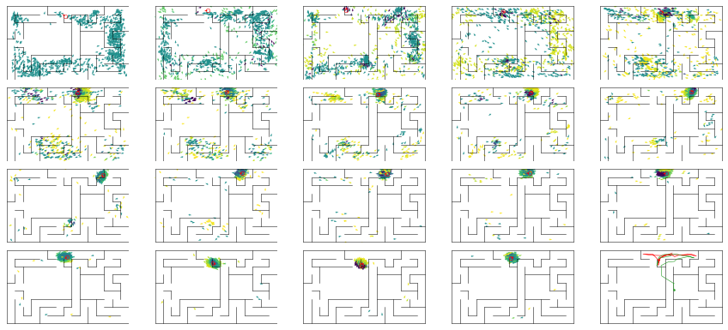

epoch 3 == mse_last: 3.38+-0.54/1.84+-0.29 -- mle: 5.04+-0.11/4.22+-0.06 --

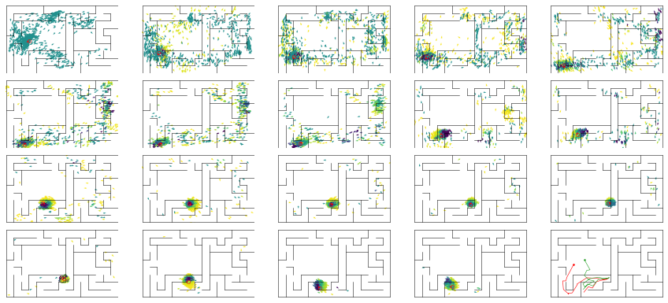

epoch 4 == mse_last: 3.03+-0.51/2.57+-0.42 -- mle: 4.86+-0.09/4.31+-0.07 --

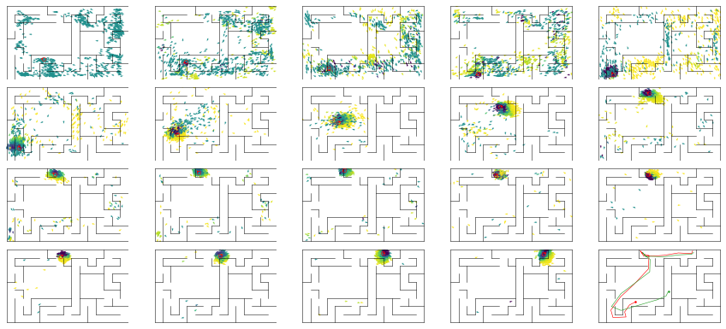

epoch 5 == mse_last: 2.43+-0.51/2.06+-0.31 -- mle: 4.71+-0.13/4.10+-0.07 --

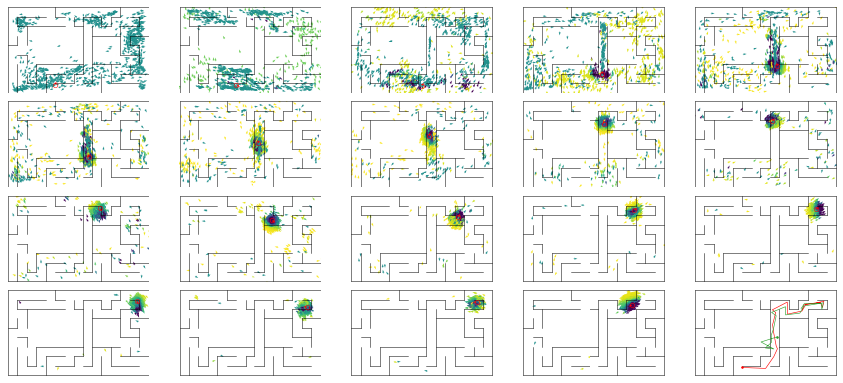

epoch 6 == mse_last: 2.66+-0.52/2.20+-0.33 -- mle: 4.70+-0.12/4.18+-0.07 --

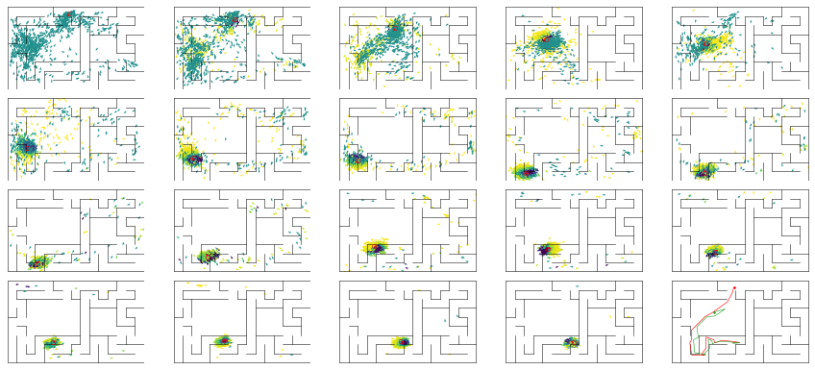

epoch 7 == mse_last: 2.85+-0.44/2.60+-0.39 -- mle: 4.60+-0.10/4.16+-0.06 --

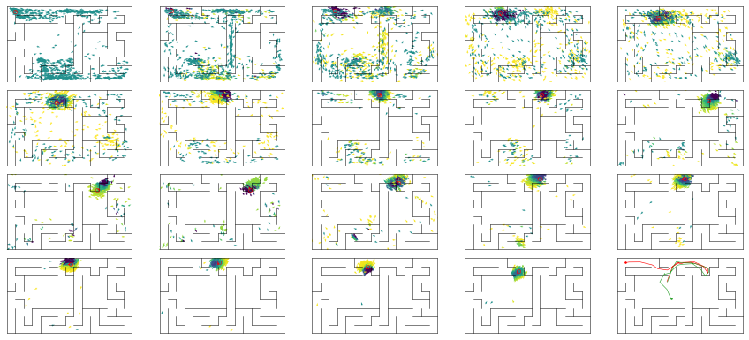

epoch 8 == mse_last: 2.52+-0.46/2.64+-0.43 -- mle: 4.53+-0.09/4.02+-0.06 --

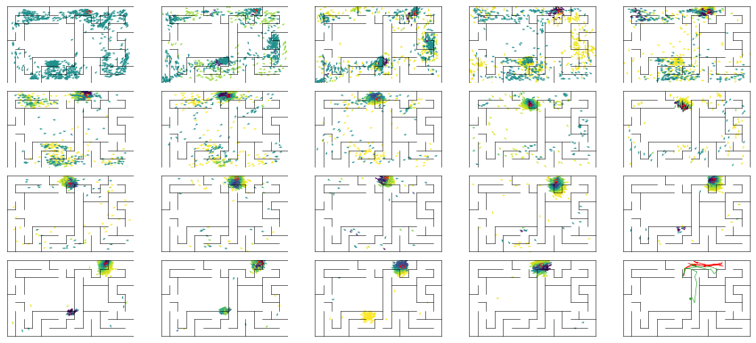

epoch 9 == mse_last: 2.41+-0.43/3.32+-0.45 -- mle: 4.70+-0.11/4.20+-0.07 --

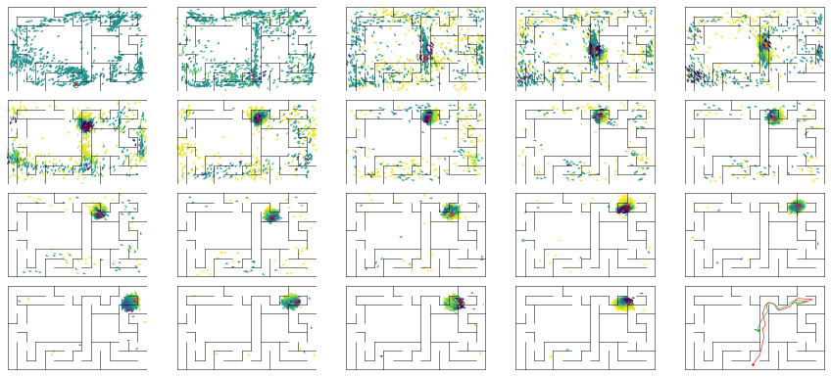

epoch 10 == mse_last: 2.83+-0.51/1.89+-0.31 -- mle: 4.64+-0.09/4.01+-0.06 --

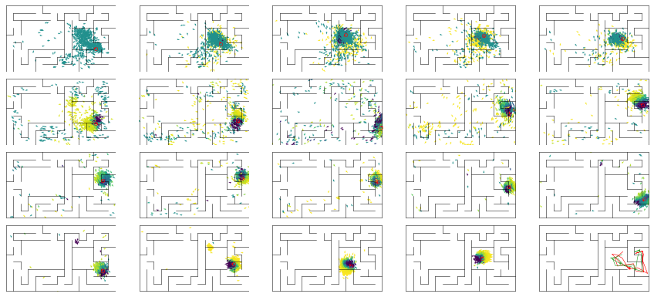

epoch 11 == mse_last: 2.68+-0.60/2.09+-0.26 -- mle: 4.56+-0.11/4.18+-0.06 --

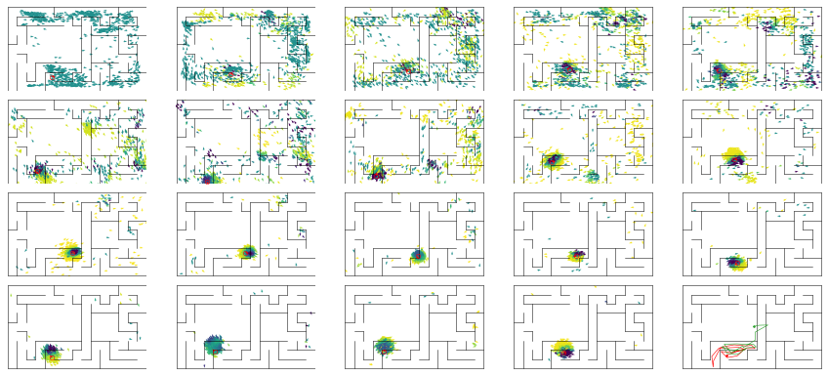

epoch 12 == mse_last: 2.32+-0.38/1.87+-0.28 -- mle: 4.43+-0.09/4.15+-0.06 --

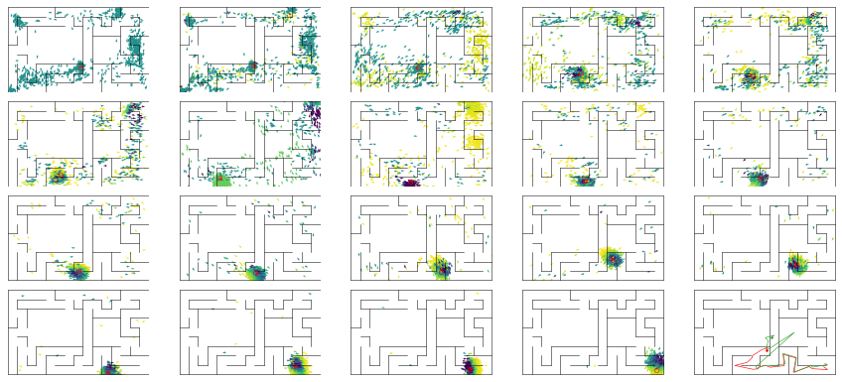

epoch 13 == mse_last: 1.56+-0.33/1.85+-0.27 -- mle: 4.41+-0.10/3.99+-0.06 --

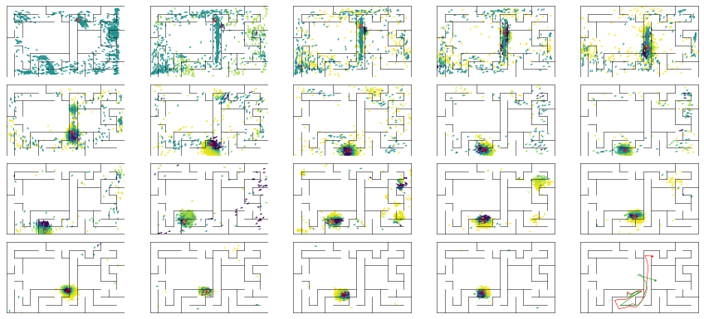

epoch 14 == mse_last: 2.20+-0.46/1.86+-0.30 -- mle: 4.42+-0.10/4.00+-0.06 --

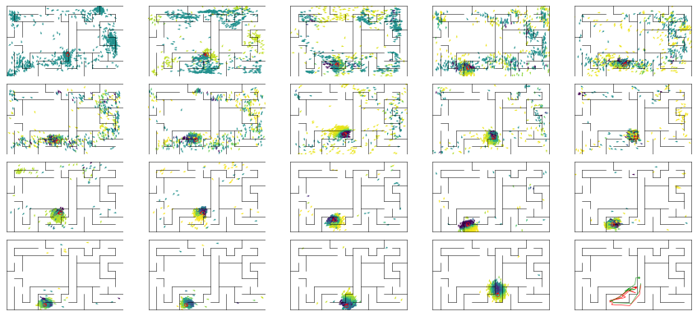

epoch 15 == mse_last: 3.18+-0.56/4.27+-0.56 -- mle: 4.85+-0.10/4.35+-0.08 --

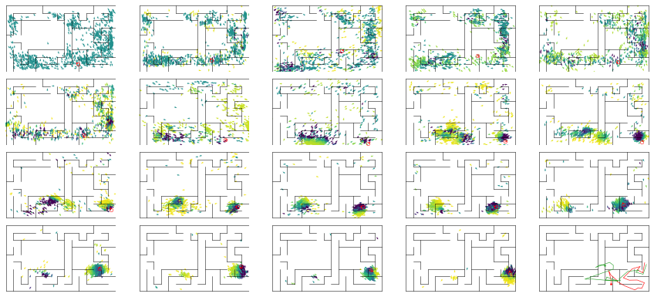

epoch 16 == mse_last: 1.94+-0.40/1.71+-0.31 -- mle: 4.34+-0.09/4.09+-0.06 --

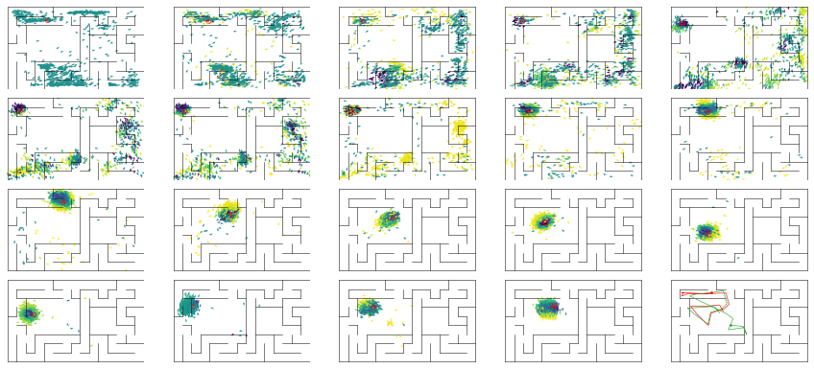

epoch 17 == mse_last: 2.89+-0.57/2.44+-0.35 -- mle: 4.47+-0.08/4.24+-0.07 --

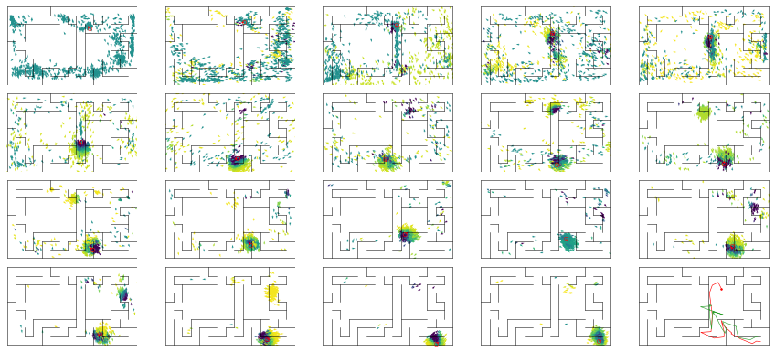

epoch 18 == mse_last: 2.68+-0.53/2.32+-0.28 -- mle: 4.49+-0.09/4.11+-0.06 --

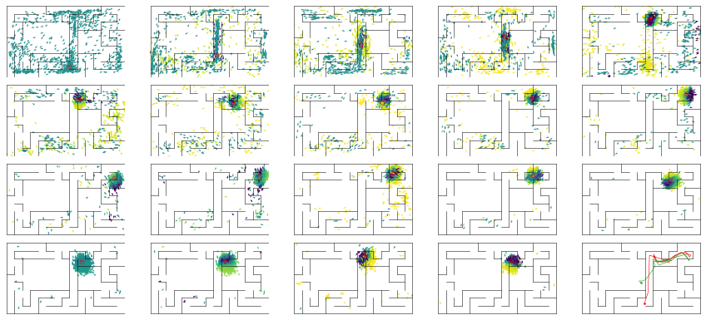

epoch 19 == mse_last: 2.24+-0.58/1.93+-0.29 -- mle: 4.59+-0.11/4.14+-0.06 --

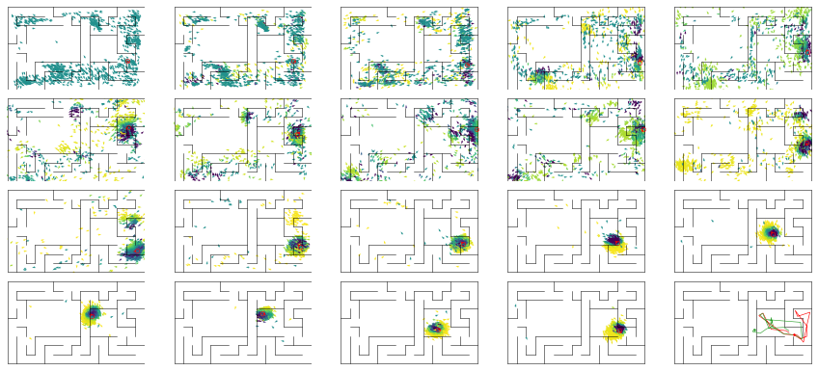

epoch 20 == mse_last: 3.13+-0.61/2.50+-0.34 -- mle: 4.54+-0.11/4.03+-0.07 --

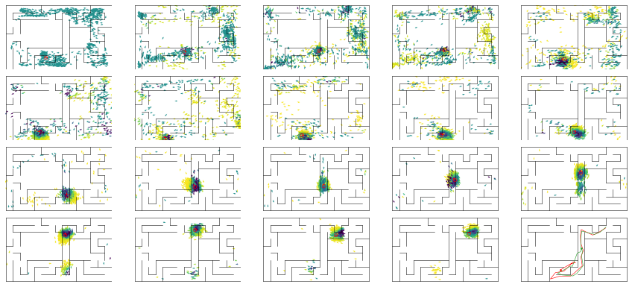

epoch 21 == mse_last: 2.30+-0.40/2.97+-0.40 -- mle: 4.55+-0.10/4.17+-0.06 --

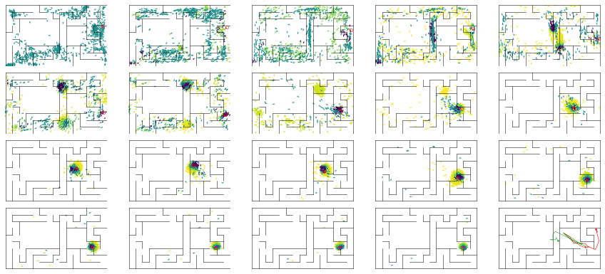

epoch 22 == mse_last: 2.70+-0.49/2.11+-0.36 -- mle: 4.33+-0.08/3.98+-0.06 --

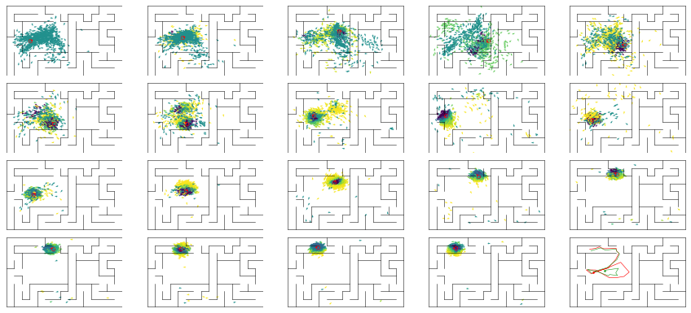

epoch 23 == mse_last: 3.40+-0.61/2.04+-0.33 -- mle: 4.41+-0.10/4.03+-0.06 --

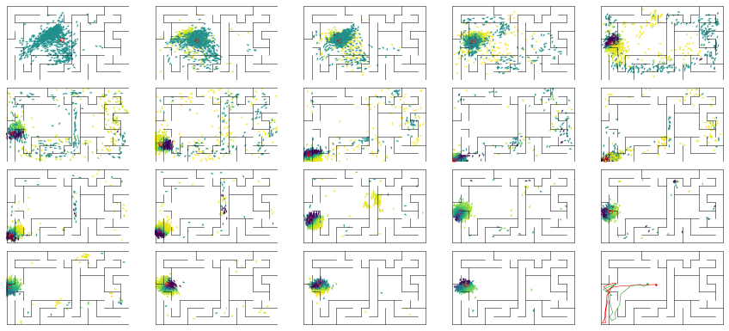

epoch 24 == mse_last: 4.45+-0.82/2.14+-0.38 -- mle: 4.68+-0.12/4.09+-0.06 --

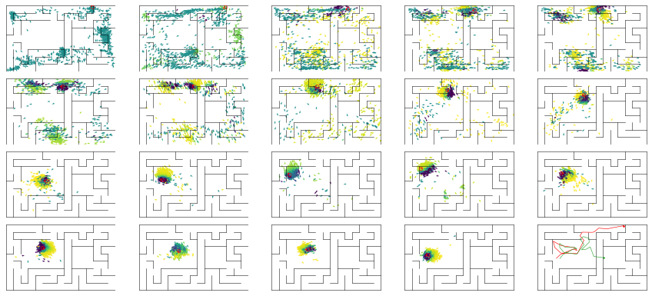

epoch 25 == mse_last: 3.46+-0.72/4.57+-0.56 -- mle: 4.50+-0.09/4.28+-0.08 --

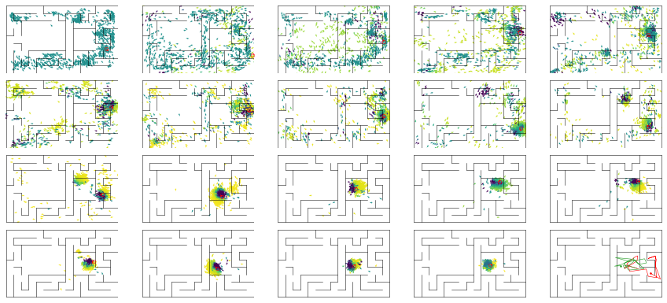

epoch 26 == mse_last: 2.69+-0.58/2.80+-0.40 -- mle: 4.52+-0.10/4.14+-0.06 --

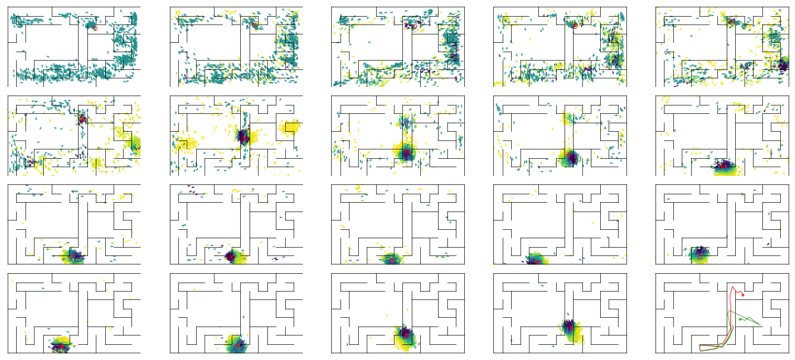

epoch 27 == mse_last: 2.57+-0.48/2.20+-0.35 -- mle: 4.50+-0.09/3.99+-0.06 --

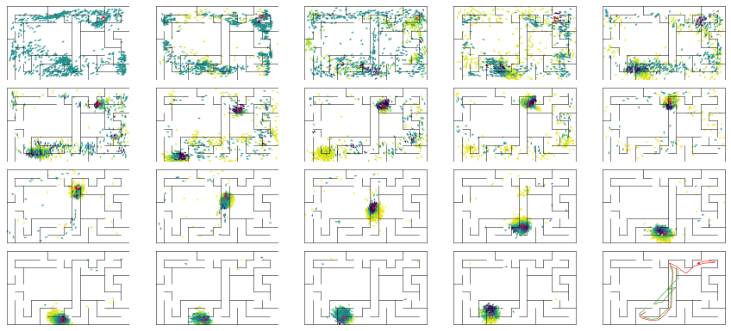

epoch 28 == mse_last: 2.81+-0.53/2.02+-0.32 -- mle: 4.52+-0.09/4.06+-0.06 --

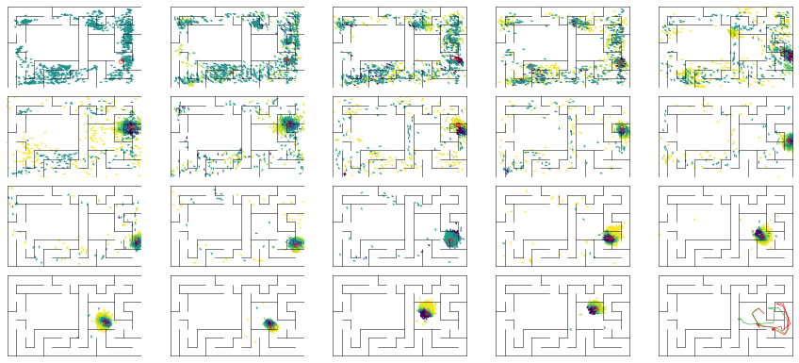

epoch 29 >> mse_last: 2.73+-0.59/1.20+-0.19 -- mle: 4.28+-0.09/3.86+-0.06 --

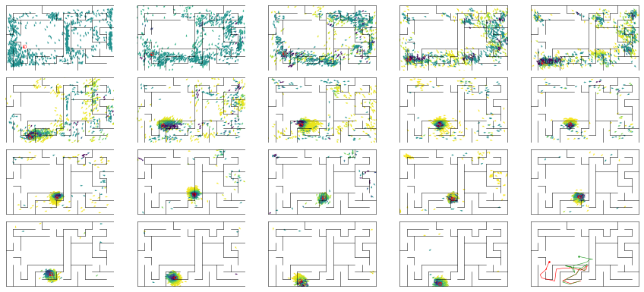

epoch 30 == mse_last: 3.17+-0.59/1.47+-0.27 -- mle: 4.61+-0.11/3.92+-0.06 --

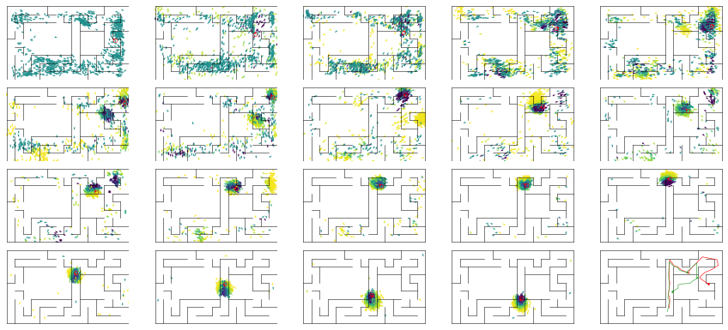

epoch 31 == mse_last: 3.10+-0.59/1.53+-0.26 -- mle: 4.46+-0.09/3.94+-0.05 --

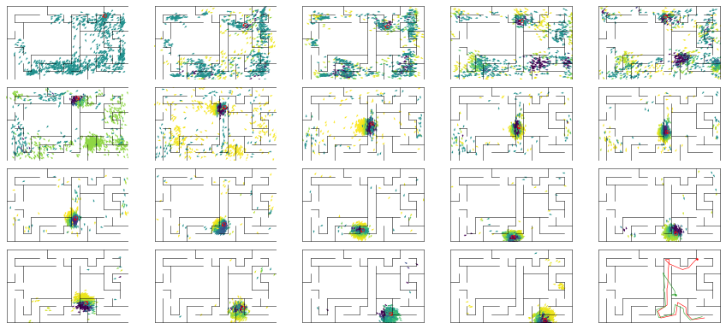

epoch 32 == mse_last: 2.51+-0.67/2.08+-0.27 -- mle: 4.64+-0.11/4.01+-0.05 --

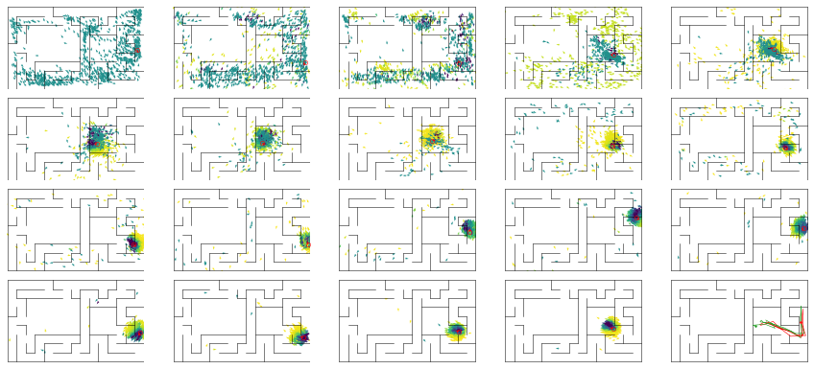

epoch 33 == mse_last: 2.35+-0.39/1.28+-0.21 -- mle: 4.61+-0.10/3.91+-0.05 --

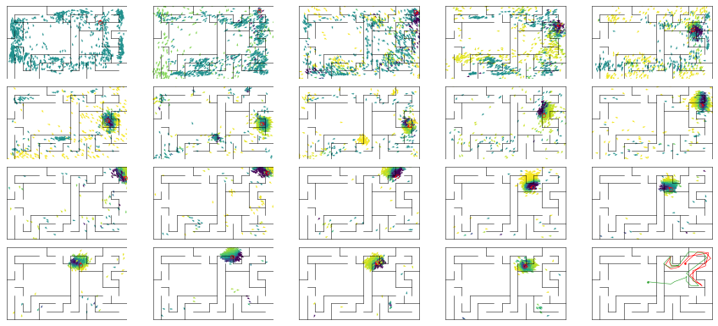

epoch 34 == mse_last: 2.97+-0.67/3.26+-0.41 -- mle: 4.60+-0.11/4.54+-0.08 --

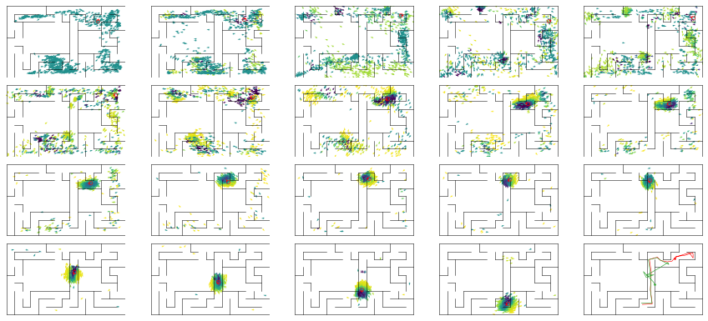

epoch 35 == mse_last: 3.01+-0.59/1.78+-0.29 -- mle: 4.66+-0.10/3.96+-0.05 --

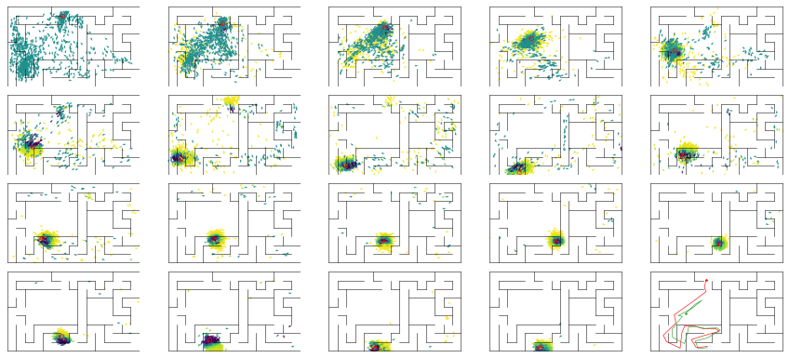

epoch 36 == mse_last: 3.26+-0.71/1.73+-0.29 -- mle: 4.67+-0.12/4.12+-0.06 --

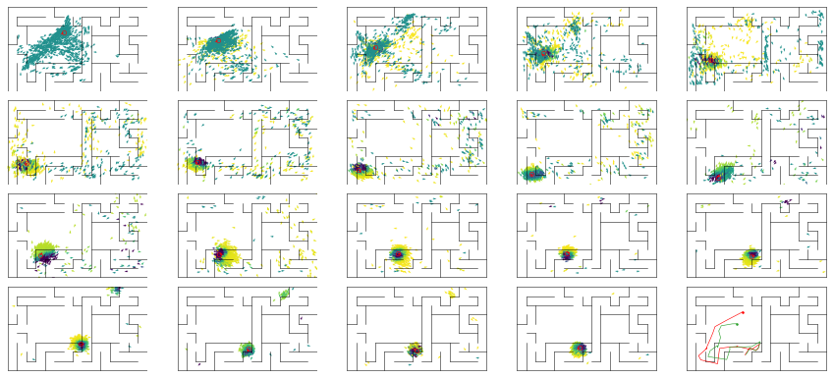

epoch 37 == mse_last: 4.65+-0.96/4.91+-0.55 -- mle: 4.88+-0.11/4.44+-0.08 --

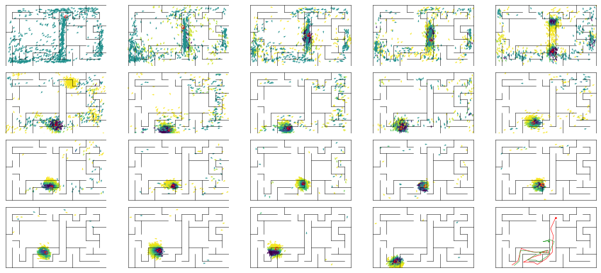

epoch 38 >> mse_last: 4.01+-0.78/1.18+-0.23 -- mle: 4.82+-0.11/3.91+-0.05 --

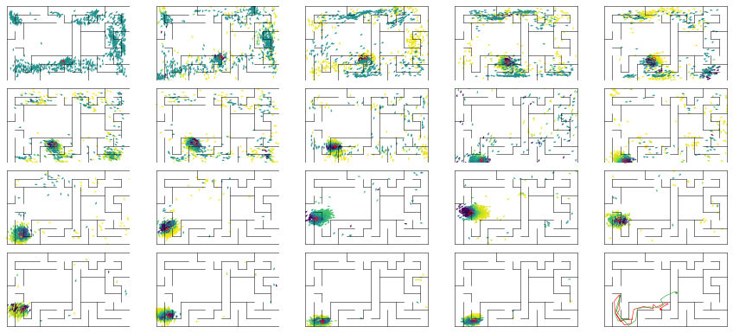

epoch 39 == mse_last: 3.15+-0.66/1.47+-0.26 -- mle: 4.54+-0.10/3.78+-0.05 --

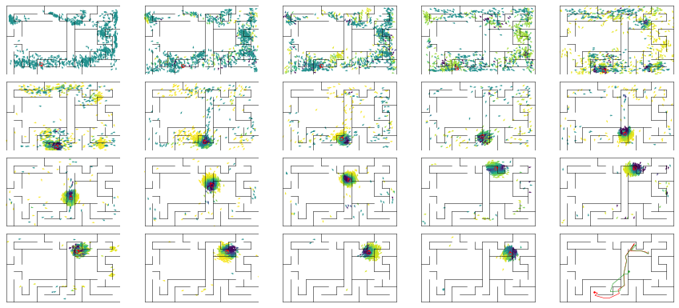

epoch 40 == mse_last: 3.26+-0.70/2.41+-0.33 -- mle: 4.57+-0.11/3.98+-0.07 --

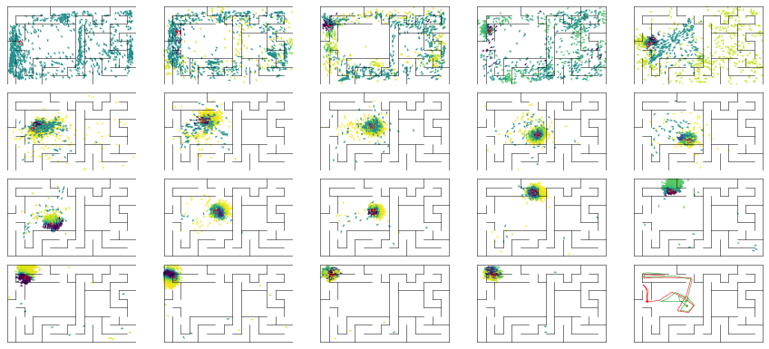

epoch 41 == mse_last: 3.32+-0.83/1.47+-0.27 -- mle: 4.50+-0.09/3.94+-0.06 --

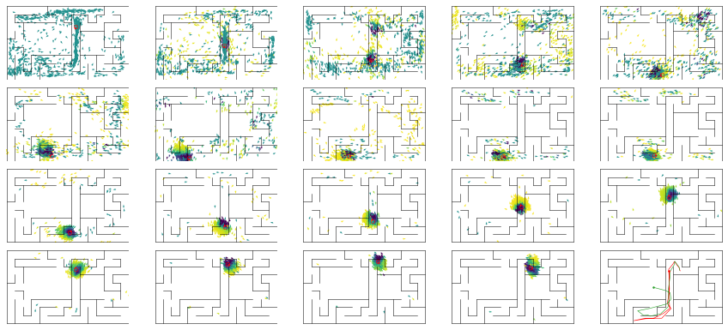

epoch 42 == mse_last: 2.61+-0.43/1.37+-0.25 -- mle: 4.51+-0.08/3.86+-0.06 --

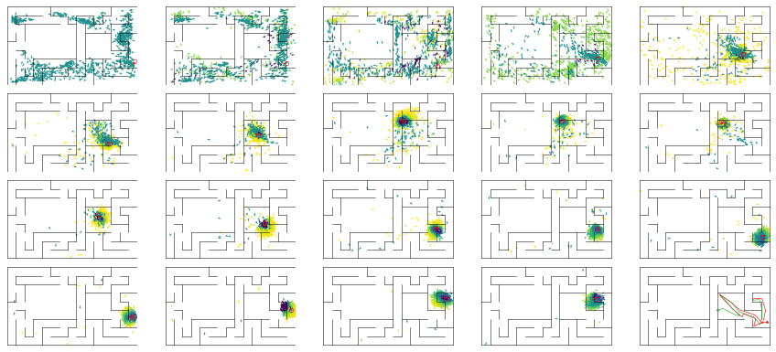

epoch 43 == mse_last: 2.38+-0.46/1.78+-0.28 -- mle: 4.39+-0.10/3.93+-0.06 --

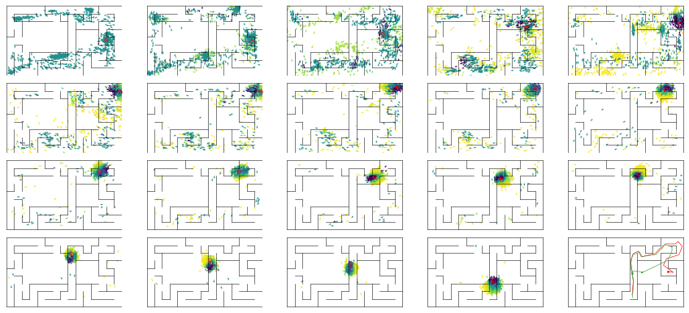

epoch 44 == mse_last: 3.11+-0.48/1.49+-0.26 -- mle: 4.68+-0.10/3.90+-0.06 --

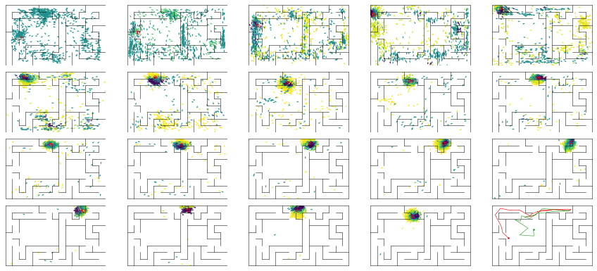

epoch 45 == mse_last: 2.54+-0.49/1.97+-0.32 -- mle: 4.51+-0.09/3.88+-0.06 --

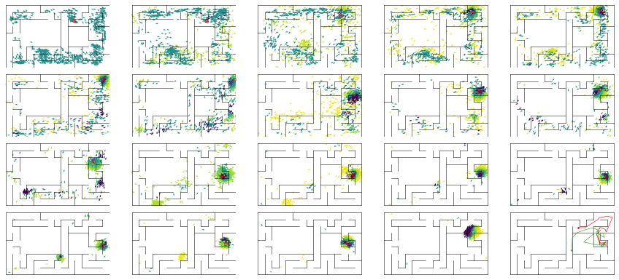

epoch 46 == mse_last: 2.50+-0.44/1.47+-0.25 -- mle: 4.62+-0.10/4.00+-0.05 --

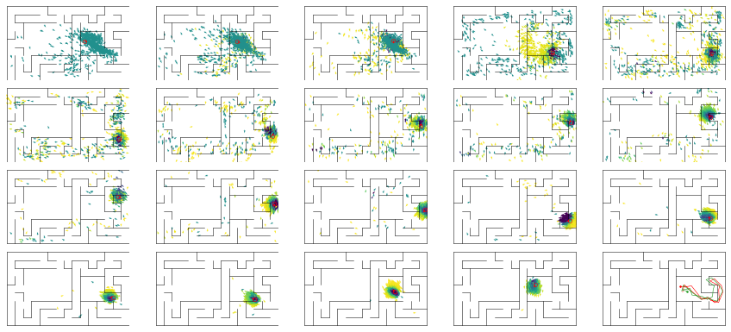

epoch 47 == mse_last: 3.19+-0.51/1.59+-0.26 -- mle: 4.81+-0.11/3.93+-0.06 --

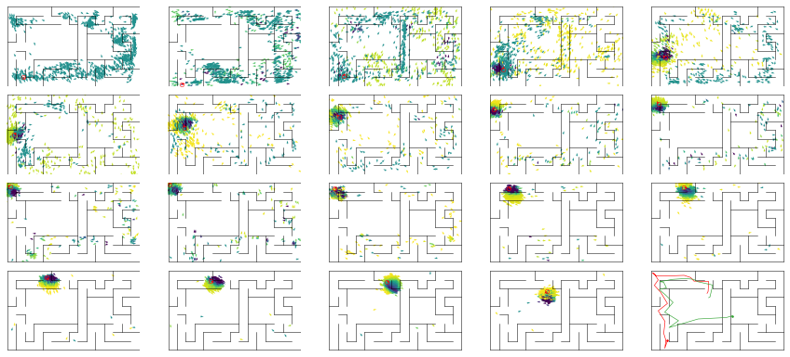

epoch 48 == mse_last: 2.29+-0.44/2.71+-0.39 -- mle: 4.66+-0.09/4.19+-0.07 --

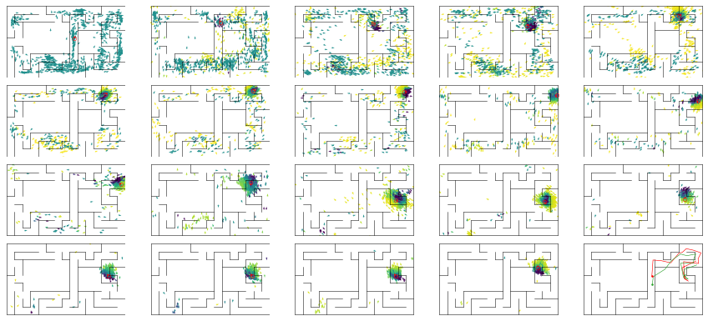

epoch 49 == mse_last: 3.81+-0.57/2.05+-0.31 -- mle: 4.77+-0.12/4.08+-0.06 --

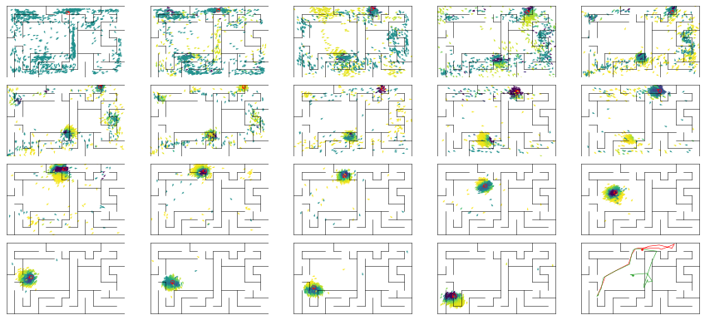

epoch 50 == mse_last: 2.66+-0.44/1.52+-0.28 -- mle: 4.45+-0.08/3.92+-0.05 --

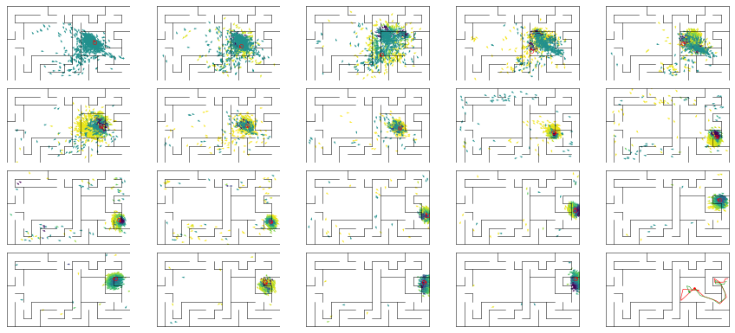

epoch 51 == mse_last: 2.65+-0.46/1.89+-0.32 -- mle: 4.53+-0.10/3.96+-0.06 --

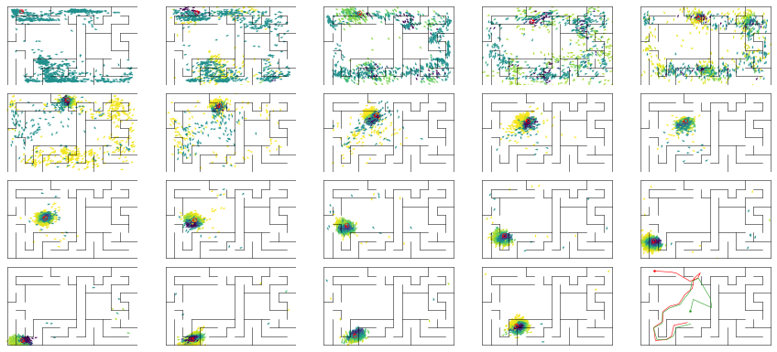

epoch 52 == mse_last: 2.78+-0.52/2.47+-0.37 -- mle: 4.48+-0.10/4.06+-0.06 --

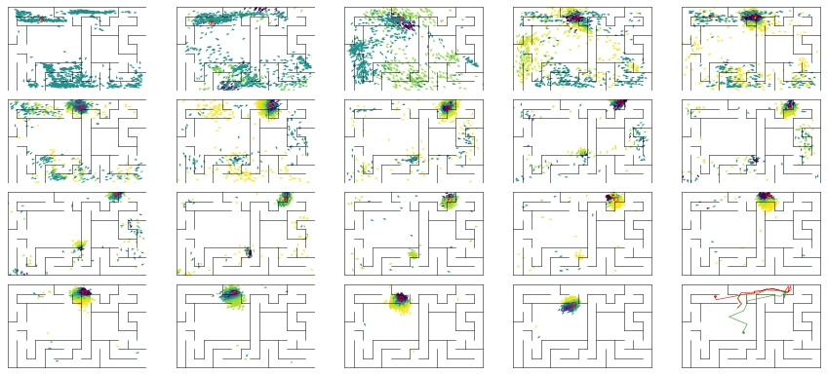

epoch 53 == mse_last: 2.84+-0.47/1.82+-0.31 -- mle: 4.47+-0.10/3.88+-0.05 --

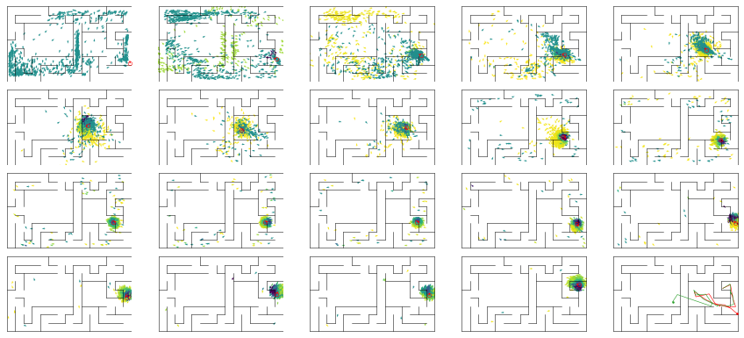

epoch 54 == mse_last: 3.43+-0.73/2.35+-0.32 -- mle: 4.35+-0.09/3.97+-0.06 --

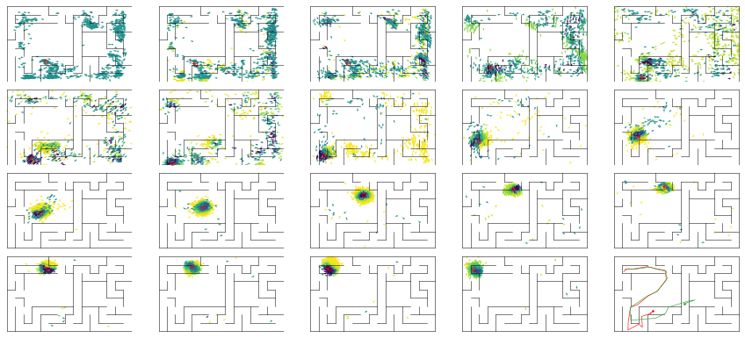

epoch 55 == mse_last: 3.25+-0.55/4.52+-0.60 -- mle: 4.53+-0.10/4.27+-0.09 --

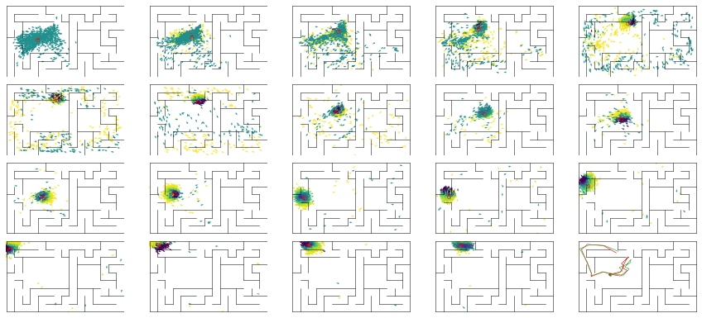

epoch 56 == mse_last: 3.29+-0.66/2.04+-0.32 -- mle: 4.50+-0.10/3.95+-0.06 --

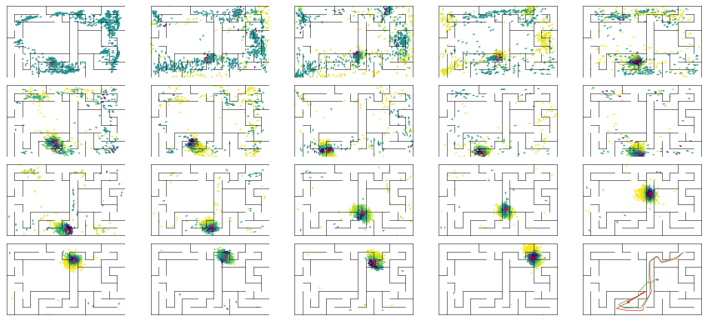

epoch 57 == mse_last: 2.15+-0.39/2.63+-0.44 -- mle: 4.44+-0.11/3.95+-0.06 --

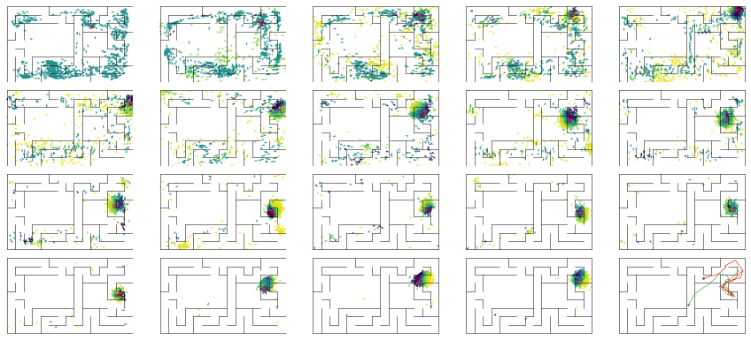

epoch 58 == mse_last: 2.47+-0.38/1.22+-0.23 -- mle: 4.54+-0.11/3.76+-0.05 --

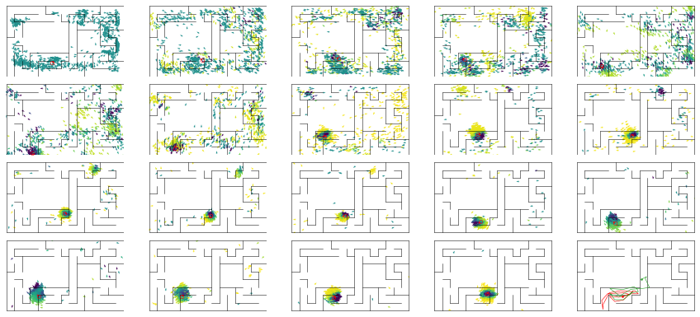

epoch 59 == mse_last: 3.04+-0.58/2.24+-0.33 -- mle: 4.50+-0.08/4.01+-0.07 --

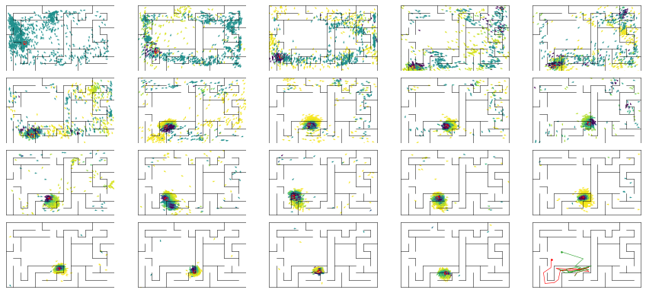

epoch 60 == mse_last: 1.88+-0.40/1.87+-0.34 -- mle: 4.40+-0.09/3.88+-0.05 --

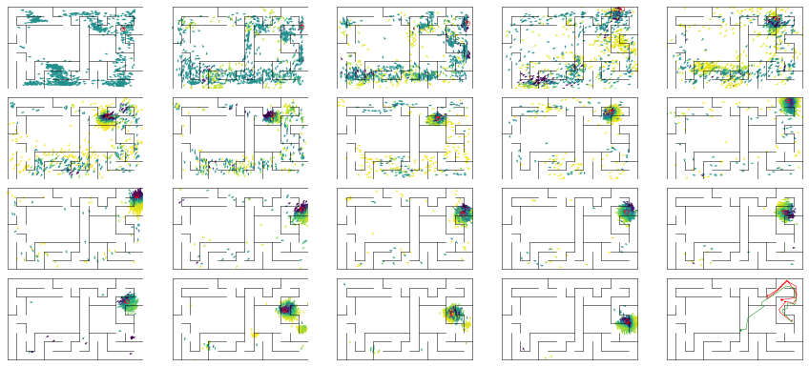

epoch 61 == mse_last: 2.60+-0.49/2.96+-0.42 -- mle: 4.42+-0.08/3.96+-0.07 --

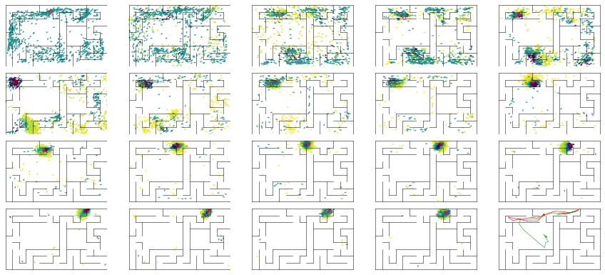

epoch 62 == mse_last: 2.24+-0.47/1.77+-0.29 -- mle: 4.41+-0.10/3.84+-0.06 --

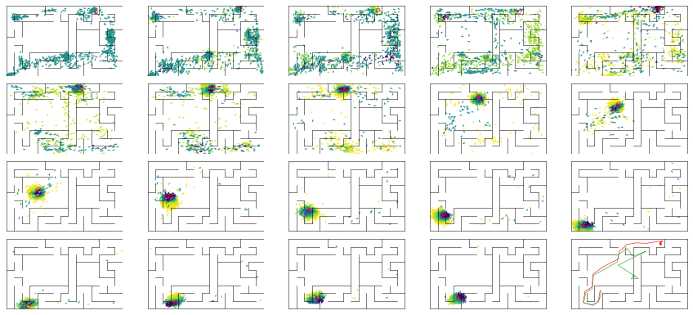

epoch 63 == mse_last: 3.17+-0.62/3.08+-0.42 -- mle: 4.31+-0.10/4.01+-0.06 --

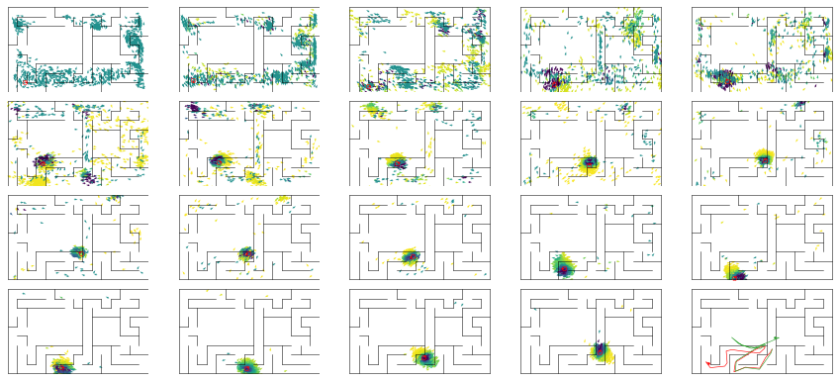

epoch 64 == mse_last: 2.67+-0.61/2.24+-0.33 -- mle: 4.41+-0.11/3.85+-0.06 --

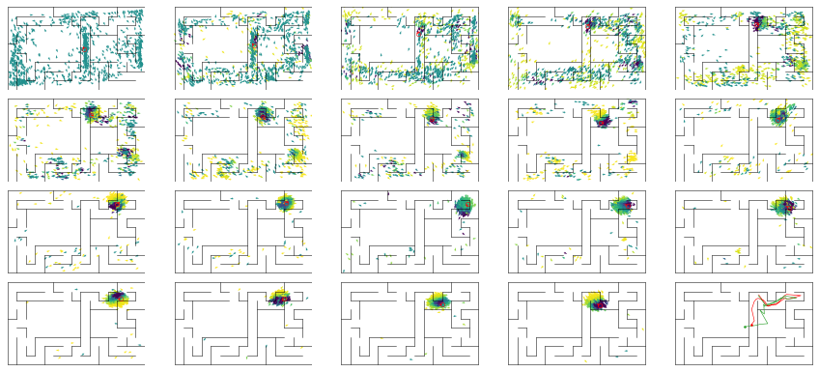

epoch 65 == mse_last: 2.53+-0.51/2.45+-0.33 -- mle: 4.58+-0.11/3.90+-0.07 --

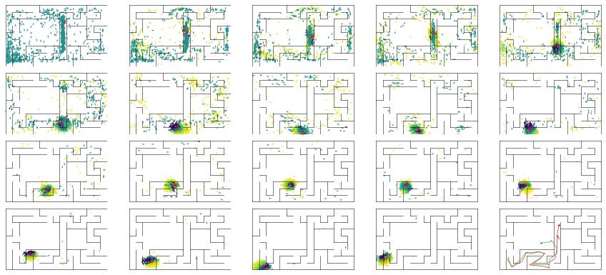

epoch 66 == mse_last: 2.54+-0.53/2.35+-0.35 -- mle: 4.28+-0.09/3.85+-0.05 --

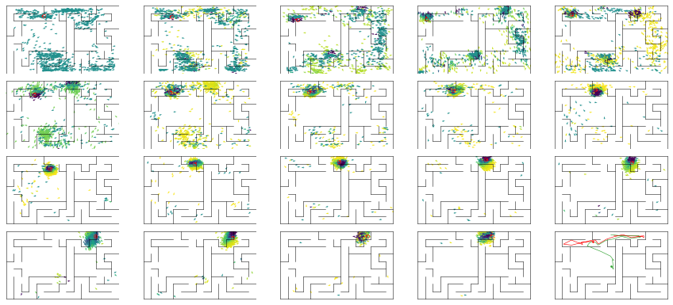

epoch 67 == mse_last: 3.00+-0.54/2.23+-0.31 -- mle: 4.52+-0.09/3.90+-0.06 --

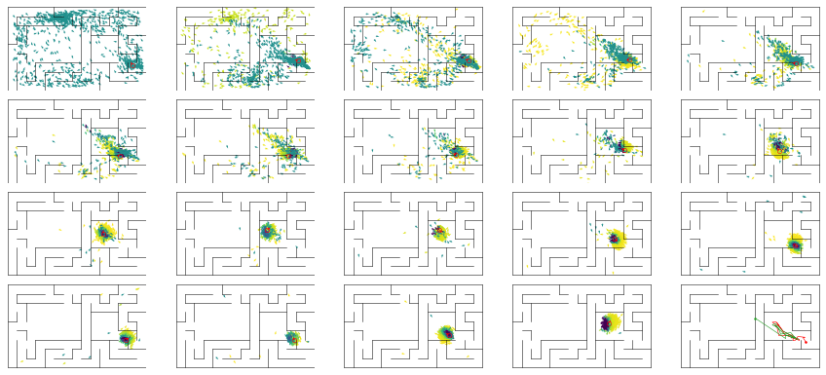

epoch 68 == mse_last: 3.89+-0.78/1.83+-0.30 -- mle: 4.65+-0.11/3.88+-0.06 --

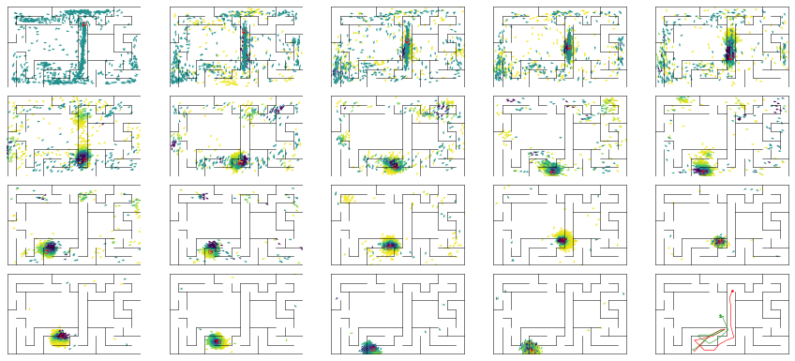

epoch 69 == mse_last: 2.68+-0.58/3.51+-0.46 -- mle: 4.62+-0.12/4.14+-0.07 --

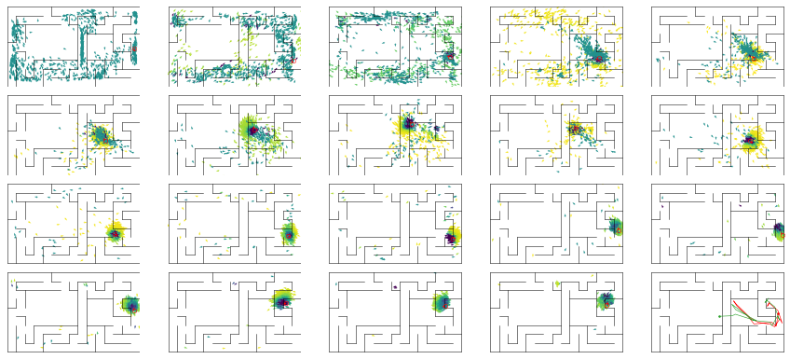

epoch 70 == mse_last: 3.78+-0.65/4.07+-0.47 -- mle: 4.68+-0.11/4.25+-0.07 --

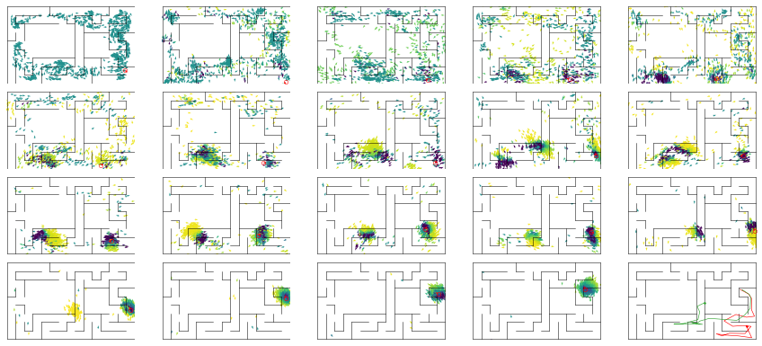

epoch 71 == mse_last: 2.92+-0.51/1.36+-0.21 -- mle: 4.72+-0.10/3.93+-0.05 --

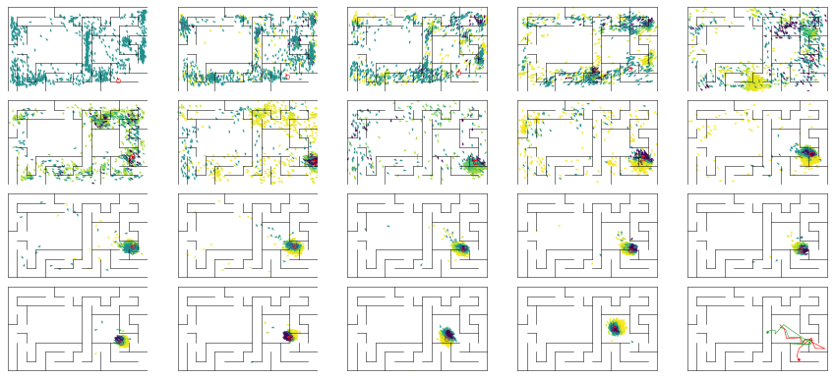

epoch 72 == mse_last: 3.85+-0.68/2.02+-0.29 -- mle: 4.79+-0.11/3.93+-0.06 --

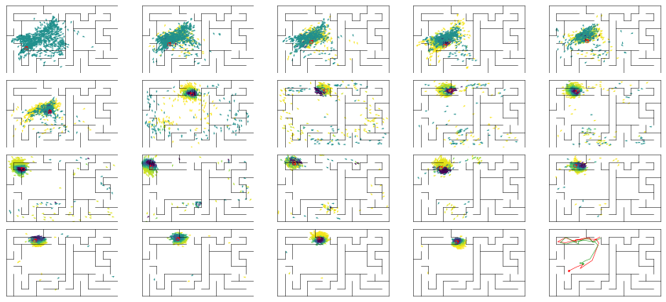

epoch 73 == mse_last: 2.24+-0.33/2.02+-0.38 -- mle: 4.44+-0.09/3.79+-0.06 --

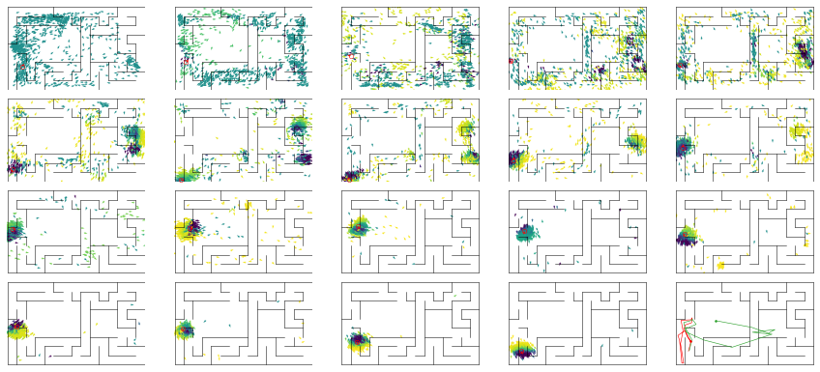

epoch 74 == mse_last: 2.74+-0.55/1.27+-0.24 -- mle: 4.35+-0.10/3.77+-0.05 --

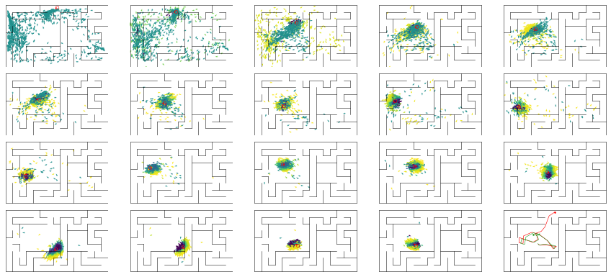

epoch 75 == mse_last: 2.57+-0.57/1.40+-0.28 -- mle: 4.43+-0.12/3.84+-0.06 --

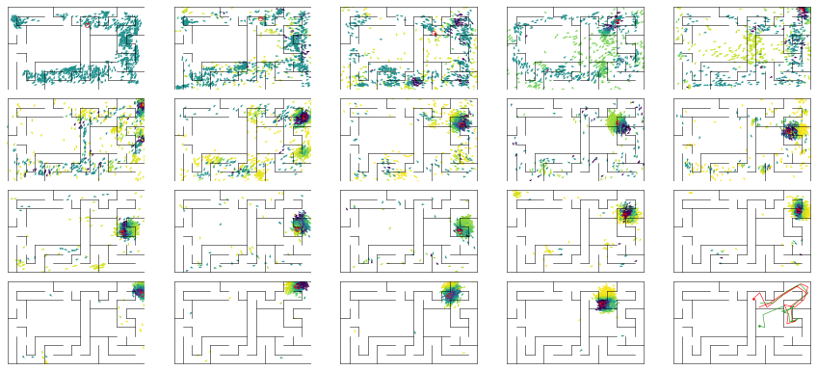

epoch 76 == mse_last: 2.58+-0.47/2.06+-0.31 -- mle: 4.43+-0.09/3.85+-0.07 --

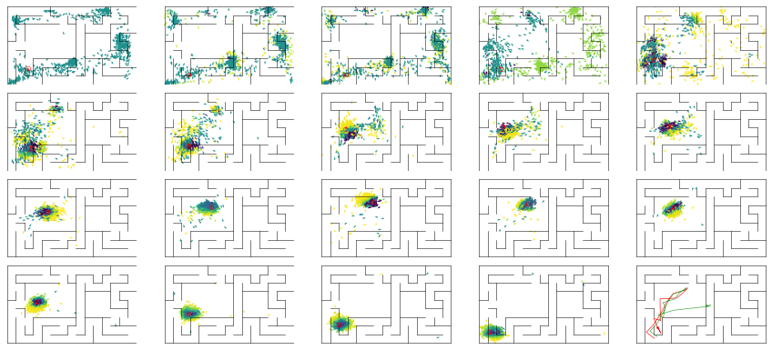

epoch 77 == mse_last: 2.26+-0.44/1.77+-0.31 -- mle: 4.46+-0.10/3.87+-0.06 --

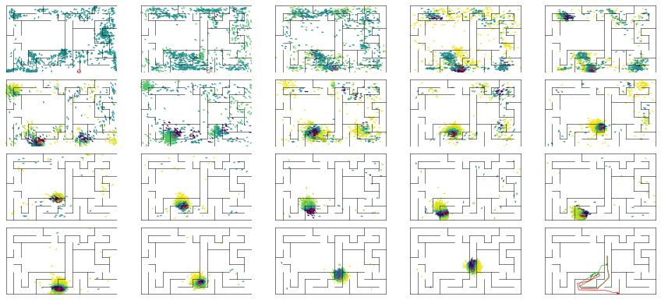

epoch 78 == mse_last: 2.20+-0.44/1.55+-0.25 -- mle: 4.36+-0.10/3.75+-0.05 --

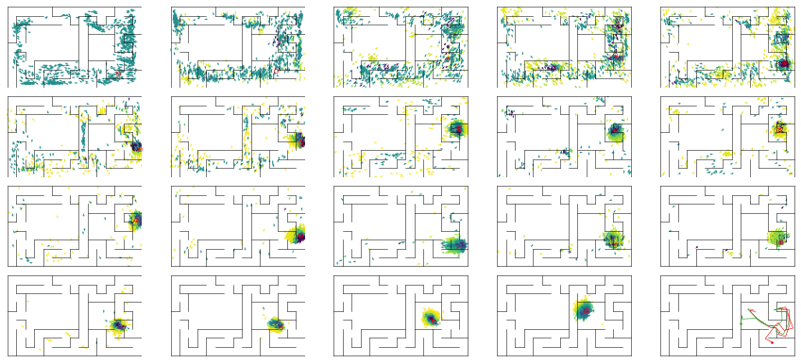

epoch 79 == mse_last: 2.65+-0.51/2.92+-0.40 -- mle: 4.54+-0.11/3.97+-0.07 --

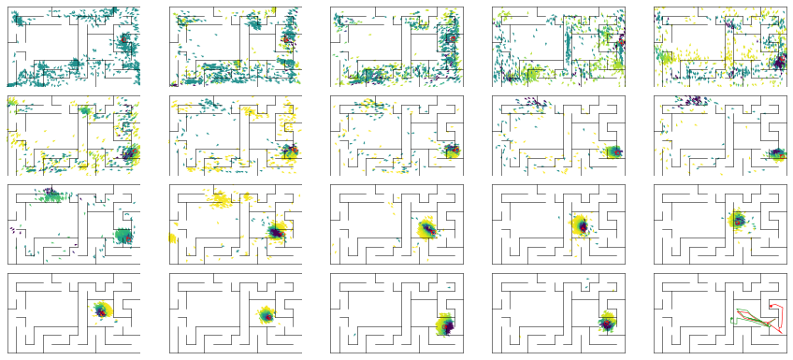

epoch 80 == mse_last: 4.06+-0.82/2.49+-0.38 -- mle: 4.41+-0.10/3.88+-0.05 --

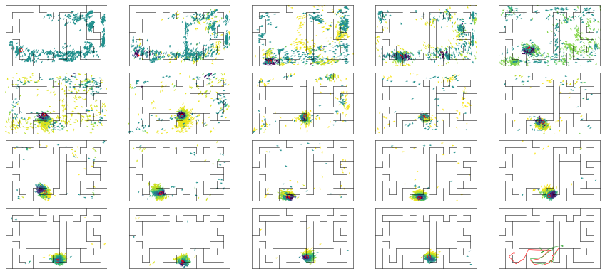

epoch 81 == mse_last: 3.14+-0.61/1.96+-0.31 -- mle: 4.48+-0.12/3.95+-0.06 --

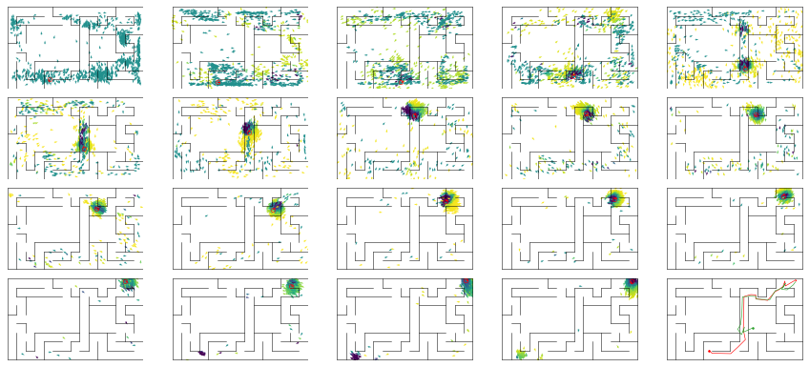

epoch 82 == mse_last: 2.87+-0.48/1.18+-0.21 -- mle: 4.39+-0.10/3.61+-0.05 --

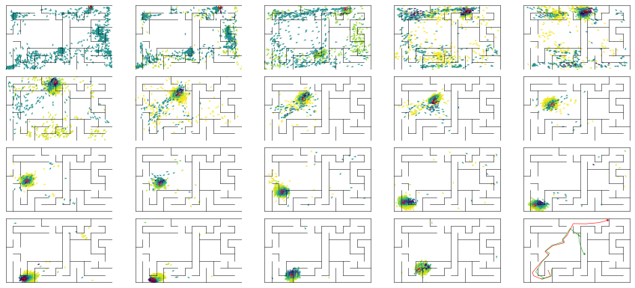

epoch 83 == mse_last: 4.14+-0.76/1.33+-0.25 -- mle: 4.45+-0.11/3.76+-0.06 --

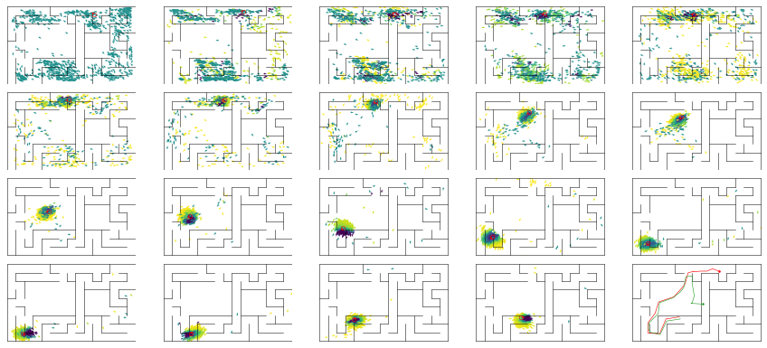

epoch 84 == mse_last: 2.39+-0.42/1.25+-0.17 -- mle: 4.45+-0.10/3.79+-0.05 --

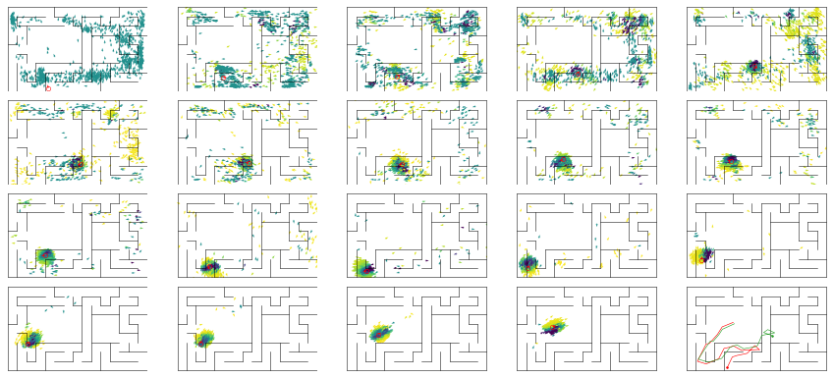

epoch 85 == mse_last: 1.60+-0.25/1.46+-0.27 -- mle: 4.45+-0.08/3.75+-0.06 --

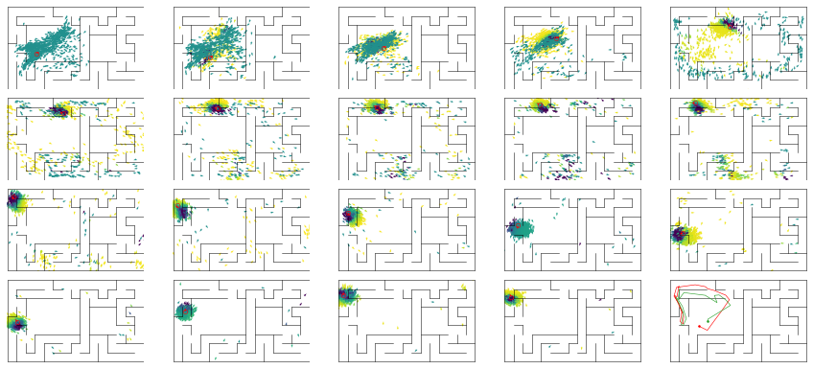

epoch 86 == mse_last: 2.12+-0.45/2.47+-0.39 -- mle: 4.20+-0.08/3.96+-0.07 --

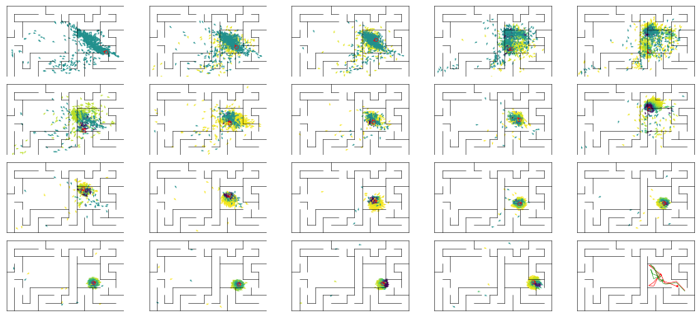

epoch 87 == mse_last: 2.01+-0.40/1.45+-0.27 -- mle: 4.44+-0.10/3.69+-0.05 --

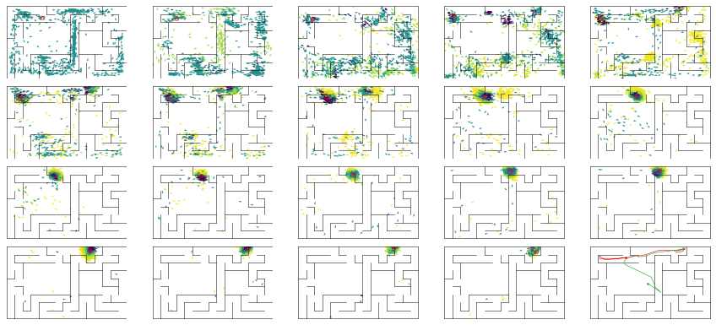

epoch 88 == mse_last: 2.91+-0.57/1.48+-0.31 -- mle: 4.57+-0.09/3.74+-0.06 --

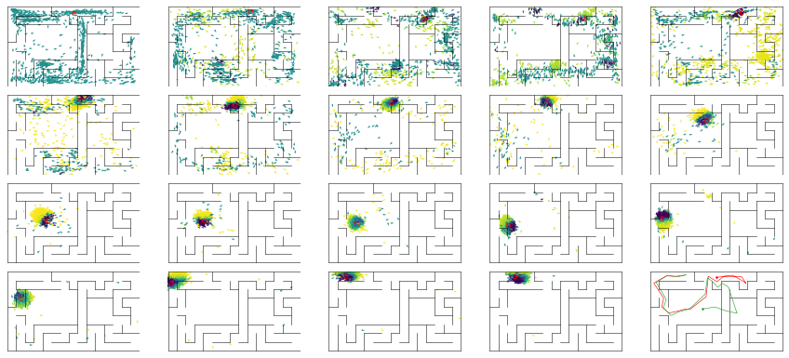

epoch 89 == mse_last: 1.75+-0.36/1.89+-0.28 -- mle: 4.15+-0.08/3.80+-0.06 --

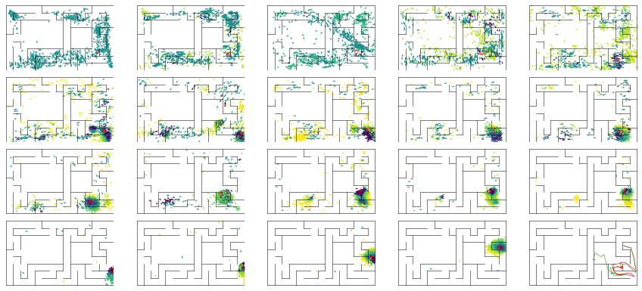

epoch 90 >> mse_last: 2.18+-0.46/1.08+-0.20 -- mle: 4.27+-0.08/3.66+-0.05 --

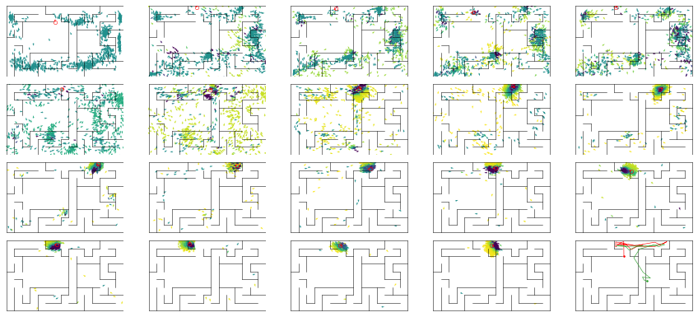

epoch 91 == mse_last: 1.60+-0.33/2.44+-0.35 -- mle: 4.32+-0.09/3.91+-0.06 --

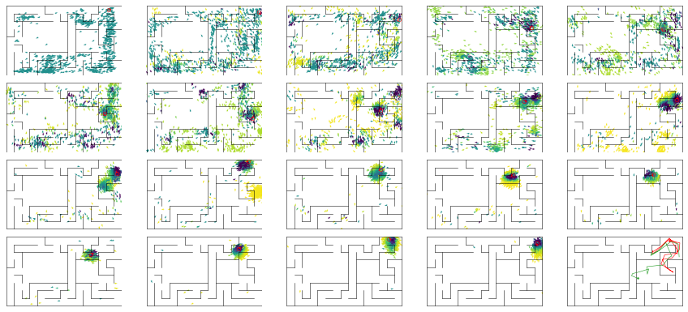

epoch 92 == mse_last: 2.65+-0.55/1.76+-0.28 -- mle: 4.41+-0.10/3.76+-0.06 --

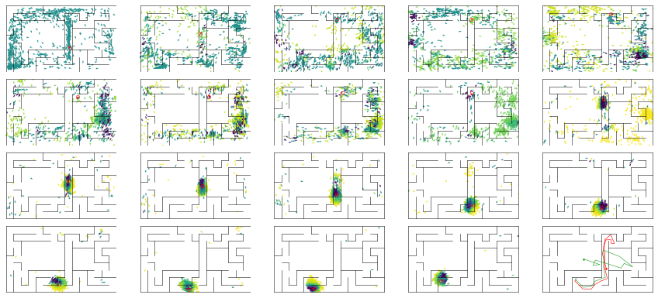

epoch 93 == mse_last: 3.17+-0.58/2.05+-0.30 -- mle: 4.45+-0.09/3.90+-0.06 --

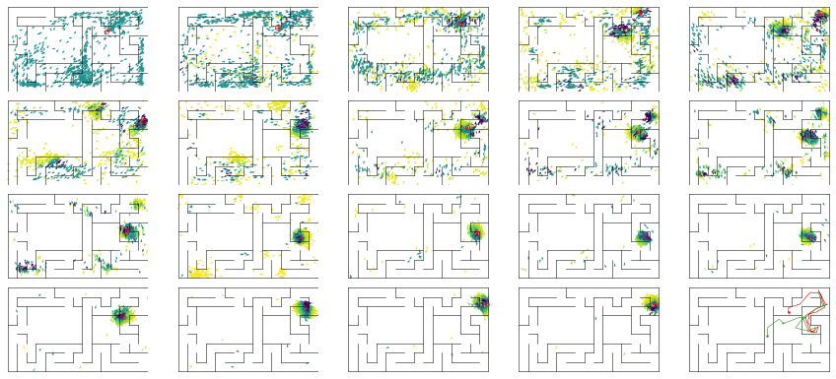

epoch 94 == mse_last: 3.56+-0.80/2.27+-0.36 -- mle: 4.61+-0.11/3.94+-0.06 --

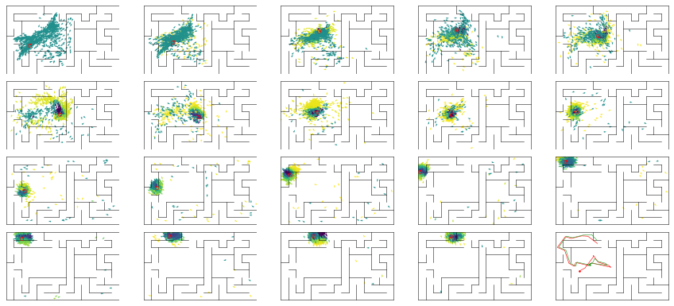

epoch 95 == mse_last: 2.92+-0.55/1.89+-0.31 -- mle: 4.59+-0.11/3.92+-0.06 --

